SCHOOL/LIBRARY/BOOKSTORE LOGO HERE [OPTIONAL]
PRESS RELEASE
Contact: [email address]
Phone number: [phone number]
***For Immediate Release***
[NAME OF YOUR ORGANIZATION HERE]
TO CELEBRATE CREATIVITY & COURAGE WITH
OVER A MILLION KIDS AROUND THE WORLD

THE DOT Book by Peter H. Reynolds,
Invites Children and Grown Up Children to Be Brave & Make Their Mark
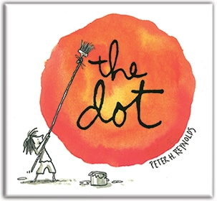
[YOUR TOWN/CITY/STATE:] – [NAME OF YOUR ORGANIZATION HERE] has joined over a million children and adults around the globe to celebrate International Dot Day – a grass roots “creativity & courage” movement, started in 2009 by a teacher in Iowa. Inspired by New York Times best-selling author/illustrator Peter H. Reynolds’ classic “storybook for all ages” The Dot, International Dot Day inspires young and old to embrace the power of personal creativity to change the world. Dot Day has generated support around the globe, including all 50 U.S. states, all seven continents, and even on the International Space Station.
[ADD OPTIONAL QUOTE HERE] The reason why [NAME OF YOUR ORGANIZATION HERE] is participating is because [QUOTE HERE.], notes [TITLE/NAME.]
THE DOT by Peter H. Reynolds is the winner of the Irma S and James H Black Honor for Excellence in Children's Literature Award, as well as The Christopher Award.
International Dot Day began six years when Iowa teacher Terry Shay introduced his classroom to Reynolds’ book on September 15th, and his student’s noticed the original publishing date of The Dot was September 15, 2003. The students decided to celebrate the book’s birthday – and, little did they know, launched what would become a worldwide celebration of creativity and courage to “make your mark.” Shay, a public school teacher for over two decades, notes “In The Dot, it is the teacher’s invitation to be creative becomes a breakthrough in confidence and courage for the student, igniting a journey of self-discovery and sharing. Every great teacher works for those transformational moments.”
Exploring the themes of creativity, bravery and self-expression, The Dot is a story of a perceptive and caring teacher who reaches a reluctant student who thinks she can’t draw by encouraging her be brave enough to “just make a mark and see where it takes you.” The Dot has been translated into many languages (including Portuguese, Chinese, Korean, Hebrew, Spanish and even Braille) and the animated film of The Dot (produced by Reynolds’ multi-media design and development firm FableVision and co-producer Scholastic) earned the Carnegie Medal of Excellence.
International Dot Day has garnered attention in schools, libraries, and communities around the globe. Registrations reached 17,500 in 2011. Noticing the phenomenon, The Reynolds Center for Teaching, Learning & Creativity (ReynoldsTLC.org), Reynolds’ non-profit educational R&D and creative learning support center, helped provide program support for the worldwide Dot Day event. The organization built and manages The Dot Club website (www.TheDotClub.org), which provides free registration for the event, along with a free downloadable Dot Day Educator’s Handbook, multi-lingual posters and an official participation certificate.
With the Reynolds Center’s help, participation soared past the 850,000 mark in 2012 – and, last year, exceeded 1.3 million participants in 84 countries. Shay can’t quite believe how Dot Day has caught on, “There are now entire towns celebrating – connecting the dots between the schools, public library and community at large – it’s truly amazing.” Indeed, Dot Day celebrations now take many forms; from short art workshops where students make dots and sign them to animating dot-inspired art/stories on the computer, from weeklong school-wide celebrations to a year-long theme for a school district.
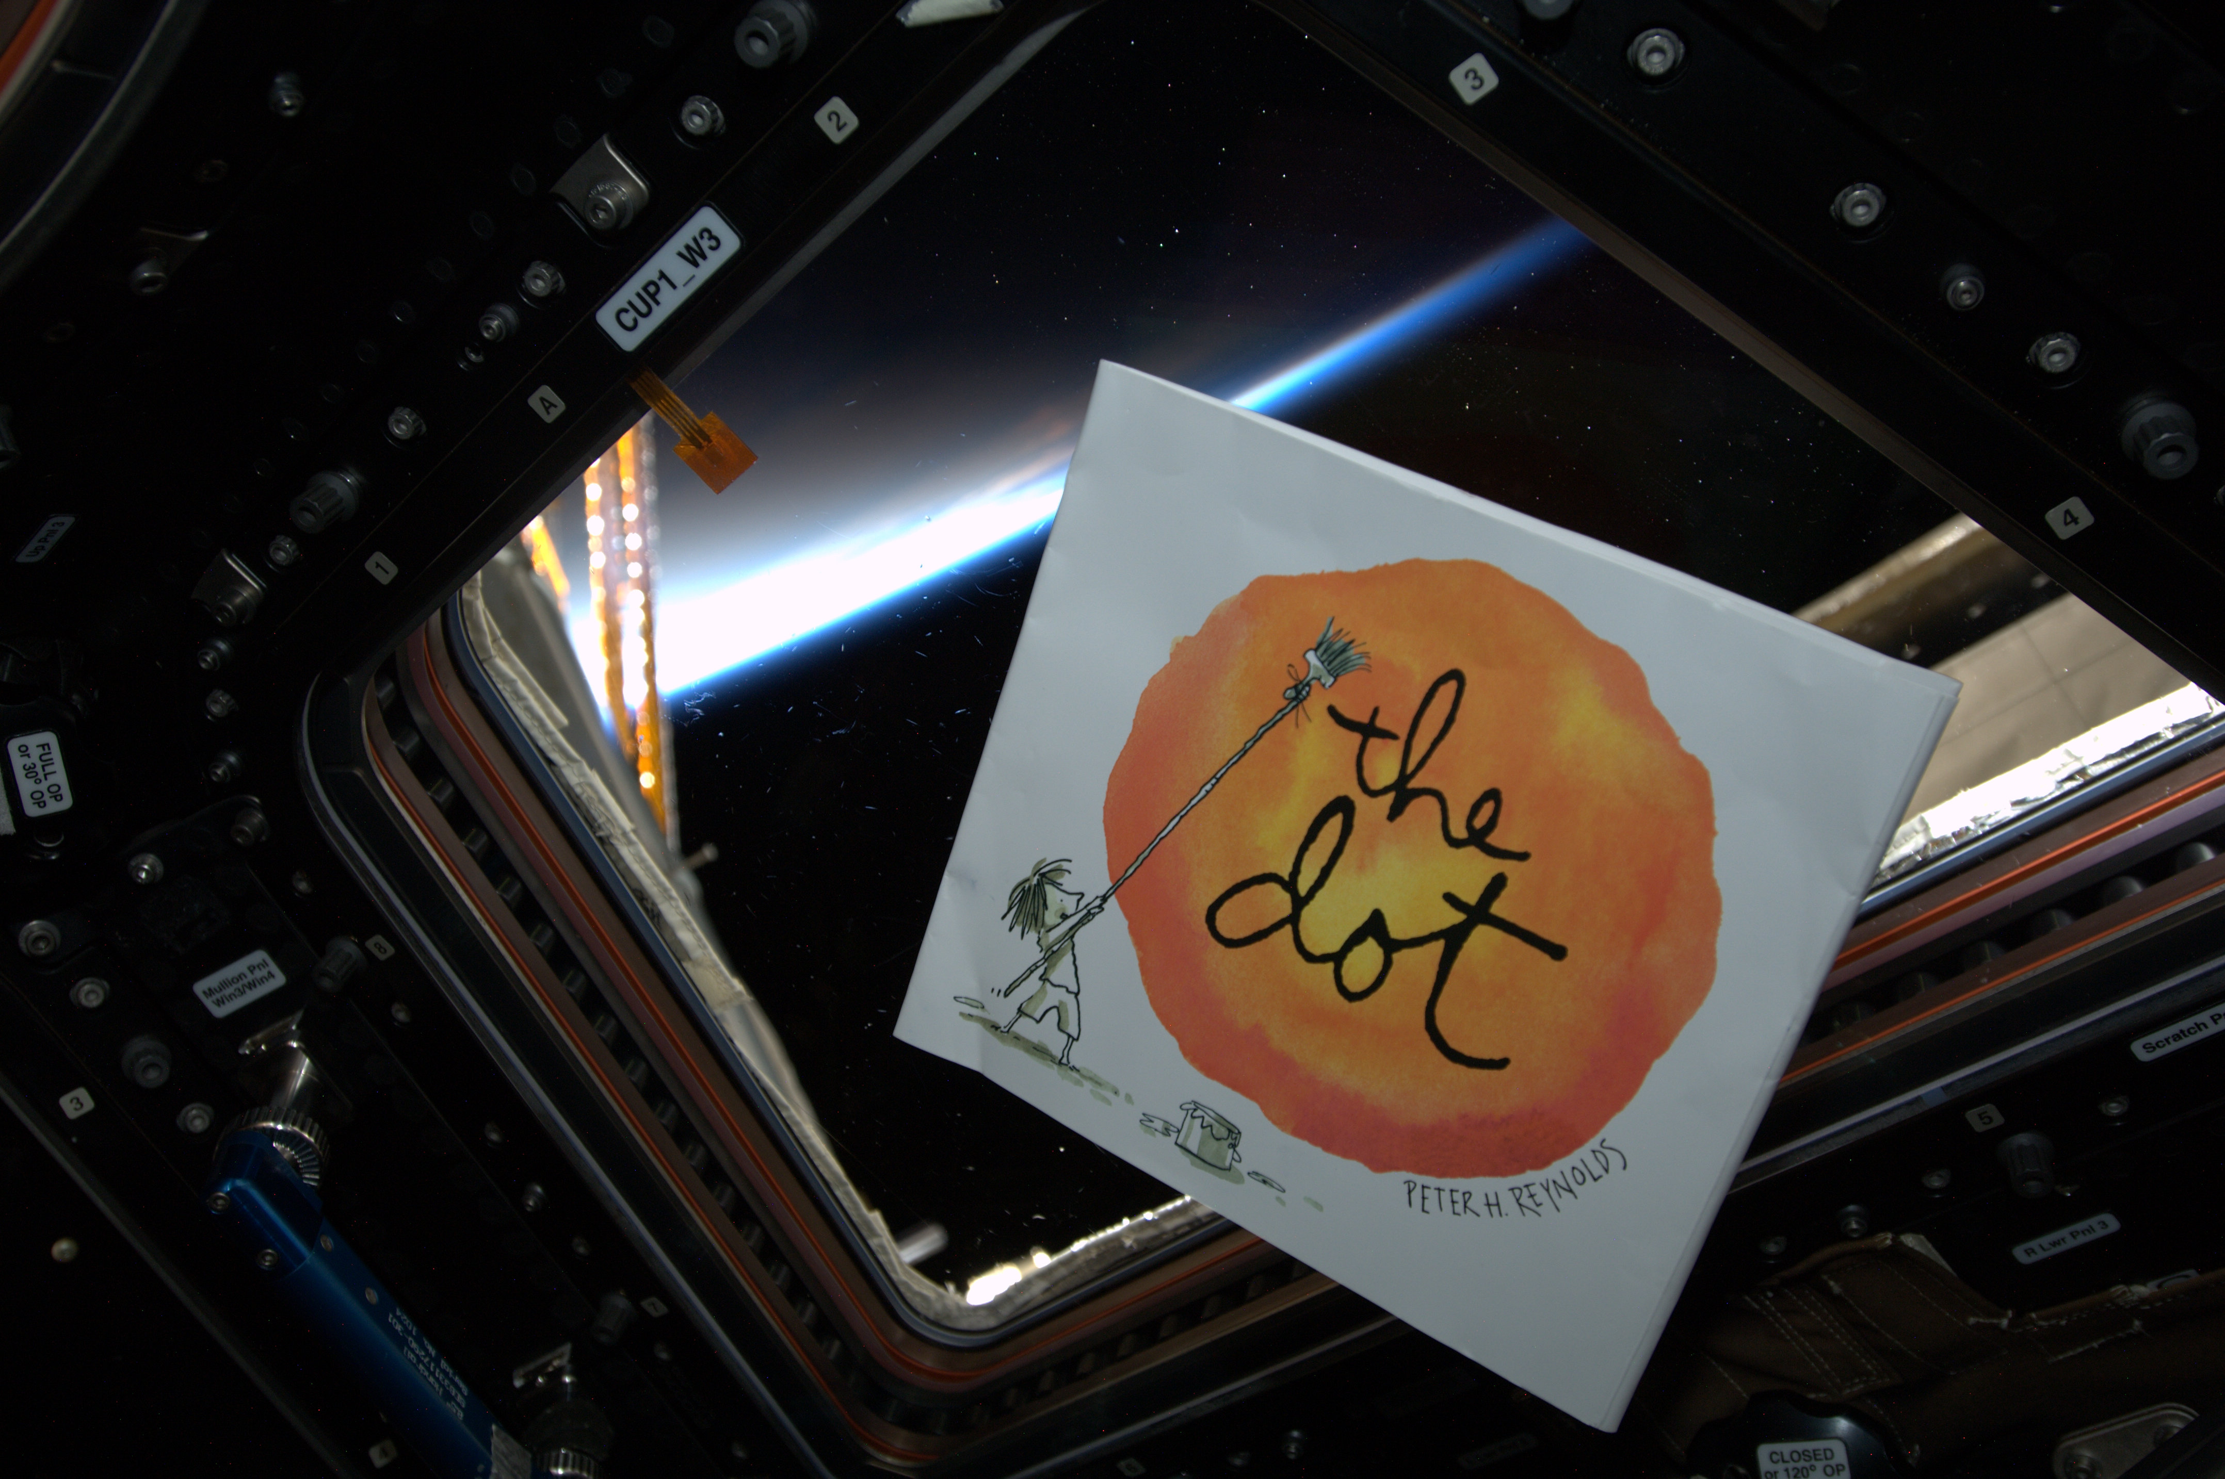
Early last year, a copy of The Dot book was even rocketed to Canadian Astronaut Col. Chris Hadfield serving at Commander aboard the International Space Station. The Dot’s author/illustrator Peter H. Reynolds explains, “Commander Hadfield snapped a few photos of The Dot book floating in the cupola of the space station. On his last day of his recent Boston visit, he handed me my book, which he had signed, noting that this copy…had made 2,500 trips around the big blue dot – planet Earth.”

[NAME OF YOUR ORGANIZATION HERE] is planning to celebrate Dot Day by [LIST WAYS YOUR ORGANIZATION IS CELEBRATING, EVENT DATES]
For more information about International Dot Day, visit www.thedotclub.org/dotday. For official Dot Day Twitter feed, follow @DotClubConnect. Find International Dot Day on Facebook at https://www.facebook.com/InternationalDotDay.
##
About Peter H. Reynolds and The Dot

Peter H. Reynolds (www.peterhreynolds.com) is a NY Times best-selling author and illustrator, creativity advocate, and founder of FableVision (www.fablevision.com), an award-winning educational multimedia development company co-located at the Boston Children's Museum, as well as FableVision Learning, a K12 educational media & technology publisher based in Dedham, MA. Reynolds’ goal is “to help children protect their creative spirit and give their parents, teachers, and caregivers the support and tools to bravely make their mark in learning, creative self-expression, and civic problem-solving.”
In 2007, Peter received an honorary Doctorate of Humane Letters from his undergraduate alma mater, Fitchburg State University, in recognition of his “substantial contributions to education and the arts.” He was named Verizon Literacy Champion for his “tireless efforts in promoting reading, writing and self-expression”, and was also awarded the 2012 Champion of Arts Education Advocacy Award at the Massachusetts’ Statehouse for his “amazing work supporting & promoting arts education.” Last December, Reynolds was presented with the 2013 Visionary Award by the Association of American Publishers (AAP) for his “insight and exceptional leadership.”
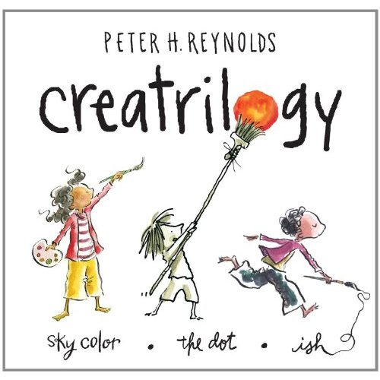
Peter’s book The Dot was named as one of the top 15 “Greatest Books for Kids” of all time by Scholastic Parent & Child magazine - alongside Charlotte's Web by E.B. White and A Wrinkle in Time by Madeleine L'Engle.
Published in over 25 languages, Peter's books - including The Dot, Ish, Sky Color, Rose's Garden, I'm Here, So Few of Me and The North Star - inspire children and grown up children with his messages about authentic learning, creativity, bravery, empathy, and courageous self-expression. Peter also illustrated the best-selling Someday by Alison McGhee, and the Judy Moody series by Megan McDonald, which has sold over 20 million copies worldwide.
Reynolds’ “Crea-trilogy” series includes The Dot, Ish, and Sky Color.

