Cardboard People
Description: Each group is to create a cardboard person (Astronaut, Farmer, Doctor, Construction Worker, or Doctor).

Setup: MKT & TA’s project outline onto pieces of cardboard and cut them out for each character. Also have other random shapes precut and in a box. Gesso the figures for easy painting surface. Let dry before class.
(whole puncher and brads are optional. Brads might get stuck unless added after paint is dry.)

Students: May add additional shapes to make a helmet, tool & other accessories.

Materials:
Cardboard
Scissors
Paint
Hot Glue
Plastic Drop Cloth
(Additions such as glitter and class room trinkets)

Step 1:Pick numbers from a hat, each number matches a figure.
Step 2: Talk with team member about how what to paint on the figure.
Setp 3: Paint and let paint dry.
Step 4: Glue

UH Cougar Logo / Self Logo

Description: Make grid of UH Logo and have kids paint and connect.
Ask kids to make their own logo and paint using fabric paints and fabric squeeze paint bottles.

Set Up: Have Cougar Outlined onto cardboard. Have illustration books with logo looks (especially for kids that seems stuck to stay on schedule.)

Materials:
Cardboard and poster paint (UH Cougar)
Various Fabric Paints
Paint
T-shirts (will need extra shirts)

Part 1
Step 1: Pick numbered part.
Step 2: Draw it on cardboard with marker.
Step 3: Paint
Step 4: Dry

Part 1
Step 1: Kids get draw their logo idea and then get T-shirt.
Step 2: Paint with fabric paints
Step 3: Set out to dry
Step 4: Clean Up

Reconstruction of House

Description: Make house furniture for remodeling project (Couch with patterns, Car with stripes, Computer with large screen & keyboard, Stove and Microwave). Little kids will work on wall paper by drawing & coloring animals/insects.

Setup: MKT & TA’s project outline onto pieces of cardboard and cut them out for each character. Also have other random shapes precut and in a box. Gesso the figures for easy painting surface. Let dry before class.
(whole puncher and brads are optional. Brads might get stuck unless added after paint is dry.)

Materials:
Paper / Cardboard
Scissors
Paint
Duck Tape
Hot Glue

Step 1:Pick numbered part with basic layout
Step 2: Draw & Cut it on cardboard with marker.
Step 3: Tape it together
Step 4: Splatter paint it colorfully.
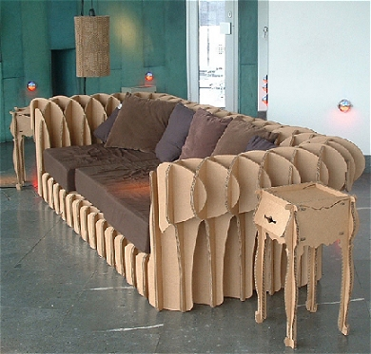
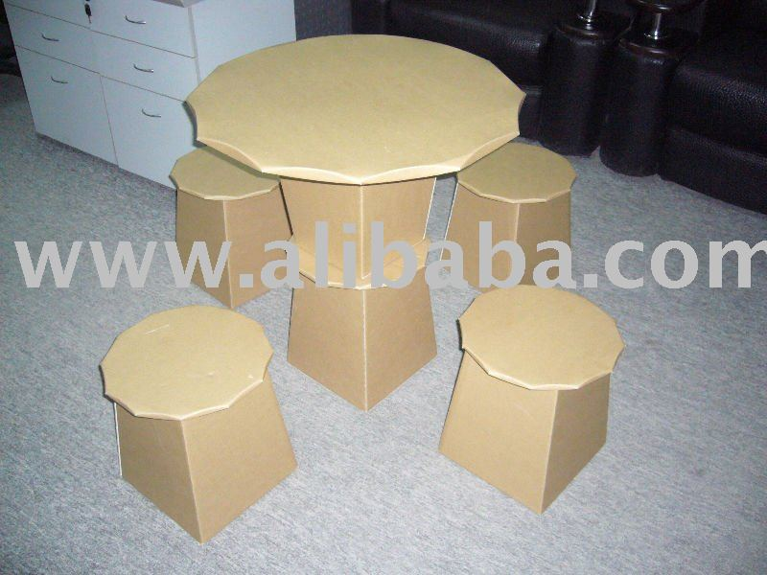
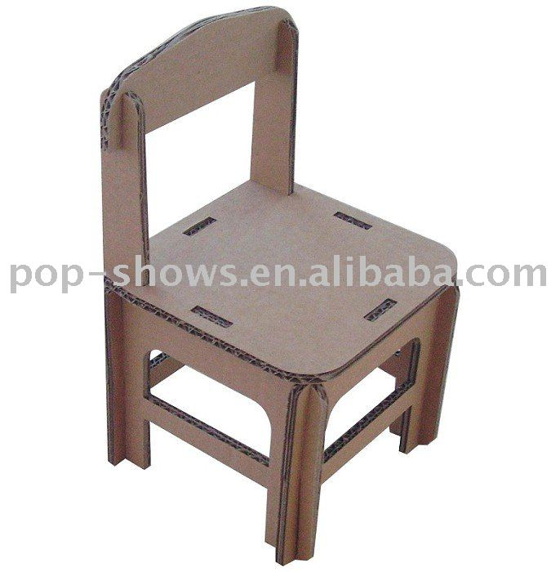

Planet

Description: Make planets with different geographies and continents made up by the kids. Discuss mountains, and lakes, and rivers, etc.

Setup: Blow up Bleach balls
Materials:
Beach Balls
Paint
Blow Dryers

http://www.toysplash.com/Product/Beachball20 $0.97

http://www.acehardware.com/product/index.jsp?productId=1342553 $2

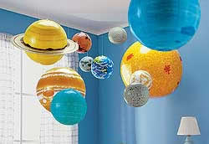

Tower
Description: Make one big building using multiple cardboard boxes.

Setup: Gather cardboard pieces and boxes over a few days or weeks and stock in the room.

Students: Paint the boxes to be part of one building, little kids can draw people for windows and side walks.

Materials:
Cardboard
Scissors
Paint
Duck Tape
Hot Glue

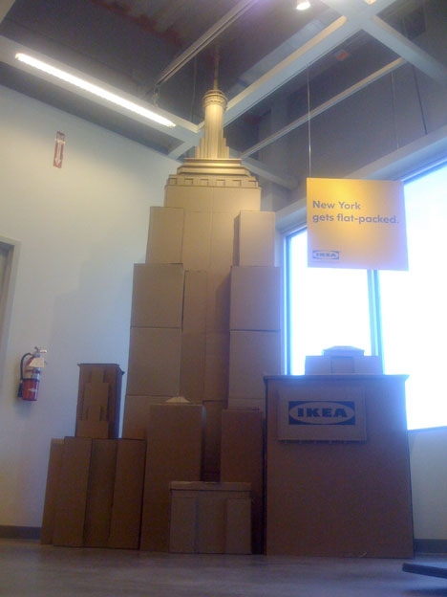

Book Making

http://www.makingbooks.com/accordion.shtml
http://www.makingbooks.com/elastic.shtml

Potato Prints
http://www.marthastewart.com/264217/potato-prints
http://rubberstamping.about.com/od/stampingforchildren/ht/PotatoStamp.htm

Model Magic

