Storage Chest
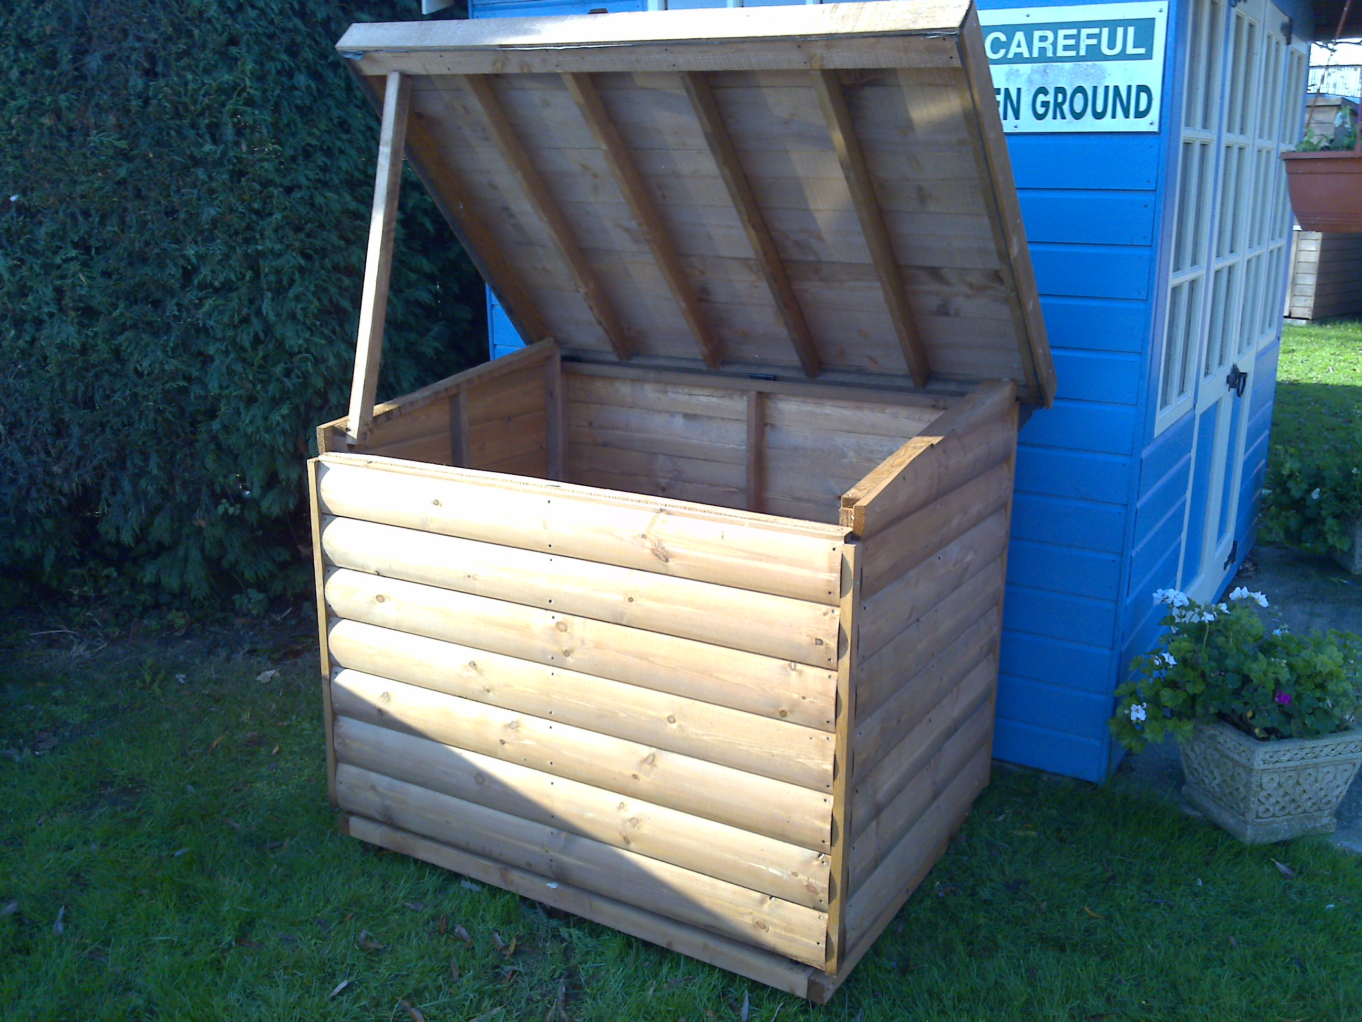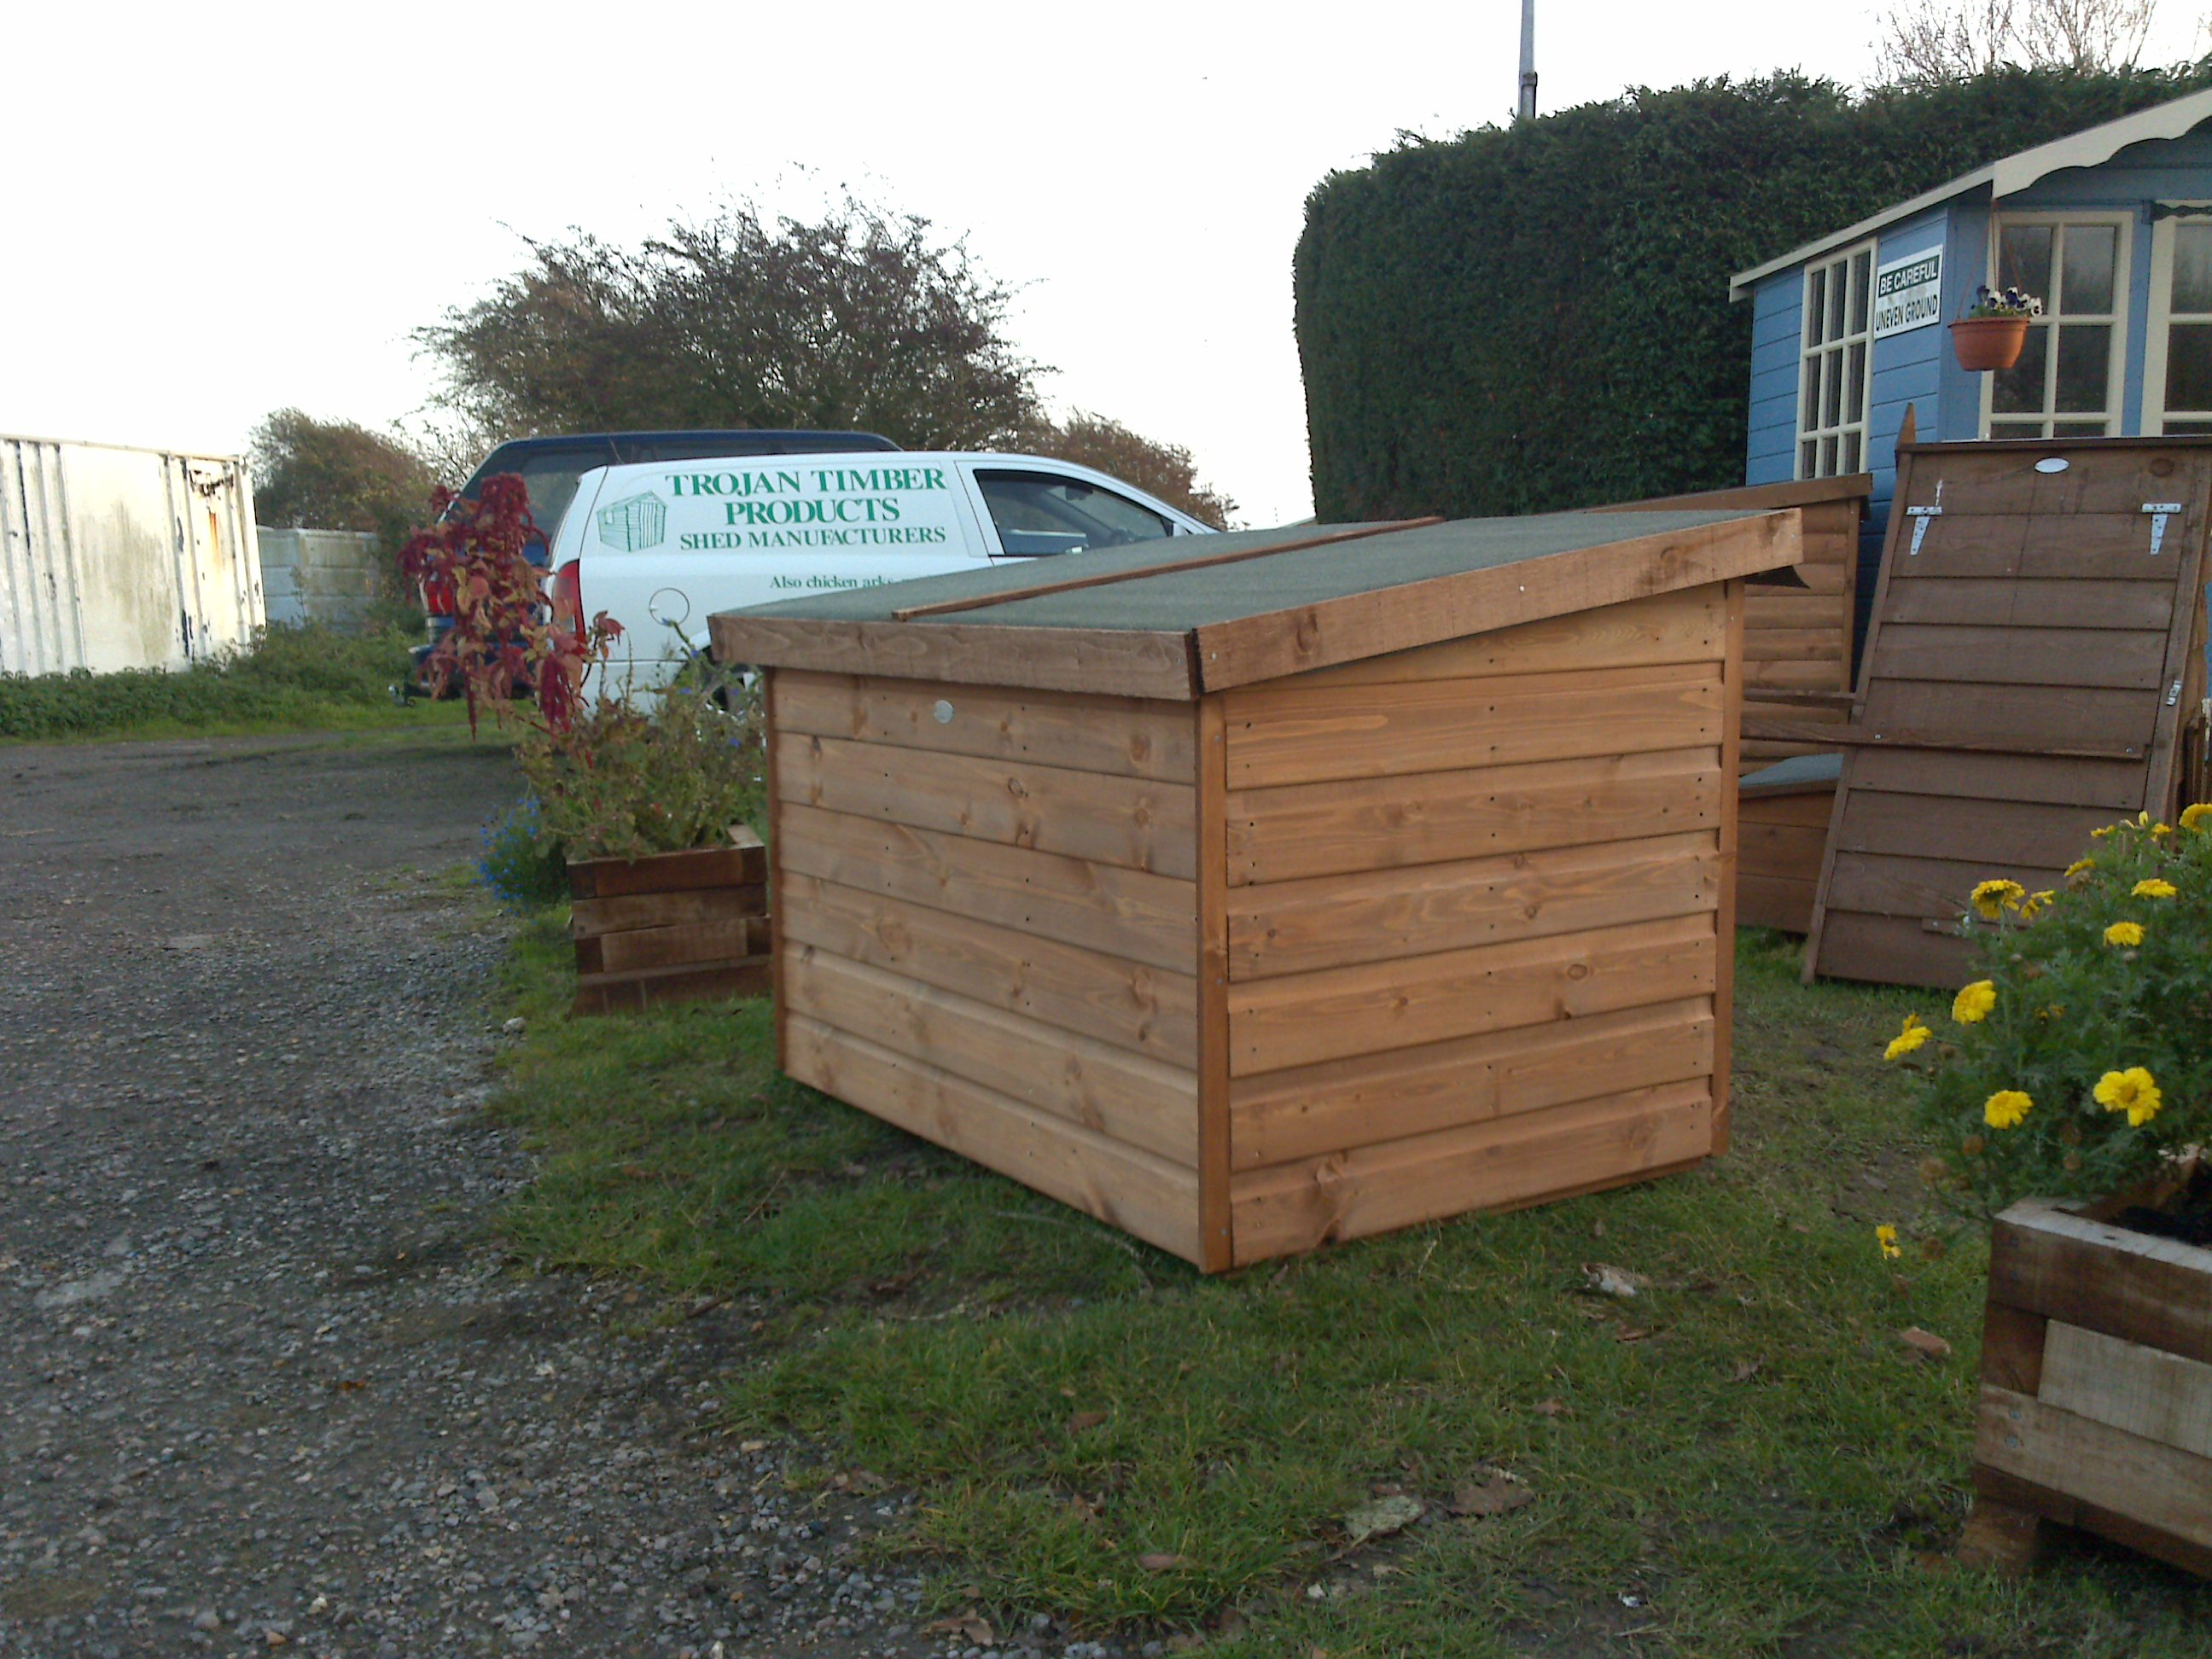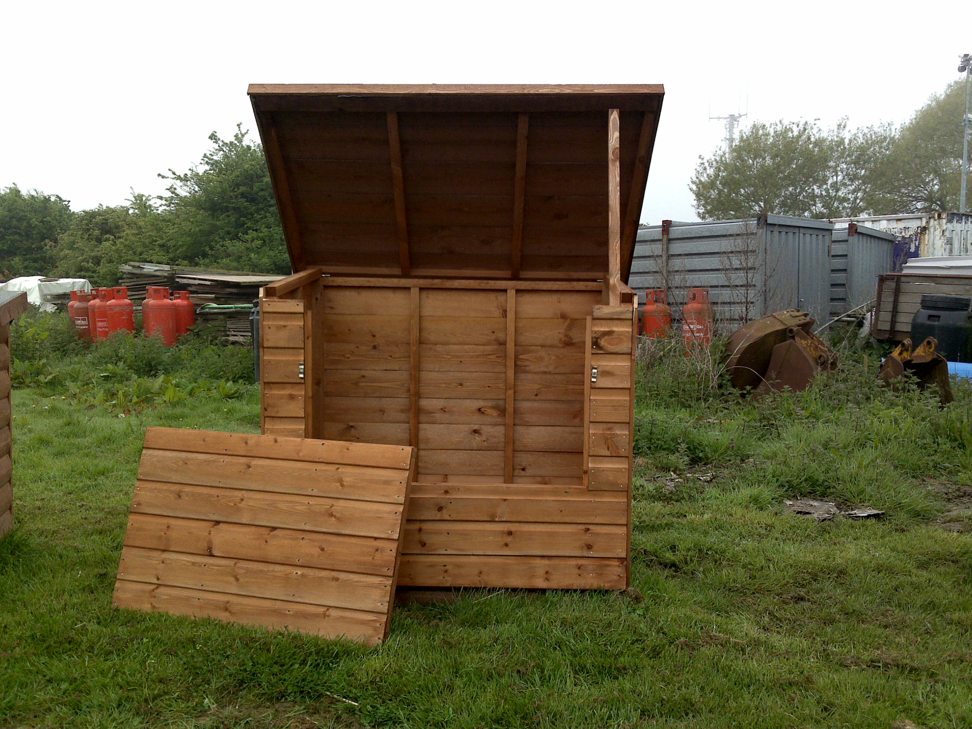

3’ X 4’ £145.00

3’ X 4’ £156.00
(Removable front panel)

Delivery to your area £?

All prices are plus V.A.T.
We need to know if this item can be delivered erected or erected once in the garden.

