THE FOLLOWING CLASS AGES FOR BOTH BULLS & HEIFERS
SENIOR CLASSES
1ST JULY 2013 – 31ST DECEMBER 2013
JUNIOR CLASSES
1ST JANUARY 2014 ONWARDS
CLASSES WILL BE SPLIT AFTER ALL ENTRIES ARE RECEIVED.
YOUNG HANDLERS – NO ENTRY FEE
AGE 15 – 18 AGE 11 - 14
NO ENTRIES WILL BE TAKEN ON THE DAY

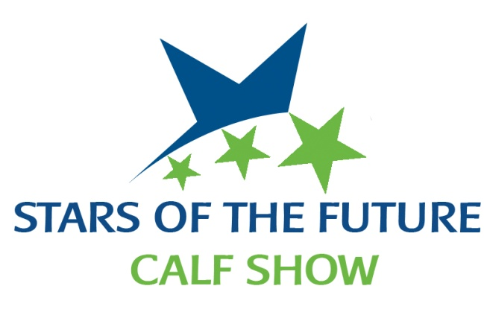
SATURDAY 15TH NOVEMBER 2014 – UNITED AUCTIONS, STIRLING
HERD PREFIX ___________________________________________
NAME __________________________________________________ MUST BE BVD TESTED OR ACCREDITED
ADDRESS _______________________________________________ MUST BE FROM TB4 OR PRE MOVEMENT TEST
_____________________________ POSTCODE: ________________ ENTRY FEE £15.00
MOBILE TEL No __________________________________________ ENTRIES CLOSE 30TH SEPTEMBER 2014
E-MAIL __________________________________________________
BREED | ANIMALS NAME | EAR TAG No | SEX | D.O.B. | SIRE | DAM | WILL DAM  ATTEND? | ENTRY FEE
PLEASE MAKE CHEQUES PAYABLE TO: STARS OF THE FUTURE PASSPORTS MUST ACCOMPANY ALL ANIMALS
No. of Entries | Entry Fee | BBQ Tickets | Grand Total Enclosed

PLEASE RETURN COMPLETED ENTRY FORMS TO STRATHISLA FARMS BY 30TH SEPTEMBER 2014
MOOLIES, MEIGLE, PERTHSHIRE. PH12 8RF – 07711 288346 – adrian@strathislafarms.com

IF YOU WOULD LIKE BBQ TICKETS PLEASE FILL OUT THE NUMBER REQUIRED ON THE ENTRY FORM – TICKETS ARE £12 EACH
TICKETS ARE LIMITED SO PLEASE BOOK EARLY TO AVOID DISAPPOINTMENT

PLEASE NOTE – ALL ANIMALS CAN ENTER THE MARKET FROM 4pm ON FRIDAY 14TH NOVEMBER BUT MUST BE PENNED BY 8.00am ON SATURDAY 15th NOVEMBER 2014
IF ANY CALF’s DAM WILL BE AT THE SHOW CAN YOU PLEASE INTIMATE WHEN SENDING ENTRIES TO ALLOW FOR STALLING
(ALL COWS MUST BE HALTERED)
MOOLIES, MEIGLE, PERTHSHIRE. PH12 8RF – 07711 288346 – adrian@strathislafarms.com

NEW FOR THIS YEAR – THERE WILL BE A SECTION FOR ANY OTHER BREED ALONG SIDE ABERDEEN ANGUS, CHAROLAIS, SIMMENTAL, HIGHLAND, SHORTHORN, BRITISH BLUE, HEREFORD, AND LIMOUSIN

PLEASE NOTE THAT HIGHLAND CATTLE ENTRIES WILL BE ACCEPTED FROM DATE OF BIRTH 1ST JANUARY 2013 ONWARDS

IF YOU WOULD LIKE TO ENTER THE YOUNG HANDLERS PLEASE FILL IN THE FORM AS NO ENTRIES WILL BE TAKEN ON THE DAY – ALL YOUNG HANDLERS MUST BE ACCOMPANIED BY AN ADULT – FAILURE TO DO SO WILL RESULT IN THE YOUNG HANDLER BEING REFUSED ENTRY TO THE RING (THIS IS TO COMPLY WITH HEALTH AND SAFETY)

NEW FOR THIS YEAR – THE YOUNG HANDLERS WILL BE JUDGED ON A BREED BY BREED BASIS WITH THE CHAMPIONSHIPS HAPPENING BETWEEN THE SENIOR AND JUNIOR CHAMPIONSHIPS. AS PER THE CHAMPIONSHIPS THERE WILL BE A SENIOR AND JUNIOR CHAMPIONSHIP BUT THESE WILL NOT BE SPILT INTO CONTINENTAL AND NATIVE

THE COMMITTEE HAVE THE RIGHT TO REMOVE ANY ANIMAL FROM A CLASS

PLEASE NOTE WE ARE NOT VAT REGISTERED

