THE BEAUTY OF THE INCOMPARABLE CHRIST
Hebrews 1:1 –2:4

Introduction

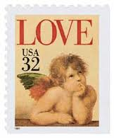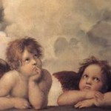

Thesis – Heb 1:1-3

1.

2.

3.

4.

5.

6.

7.

Better than _____________ -- Heb 1:4-14

Son Angels

Bottom line: Jesus is ___________________

Warning – Heb 2:1-4

Conclusion – “Himself” by A.B. Simpson

HIMSELF
by A. B. Simpson
Once it was the blessing, Now it is the Lord;
Once it was the feeling, Now it is His Word.
Once His gifts I wanted, Now the Giver own;
Once I sought for healing, Now Himself alone.
Once 'twas painful trying, Now 'tis perfect trust;
Once a half salvation, Now the uttermost.
Once 'twas ceaseless holding, Now He holds me fast;
Once 'twas constant drifting, Now my anchor's cast.
Once 'twas busy planning, Now 'tis trustful prayer;
Once 'twas anxious caring, Now He has the care.
Once 'twas what I wanted, Now what Jesus says;
Once 'twas constant asking, Now 'tis ceaseless praise.
Once it was my working, His it hence shall be;
Once I tried to use Him, Now He uses me.
Once the power I wanted, Now the Mighty One;
Once for self I labored, Now for Him alone.
Once I hoped in Jesus, Now I know He's mine;
Once my lamps were dying, Now they brightly shine.
Once for death I waited, Now His coming hail;
And my hopes are anchored, Safe within the veil.

