Creating New Radio Accounts

In order to create a new account, an application must be submitted to eMediaTRADE. The customer can submit an application via the Self Sign On (SSO) service, or someone in Support can create the account using information emailed by the customer. The Support Rep should also use the SSO.

Self Sign On.

The customer can sign up at our website, www.emediatrade.net, by following the link on the main page “REGISTER”

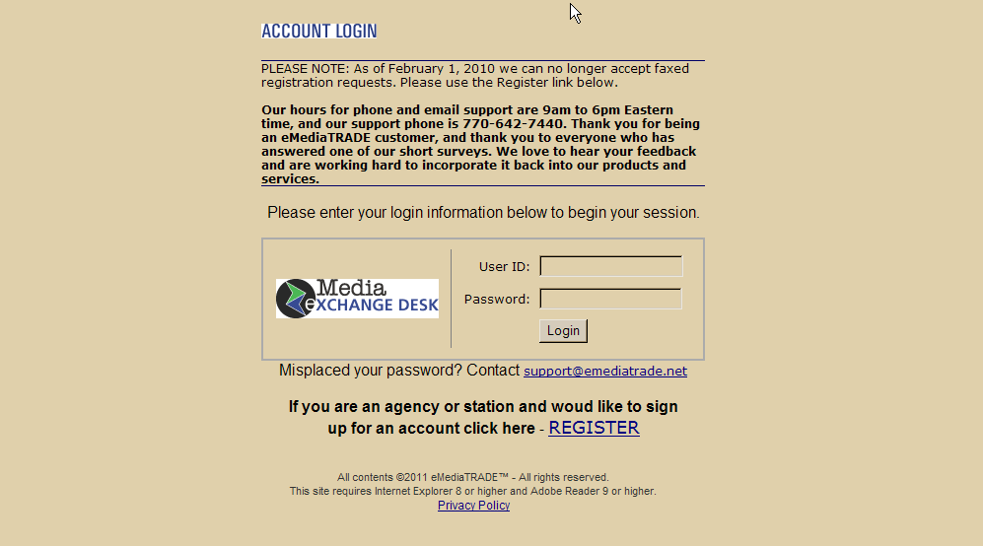

The sign up process is straight forward and shouldn’t take the customer longer than 5 minutes to fill out.

When the “REGISTER” link is clicked, the following opens up:

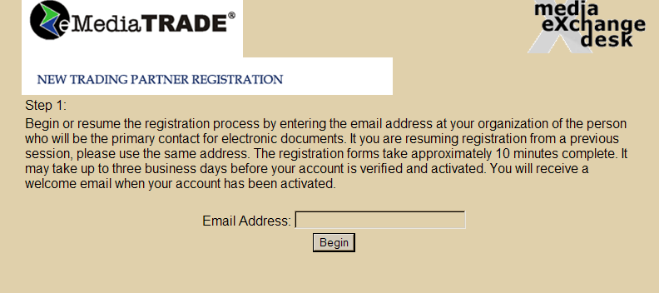

The email address entered here should be the address for the person who will be in charge of the account. Once the address is entered, the client will click the “Begin” button.

The next screen that opens:

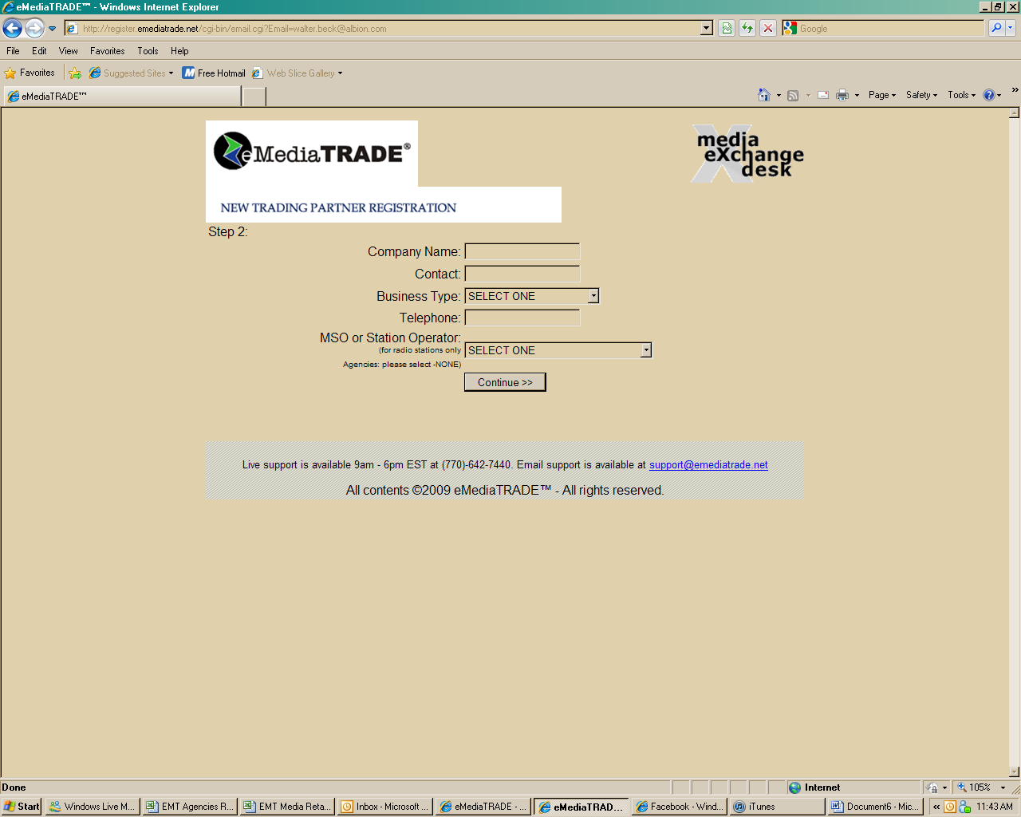

Company Name = name of business.
Contact = name of person at business who will be accessing the account primarily.
Business Type = the options are Agency, Radio Station, Television Station, Network
Television, Local Cable Ad Sales, National Cable Ad Sales, Satellite
TV Ad Sales, and Rep Firm.
Telephone = preferably the direct number to the Contact individual.
MSO or Station Operator = For Radio Stations ONLY. If a station is part of a station
group, they will choose that group from the drop down menu.

Once this is all filled in, click “Continue”.

The next screen:

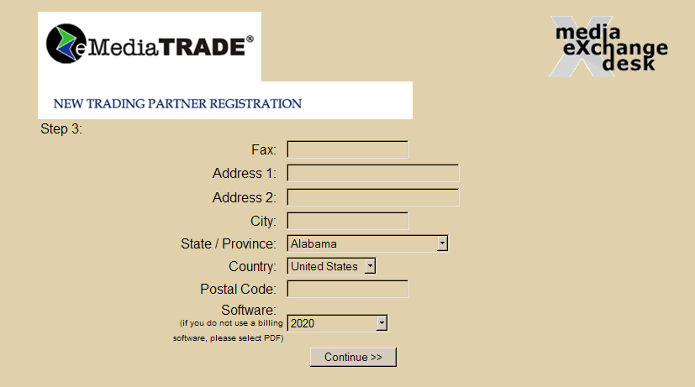

Fax = Fax number. Although it doesn’t say so here, this field is optional.
All the address lines are for the business’ address.

Software = This is where the client will choose their invoicing software format. The options available in the drop down menu are:

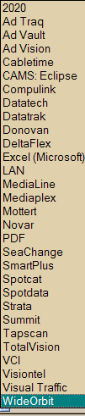
The next screen:

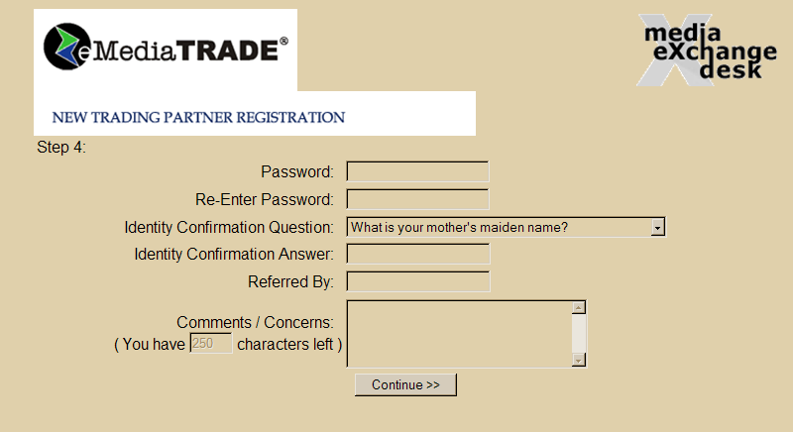

The password can be any combination of numbers and/or letters. NOTE: This field is case sensitive.

Identity Question and Answer – There are 4 questions to choose from in the drop down
menu; mother’s maiden name, elementary school
attended, pet’s name, and town where born.

Referred By, and Comments, are both optional fields.

Once this is all filled in, click “Continue”.

The next screen that opens will be the summary page showing all information entered. The client can at this time edit any of the fields shown. PLEASE NOTE: Edits must take place here. Hitting the back button will cause the entire application to be discarded.

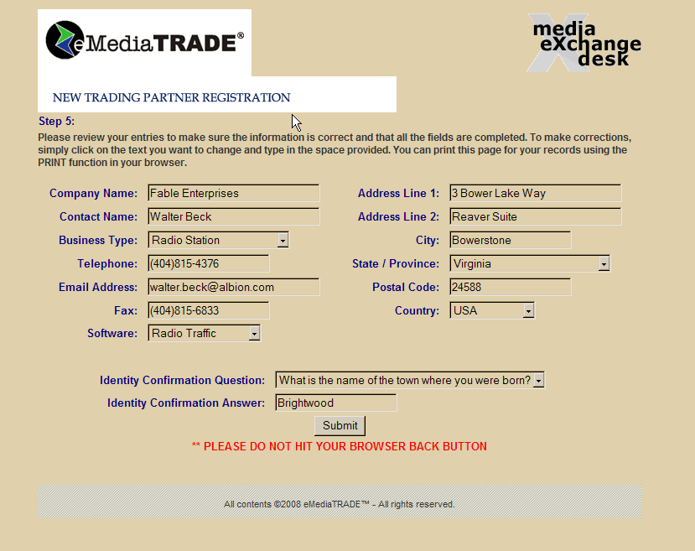

Once the client has verified the data, the “Submit” button is clicked.

The next page that opens is the legal data page. This is the main reason why it is preferred the client sign up via Self Sign On. The client will have to choose “Do not agree” or “Agree” to the legal text before the application is actually submitted to eMediaTRADE.

The legal page is on the next two pages.

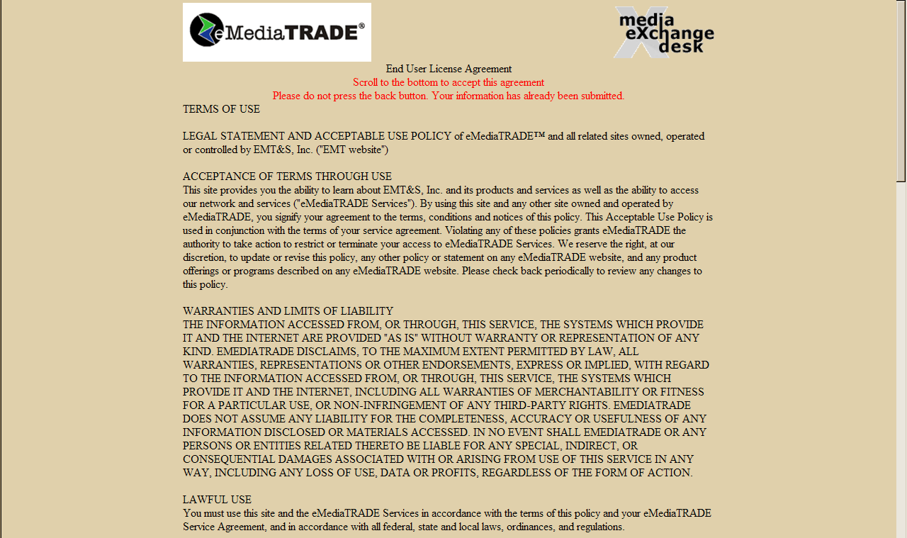
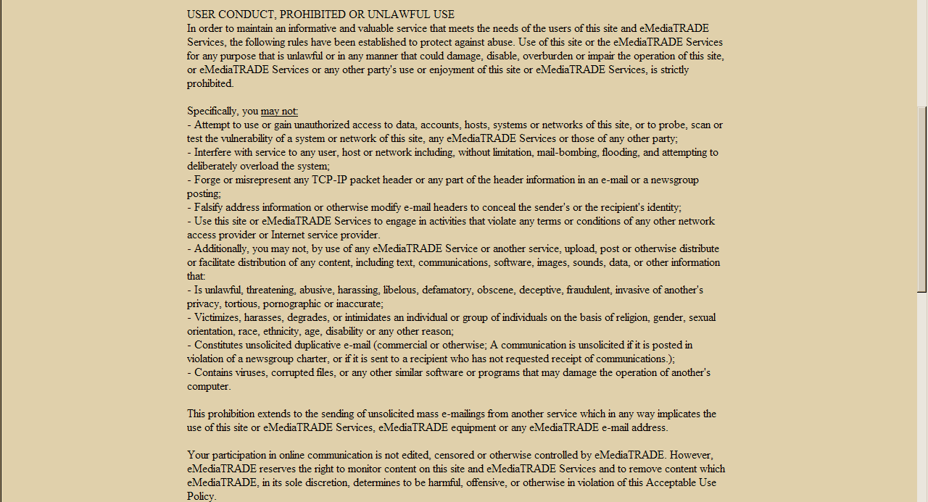

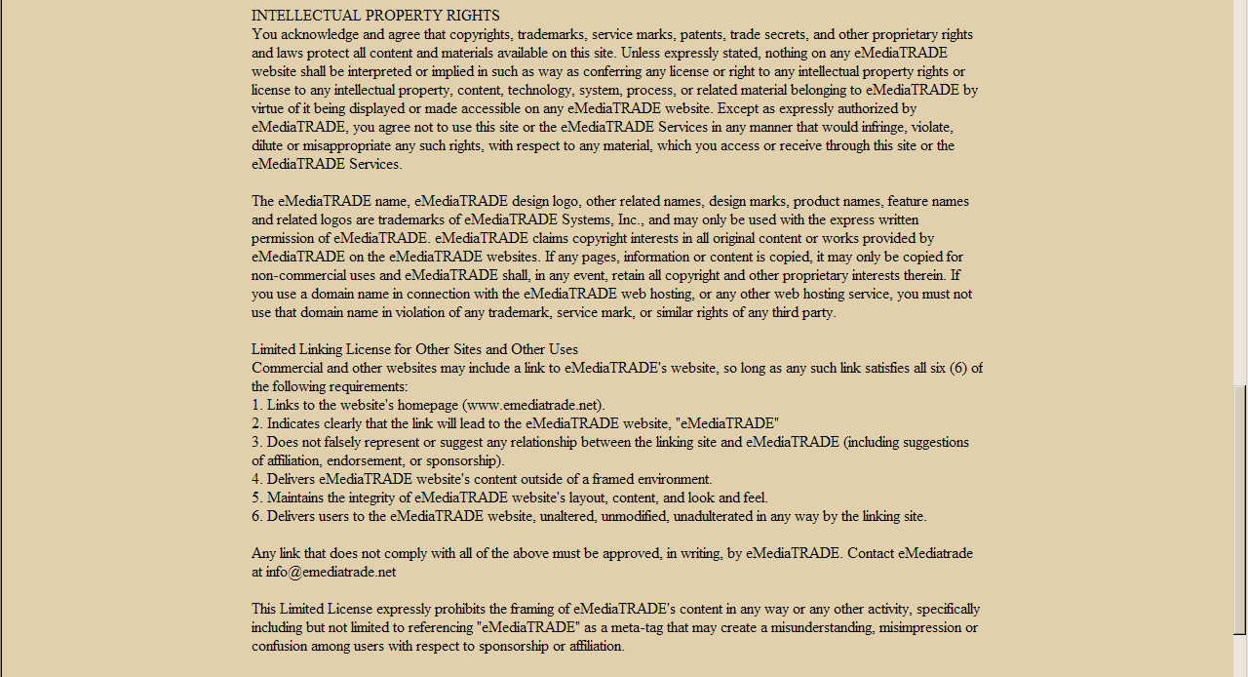
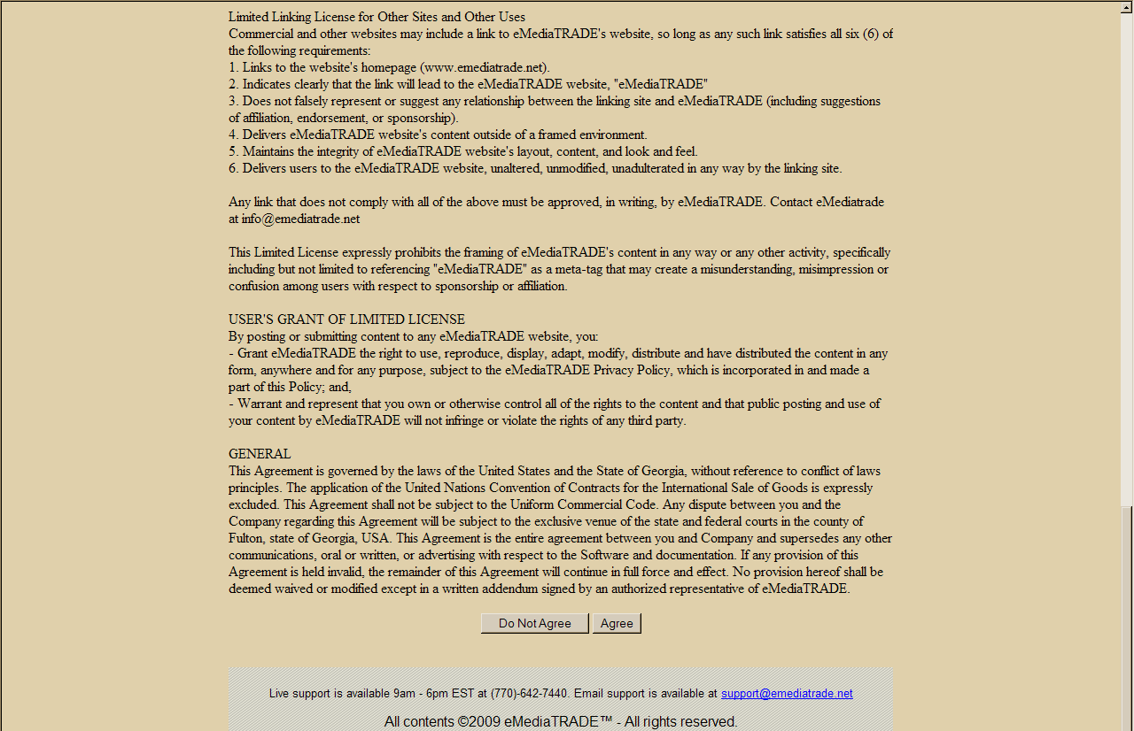

NOTE: If the client is setting up a radio or TV account, the next screen that opens will be where they will list the station(s) that will be on the account. Up to 9 stations can be entered (if more than 9 stations are on the account, please email a full list to support@emediatrade.net).

For Radio and TV Accounts:

The steps to enter the stations are as follows:

The screen to open up will ask for the number of stations.

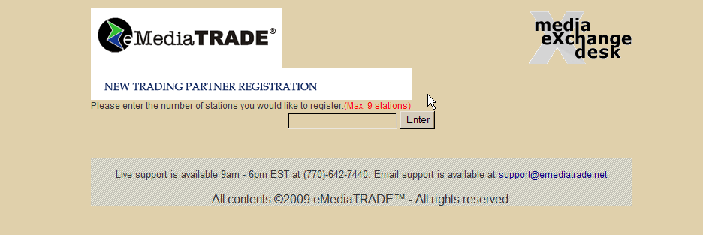
Once a number has been entered, list will appear for that number of stations to be entered. For this example, we said 2 stations.

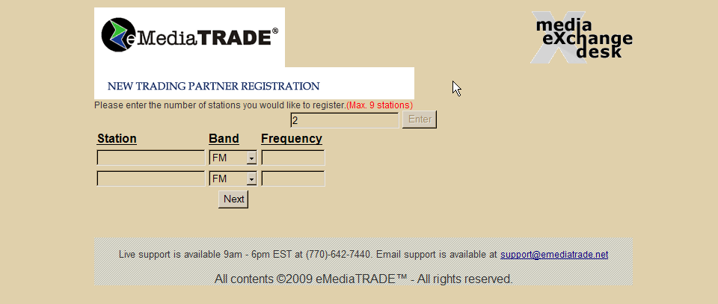

Enter in the appropriate information and click “Next”. The final screen to open will be;

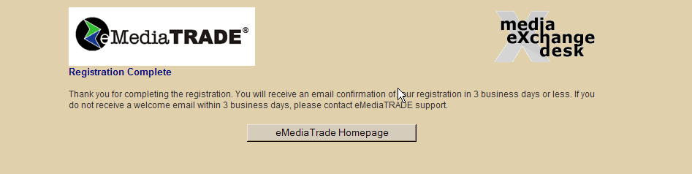

Once the application is submitted, an auto-generated email will be sent to support@emediatrade.net requesting confirmation of the account.

