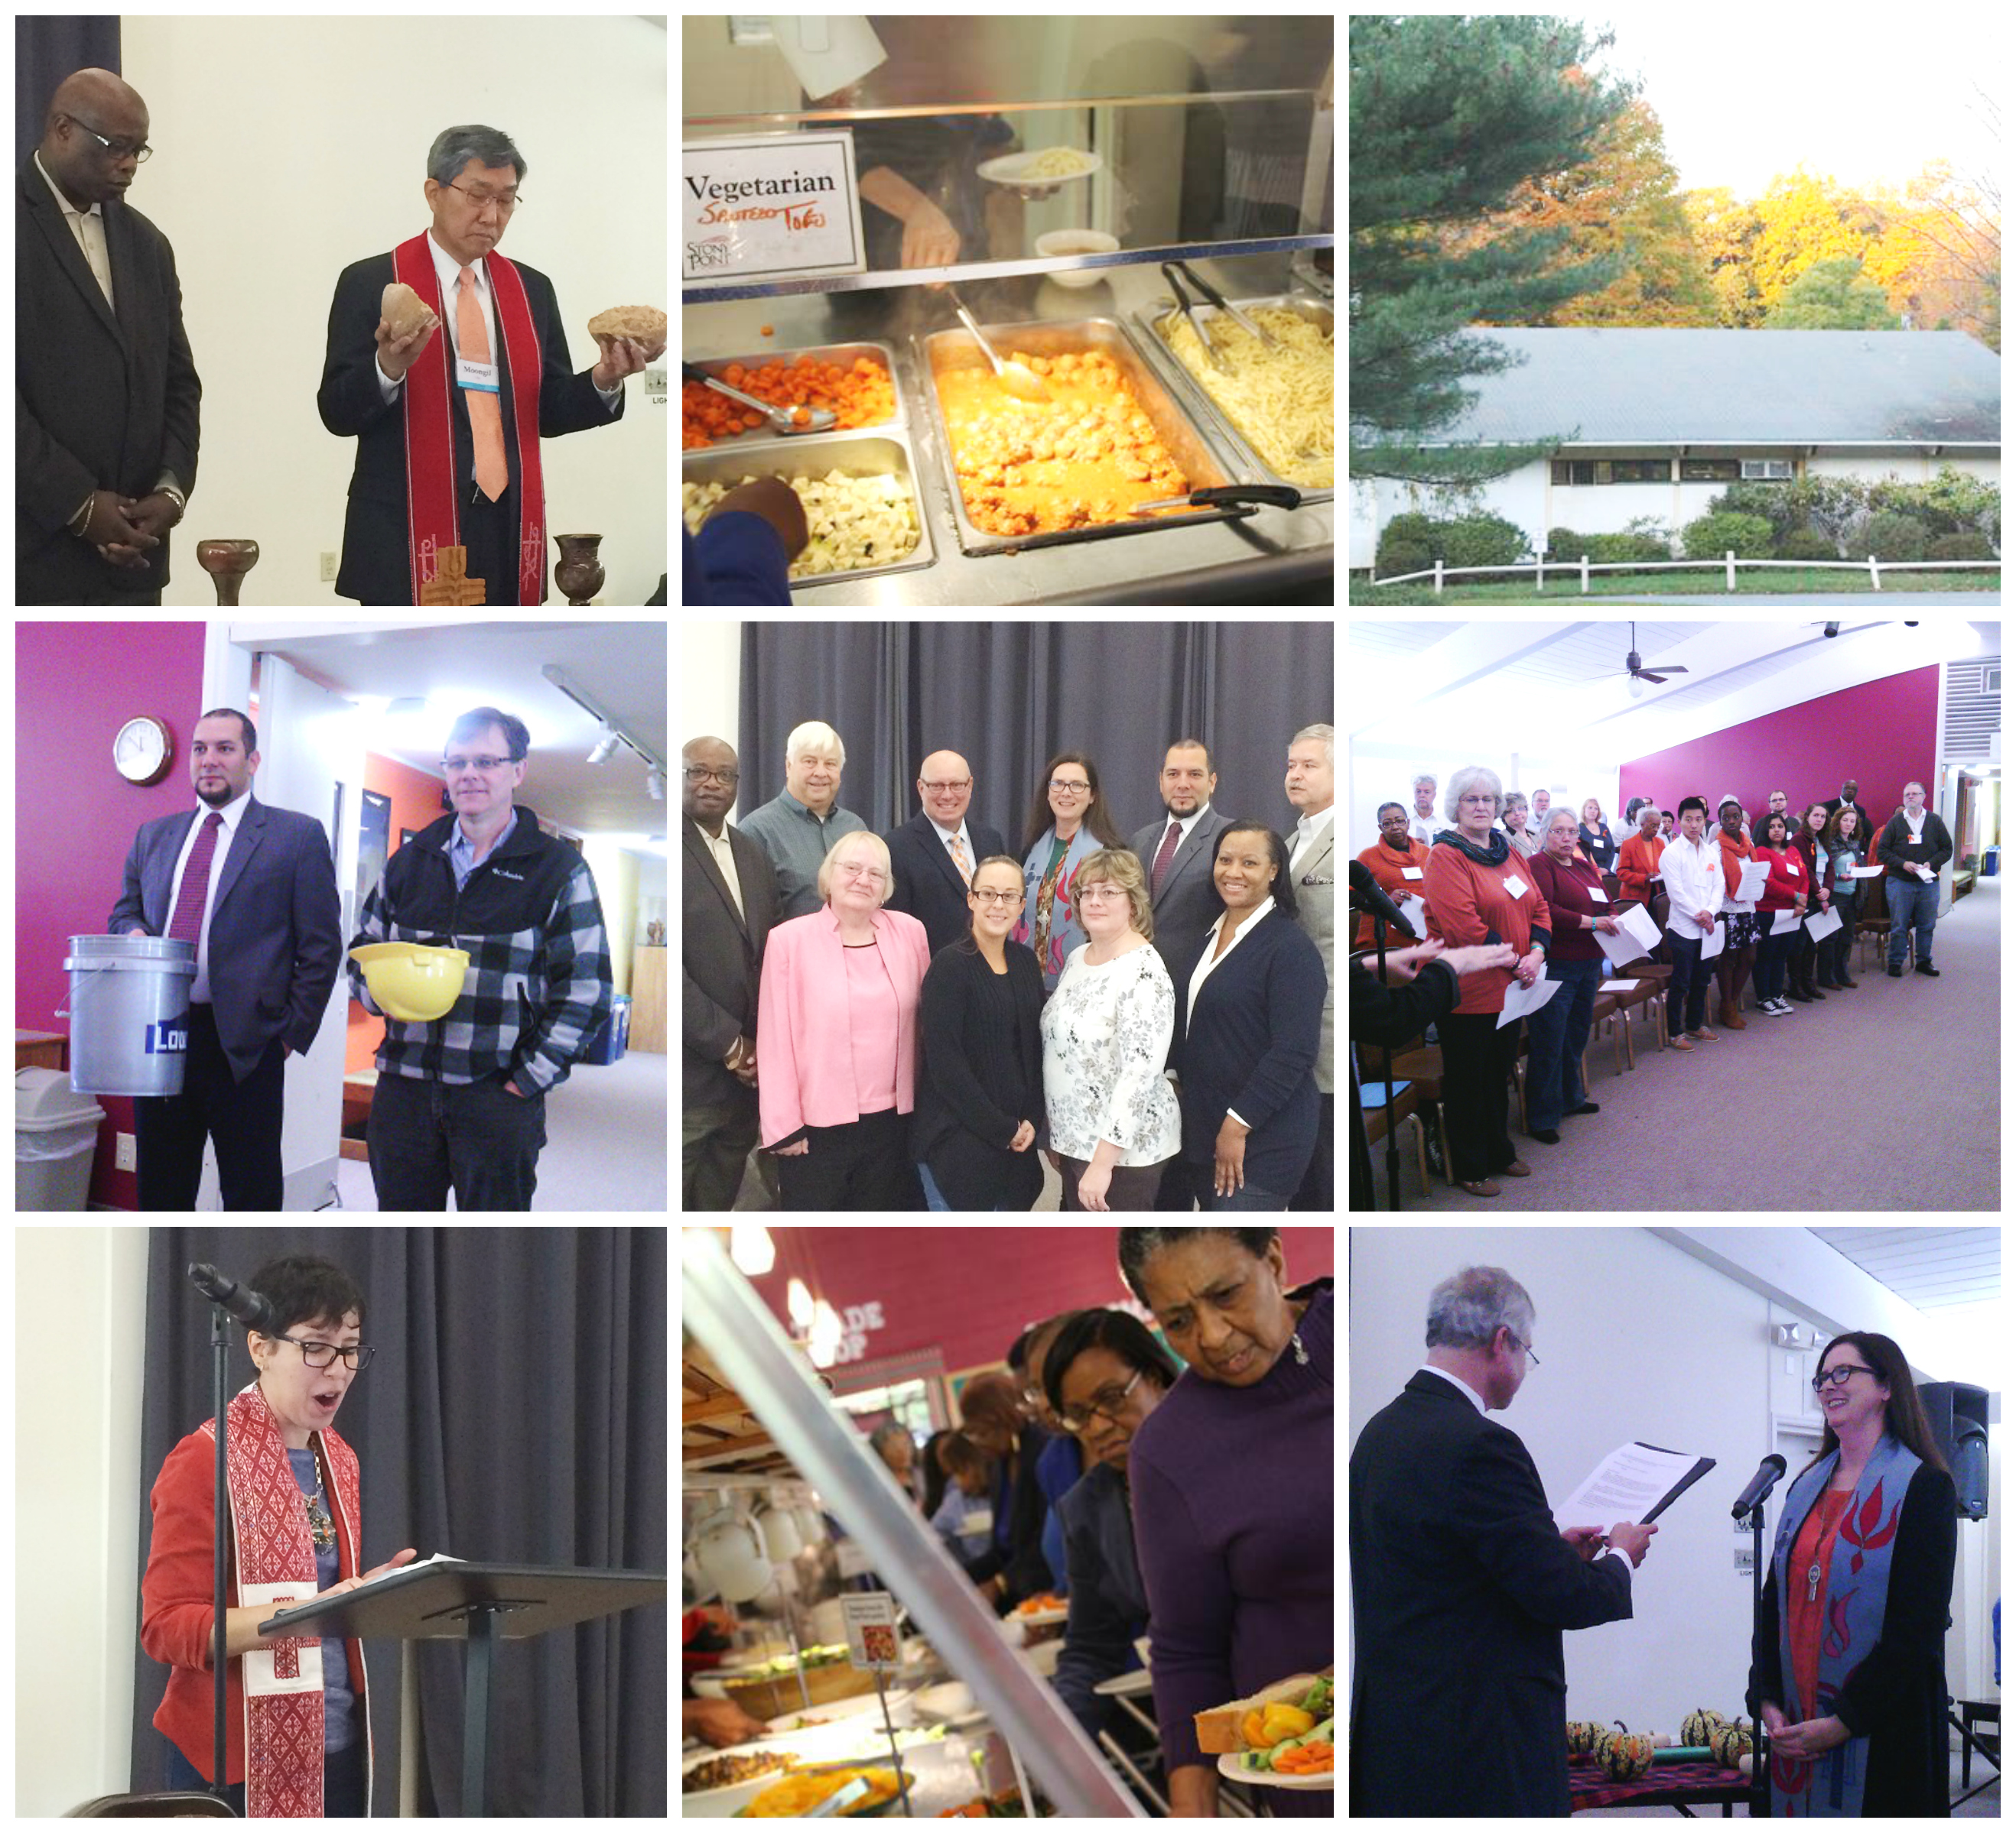

2014 Synod of the Northeast Assembly Report

The 2014 Synod Assembly marked the end of the transition year for the New Way Forward. Throughout this Assembly discussions as well as votes reflected people’s understanding and incorporation of the New Way Forward and its core values that we wish to live out within this community.

PPAN (Public Policy and Advocacy Network) started us with a strong and decisive evening with Dr. Margaret Aymer, Teaching Elder, PCUSA and Associate Professor of New Testament at the Interdenominational Theological Center in Atlanta. Margaret unpacked the framework that led to the killing of Michael Brown in Ferguson, MO, the same framework that exists in many of our communities. She encouraged us to begin to think about ways that we can take action in our churches, our presbyteries and the synod to create change within racially unjust systems that are a part of our daily lives. You can view her presentation and live streaming on the synod website: www.synodne.org.

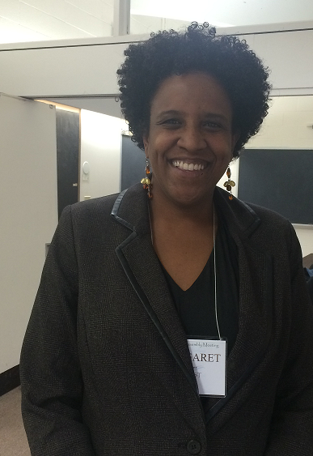

The discussion of race and the work of the synod continued through the presentations of the Racial Ethnic Caucus that asked salient questions concerning the work of the Committee on Representation, the Working Group on Race which has begun a synod-wide discussion on race and White Privilege, and discussions about how we continue to include voices that have typically been on the margins of PCUSA and within our congregations and presbyteries.

This led to a small group preparing a statement for approval by Synod Assembly. The following statement was approved and will be sent to presbytery leadership with additional documents that may help frame discussions within presbyteries and congregations.

The Synod of the Northeast is alarmed by frequent occurrences of police brutality in the United States that are grounded in historic patterns and structures of racism in which all of us are complicit. We emphatically denounce this violence and stand in empathetic solidarity with the families of those who have had their lives harmed or taken by those who have sworn to protect them. We pray for the officers who are unable to speak out against the corruption and bigotry among their ranks for fear of retribution. Simultaneously, we call on not only Presbyterians but all good people of this earth to commit to combating the sin of racism and authority abuse.

We recommend the following steps:

1. Encourage church leaders in presbyteries and congregations to call for body cameras on police officers in their community and dash cameras in their vehicles.
2. Encourage church leaders in presbyteries and congregations to meet with leaders of other religious groups to participate in civilian review boards.
3. Hold meetings in churches between police officers and those who are often victims. For communities without a civilian review board, we encourage congregations to press for establishing one.
4. Consider what can be done to provide a safe haven for police officers who object to the harassing actions of their colleagues.

Emerging Leaders and YAADs at the Assembly

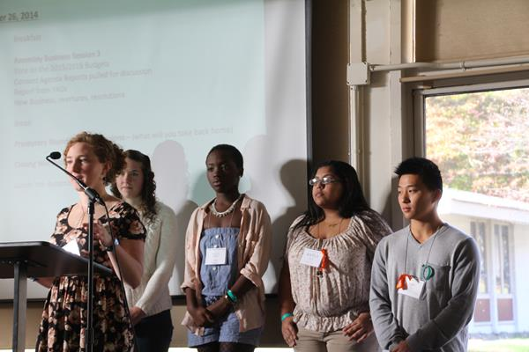

The New Way Forward includes a commitment to support and facilitate programs and initiatives that encourage and resource our younger leaders who are under the age of 40. A working group met over the last 18 months culminating in the first retreat with emerging leaders across the synod and beyond. The retreat was a time of conversation, connection, movement building and finding new partners in ministry. The group will hold at least one additional large gathering. In the meantime they will organize through social media and meet in smaller groups locally. While they do not know yet how this group will manifest itself within the synod, they do know they will engage with each other and with the synod with energy, intelligence, imagination and love.

Although YAADs hailed from only five presbyteries, they were active throughout the assembly and contributed significantly to different conversations including membership changes to the by-laws and standing rules. Their final report stressed the importance of this Assembly experience in understanding how the Presbyterian Church works. For those who had attended GA this rounded out that experience and provided another lens through which to experience the Church. The YAADs challenged the Assembly not to forget them and emphasized how important it is for presbyteries to make sure YAADs attend and do not miss out on the opportunity to be present. They expressed the need to be together and be part of the larger church. If there are only a few present, the Assembly will not have their full voices and perspectives. It is as important for them to hear from the Assembly as it is for the Assembly to hear from them. The Synod Assembly voted to sponsor at least one event for Young Adults prior to the next Assembly.

Synod Response to the 221st General Assembly’s Action on the Mid Council Commission II Report

The 221st General Assembly approved the following: Direct that a new configuration of synod boundaries be established based on an emerging sense of purpose, partnership, context, and call through a collaborative process between the synods and presbyteries resulting in no more than 10-12 synods. The synods shall report to the 222nd General Assembly (2016). Item 05-04

In response, the Synod Assembly passed the following statement and pledges to move forward in the following ways:

For more than four years our Synod’s leadership and its assemblies have been following and attempting to respond to the work of both Middle Governing Commissions of the General Assembly (MCCI and MCCII). Over the past three years, we have engaged in a deep season of reflection upon our purpose and function, as well as considering our geographic and other parameters that define us as a synod. We have spent significant time and energy in listening among our presbyteries with full transparency.

Therefore, in response to the 221st General Assembly action on item 05-04, we recommend that the 2014 Assembly of the Synod of the Northeast establish the following three principles of how we will respond to this action of the General Assembly and instruct our officers to work on our behalf in this matter according to these principles.

Our strategic mission, ministry and governance plan outlined in the New Way Forward must remain the guiding principles for how we live together as a regional body of presbyteries. This plan has been overwhelmingly adopted and celebrated throughout our Synod community for two consecutive years. In the actions of our annual assembly it both directs how we choose to exercise our governance responsibilities and how we will direct our mission and ministry. It more importantly establishes essential values in how we live together in community and clearly articulates our purpose as a missional body.

The values established in the New Way Forward call us to act in ways that are fully hospitable and gracious. This includes our relationship with neighboring presbyteries and synods. We therefore make a full and deep commitment to encourage our member presbyteries who share borders with other presbyteries, both within our current Synod boundaries and those within neighboring Synods to engage in mutual conversation to explore ways in which they might re-align in order to more effectively engage in mission. We will support this work providing both staff and financial resources as needed by the presbyteries. We commit to graciously support those presbyteries that wish to become members of our neighboring synods. We will fully welcome those neighboring presbyteries from other synods into our synod community offering them full access to the support and resources of our Synod as established in the New Way Forward.

We will fully commit to establishing more porous boundaries with our neighboring synods in order mutually to share good work and mission opportunities wherever possible. Living out our values of gracious hospitality we are eager to encourage partnership with all our neighbors both within the PCUSA as well as our ecumenical and interfaith partners. We will (and have already begun to) intentionally reach out to our neighboring synods and their presbyteries.

By acting in accordance with these three simple guidelines, we believe we will remain faithful to our commitment to living into our New Way Forward and fulfill our commitment to the mandate of the General Assembly.

Synod By-Laws and Standing Rules

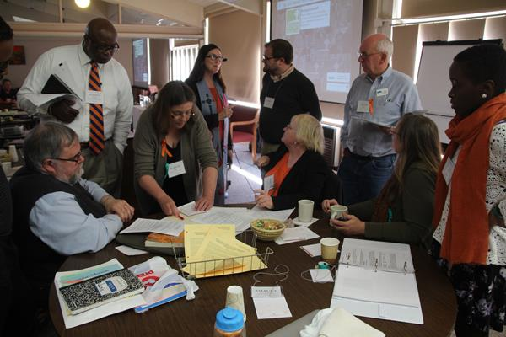

The By-Laws and Standing Rules Committee worked extensively to revise both documents for Synod Assembly Approval. The changes reflect the New Way Forward document adopted at last year’s Synod Assembly as well as core values. Key changes include:

- Beginning this fall the Synod Assembly will meet every two years and will hold a Big Tent in alternate years.
- Synod Council’s name is changed to Synod Mission and Ministries Commission to reflect the value that mission is at the center of our work.
- Synod Assembly Commissioner membership and Synod Mission and Ministries Commission Membership have been broadened to include teaching elders, ruling elders and active members of congregations. The sections in the by-laws and standing rules related to membership will be sent to presbyteries for a vote of approval.
- All 22 presbyteries have a seat with voice and vote on the Synod Mission and Ministries Commission as well as representatives from Racial Ethnic Caucuses, Presbyterian Women and Young Adults representing 1/3 of the presbyteries.
- Synod Mission and Ministries Commission now serve as the Board of Trustees of the Synod.
- Synod Mission and Ministries Commission are divided into three working groups – Mission, Networks and Administrative. Each working group will do the detailed work and discussion required before bringing recommendations to the Commission for action or vote.

Much of the discussion centered on opening the membership of the Assembly and Commission beyond teaching elders and ruling elders. The committee who revised the documents as well as many others stood to explain that this change reflects our values and commitments within the New Way Forward to include those who have traditionally been shut out of having a voice at the table. This decision parallels raising up Emerging Leaders, raising up Young Adults, and becoming more racially and ethnically diverse within our leadership. The revised By-Laws and Standing Rules were adopted. A full rationale concerning the changes to membership will accompany the Sections of the By-Laws and Standing Rules when they are sent to presbyteries for discussion and vote.

Additional Actions Taken:

- Elections: The following were elected to four year terms: Harold Delhagen, Synod Leader; Nancy Talbot, Stated Clerk; Alan Ford, Treasurer.

- Nominations: The following people were elected for a term of two years to the following committees beginning in 2015 and for a six year term to the permanent judicial commission.

Personnel: Theodore Demarco, Boston Presbytery; Victor McKusick, Utica Presbytery; Marianne Rhebergen, Palisades Presbytery for a second term.

Committee on Representation: Luci Duckson-Bramble, Long Island Presbytery; Lydia Tembo, New York City Presbytery. There is still a vacancy for a young adult male.

Synod Permanent Judicial Commission: Jin Oh Bae, Newark Presbytery; Carol Dornbush, Hudson River Presbytery; Blair Moffett, Northern New England Presbytery; Dorothy Pearman, Western New York Presbytery.

- For a number of years the Synod had maintained a relationship with the Church of Jesus Christ in Madagascar that has not been active recently. Synod Assembly voted to refer to the Mission Working Group the recommendation from Presbytery of New York City to review this relationship and provide guidance to the Synod concerning the future.

- Synod Assembly voted to receive the audit. It was spotless for 2013.

- The Synod Assembly approved a two-year budget for 2015 and 2016 with the following provisions: increase the per capita rate to $4.00; increase the draw from synod assets by 1% to a total of 5%; give the Synod Mission and Ministries Commission authority to increase the total budget for 2016 if necessary. However, the increase many not exceed 3% and will be reported to the Synod Assembly in 2016.

- Synod Mission and Ministries Commission will implement a study and discussion on appropriate use of synod financial reserves in the context of declining membership and challenging congregational and presbytery resources. The report will be disseminated no later than 120 days before the next Synod Assembly.

Respectfully submitted,

Rev. Nancy Talbot, Stated Clerk

