Name of School: |  |  | Hunton CEP School
School Post Code: |  |  | ME15 0SJ |  |  |  | Project Completion Date: |  | 28/03/13
Eco-Coordinator: |  |  | Sue Wood/Jane Crane |  |  |  | Current Award Level: |  | Ambassador
Project Title: |  |  | Hunton /Malawi
Eco-Schools Topic: Please enter “X” in relevant boxes |  |  |  |  |  |  |  | 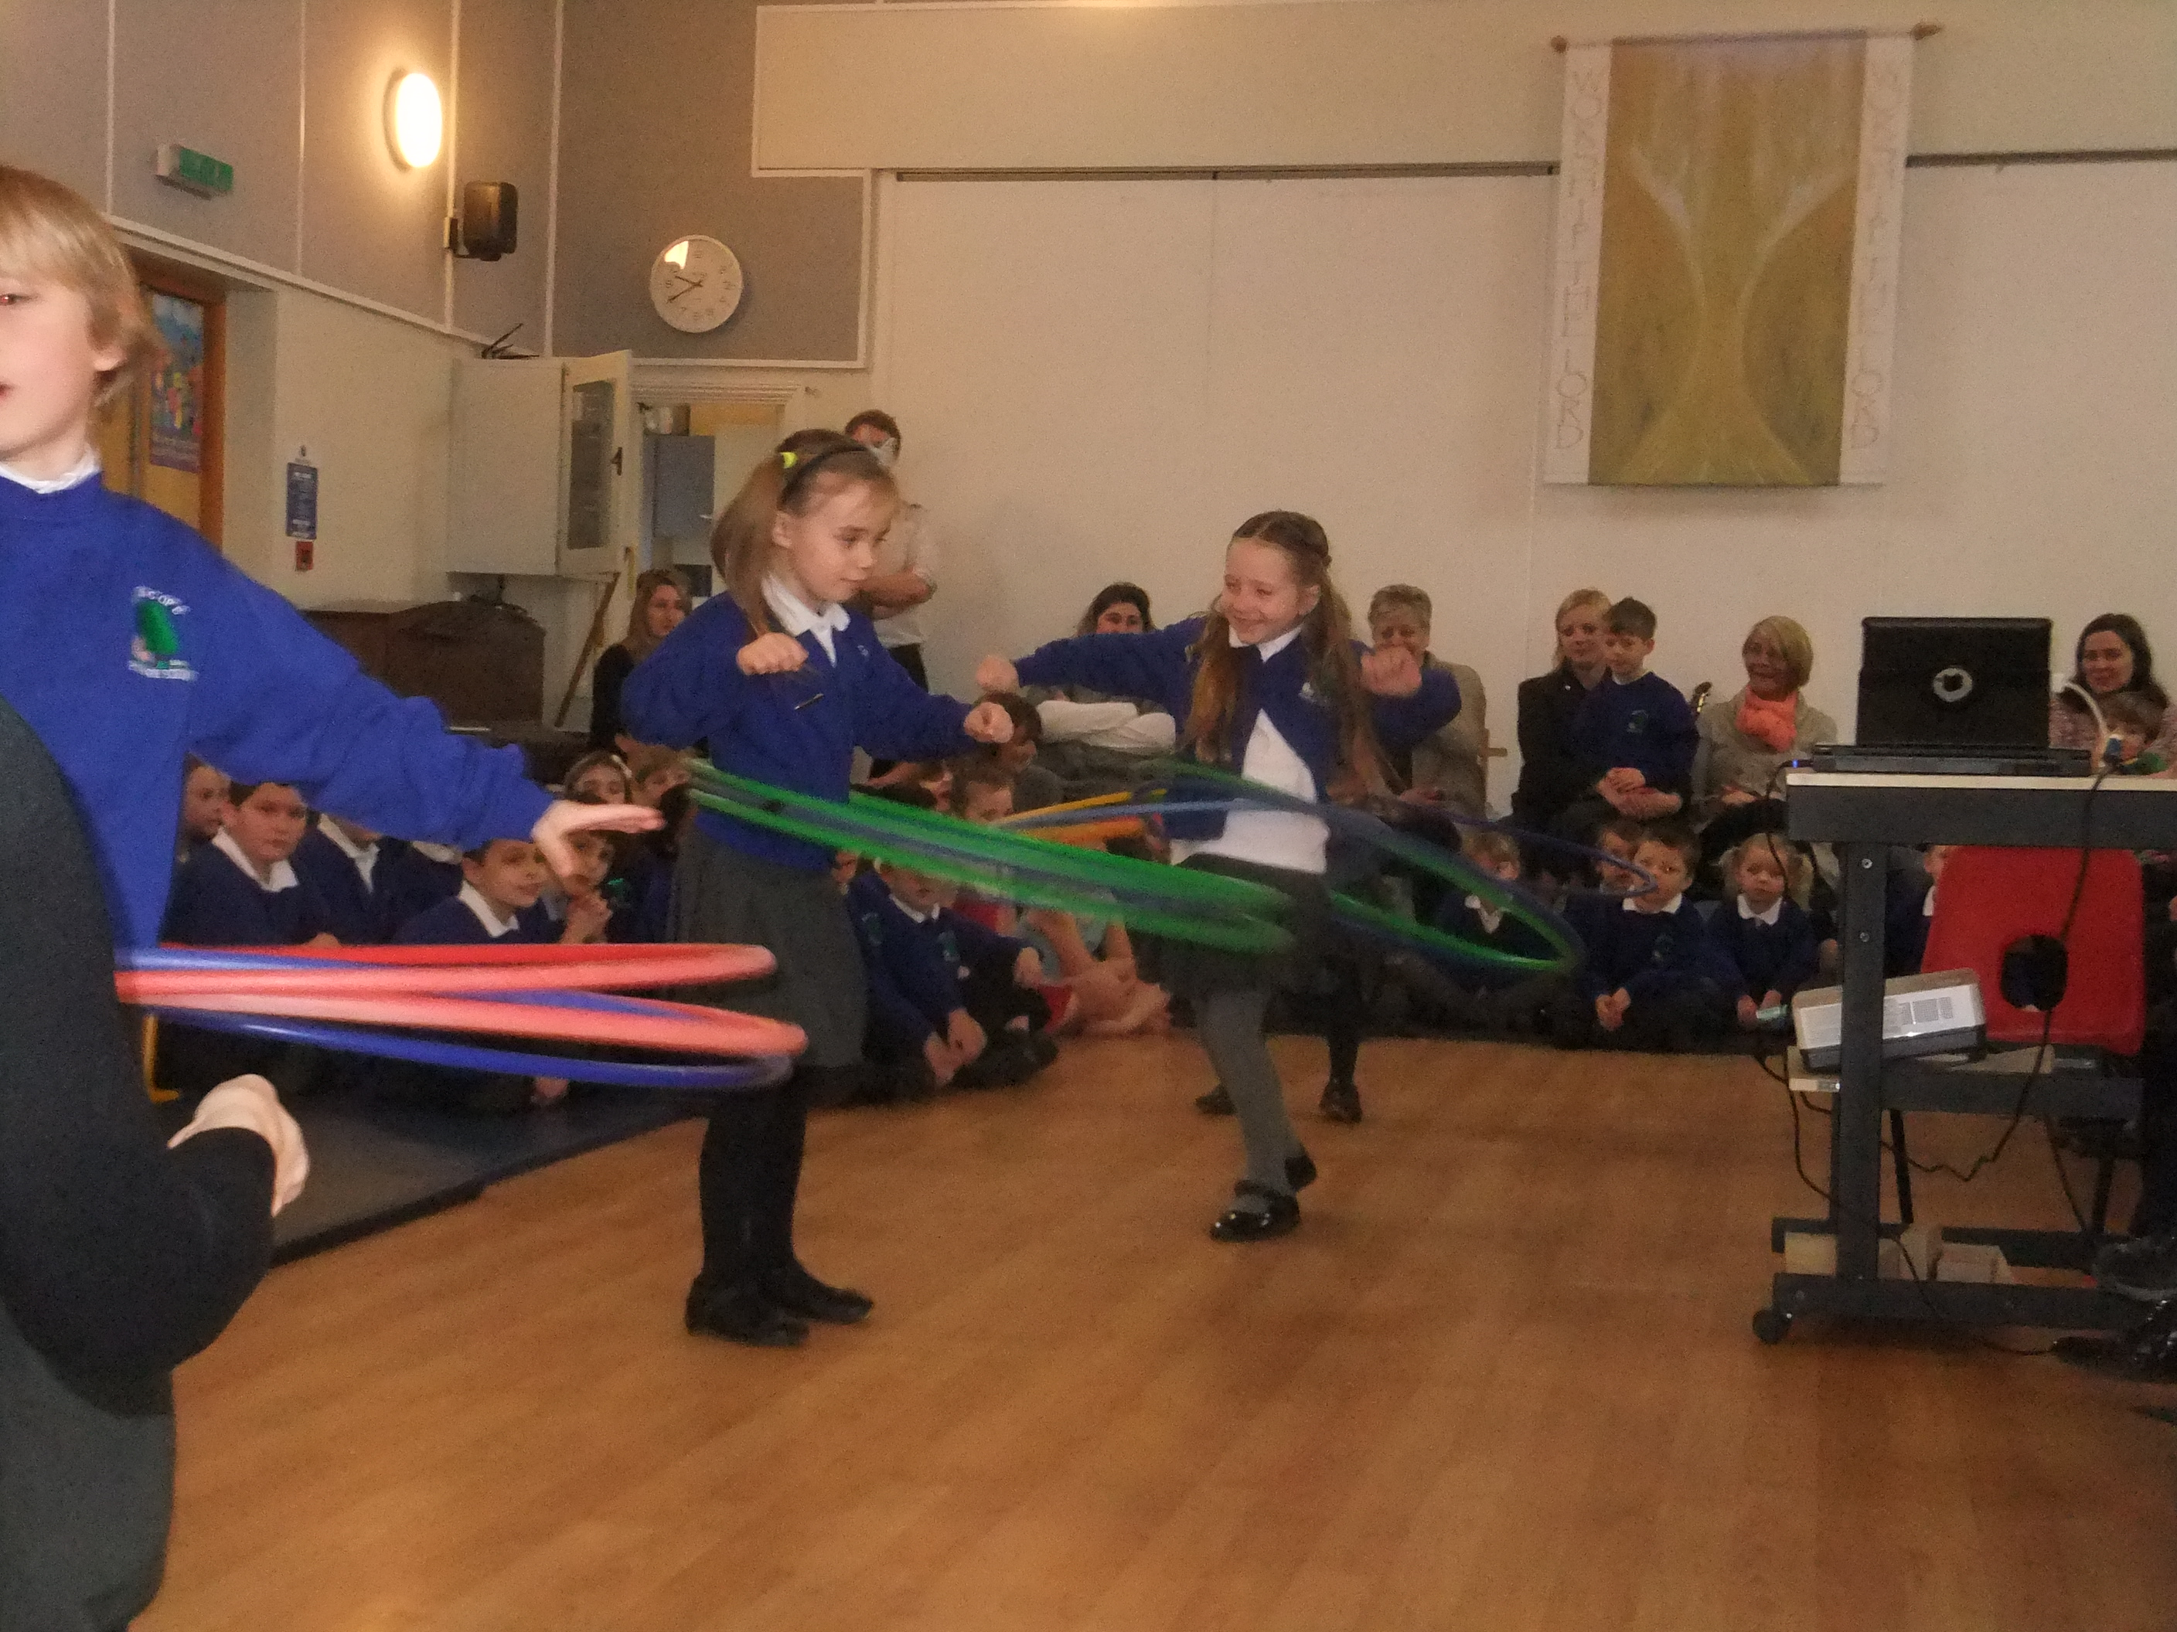  1Children hoola hooping at our fund raising event
Water: |  |  |  | Healthy Living:
Waste: | X |  |  | School Grounds:
Litter: | x |  |  | Biodiversity:
Energy: | X |  |  | Global Perspective: | x
Transport: |  |  |  | General:

Guidance Notes:
- Please type in the boxes below. The boxes will expand automatically with the text when entered.
- You are more than welcome to separate your projects out into different case studies or cover a variety of projects within the one template.

Project background
Why did you decide to undertake this project? (I.e. was it a particular issue in school or part of a larger campaign)
What aims did you have starting out?
For Hunton CEP School this was a new area of learning for the eco council as this was a joint venture with our partner school in Malawi.
Our aim was to share with our partner school in Kaputu Malawi our knowledge about litter and deforestation and to offer support with recycling, composting so that deforestation is reduced.
- The children researched and made brickets from recycled paper and materials which could be used instead of firewood for cooking
- Undertook weekly assemblies to keep the whole school updated
- They made a short video about our school and how we recycled waste.
- They researched how plastic bags were beginning to be a problem in Malawi and how these could be used in weaving wastepaper bins. The children then undertook weaving.
- They made model compost bins to show how palettes can be recycled into compost bins.
- They designed and commissioned a flag for Kaputu school (similar to the Eco Flag)
- And finally they organised a talent show to fund raise for saplings to be purchased to replace chopped down trees.
- All the models, flag, money and video are being taken to Malawi on 11th April when a lesson will be given to the pupils.
Action
How was the project delivered?
Was the project topic integrated into the curriculum? If so, please describe how.
The Eco Council came together to talk with the Director of Starfish Malawi they then drew up an action plan which took into account themed learning on deforestation and rainforests that was being undertaken in school during the term.
Pupil leadership
How did you get the pupils involved? How did they have ownership?
The Eco Council had total ownership as they decided and drew up the action plan, timeline and final outcomes. The pupils facilitated all the actions with some adult support.
Funding
Did you have to source funding for the project?
The children funded the project through a Hunton’s Got Talent show which they invited parents, carers and the local community to.
project support
Did you receive any support from parents, staff or outside agencies in regards to the project?
We received support from Starfish Malawi Charity, Commonworks, parents, staff and local community. Starfish Malawi supported the school in forging a link with Kaputu School in Malawi. They helped the children appreciate what life is like there to recognise the similarities and differences in our cultures and how we could learn from the children in Kaputu School and they from us regarding recycling and litter. Especially as their global footprint is far reduced in comparison with ours.
Challenges
Did you have to overcome any challenges to make the project succeed?
We had a time restraint as the Director would be visiting Malawi in April and would be teaching our lesson on our behalf.
Result
How have the pupils benefitted from the project? (E.g. knowledge gained, skills learnt, an improvement in behaviour, attainment or attendance?)
Have there been any other benefits for the school as a result of the project? (E.g. reduced costs, cleaner school, etc). Please include any figures and analysis if appropriate.
The children gained skills of organisation, cooperation, working towards targets and time restraints. They learnt how to make and edit a short video to be shared with the children in Malawi and how to use recyclable materials effectively. They also began to gain an understanding about shared global responsibility.
Impact
How did you measure and monitor the impact of the project?
- Action plan successfully completed on time
- Children demonstrated a commitment to the project and gained greater knowledge of global responsibility
- Children confident to lead whole school eco assemblies
The Pod
Have you used any of the educational resources or activities on www.jointhepod.org or taken part in any of their campaigns? (If yes, indicate which activities you have taken part in)
- Recycling clothes
- Lesson plans/assembly ideas
- Water and energy saving campaigns
Other educational resources
Have you used any other educational resources or participated in any local or national campaigns or events? (If yes, indicate which activities you have taken part in)
We have recently been involved with WEEE Recycle where we had a large recycling skip for electrical waste, This was advertised around our local community and had a very good uptake we collected 160 Kgs of WEEE!
We are part of Commonwork where we undertake a range of education programmes and experiences around organic and sustainable food and farming, sustainable development, global citizenship, social enterprise and wellbeing.
Lessons learned
What advice would you give to schools that want to follow in your footsteps?
The link with our partner school has fostered a sense of ownership with the children and the shared videos has facilitated a greater understanding of our similarities and differences. Allow plenty of time for each activity and ensure that time is allocated to the action plan so that all ideas are considered.
Next steps
Has this project inspired or driven other Eco-Schools ideas? What is the school working on next?
To work with local schools within our collaboration to support them to become Eco schools.
External Support
Has your school received any Local Authority support with regards to the Eco-Schools Programme?
Yes

Please return your completed case study and
any relevant photographs to eco-schools@keepbritaintidy.org

We will endeavour to publish it on the Eco-Schools Case Study page as soon as possible.

