HYENA AND HARE
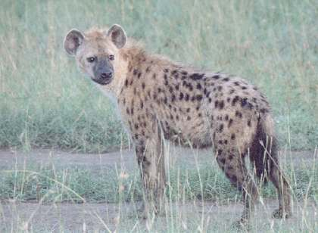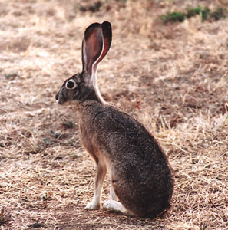
A long time ago hyena and hare were great friends. They visited each other whenever they had some food to share. They loved having a chat.
One Sunday morning hyena told hare that he wanted to marry. Hare laughed and teased him like good friends do. Hyena had never asked a girl out as he was a shy guy. Whenever hyena met girls he could greet them but wouldn’t look them in the eyes, but turned away and spoke in a low trembling voice. Hare laughed again and asked if his friend had a particular girl in mind.
Hyena asked hare if he could accompany him to Chipini village to help him propose to Chiphetsa, the most beautiful girl there. Indeed Chiphetsa was not only beautiful but had good manners too. She was hard working in all house duties. Her father was a prosperous farmer. He had taught Chiphetsa not to fear farming. She had goats, chickens and doves of her own. The family had big barns of maize, ground nuts and millet. Knowing how lazy hyena was, hare laughed until it hurt.
After insisting, hare finally agreed to escort hyena. The following Sunday, they started for Chipini village. Hyena was in his only brown black dotted suit and black/brown shoes. Hare was in his grey suit with his black shoes.
Upon arrival at Chipini village, people marvelled at the two. They went straight to the chief to tell him that they had come to propose to Chiphetsa. It was the custom then to tell the chief when boys were marrying in his village.
The chief sent messages to call Chiphetsa. She did not hesitate as she had a picture in her mind of who she wanted to marry. She was told the reason why the two gentlemen had come to the chief’s house. As was the custom, the chief asked the girl to choose between the two who was the man of her choice. As usual, the hyena was very shy. Chiphetsa instead chose the hare in a grey suit to be her husband.
With eyes very wide open hyena was angry but still shy. He ran as fast as his feet could carry him into the bush. Ever since hyena and hare have been enemies.

Moral of the story:
- The story states how hatred comes in our communities
- In most cases stories are told as a good example without mentioning ones name.
- Telling the story with animal names means the children don’t forget it.
- In this story how would we help hyena and hare to be friends again?
- Everyone has his own rights. Rights to choose things that suit her as Chiphetsa did. Do you see hyena’s rights being offended? How could you help hyena understand the issue if you were the chief?

Compiled By Mrs Mary Gapala

