SNAKE IN THE GRASS

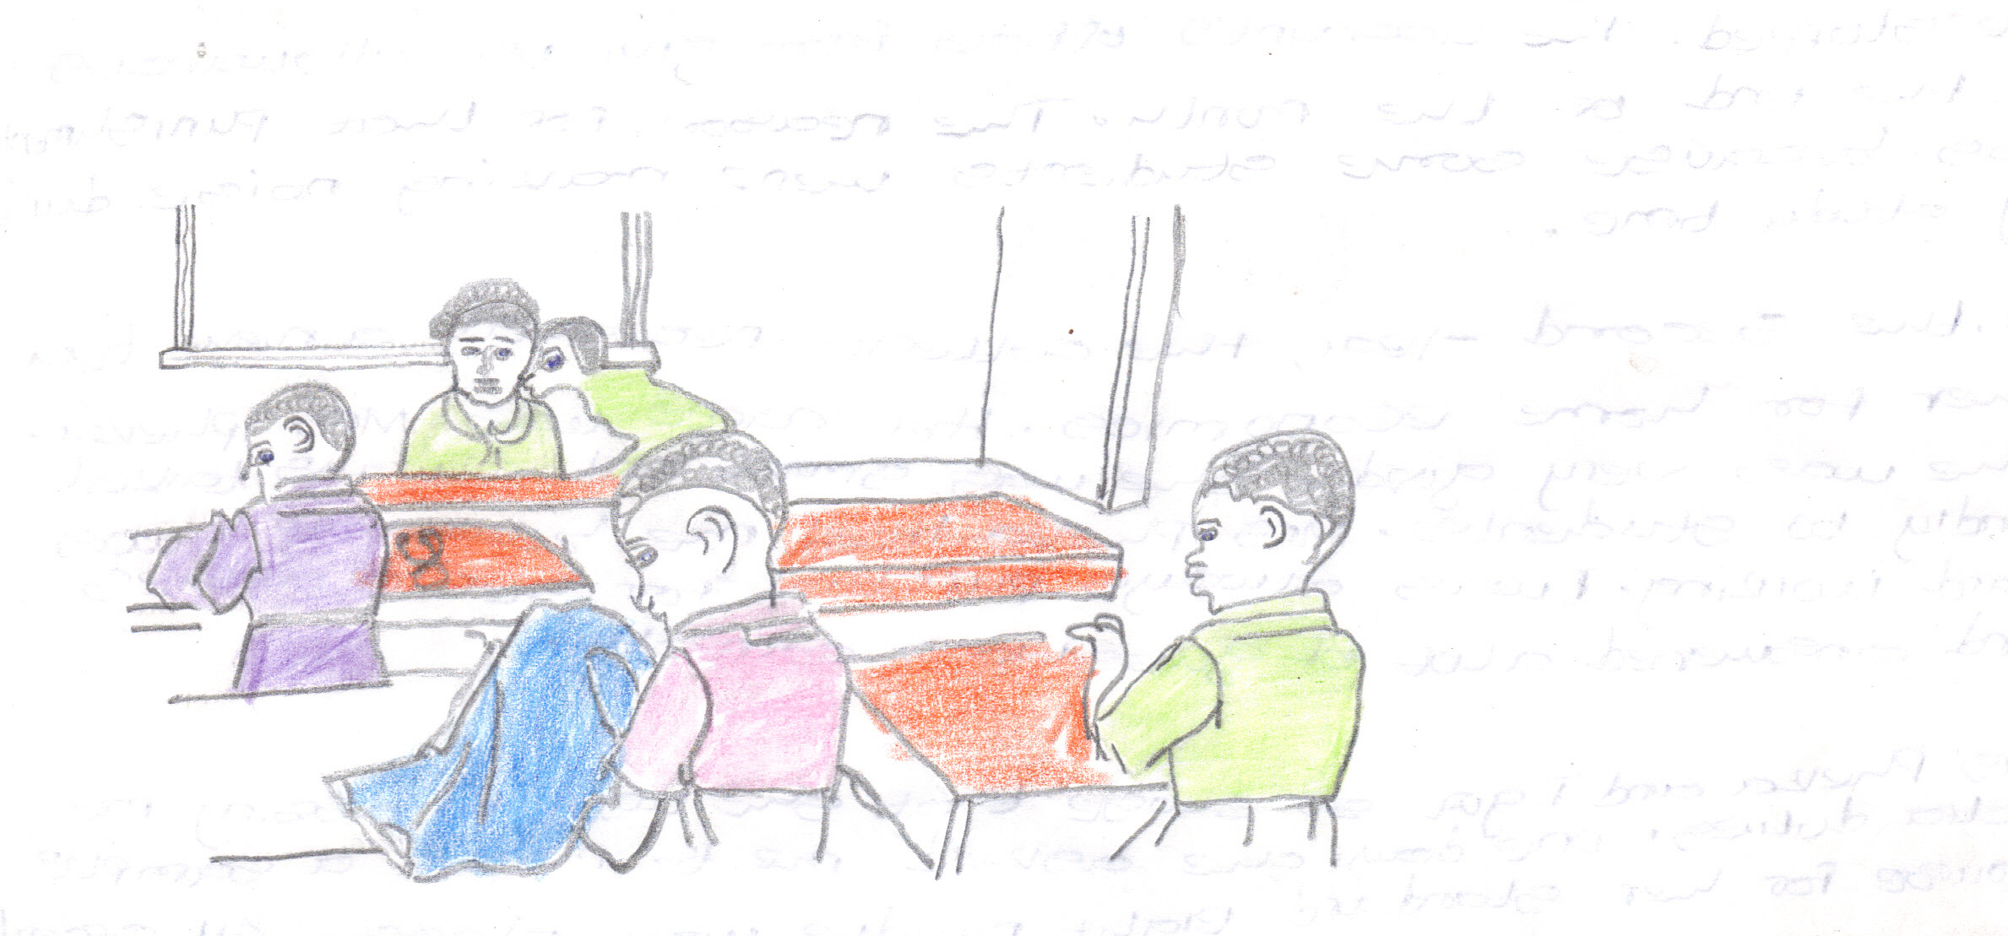
After completing secondary school, I did not know what to do. However, one of my teachers encouraged me to go to a teacher training college. I got a place at one of the teachers colleges. At first, I was not happy. Later I began to like life at the college.

One of the things that made me start liking life at college was my friend Takondwa. Takondwa and I were at the same secondary school and we were from neighboring villages. We were inseparable. We did everything together. Many students admired us because of how close we were. We loved and cared for each other very well. When one of us had no money the other would always help. I particularly remember a time when Takondwa did not attend classes for a week because she was looking after me at the hospital.

During the first year, life was hard. Most teachers at the college were not very friendly. They would tell us off for no reason. Sometimes we would be given tough punishment. I remembered one time it was the principal of the college who punished our class. He stopped the account’s office from giving us allowances at the end of the month. The reason for that punishment was because some students were making noise during study time.

In the second year, the college received a new teacher for home economics. Her name was Mrs. Pheka. She was very good. She was smart and always talked kindly to students. Mrs. Pheka liked me because I was hard working. I was always punctual for her classes and answered a lot of questions correctly.

Mrs. Pheka and I got so close that she used to assign me extra duties. One day she asked me to make a sample blouse for her standard eight needle work class. All second year home economics students were supposed to make a blouse and skirt. The blouse was very difficult to make, especially the sleeves. It was difficult to set in the sleeves. However, through my hard work I managed to set in the sleeves correctly.

The teacher was very happy to see the sample blouse I had made. She told me to help the other students who had problems. I was very happy to help my friends. Takondwa my best friend was not very happy to see me surrounded by other students. So, she thought of a way to tarnish my image before the teacher.

One day, instead of going straight to the classroom, she said she wanted to talk to the teacher. So I left her to go alone while I went straight to the classroom. Within a short time my friend came into the classroom smiling at me as usual. After a few minutes the teacher came to the class and for first time she looked sad so she told us that she had something to say. Everyone felt guilty. The teacher said that she was disappointed because some of the students from her class were boasting that the teacher relied on them.

After the announcement, the eyes of my classmates fell on me. Everybody knew that the teacher was talking about me. I became sad. When the teacher left the room I followed her to her office. When I asked her to explain what was wrong, she told me plainly that Takondwa had told her that I was back biting her. I told her I did not know anything about it but the teacher could not believe me.

I felt sorry for myself. I asked another teacher to explain to Mrs. Pheka that I was innocent. Later the teacher believed me. She forgave me. From that time, I knew that some people do not show their true colours. They pretend to love you at the same time do all they can to pull you down. They are snakes in the grass. “When moving in the grass it smiles at you, at the end it bites”. Our friendship ended there.

Moral of the story;

Do you think what Takondwa did to her friend good or bad?

If the answer is good, why?
If the answer is bad, why?

Do you think that the end of the friendship was the right outcome?
If you were Takondwa in this story, what can you do or say to your friend to maintain your friendship?

If you were a teacher in this story, what would you have said to both girls first or after discovering the truth of the story?

Ngolowindo Primary School

