THE FRUITS OF FAITHFULNESS
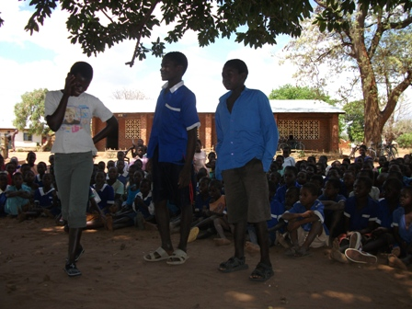
Long time ago there was a school boy so called Mayamiko (Praise). He was in standard 4 at Katitima Primary School. The school was in the village of Matumba. Mayamiko was a well mannered and an intelligent boy. His parents never tired in giving him good advice. He was taught through proverbs, stories and expressions so that he could grow up as a good human being.
One day as he walked to school with his friends, he saw a Kwacha 500 note (about £1, but worth a lot in Malawi) lying on the ground. He picked it up and showed it to his school mates. Mayamiko told them that he was going to surrender this note to the headteacher. His friends laughed at him and looked down on him. They thought he was so foolish. They wanted him to buy cakes and sweets with the money during break time. Mayamiko did not agree with his friends’ plans.
When they arrived at school, Mayamiko rushed to the headteacher’s office. He knocked at the door. Later he was told to enter the office. He walked slowly with light foot steps like a cat towards the head teachers table. He was amazed to see his father sitting on a chair and he was crying. He greeted his father in the office.
His teacher too greeted Mayamiko.
The headteacher thought that Mayamiko had come to see his father. After a while, he learnt that he came to surrender the 500 note that someone had lost on the road.
While in the office, the headteacher asked Mr Phiri, Mayamiko’s father, to explain the cause of visiting the headteacher in the morning.
“I had come to pay school fees for Mayamiko, but unfortunately I lost the money”
The money was for contributions towards a trip for standard four learners. They were to visit a sugar factory. Pupils were to see how sugar is manufactured. It was the only money that Mr Phiri had. If Mayamiko had squandered the money, he would not go on the trip.
Later the headteacher thanked Mayamiko. His father was so proud of him.

Moral of the story:
Learners have to apply knowledge that they learn in life skills to everyday situations.
We sometimes do not meet our targets because of poor decision making.
Do we prompt our friends to make poor decisions as Mayamiko’s friends did?
How can we help Mayamiko’s friends to be good citizens in the society?
If you were Mayamiko what could you have done in a situation like this?
This story helps communities to teach children good manners.
Play & Story by Sailos Mzuwala (Katitima)

