Hi Chris,
As requested I thought I would share some of my thoughts about Rabson’s visit. This includes reflections about global citizenship and enriching education practice and how his time in the UK and my time in Malawi will change their approach to teaching in the future…

Firstly I would like to express my thanks for being invited to be part of such a wonderful charity and already my experience has been both a very happy and emotional one. When I first read the starfish story I was truly touched as it follows the same notion as the one I am trying to currently achieve in our own school(s) as an advanced skills teacher / specialist leader in education.
Work
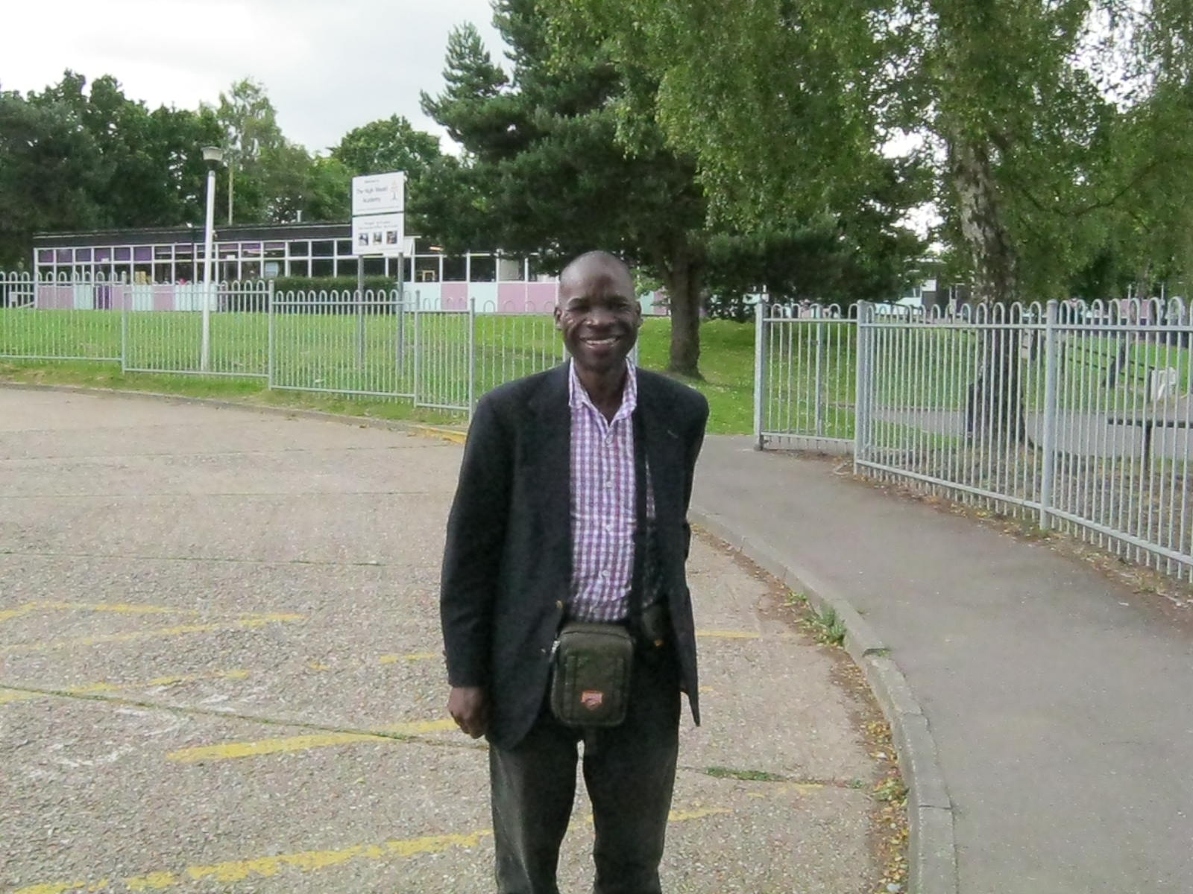
When Rabson Mpinganjira first arrived at our school I was immediately struck by the warmth of his character and so Gillian, Rabson and I were soon sat chatting about the educational developments happening in both of our schools.

I was quickly educated on a range of school policies and procedures used at Salima Secondary School and these were then expressed in more detail through a number of assemblies carried out by Rabson. The pupils at the High Weald Academy were in awe of what they were hearing, shocked about the 5am starts and the cleaning and maintenance routines that the pupils had to follow.
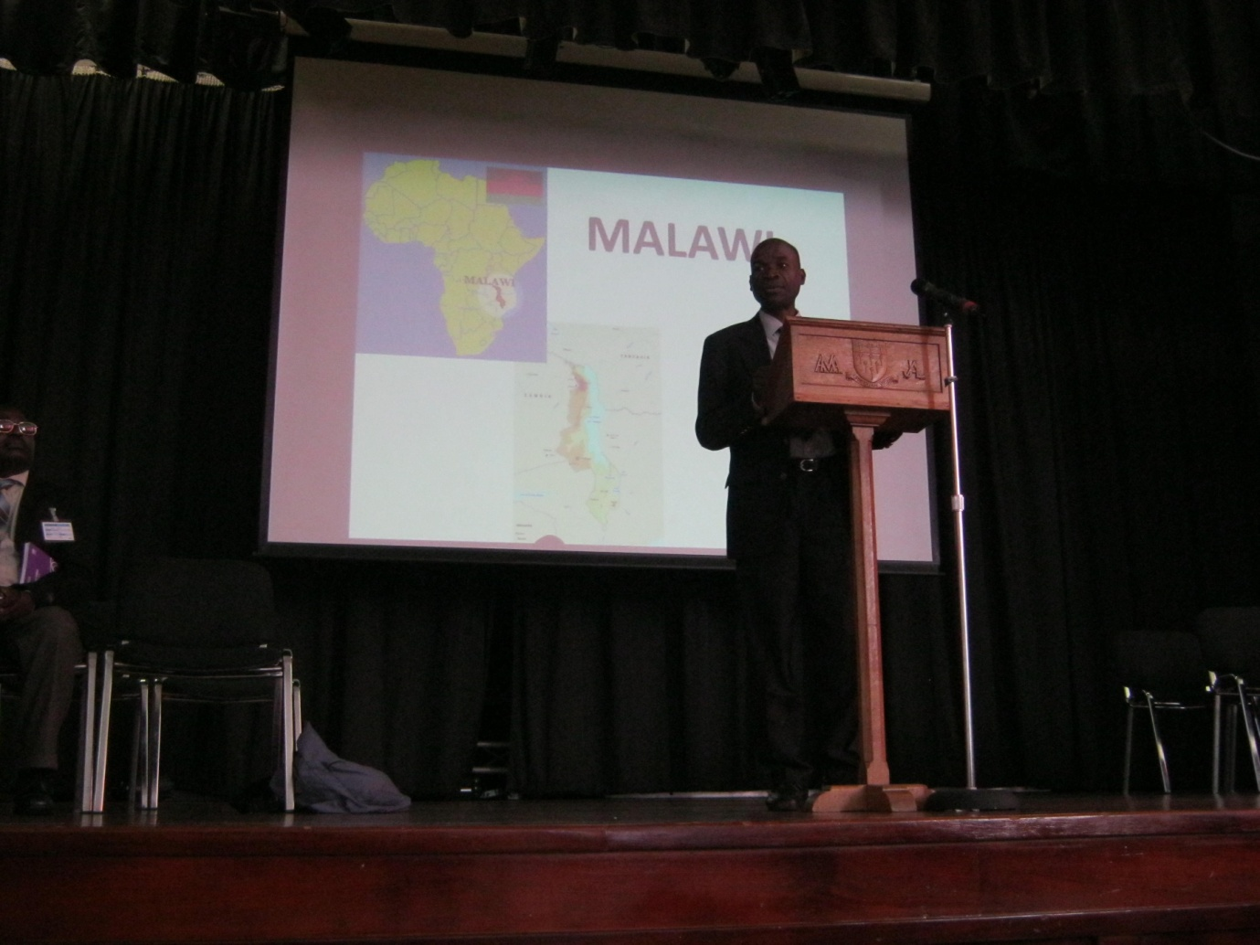
During his time here we discussed a range of teaching issues including the needs of SEN pupils, technology, sports and behaviour, discipline and leadership.
- SEN: Rabson was surprised to see the wide range of SEN ‘labels’ we have for our pupils and this made him reflect and understand more about the behaviour and needs of all of his pupils.
- Technology: Rabson is now the proud owner of an iphone and has had a quick guide on what it can do and how he can do it. In addition I am supplying him with a new laptop battery because currently unless he is connected to a power source he has about 5-10 minutes battery time. He’s cooked it!!! We have exchanged Skype addresses and we are having regular communication.
- Sports: I have already provided Rabson with a set of key words and definitions which can and do allow pupils to structure their answers in their work at the desired level. We will be sharing athletic times and distances to provide extra incentive and competition for all pupils to perform to the best of their ability.
- Behaviour, Discipline and Leadership: Rabson was impressed with the way in which we engage our pupils in their learning. I told him that we aim for an 80:20 split between active pupil led learning and the intervention and guidance of teacher talk.
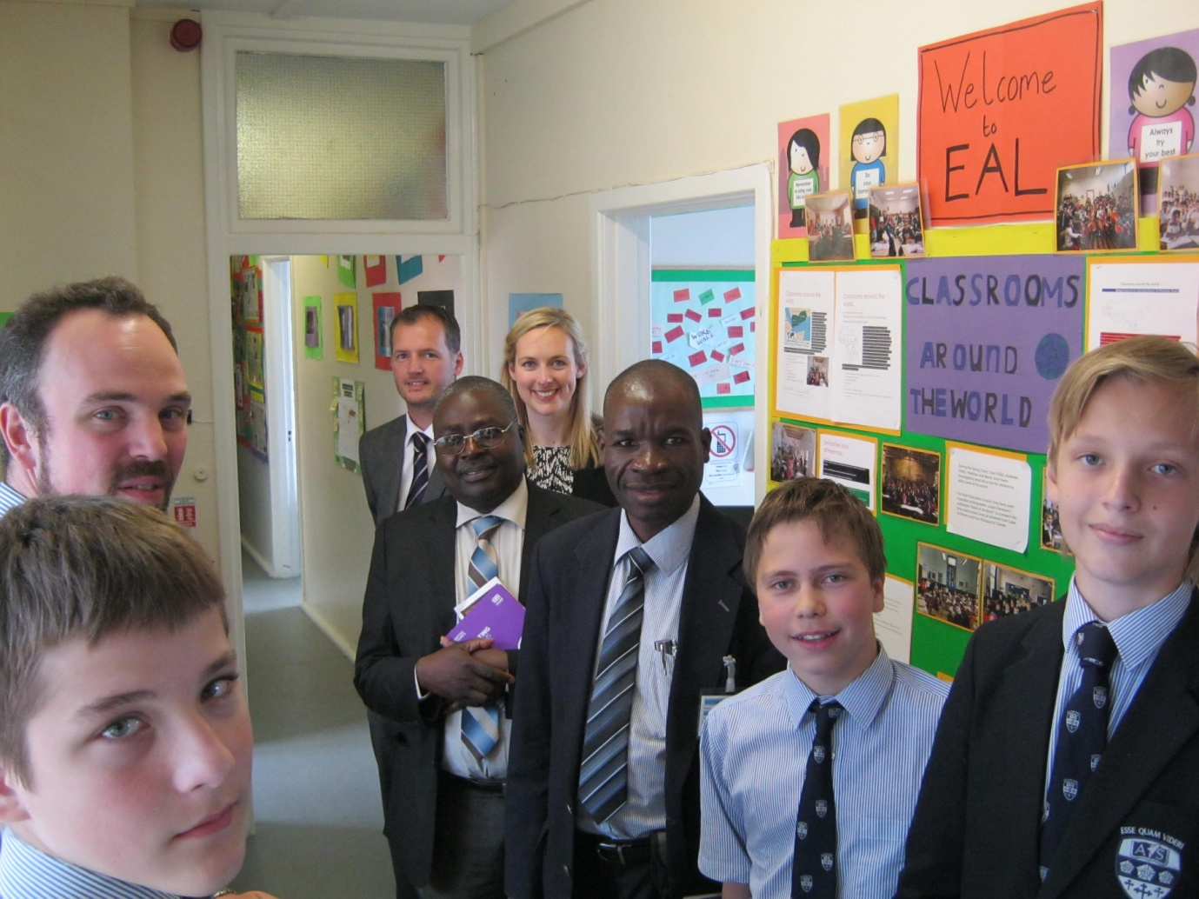
Together with our head teacher we discussed the challenges facing school leaders in Britain and in Malawi and the extent to which we have autonomy to make decisions independently of central government control.

Playtime
It goes without saying; we introduced him to a range of all things traditionally British. The sights and sounds of London, fish and chips, pubs, beaches, castles, cathedrals, white cliffs of Dover, pop stars (Pixie Lott) and the poor performances of our national team at the World Cup.
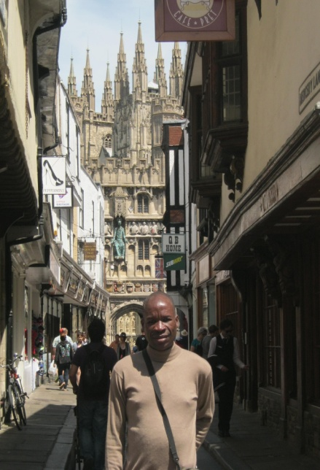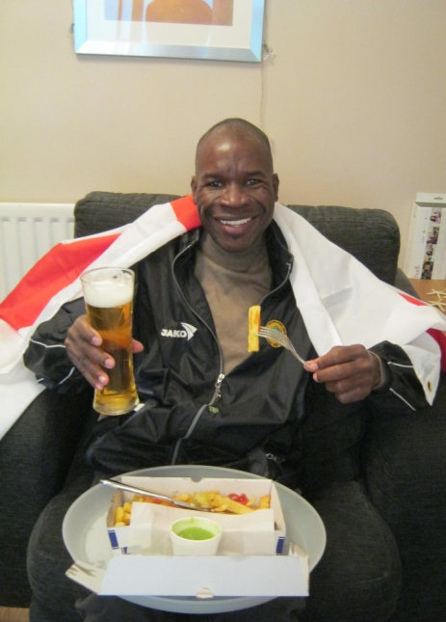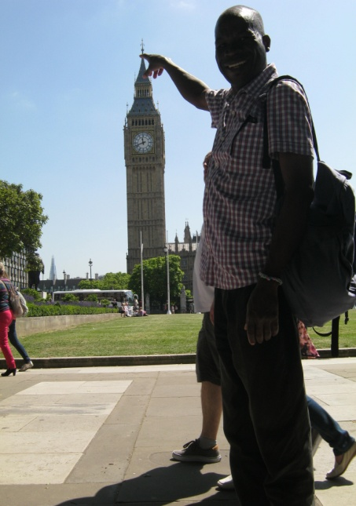
During a trip to pizza express, after his attempt at tossing the dough, I was interested to hear all about the eating habits of the Malawi people. I can simply summarise this into, they eat when they are hungry and we eat when it’s dinner time. We also popped into pets at home to take a look at some of the animals and food stuff that can be purchased. Rabson thought that when you bought a Guinea Pig the shop keeper then killed it and prepared it for you to cook! In addition we talked about the insects that were consumed by the Malawi people.
We also played a range of games including petanque, mastermind, Perudo, chess (what a long hard fought game that was!) and I showed him some magic!
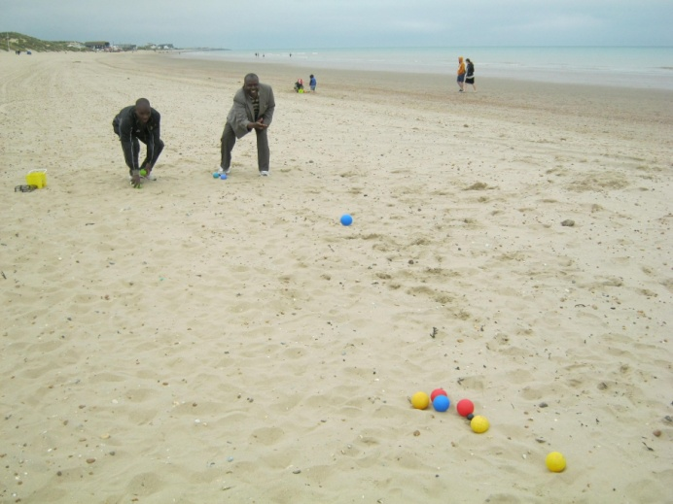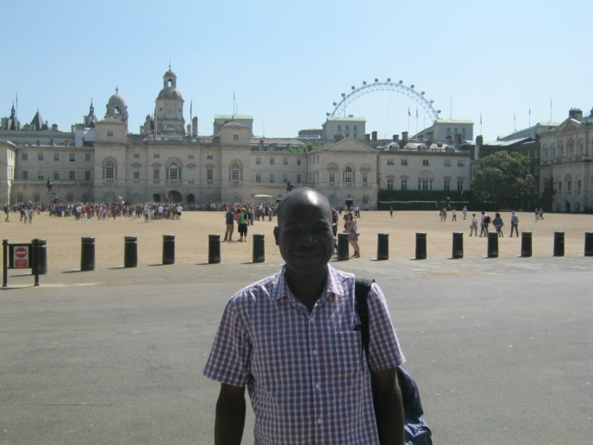
Rabson was fascinated by the sunrise and sunset and one of the first few emails I received when he got back was…
The sun has set at 5.20 pm here in Salima today and it is now getting dark.
This is very strange. We were used to the sun setting at 9.30 pm.
Unbelievable!

The Future
Peer mentoring and sports leaders remain to be an active part of our school life at the HWA and Rabson is keen to embed this on going good practice into his own school.
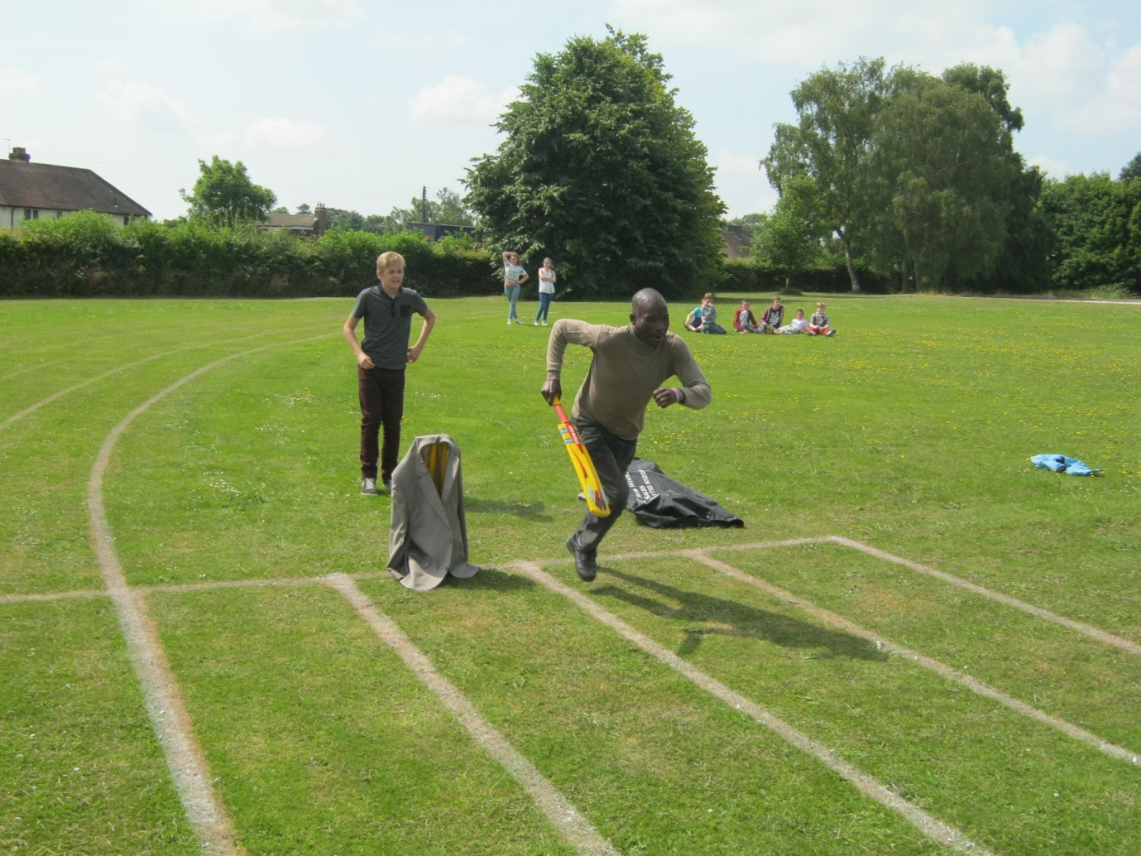
Curriculum links and teaching practice ideas continue to be shared. The internet has proved to be invaluable in sharing good practice and I am currently providing staff at the HWA with weekly teaching and learning tips. These are on a broad range of teaching issues and I will also be sharing these with Rabson.

Lesson observations during his visit were thought provoking and enjoyable. As a teacher responsible for teaching and learning it was good to show him how all of our staff follow a consistent approach to ‘showing off’ their lessons during visits. Grab files, with a range of class data in, are something that Rabson may want to introduce in the future.
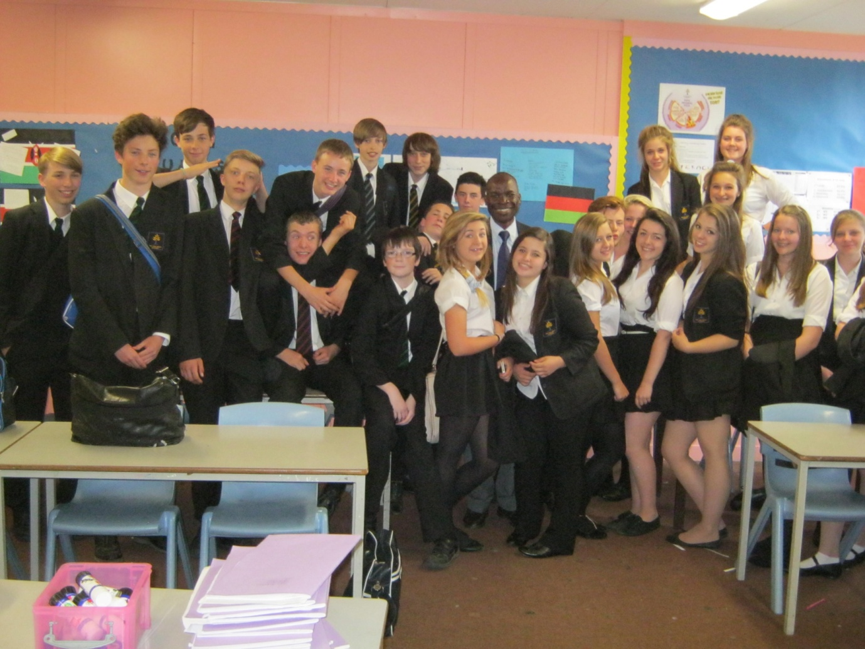
I am looking forward to my visit in October where I am expecting to be able to empower Rabson and his team further by discussing and delivering positive change. Global education is a shared responsibility and with it comes shared reward and success.
‘Coming together is a beginning. Keeping together is progress. Working together is success’. (Henry Ford)

Wayne Wilkinson
PE & Pedagogy - AST

