Sharing Experiences – Diary of Mr Abinele Yotamu.
Visit to St John’s Meads, Eastbourne, June 2014.
Day 1: Wednesday 18th June
Arrived at Heathrow Airport (London) at 6.15am.
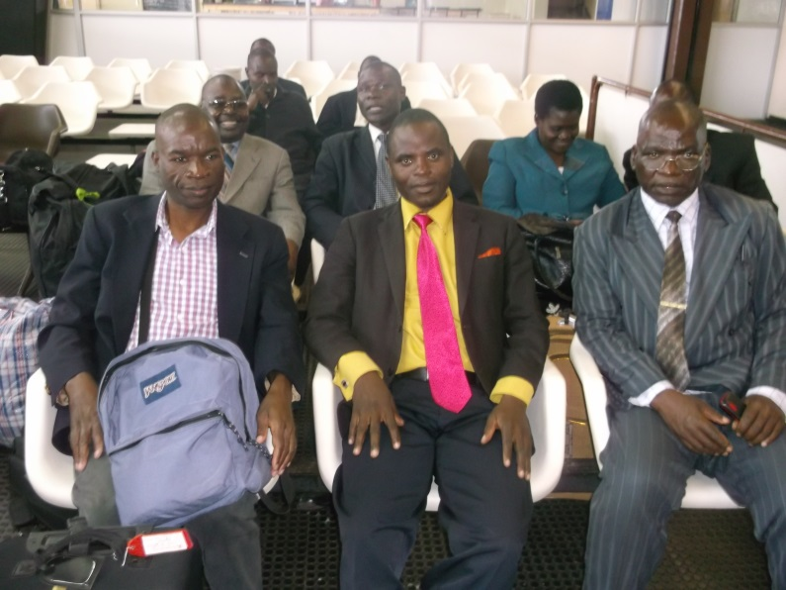
After check off process, we were dispatched into various schools by the director of Starfish (Chris Knott).
I was warmly welcomed by the link coordinator, and the entire members of staff. I was introduced to every class Reception – Year 6 during the afternoon in school.
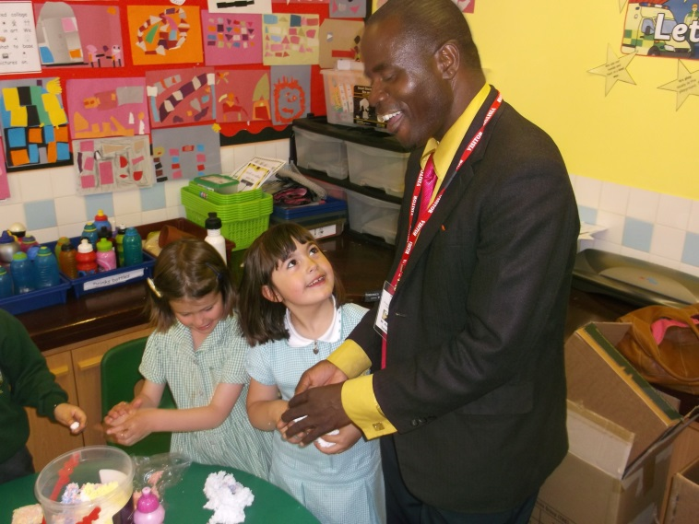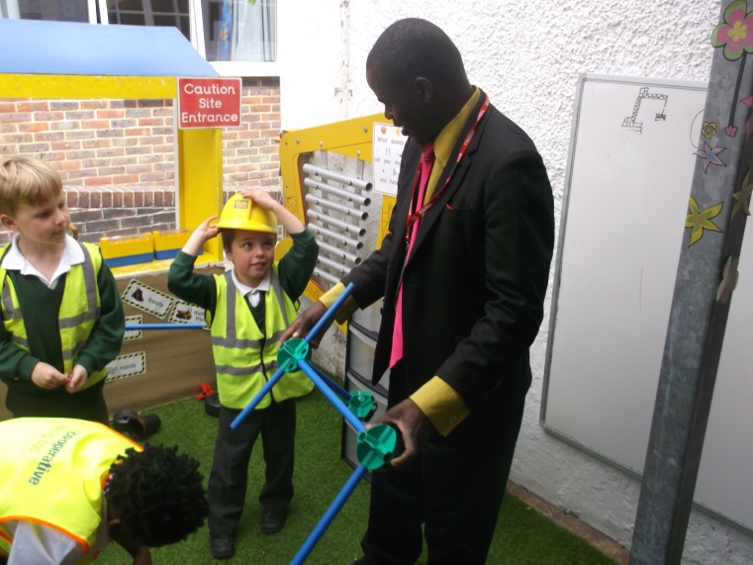
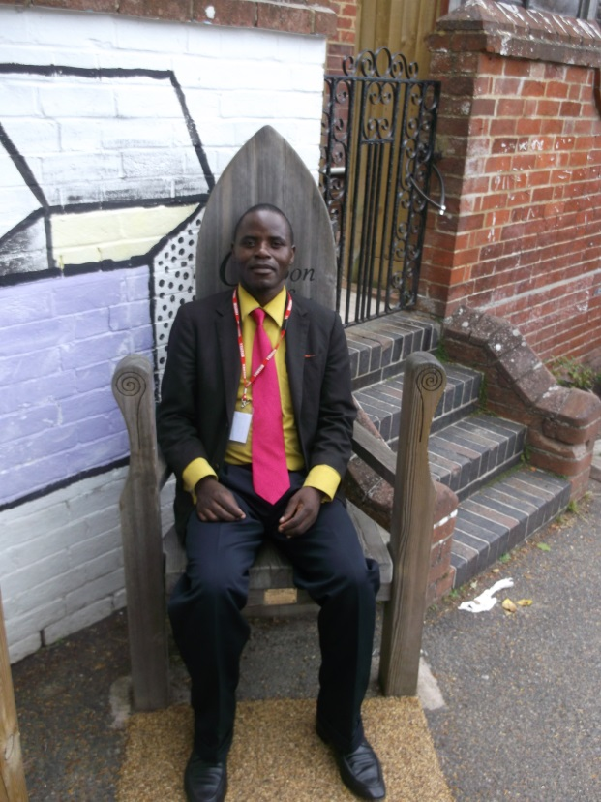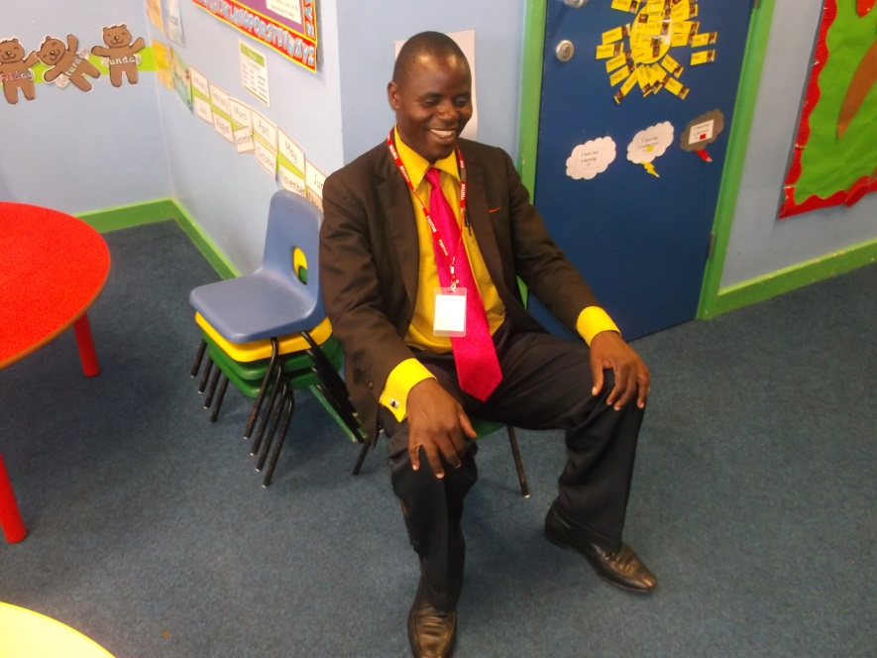

After lunch in the staffroom, I observed two lessons, one in Y4 and one in Y5.
At 4.30, I was taken to Mr David’s residence (St Omer guesthouse), to rest and enjoy a beautiful dinner (mushroom and bacon). I enjoyed it very well.
Day 2: Thursday 19th June
Activities on this day were as follows: Firstly, I observed the Y4 class.
Successes
Controllable class which made good management (30 learners).
Adequate teaching and learning resources used.
Effective communication with learners.
Time managed well.
Good presentability
Learner centred
Had early work (so fantastic).

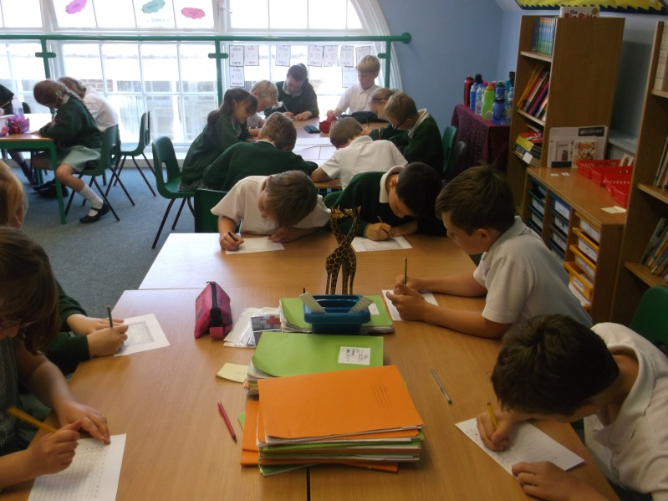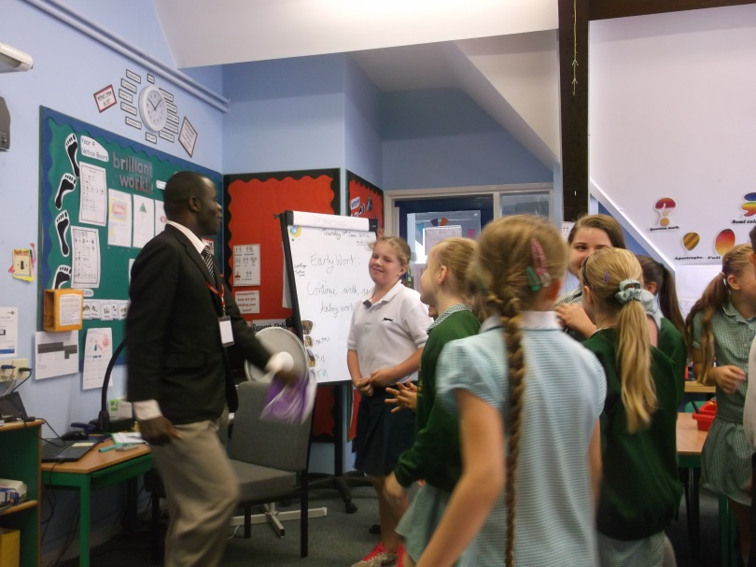
The children also completed times tables tests. He is a good teacher and addressed various strategies. Lastly, before the session finished, the learners sang different songs which touched my heart.
- May God bless our teachers.
- Malawi National Anthem
- St John’s School Song (Be responsible…)
Secondly, I taught learners of St John’s Meads a song of Chiluwa 2 assembly as ‘Hard work is our motto’. Learners liked the song, but because of the time factor, we stopped for school assembly, where Head of School, Nathan Cline played keyboard (piano) while learners practised songs.
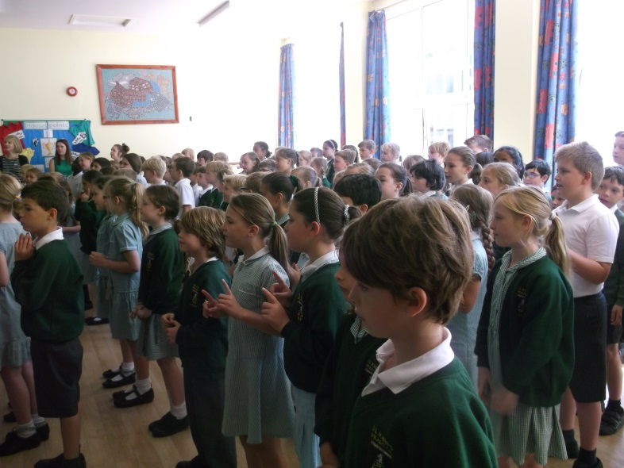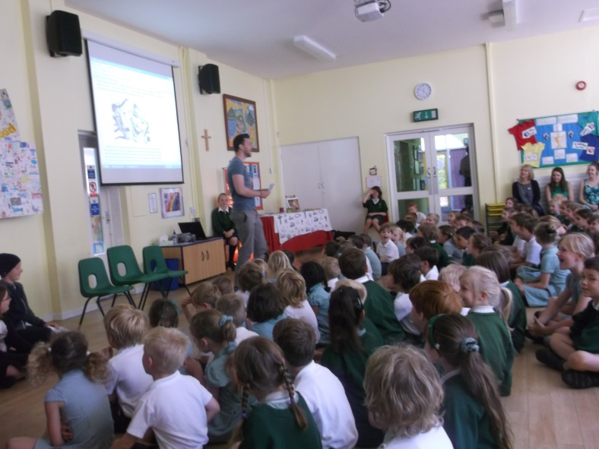
Thirdly, the school hired a cricket teacher where both teachers watched and played cricket together with the learners. I enjoyed very well because the skills of cricket have stuck in my brain such that when I go back to Malawi, I will share it with teachers and learners of Chiluwa 2 school. We have the materials already, but didn’t know the skills.
After school. I was taken to the Hydro hotel with many of the staff to enjoy an English cream tea with delicious food provided. Nicely.
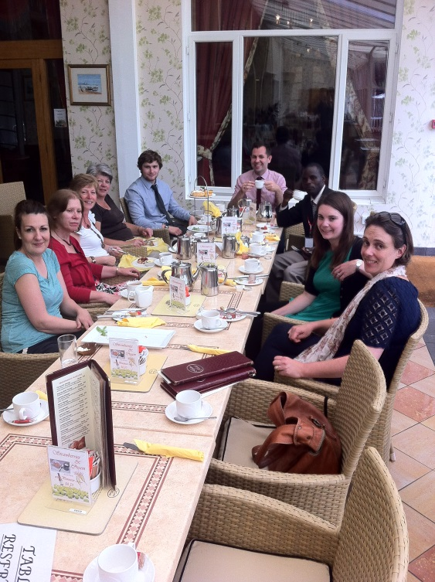
Day 3: Friday 20th June
On this day, I started to present my lesson on different crop types grown in Malawi. The lesson was presented in Year 4 after attending a Spanish assembly. Learners at St John’s School learn a different language, Spanish, and every Friday a teacher teaches every class. Learners from Y3,4,5 and 6 participated. They sang Spanish songs and activities tremendously. (Lovely).
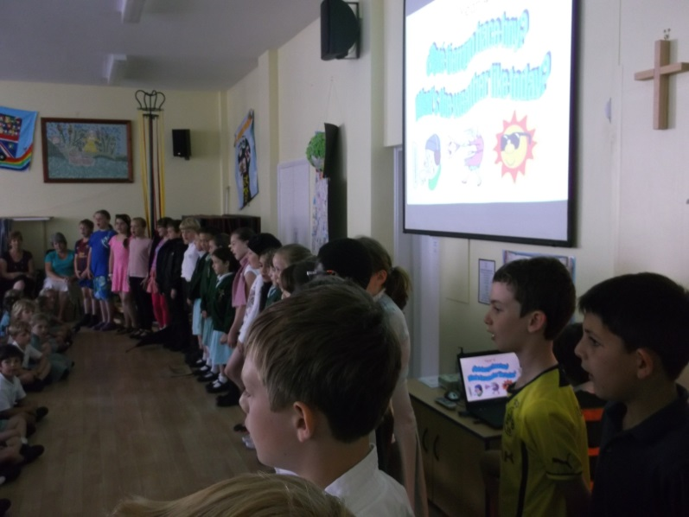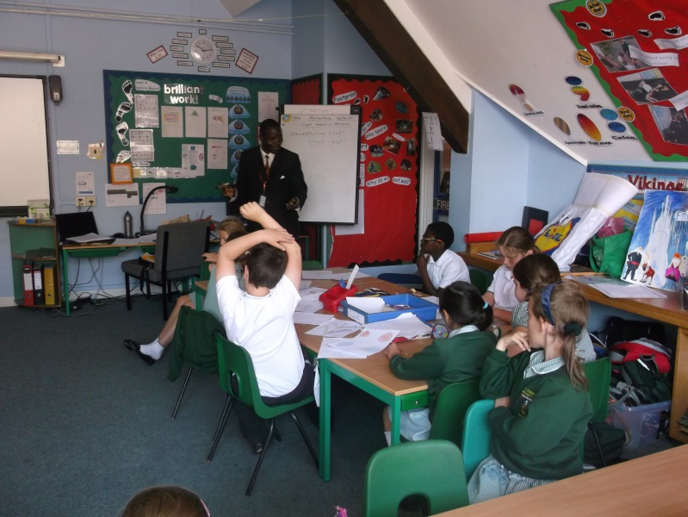
The lesson was good and I was informed later by Tim that the teaching and learning resources were good, but only not to use groundnuts and seeds, as a learner had an allergy and had to leave the class room. I had no knowledge, so was forgiven, but it was good to know. Before the lesson, I advised learners not to taste any food. I just pray to God that the children paid attention to this.
Secondly, I was with Year 1 learners with question and answer about Malawi, climate, Chiluwa 2 school, culture and lifestyle. It was so good and we danced together songs I presented to them. These were spiritual songs coming from the books Genesis 1 and John 3 v 16. I love these songs and loved sharing them with Year R, 1, 2 and 4.
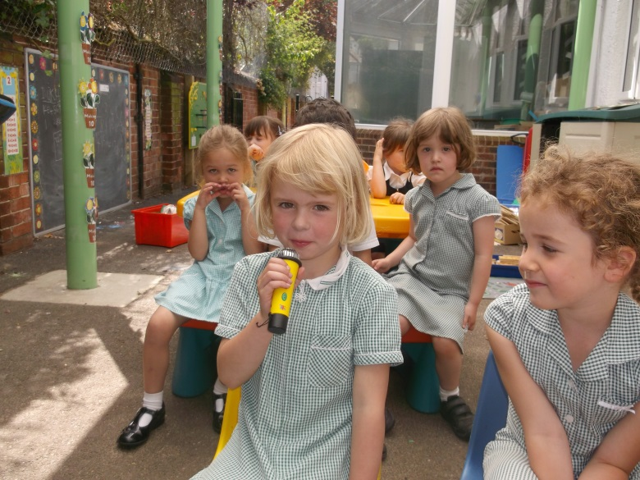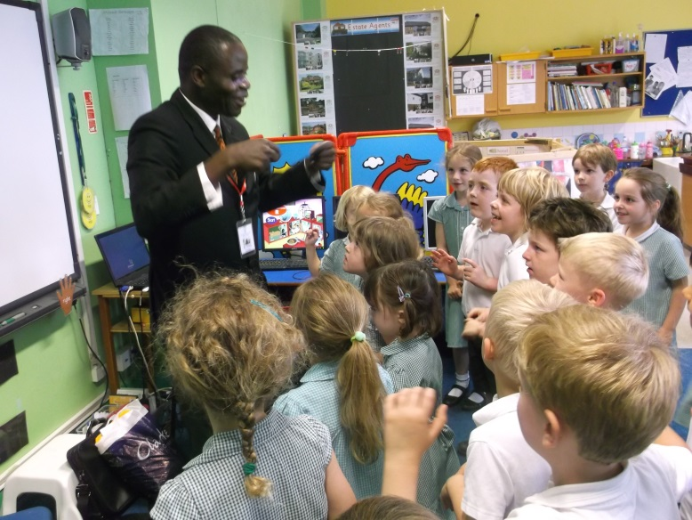
I also met with the St John’s Student Council. There were lots of questions and they were so inquisitive to know what Chiluwa 2 council is doing, what are their codes, their roles as student councils, what benefits do the schools when a learner is doing fine in class? We exchanged codes and I have taken some and left some with the link officer, Tim De Marco.

After taking lunch, I attended Year 2 class where by learners asked me questions on what subjects are learnt in Malawi, how many learners and teachers, do we have plastic bins, How do we maintain health at our school, do we recycle our rubbish and litters? Do I have a car? How about other teachers? How do you travel to school? Do we have electricity? How do we manage it? Do all learners have school uniforms, pencils, exercise books etc?
There were so many questions, the time was exhausted. The teacher was very excited and interested. It was a lovely exercise. Later, the whole class with both teachers from UK and Malawi danced a song for learners.
After this, I was invited for a private talk with the Executive Head, Alison Flynn.. We talked about administrative issues to learn more about how she administers. I also had to highlight to her a clear picture of Chiluwa 2 since this was the first meeting between heads of both schools. We also reminded each other of the curriculum shared between both schools so far, e.g. My health, My village, letter exchanges, sporting activities on Olympic values, footprints and environment.
We ended the day with an assembly where children presented their work (from Global Week) for the whole of the week. Among other work, litter picking, environment, recycling, lots of writing about countries of the world. Questions and answers together with songs were presented. It was a very brilliant show!! I will still remember this and share it.
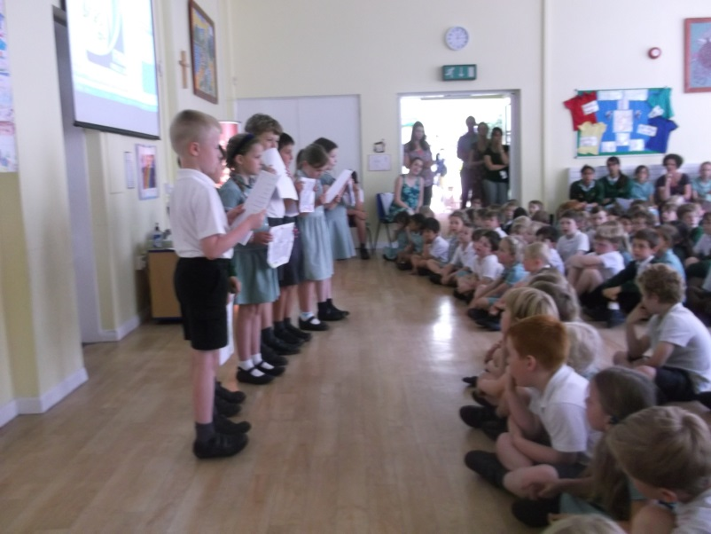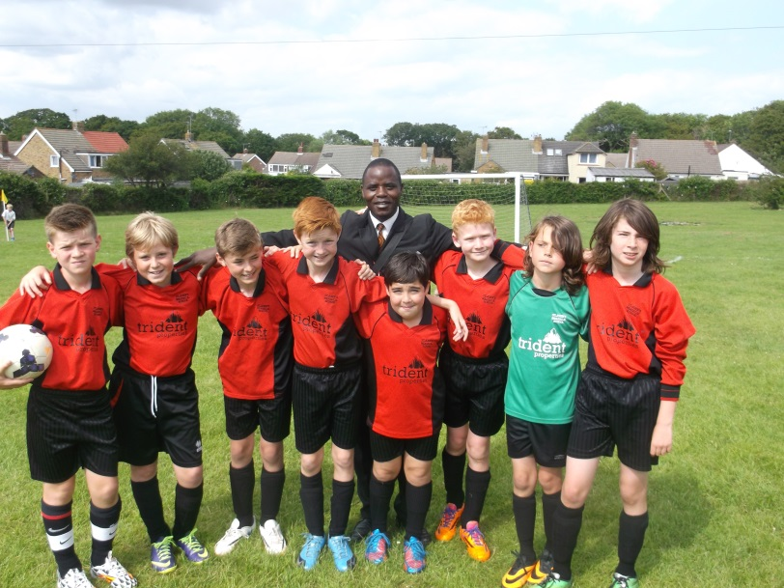
To mark everything on this day, we had also a trip for St John’s Meads school (football team) to play against another school in the other side of Eastbourne. So far, St John’s have been awarded trophies for beating other schools, and this was the final. Unfortunately they lost 2 goals in favour of the other school.

Day 4: Saturday 21st June
I got off to London City directed by Tim De Marco. I had to feel a nice electric train which took us to London. When I arrived there, I saw very interesting places like:
- David Cameron’s residence
- Buckingham Palace (Queen Elizabeth II)
- Clock tower (Big Ben)
- Government buildings
- Westminster Abbey
- The Eye of London City.
- River Thames
- MP Buildings
- St James’ Park with beautiful white bird with long neck (Swan).
I experienced the longest day (Sunrise 5am, and Sunset past 10pm).
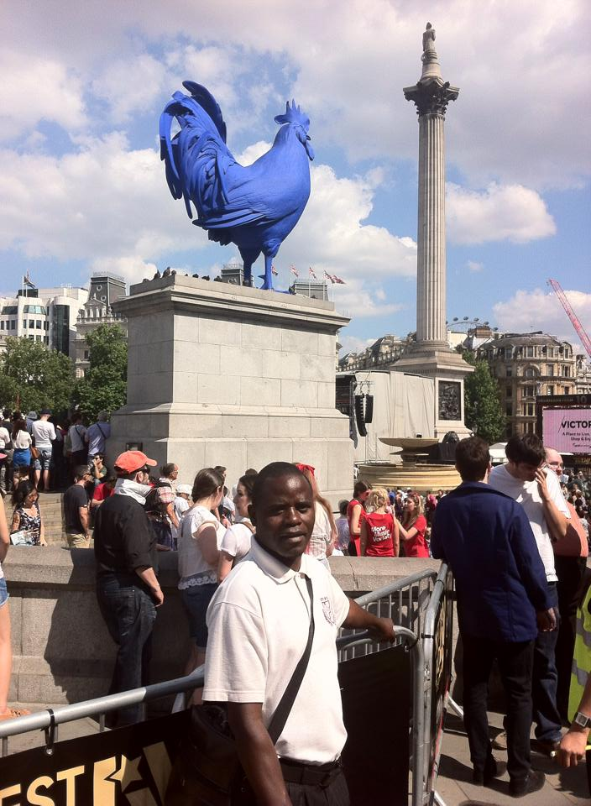
Lastly, we were invited to go to London Beach Hotel, where all teachers from Malawi had our meeting and shared experiences with nice meals. During the whole day, Tim and I discussed the collaborative projects between the two schools. The day went on well.
Day 5: Sunday 22nd June
One of the parents from school invited me to their church and to lunch. They took me to St. Mary the Virgin church at Willingdon. The book of Luke was read and the verse was focusing on the lost sheep over 99 available ones. Jesus teaches us that when one person receives faith and repent his sins, the angels and God gets proud. We shared luncheon with some secondary teachers. The children played in the house. I learned about their family and was flexible to share about my family background.
Day 6: Monday 23rd June
I observed Tim teaching Year 3 a lesson. It was so fantastic, using different skills in teaching.
Later, I attended Mrs Alison Flynn’s assembly where she read aloud a story from India. The story was to teach learners not to judge things from their cover or appearance. Some learners were given ‘Green Cards’ (reward for good work). I enjoyed it and it had lovely organisation.
Lastly, on this day I observed a lesson whereby learners themselves were making research using websites. It was so fantastic. The day went well. Then I observed a lesson in Y2 about safety and rescue. It was a good job done by the teacher.
In the evening, I attended St John’s Church for the welcoming of a new priest to the church. There was lots of singing. It was very special.
Day 7: Tuesday 24th June
On this day, I met with the Head of School, Nathan Cline and shared some administration skills in the following areas:
- Quality of teaching
- Achievements of levels.
- Leadership and management skills
- Monitoring and evaluation processes
- Behaviour of learners
- Misbehaving of learners (monitoring and learning advices).
Assistance for challenges
- Communication (laptop and phone needed).
- Teaching and Learning resources.
- Building funds – teacher’s houses.
We signed the partnership agreement for 2014-2015.
I met the school Eco-Council where both schools took collaborative ideas for the new projects for 2014-2015. Learners gave their own views on how to build a brighter future for Chiluwa 2 and St John’s.
I took a lesson in Year 3 on expressive arts (weaving and practising brooms). In the process, the link had been exchanging letters between learners. They exchanged questions and answers and discussed curriculum themes.
Lastly, I watched Mr De Marco and Y3 as they played some different learning games. It was so fantastic and I will teach them to learners at Chiluwa 2.
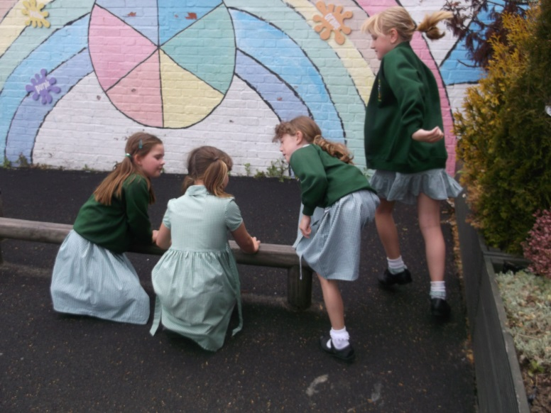
Y3 Classroom:
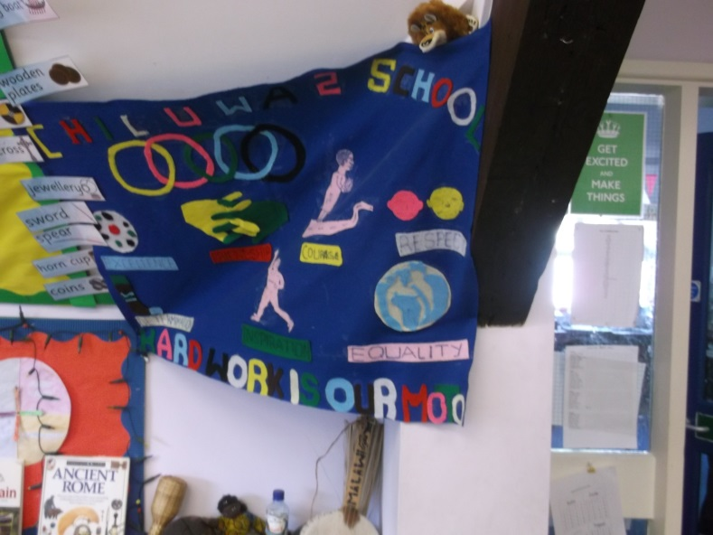 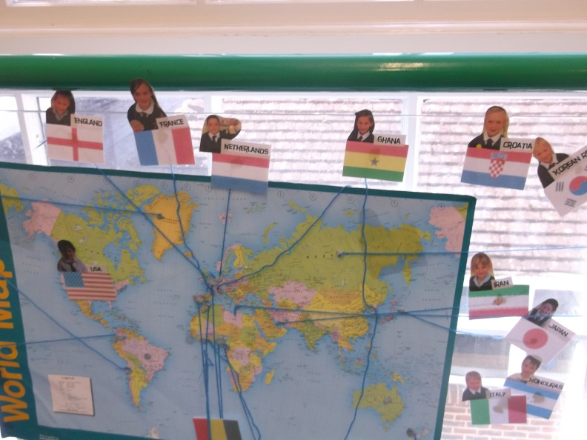
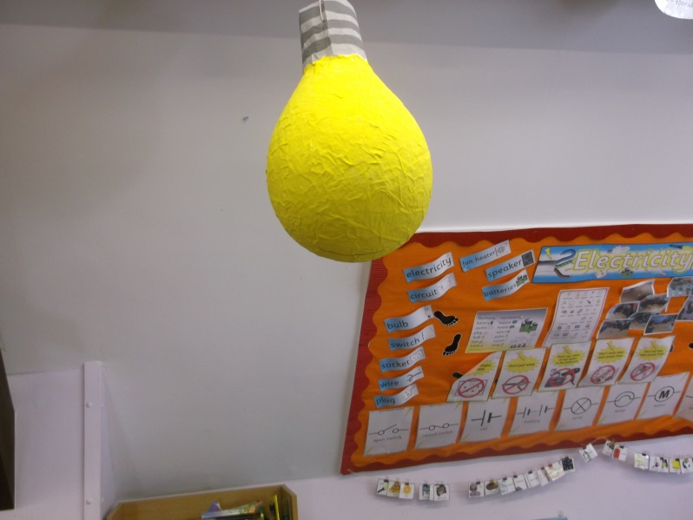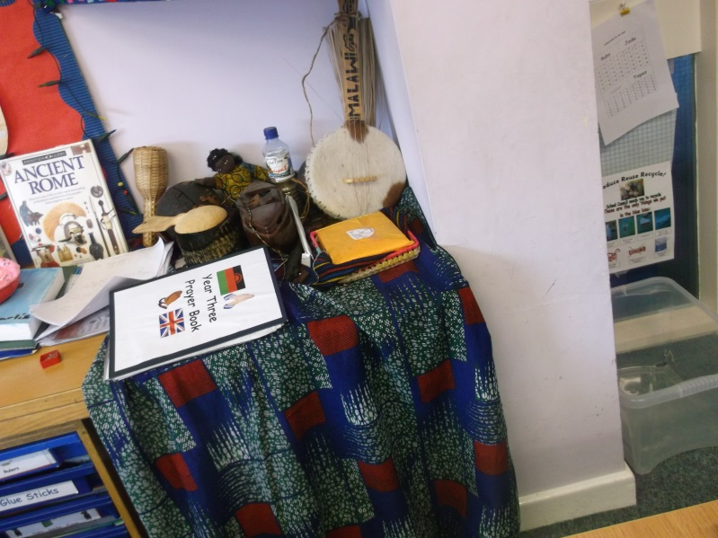
Day 8: Wednesday 25th June
I observed a lesson in Y1 and talked about school to small groups, allowing learners to give differences between the two schools. I answered many questions and asked some myself – about the legal starting age, and the learning they do in YR, for example, toys, buildings, space, environment, research on the wider world. At the end, learners drew pictures of St John’s and Chiluwa 2.
I had also a chance to observe and learn skills on the netball pitch and observed the last lesson in Yr 6. I also joined Year 1 for a ‘fire safety’ demonstration with a fire vehicle, where the learners were shown how different items are rescued from a fire. It was so fantastic. In the evening, I enjoyed a meal at a restaurant with Tim De Marco.
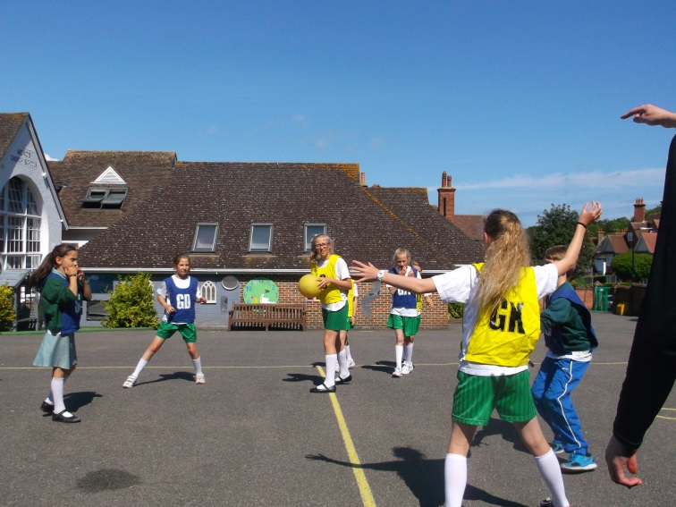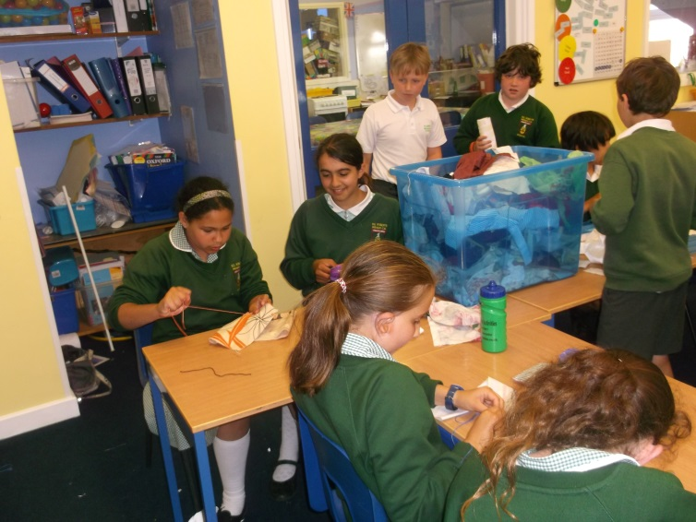
Day 9: Thursday 26th June
This morning, we held a farewell assembly attended by pupils, staff, parents and representatives of the school community (governors). We exchanged gifts and shared songs. It was wonderful.
Reflections of Tim De Marco, UK Link Co-ordinator
Mr Yotamu’s diary has provided such a good account of his time with us, that I won’t repeat it, but I will add some thoughts on what I thought was successful about the visit.
Firstly, when he arrived, the Reception class were lined up ready for a swimming trip. As he walked in, they cheered, clapped and welcomed him by name. Even a class in their first year at St John’s were excited by the link. Teachers had been talking about his visit, and they were very pleased to meet him.
Secondly, Mr Yotamu’s enthusiasm to learn and experience as much as possible is evident in the detail of his diary. He asked lots of questions to children, adults and parents and got fully involved.
We had excellent discussions on the train journey to and from London about our curriculum plan for the year ahead, deciding on ‘Building a Brighter Future’, with three main projects, one for each of their terms (2 of ours). He brought the relevant documents and materials, and together we had a truly collaborative discussion, both contributing ideas which were built on by the Eco-Council , and will be by the Eco-Council at Chiluwa 2 as well.
Everyone who met Mr Yotamu commented on how polite, kind, good with the children and keen to learn he was. People who hosted him, gave him lifts to and from school, and got to know him through the week were all impressed. He also took a lot from working alongside and shadowing management in the school.
Finally, on the last evening, I discovered that the fruit of his visit was really beginning to blossom. He thanked me for the visit, and said he had learned so much. He commented on how he was planning important changes to Chiluwa 2, aiming to make it much more learner focused with less teacher talk. Moses Mhango, the link coordinator had seen this, but realised he needed the head teacher to experience it in order for this positive change to happen. My hope and prayer is that it now will.

