Trip Reports 2012
The Malawian Teachers visit to the UK

Lamberhurst to Chikombola (photo diary)

Caroline Bromley Head Teacher @ Lamberhurst ST Mary’s wows the Chief of Chikombola with her drumming skills
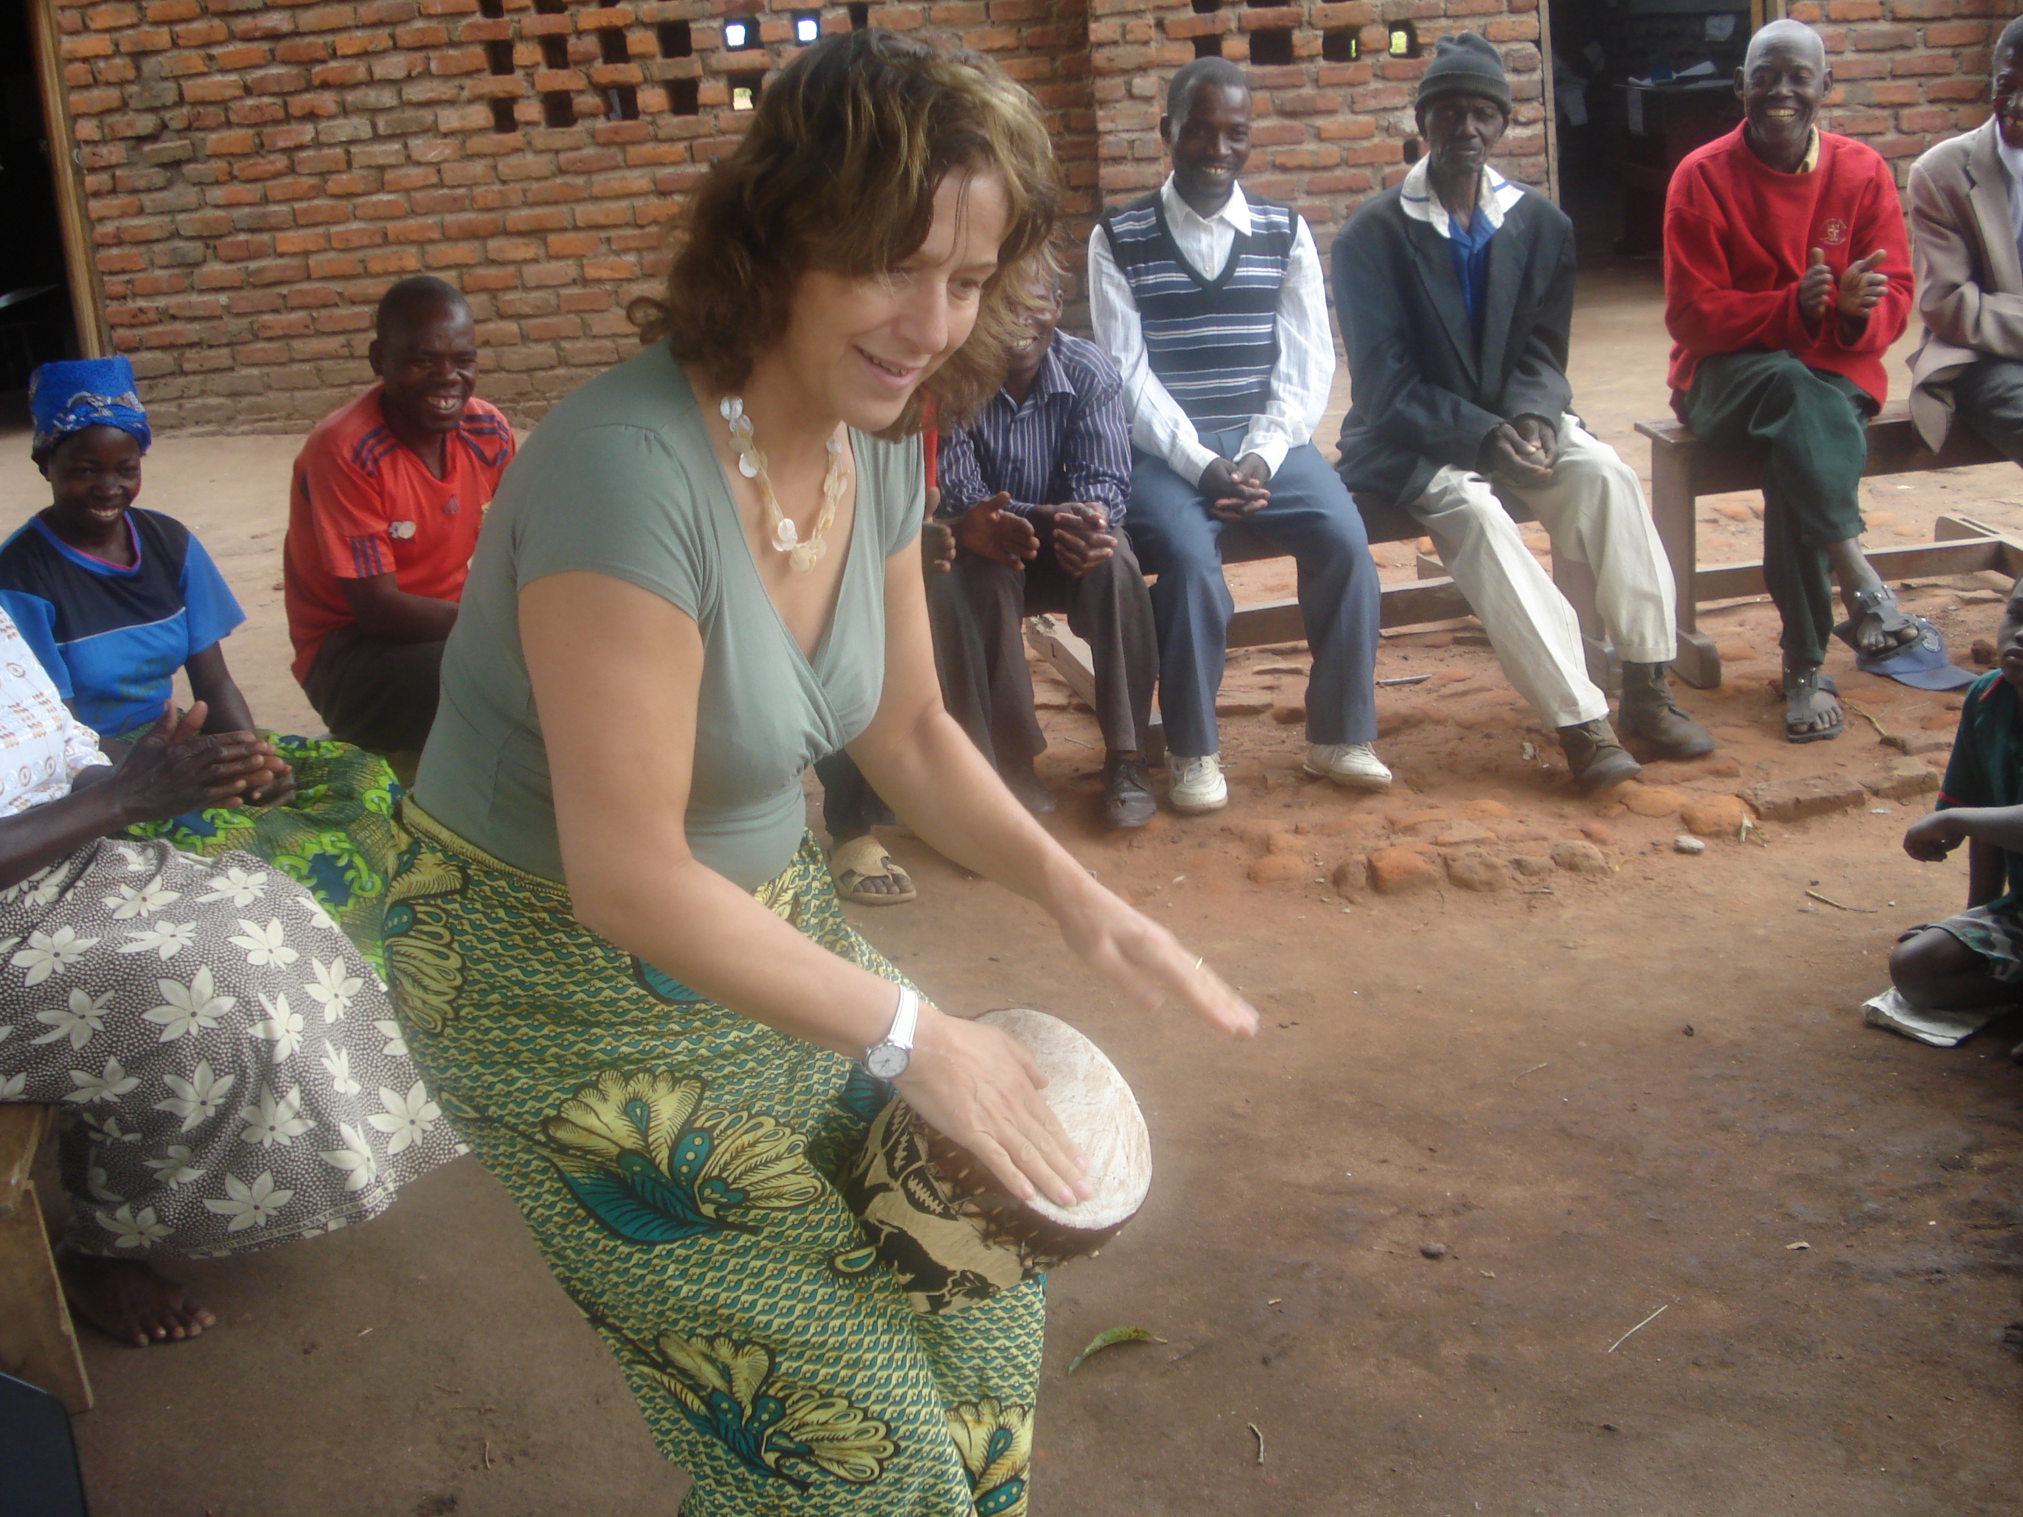
Caroline gets in the swing with the women of the village
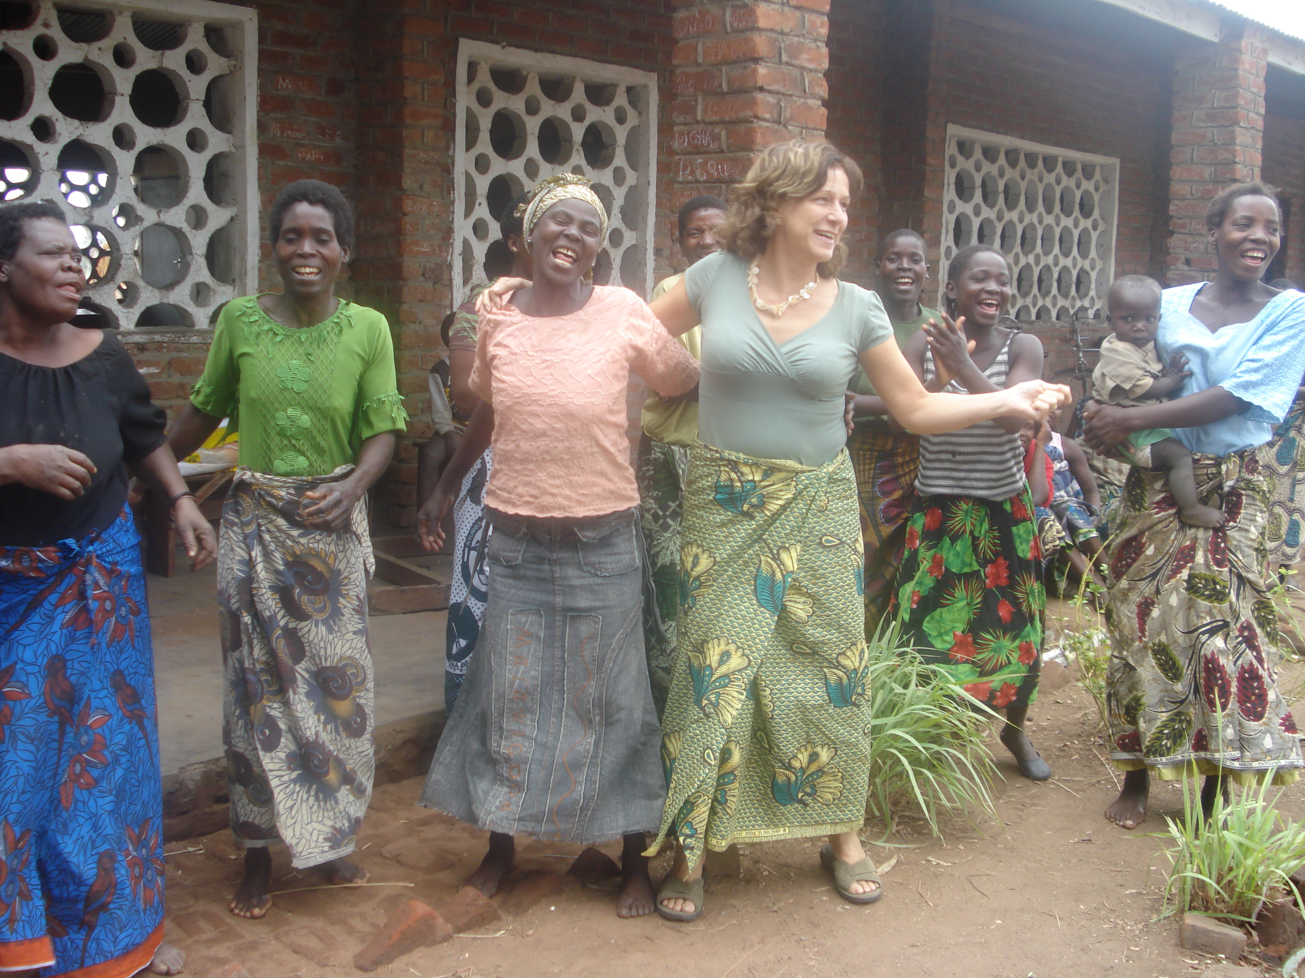

Georgia is beating Emmanuel Chiumia (Starfish schools coordinator) on a Malawian board game.
