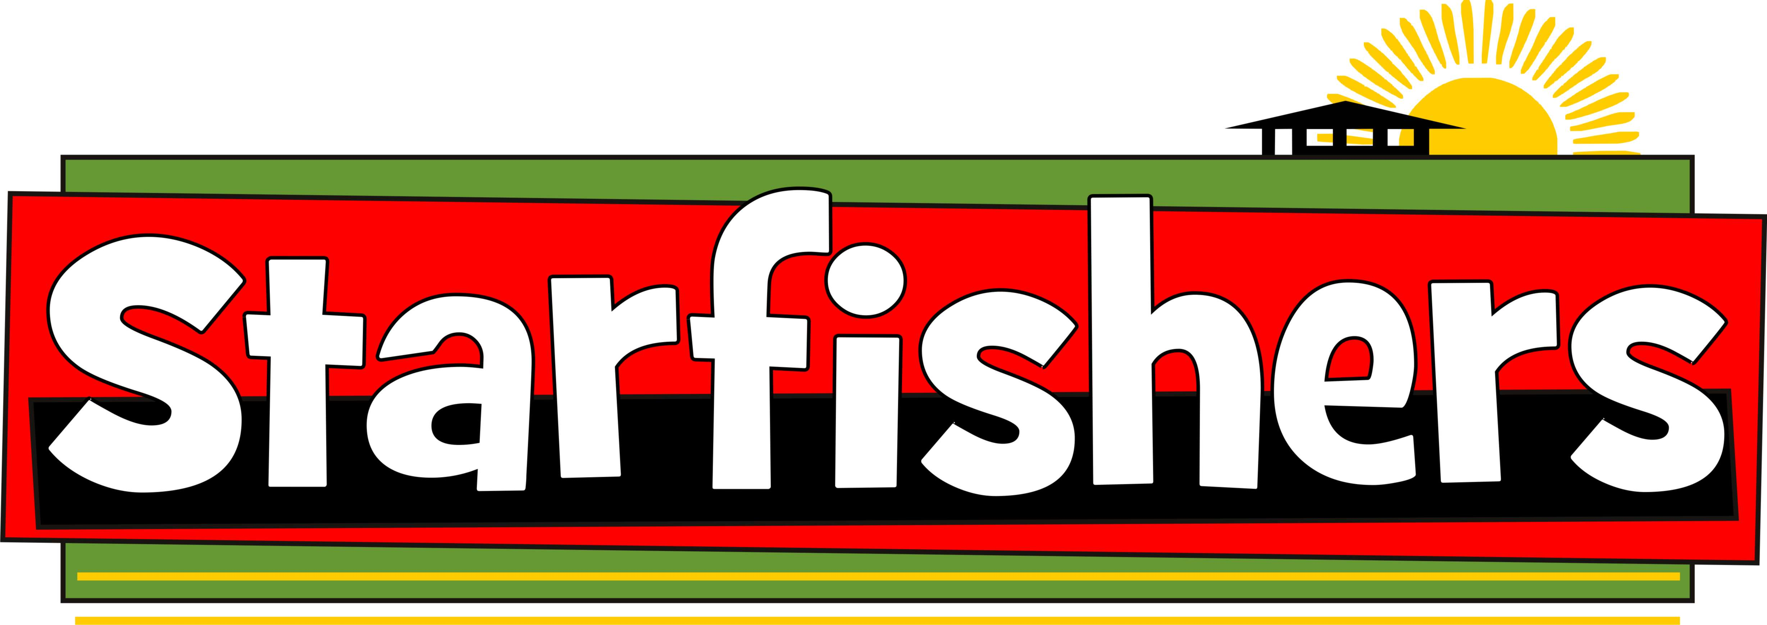

**Case Study Report**

**Year 4 Activity F –** Where Does our food come from?

**St John’s Mead Primary School, Eastbourne linked with Chilluwa Primary School, Malawi**

Submitted by Tim De Marco Y3 Class Teacher

Date: 28/09/2013

**In our Year 3 and 4 classes, we looked at the ‘Carbon Footprint of our food’, thinking about where in the world our food comes from. We looked at food packets, did maths investigations into the distances involved and discussed the results.**

**As a writing response, children had ideas for a class poem on the matter which was formed into this. This was performed at our school Harvest festival as a choral speaking performance, with children standing on 4 sides of the church reciting the poem, about 16 children in each group.**

**Chorus (ALL)**

It tastes so good. It tastes so good.

But what's the footprint of our food?

**Group 4 (Back)**Footprint? What’s a Carbon Footprint?

**Group 1 (Front)**  
A footprint tells us the energy we use  
From fossil fuels which are often abused.  
We think our planet will last forever   
Will we run out? Oh surely never!

**Chorus (ALL)**

It tastes so good. It tastes so good.  
But what's the footprint of our food?

**Group 4 (Back)**But how can food have a footprint?

**Group 2 (side)**Food’s footprint is the energy it needs  
To get it to our homes where our tummies it feeds  
We should all stop and think   
Where do we get our food and drink? **Chorus (ALL)**

It tastes so good. It tastes so good.  
But what's the footprint of our food?

**Group 4 (Back)**

Our food comes from the supermarket!  
  
**Group 3 (side)**

We just drive a car and park it  
Just outside the supermarket  
Bananas travel 4000 miles  
Grown, picked, wrapped and put in piles

Apples from Australia,  
Tomatoes from Spain,  
Plane, Boat, Car, Truck  
Using fuel’s a pain.

**Chorus (ALL)**

It tastes so good. It tastes so good.  
But what's the footprint of our food?

**Group 4 (Back)**

At least we’re helping people in countries all over the world.  
  
**Group 2 (side)**People work in the field all day  
Working in the heat for not enough pay  
Buy one get one free and bargain food  
Not enough given to the person who grew  
  
**Chorus (ALL)**

It tastes so good. It tastes so good.  
But what's the footprint of our food?  
  
**Group 4**  
What can we do to help?

**Group 1 (front)**Make a start and don’t take for granted  
All the food that’s grown and planted  
Above all, when in the Harvest mood  
Please thank God for local food!