HOLLINGBOURNE PRIMARY SCHOOL

GLOBAL EDUCATION JANUARY 2014 – DECEMBER 2014
CASE STUDY – BIODIVERSITY

Introduction
- This topic was identified as a result of the children’s interest in natural history in both Hollingbourne (England) and Kaputu (Malawi) and also because of its global significance.
- It drawers heavily on the Starfish’s website, curriculum mapping key stage 2 year 5 and the work of Lilongwe Wildlife Trust, Eco School Malawi.
- The project period included the exchange visits of both head teachers enabling identical lessons to be taught in both schools.
The Lessons
1.
- Teachers in both schools introduce the idea of biodiversity (species, general definitions).
- Teachers in both schools play the string game with classes to illustrate the dependence of one species upon another, food chains and the natural balance in nature. This game came from the Eco Schools Malawi Teachers Guide.
2.
- Pupils in both countries make lists off all the species they know in Malawi and in Britain. These lists showed quite clearly that they knew a lot more about their own country than their neighbours.

3.
- The species lists are shared so that pupils can see the full range and note where some species are the same but many are different (There seemed to be more species specific to Malawi than in Britain).

4.
- During connecting classrooms exchange visits pupils sketch living things around their own school.
- Pupils worked in groups making bold drawings in board marker pens.
- Trees proved to be of particular interest with pupils in both countries asking why the same trees would not grow near their particular school (climate)
- This first-hand sketching gave an opportunity to include some artwork in the topic, which the children enjoyed. A mixed selection of this work (Malawi and Britain) was displayed in both schools).
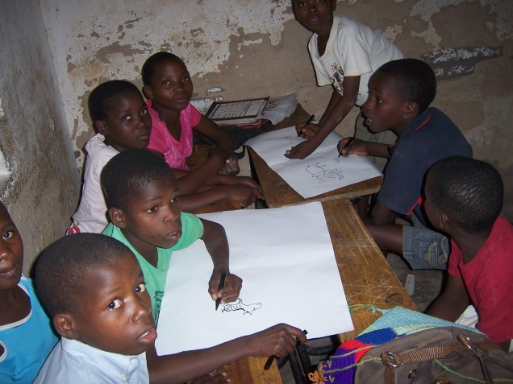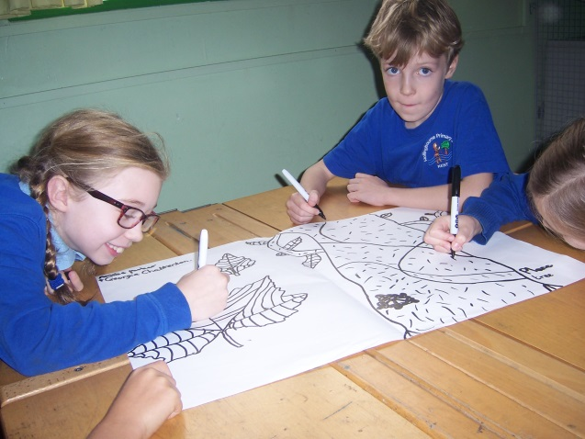
5.
- Pupils discuss the threats to Biodiversity. Again these lessons took place during exchange visits so that head teachers could bring local knowledge into their partner’s classroom.
- Some interesting differences emerged from these lessons:

Malawi Britain
Poaching Housing and infrastructure
Need for fire wood Agricultural practice
6.
- Pupils suggest solutions to the problem, with special reference to habitat restoration.
- Children decide what action they will take:
Hollingbourne – pond restoration.
Keputa – tree growing and planting
- This work was also witnessed during exchange visits.
Project Support
Visits to wildlife parks in (in Britain and Malawi) enabled children to see animals not normally encountered locally.
Challenges
- Providing and organising materials so that pupils could complete the sketching work in groups, especially as we intended as many children as possible to take part and classes in Malawi often number 60 plus.
- The idea of ‘species’ can be difficult for children and requires careful explanation so that it is consistent between schools.

Result
- Sustainability
- Children understand that world biodiversity is decreasing and the consequences this could have.
- Rights and Responsibilities
- Children are aware that government action is required to halt (or reverse) species decline (poaching and indiscriminate development).
- Identify and Belonging
- Children have a better idea of the distinctiveness and value of their own natural heritage.

Impact

- Pupils use their time to care for habitats at their own school.
- Pupils volunteer for conservation tasks in the community. 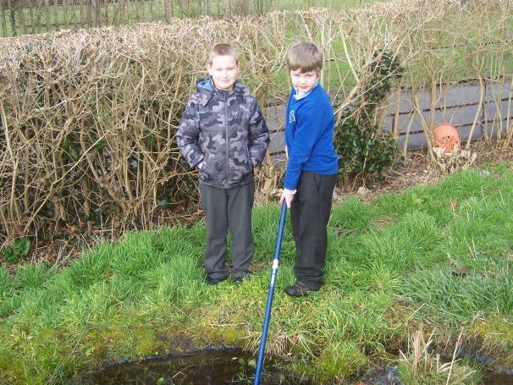 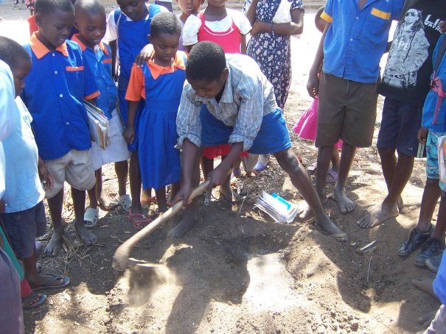
Next Steps
This topic will be followed by a project on trees. The economic value of trees will be considered, together with the effect of deforestation (soil erosion, climate change, water retention) and the amenity value of trees.

