
A partner of


PROFILE FOR KATITIMA PRIMARY SCHOOL

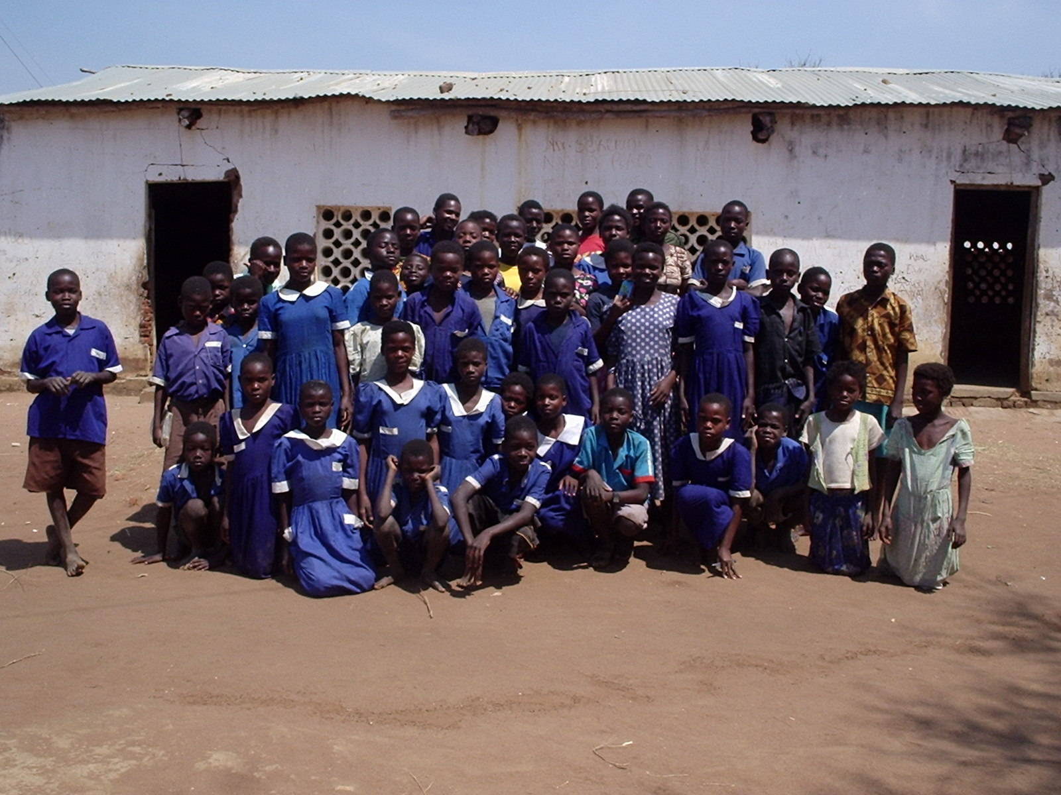

Katitima Full Primary School P.O. Box 9 Chitala, Salima, Malawi. +2659359527

Katitima Full Primary School is 41 km away from Salima District headquarters.

The school was established in 1940 under Church of Central Africa Presbyterian. The school management starts from the School Committee, PTA (Parents Teachers Association) then to the District Education Manager. The school however belongs to the government school despite being established by the church.

Katitima School has 534 pupils in classes 1-8.
Classes have students as follows: Class 1 78 boys: 83 girls
Class 2 49 boys: 51 girls
Class 3 37 boys: 44 girls
Class 4 24 boys: 21 girls
Class 5 24 boys: 35 girls
Class 6 26 boys: 21 girls
Class 7 16 boys: 17 girls
Class 8 16 boys: 10 girls

The age range of the pupils is 6-18 because some children start going to school late or repeat classes. Katitima School serves a wide distance of about 8 km in radius. Children have to walk long distances to the school. This enhances drop out rate which is high in the area.

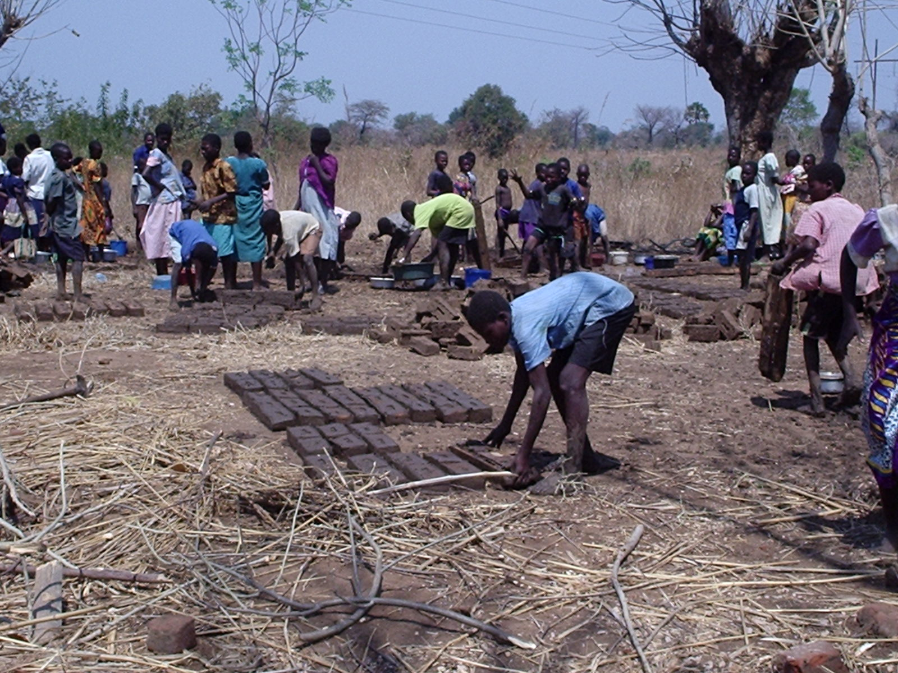
Pupils on manual work

Like any other school in Malawi, Katitima School teaches subjects like, English, Maths, Religious Education, Science and General Studies. From classes 4 and above pupils begin to learn life skills in subjects such as health education Agriculture, Science, Home Economics and Creative arts. Most teaching is done in Chichewa in standard 1-4. However, children may be capable to speak English as they continue into the senior classes.

At Katitima School, pupils do the some work such as building toilets. In the picture above pupils are moulding bricks for the toilets. The school has a dream to improve itself to be a better environment for learning. Meanwhile, infant section at the school learns under shades due to shortage of school blocks.

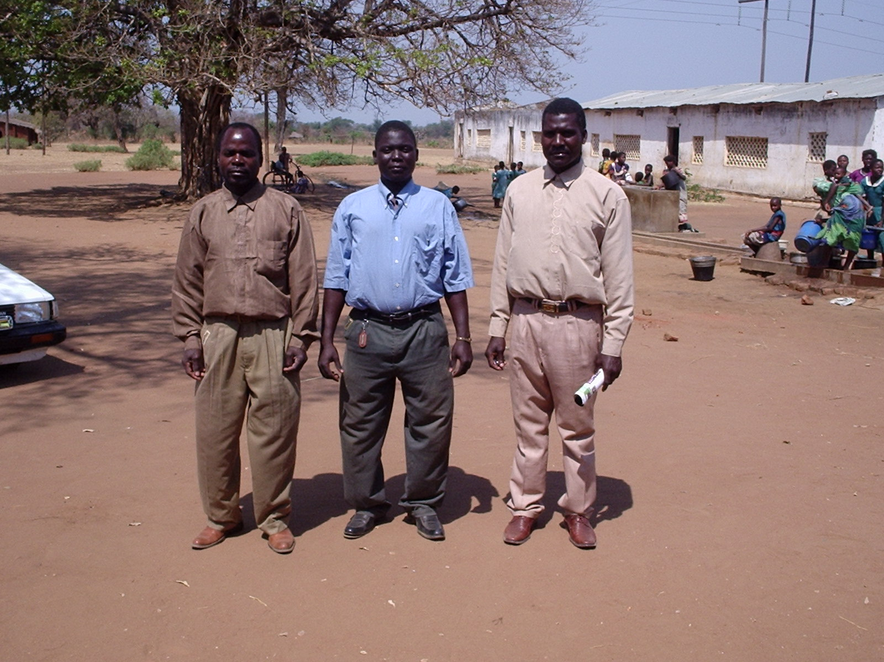
Left-right Mr Chikaoneka J.P. Sefasi, Mr Pearson N. Kalowa, Sailos D Mzuwala (Head Teacher)

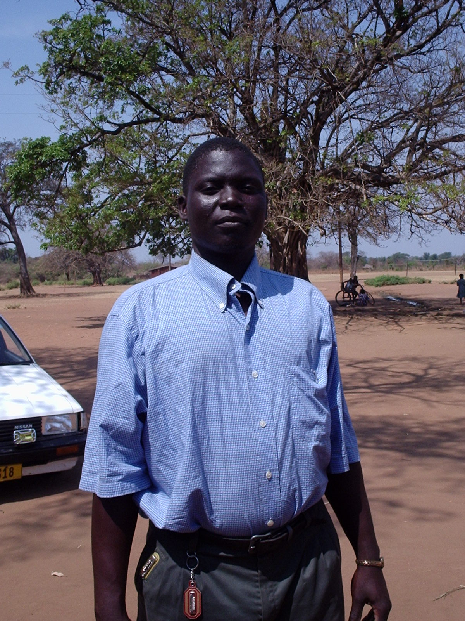 Mr Pearson N. Kalowa (Nominated lead Contact)
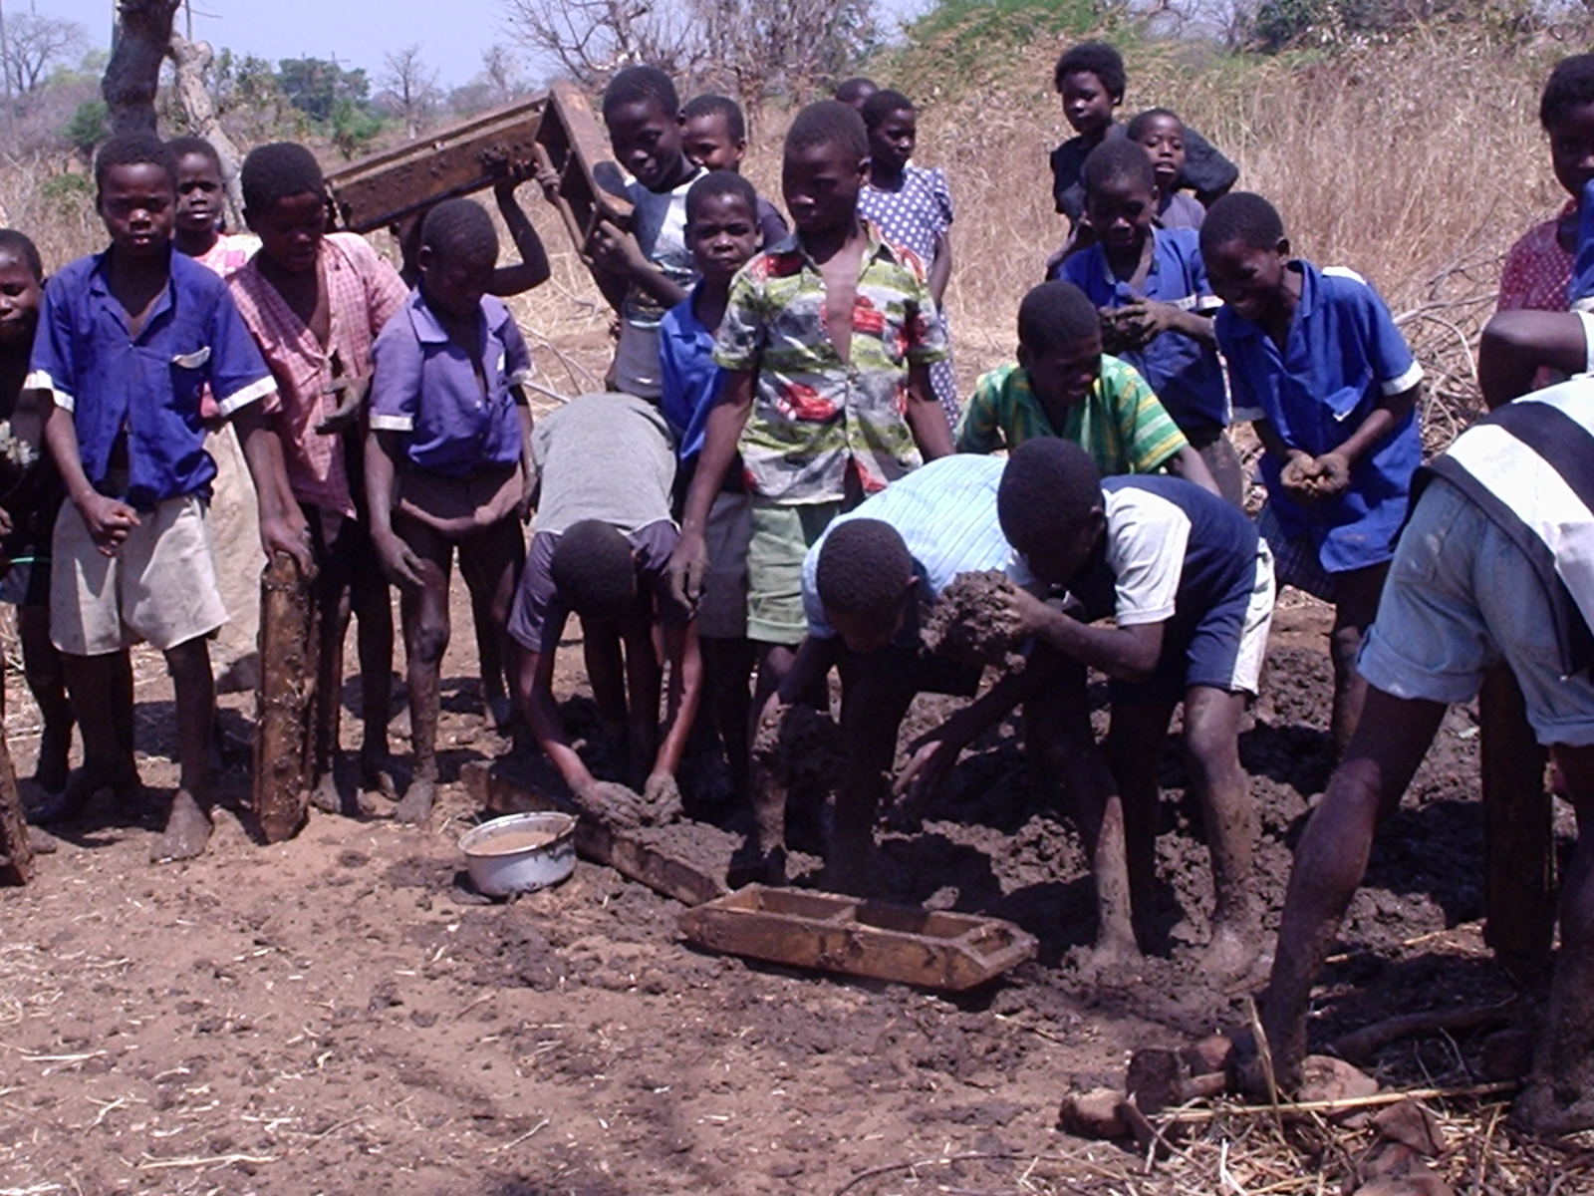

As a school, we want to be involved in the link so that we can learn from our friends in the UK especially in the developed countries. The link will greatly assist children to work hard so that they can be as their colleagues in the UK. Teachers will also be able to enhance their professional skills through dialogue and interaction with fellow teachers in the UK.

