
A partner of
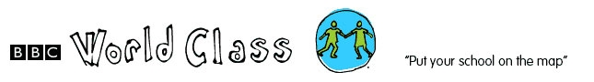

PROFILE FOR MCHOKA L.E.A. PRIMARY SCHOOL

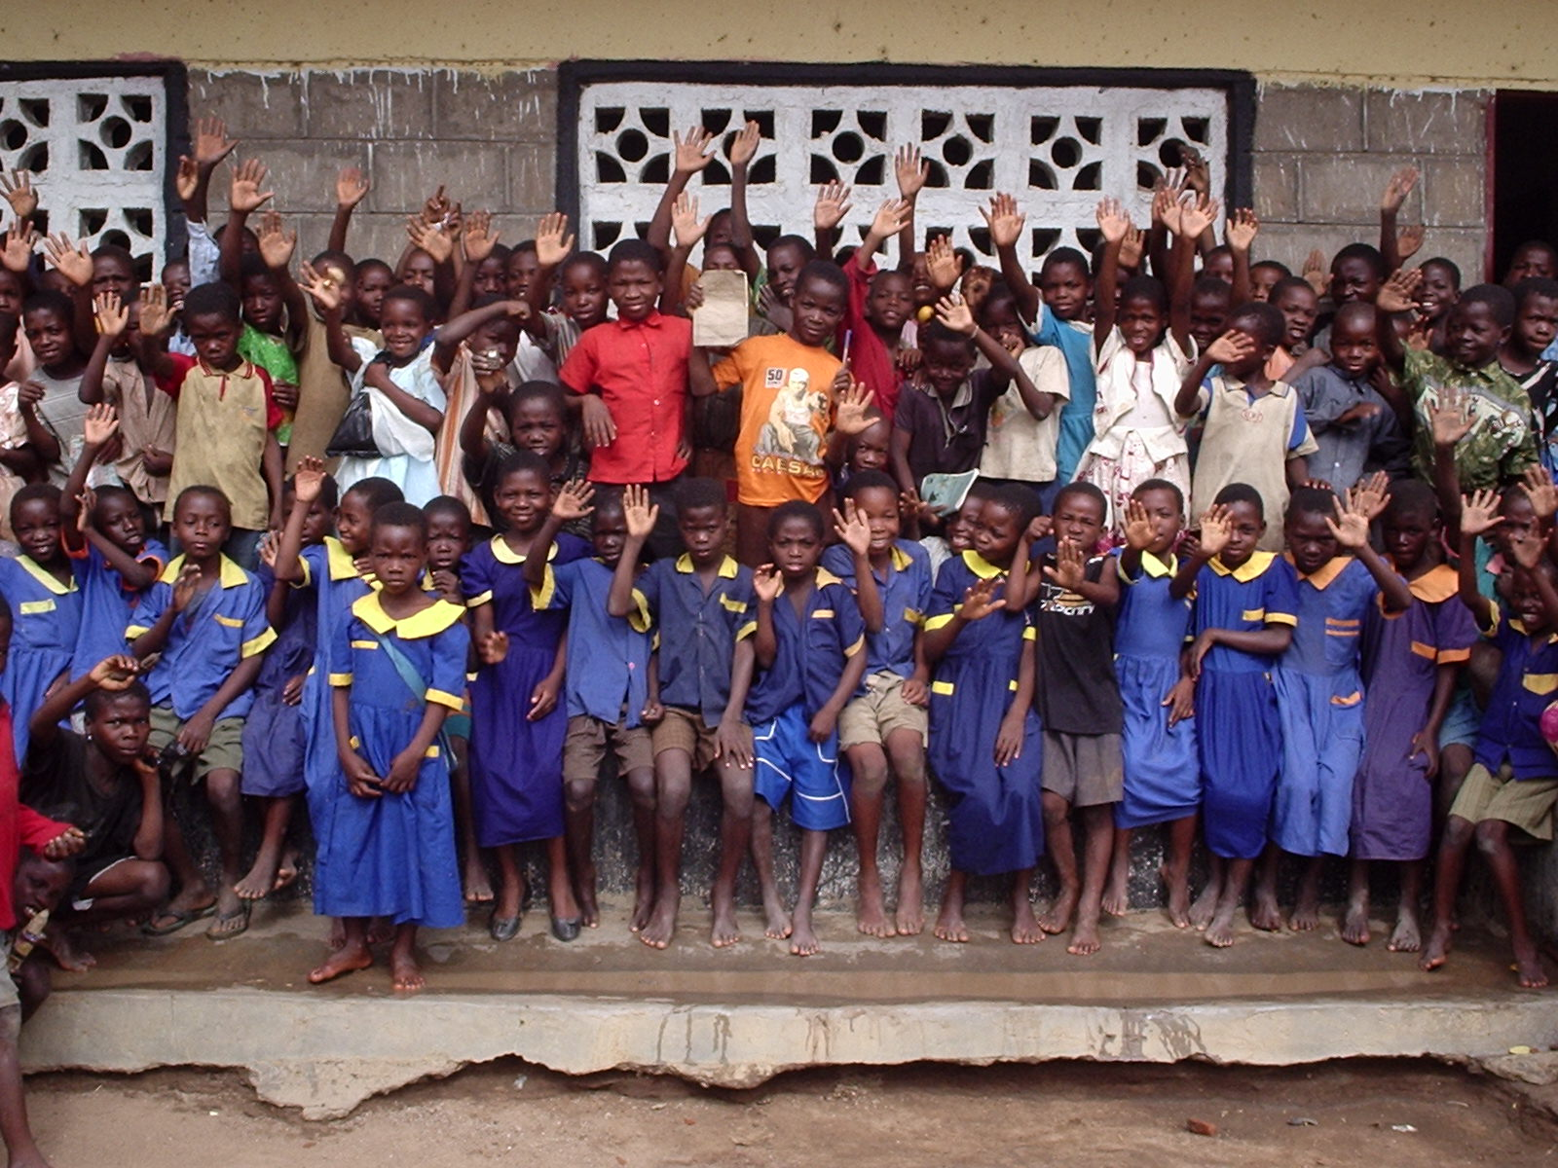

Mchoka Local Education Authority Primary School, P.O. Box 30, Chipoka Salima, Malawi. +2659431831
Email: starfish@africa-online.net

Mchoka Local Education Primary School is 23 km away from Salima District Assembly. The school was established by local chiefs.

Mchoka Primary School head teacher is Mr Sailes Yenga and the link coordinator is Mr Fredrick Manjano.

The school management comprises of the Staff, School Committee, PTA (Parents Teachers Association) then the District Education Manager.

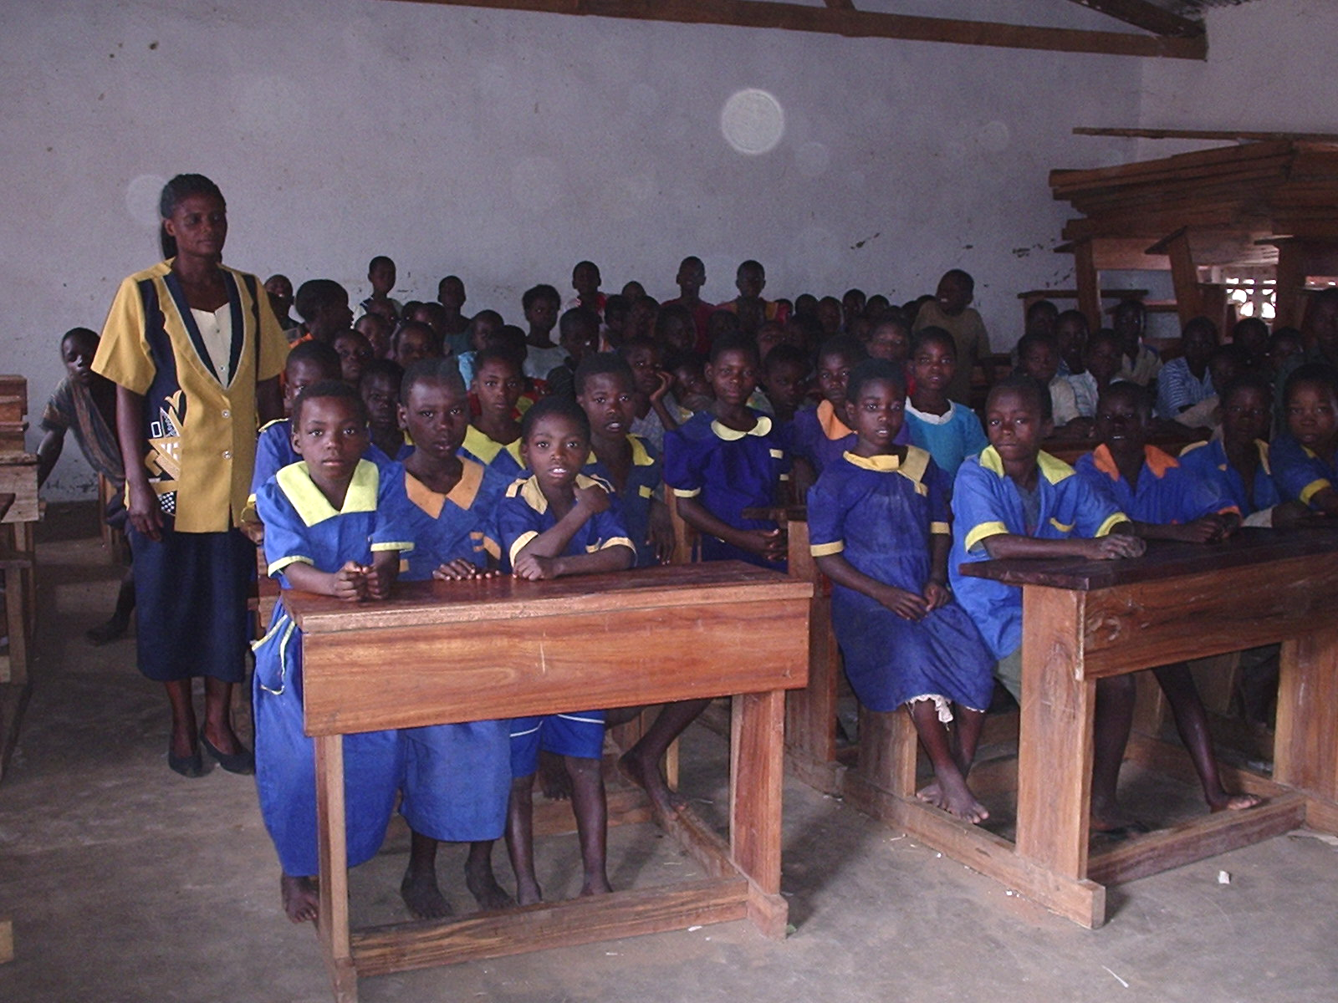

Standard 3 in class

Mchoka has 983 pupils in total who are in classes 1-8.
Classes have pupils as follows: Class 1 210 boys: 282 girls
Class 2 088 boys: 093 girls
Class 3 030 boys: 042 girls
Class 4 045 boys: 048 girls
Class 5 023 boys: 018 girls
Class 6 020 boys: 015 girls
Class 7 022 boys: 013 girls
Class 8 024 boys: 010 girls

The age range of the school is 6-16 because some children start going to school late or are repeating classes if they fail the end of year tests. However, this factor doesn’t disturb education system in Malawi. Primary education in Malawi is free but not compulsory; the drop out rate of the school is also high as you can see from the data form, enrolment declines sharply as we go into the senior classes especially for girls. There are several reasons that contribute to this like long distances children have to walk to school, overcrowding in classes and high pupil teacher ratio among others.

Mchoka School serves a distance of about 3 km in radius.

Like any other school in Malawi, Mchoka teaches subjects like, English, Maths, Religious Education, and General Studies. In classes 4 and above pupils begin to learn life skills this mostly concerns HIV/ AIDS, Agriculture, Science, Home Economics, Creative arts.

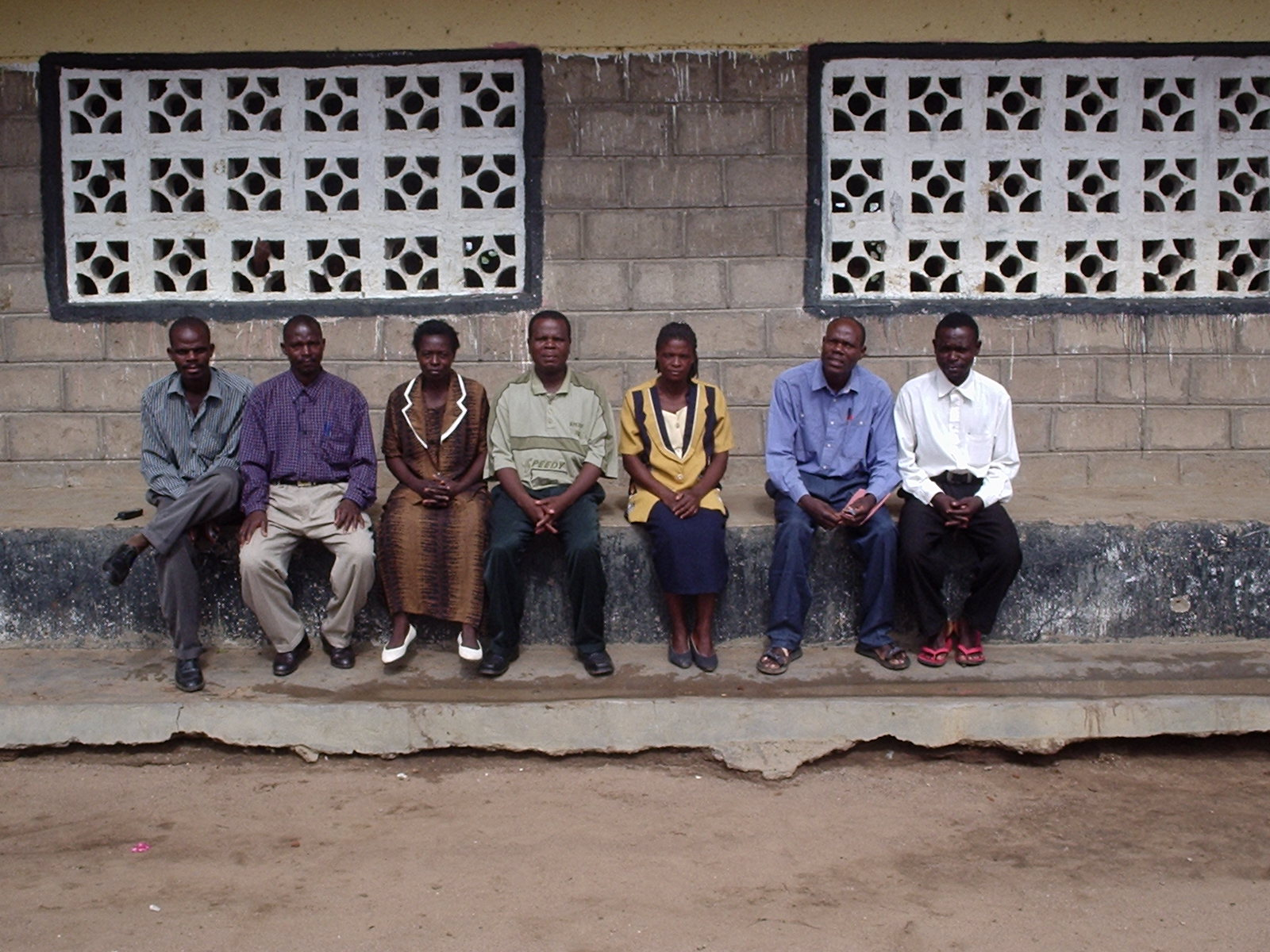

Fredrick Manjano (Nominee); Douglas Kamanga; Happiness Nyoni; Sailes Yenga (head teacher); Ethel D Msampha; Mupe Shumba; Levison B Kamwana

As a school, we want to be involved in the link so that we can learn from our friends in the UK especially in the developed countries. The link will greatly assist children to work hard so that they can be as their colleagues in the UK. Teachers will also be able to enhance their professional skills through dialogue and interaction with fellow teachers in the UK.

