
A partner of


PROFILE FOR CHIKOMBOLA SCHOOL

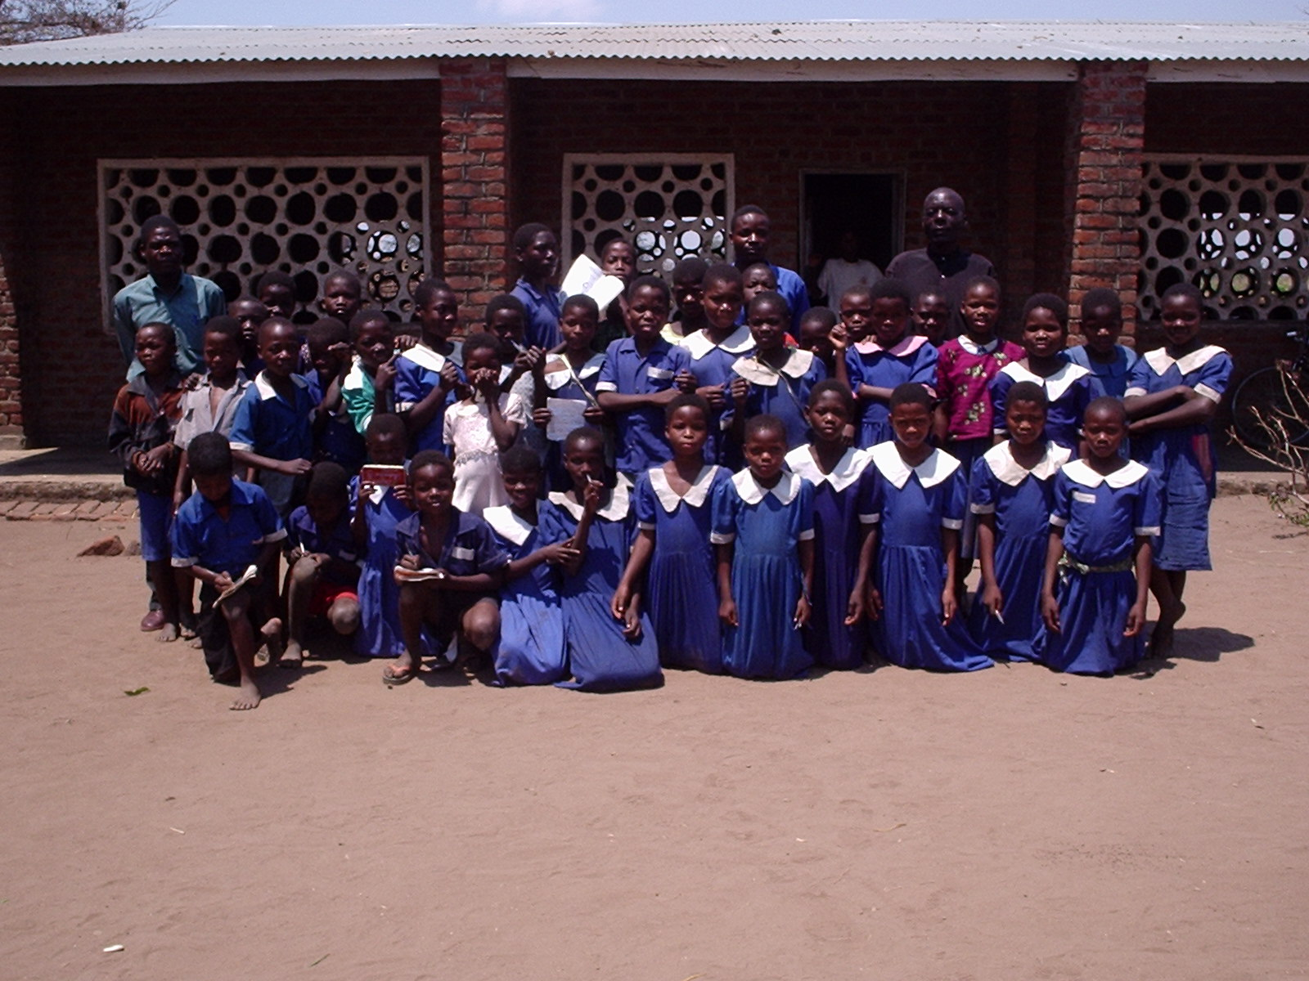
CHIKOMBOLA SCHOOL P.O. BOX 98 SALIMA MALAWI.

Chikombola Junior primary School is one of the JP’s (Junior Primary Schools) in Salima. It is 10 km away from the Salima Township and about 19km away north of Lake Malawi.

The school was established in 1998. The school has one block made of burnt bricks. This school block was built by MASAF (Malawi Social Action Fund). Besides this
, the school has uses an infrastructure made of grass and wood. The school management starts from the Head teacher, School Committee, PTA (Parents Teachers Association) then to the District Education Manager.

Chikombola School has 230 pupils in total who are in classes 1-4 only as compared to other schools which have classes 1-8.
Classes have students as follows: Class 1 41 boys: 39 girls
Class 2 30 boys: 32 girls
Class 3 20 boys: 30 girls
Class 4 20 boys: 18 girls
The age range of the school is 5-14 because some children start going to school late or are repeating. However, this factor doesn’t disturb education system in Malawi.

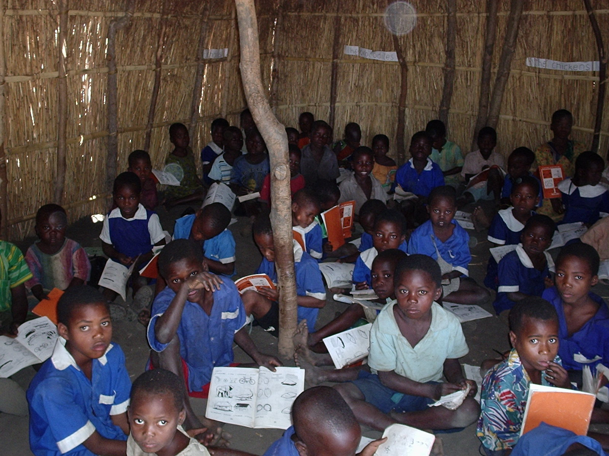
Standard 1 in class

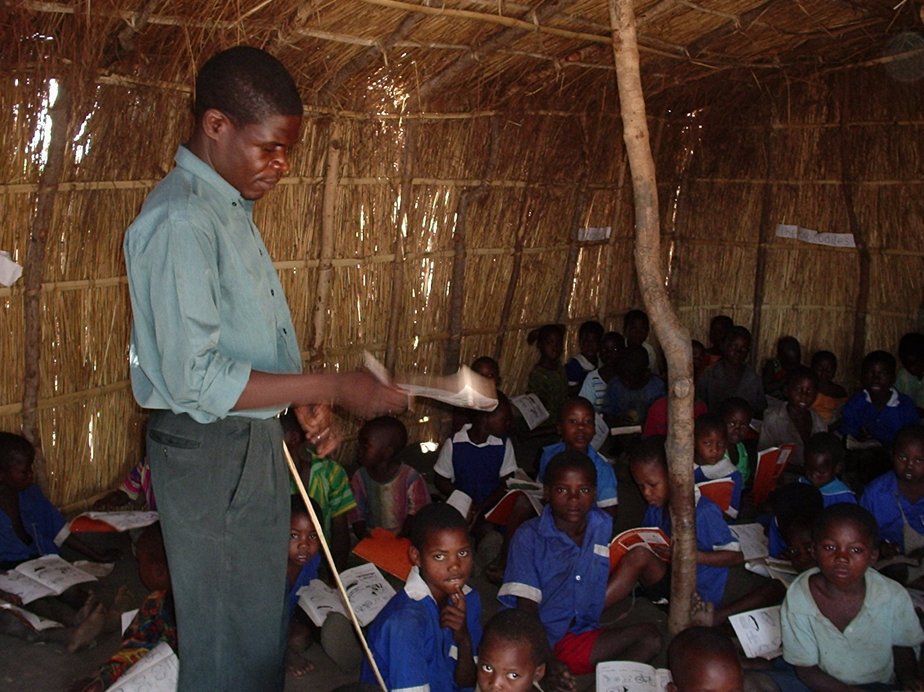

Like any other school in Malawi, Chikombola School teaches subjects like, English, Maths, Religious Education, General Studies. In classes 4 and above pupils begin to learn life skills this mostly concerns HIV/ AIDS. Most explanatory is in Chichewa since children can not understand English well. However, children may be capable to speak English as one reaches 6-8 i.e. in their senior primary classes.

Chikombola School hopes to do all classes from 1-8. The school drop out rate of the school is also high as you can see from the data form, enrolment declines sharply as we go into the senior classes especially for girls. There are several reasons that contribute to this like long distances children have to walk to school, overcrowding in classes and high pupil teacher ratio among others. By having classes 1-8 will reduce the distances which children travel.

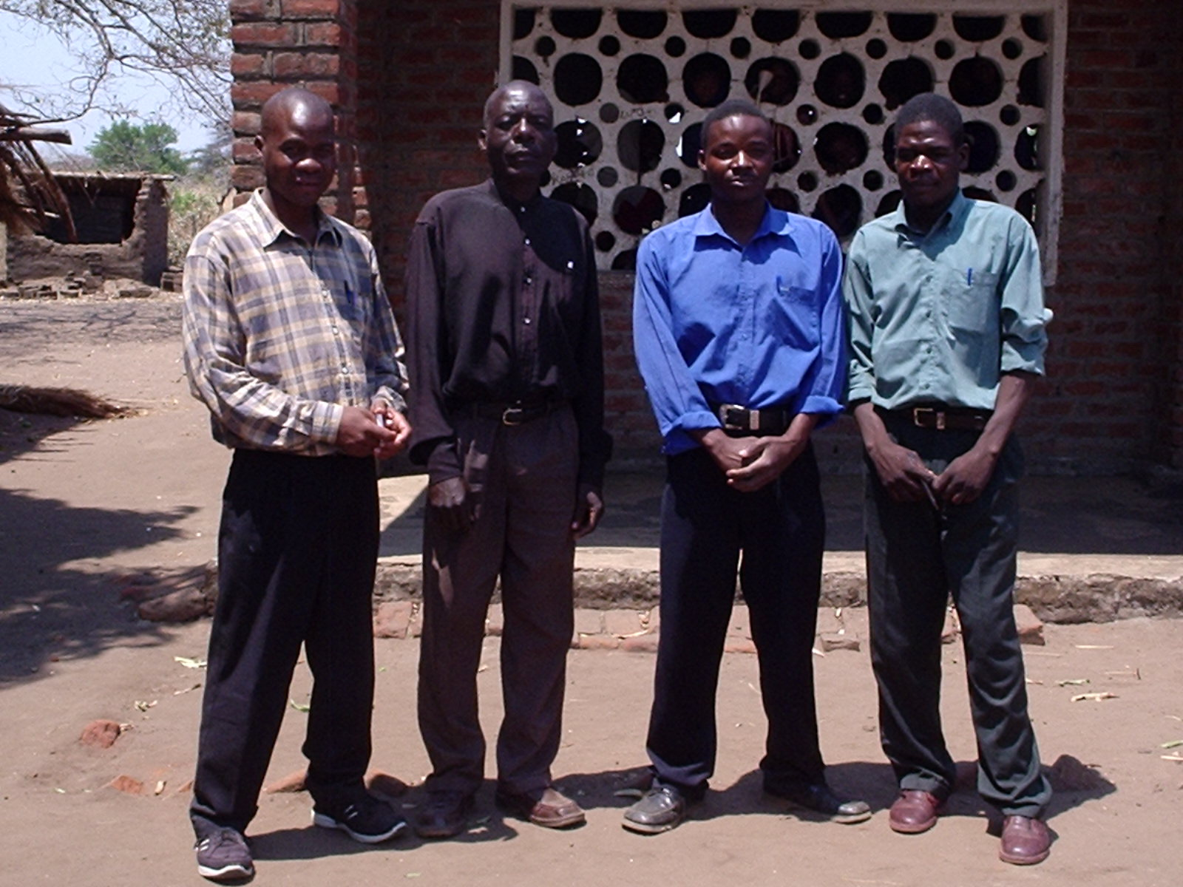
Left-right : Mr Mtembo K. Kokhwave, Bryson B. Loti, Mr Daniel Nkhoma, Mr Grant K Malata (Nominated Lead Contact)

As a school, we want to be involved in the link so that we can learn from our friends in the UK especially in the developed countries. The link will greatly assist children to work hard so that they can be as their colleagues in the UK. Teachers will also be able to enhance their professional skills through dialogue and interaction with fellow teachers in the UK.

