
A partner of


PROFILE FOR KAJENDERE PRIMARY SCHOOL

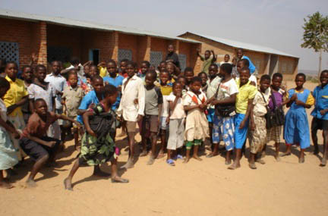

Address: P.O. Box 25, Chisemphere, Kasungu, Malawi

Head Teacher: Mr Bernie Kasinje

Total number of pupils: 460 boys: 245 girls: 215
Age range of school: 5-16

The school is in a located in the northern part of Kasungu district in Malawi. It is a government school but with a local school management committee that assists the Headteacher on the day to day running of the school. The whole school management structure consists of the School Committee, PTA (Parents Teachers Association) then on professional matters the Head teacher reports to the District Education Manager.
Like any other primary school in Malawi, Kajendere School teaches subjects like, English, Maths, Religious Education, General Studies, Agriculture Home economics and Science.

A normal school Day starts quite early and is as follows:

7:00 - 7:30 Pupils clean their classrooms and the surroundings
7:30 - 9:15 lessons start
9:15 - 9:25 break
9:25 - 11:10 lessons
11:10 - 11:20 break
11:20 - 13:05 lessons end
14:30 - 15:00 extra curriculum activities (playing football, athletics) after which children go home (extra curricula activities take place once or twice a week)

The School hopes that the link to a UK school will:

- Enable the sharing of experiences about education between linked schools
- The link will greatly assist children to understand the wider world after learning about life of their colleagues in the UK.
- Teachers will also be able to enhance their professional skills through dialogue and interaction with fellow teachers in the UK.

Some of the teachers in the school L-R: Griffin W. Jere, Zonde Chifundo, Joel Dokowe, Samson Banda

