
A partner of
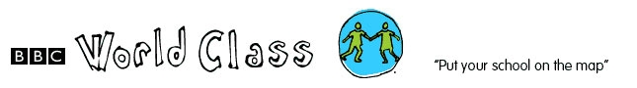

PROFILE FOR CHILUWA 2 PRIMARY SCHOOL

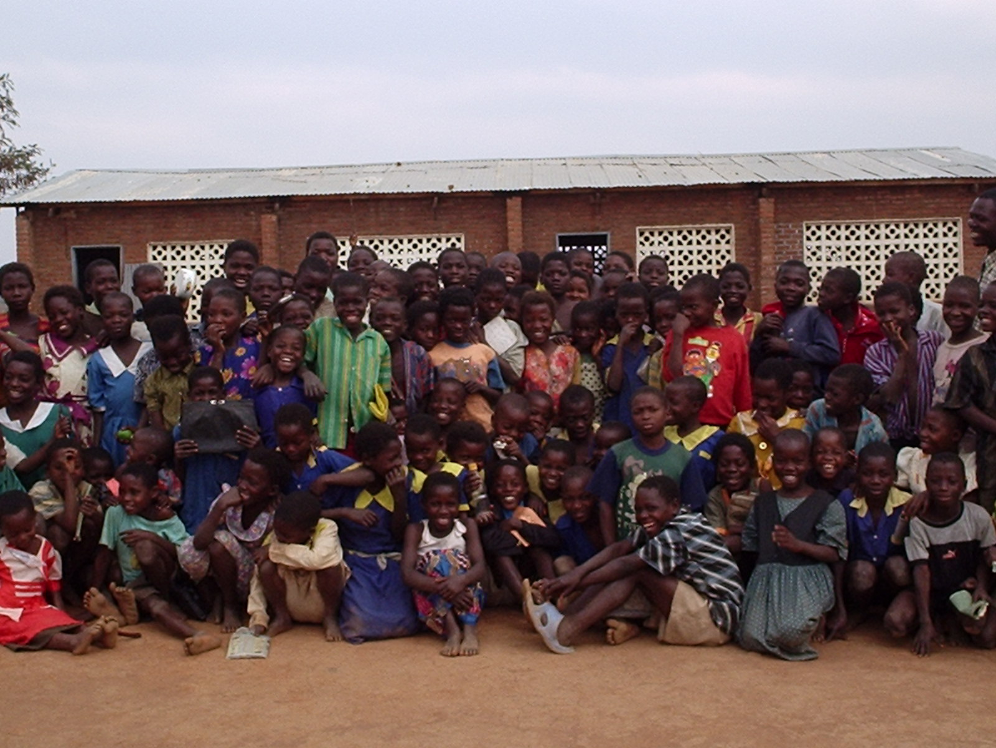

Chiluwa2 F.P. School, PA Thavite, Salima, Malawi. +265 9185998.
Email: starfish@africa-online.net

Chiluwa 2 Full Primary School is 49 km away from Salima District Assembly.

The school was established in 1983 under Church of Central Africa Presbyterian. The school management starts from the School Committee, PTA (Parents Teachers Association) then to the District Education Manager. The school however is a governmental school despite being established by the CCAP.

Chiluwa 2 School has 479 pupils in total who are in classes 1-8.
Classes have students as follows:
Class 1 58 boys: 46 girls
Class 2 43 boys: 48 girls
Class 3 28 boys: 16 girls
Class 4 34 boys: 41 girls
Class 5 14 boys: 17girls
Class 6 14boys: 21girls
Class 7 29 boys: 18 girls
Class 8 34 boys: 24 girls

The age range of the school is 6-18 because some children start going to school late or are repeating. However, this factor doesn’t disturb education system in Malawi.
Chiluwa 2 School serves a distance of about 6 km in radius which is comprised of 19 villages.

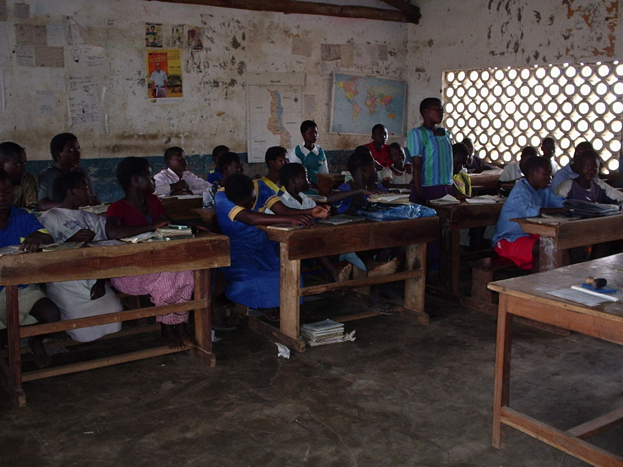Standard 7 in Agriculture lesson.

Like any other school in Malawi, Chiluwa School teaches subjects like, English, Maths, Religious Education, and General Studies. In classes 4 and above pupils begin to learn life skills this mostly concerns HIV/ AIDS, Agriculture, Science, Home Economics, Creative arts. Most teaching is in Chichewa since children can not understand English well in standards 1-4. However, children may be capable to speak English as one reaches 6-8 i.e. in their senior primary classes.

Chiluwa School has a dream of completing the projects which the government failed to complete. Further more the school is struggling to find ways of having more children back to school. Despite all these, the school produces a good pass rate for the children who sit for their Primary School Leaving Examinations. The communities surrounding the school moulded several bricks which are burnt ready to maintain existing old school blocks.
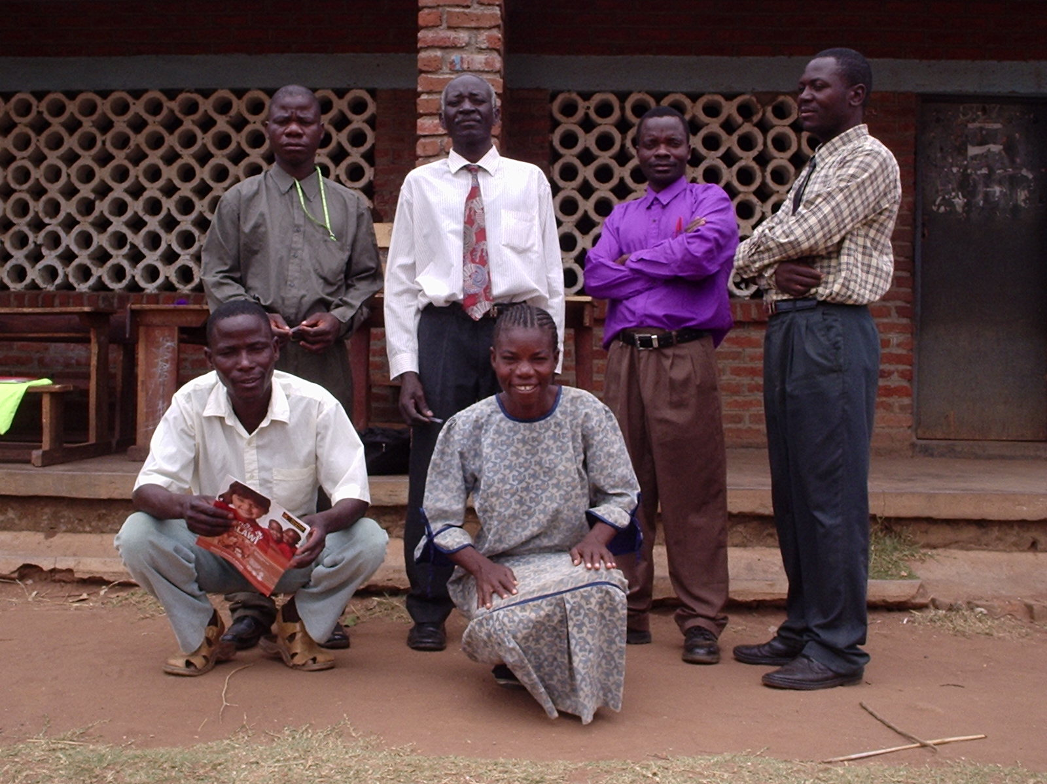
Backrow: L-R Mr Davison Chinyama, Mr Ernest M Thindwa (Head Teacher), Mr Richard Msulira, Mr Enos Kwindanguwo.
Squatting: Mr Paul Banda, Mrs Mirriam C. Makunganya

The school has 6 teachers, 1 female teacher and 5 male teachers.

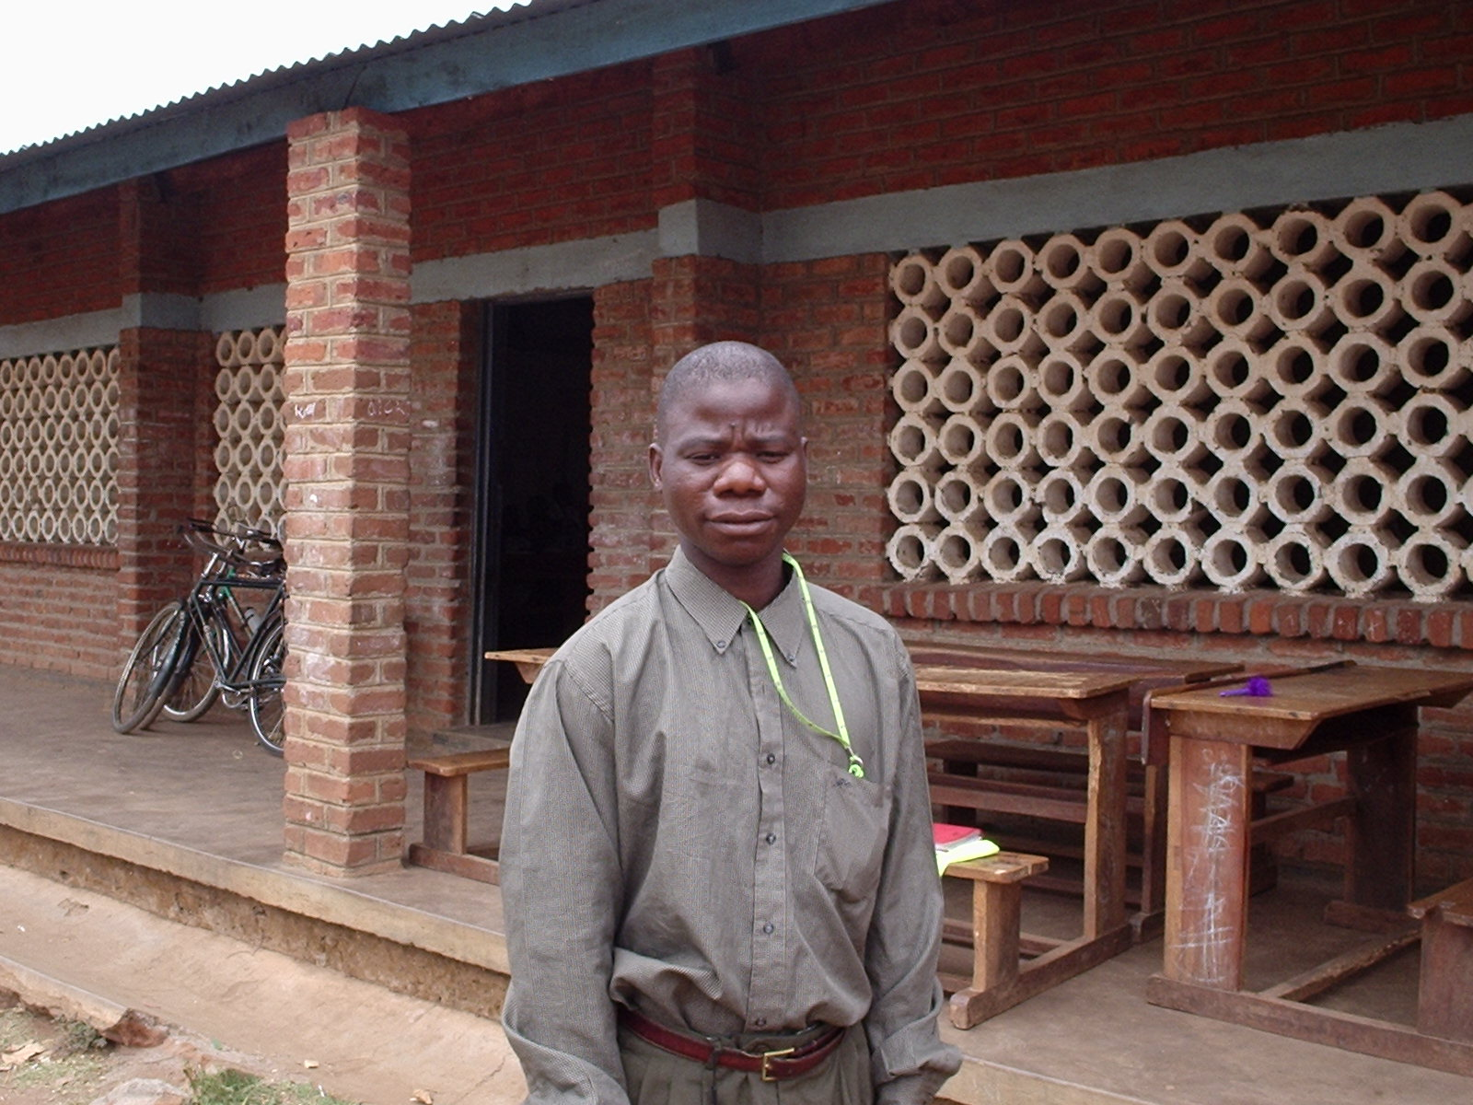
Mr Davison Chinyama (Nominated lead contact for the link)

As a school, we want to be involved in the link so that we can learn from our friends in the UK especially in the developed countries. The link will greatly assist children to work hard so that they can be as their colleagues in the UK. Teachers will also be able to enhance their professional skills through dialogue and interaction with fellow teachers in the UK.

