
A partner of
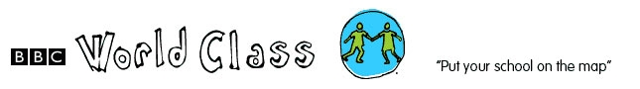

PROFILE FOR MSALURA COMMUNITY DAY SECONDARY SCHOOL

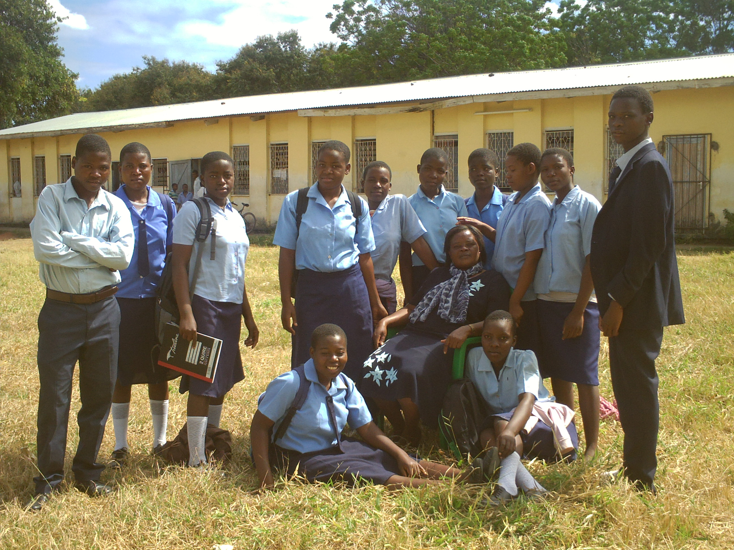

MSALURA CDSS P.O. BOX 447 Salima, Malawi. +265 111 262 22

Msalura Community Secondary School, formerly Salima District Education Centre was established in 19. The School is 1.5 km away from Salima District Township and 25 Km away from Lake Malawi. Before, the school used to have a boarding facility for both boys and girls across Salima District.

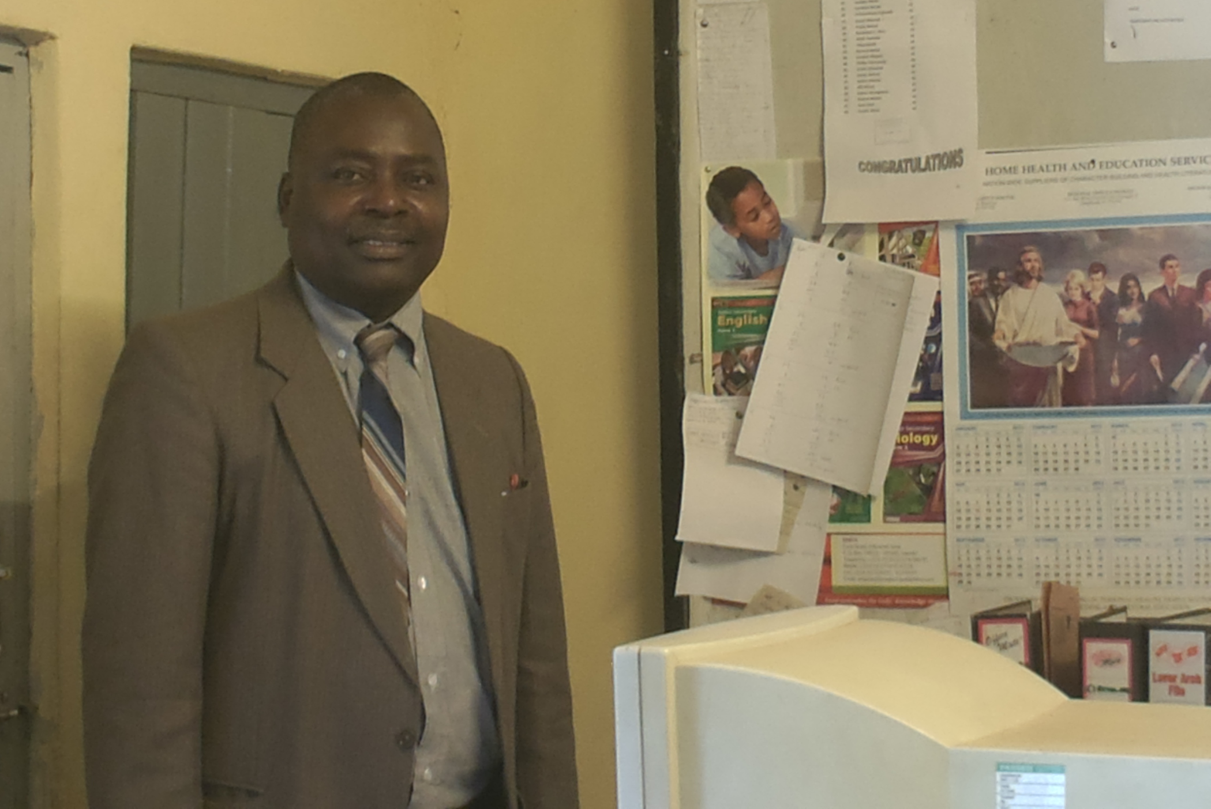

Mr Denis Kakolo is the head master for the school of 24 teachers of which 9 are female and 15 male teachers.

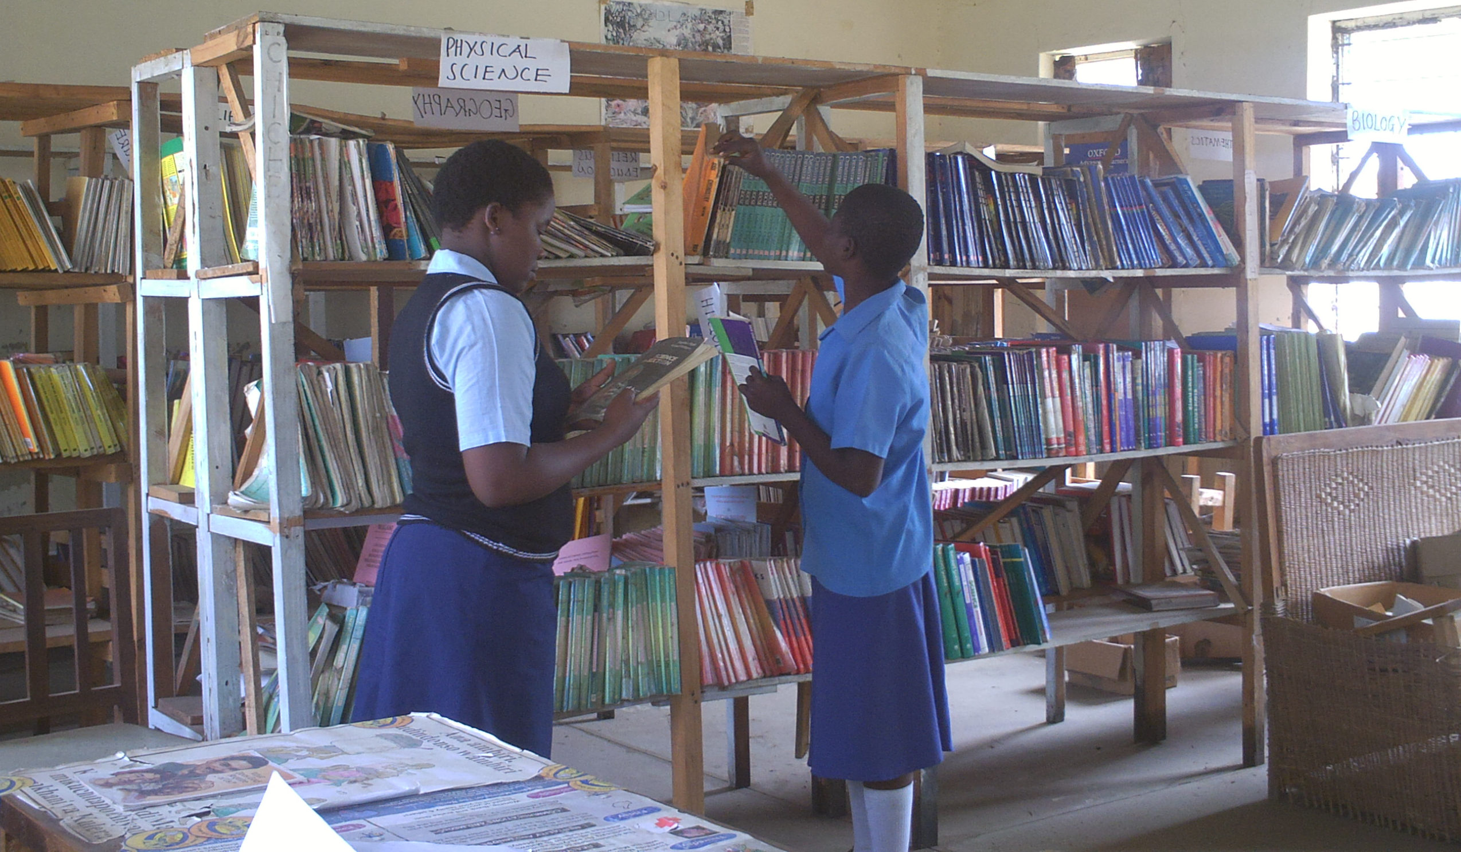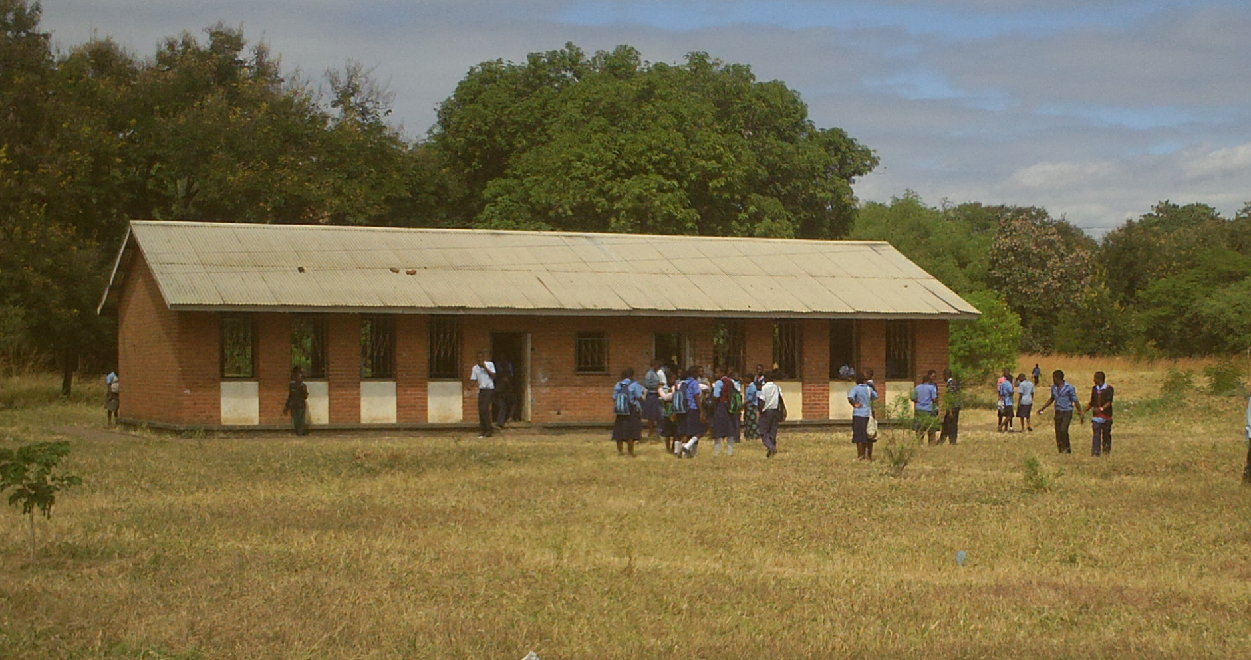
Girls in library Students during break

Msalura is a school for both boys and girls. There is no boarding facility in the school such that students walk or cycle to school. However some of the teachers live in school campus.
The school has years 1-4 i.e. form one to four. Students that come to Msalura CDSS come from other linked Primary School under Starfish Malawi.

Subjects taught at Msalura CDSS are English, Maths, Chichewa, Geography, Physical Science, Geography, Social Studies, Commerce and Computer Studies.



