In association with

School Profile by
CHIMWETA PRIMARY SCHOOL

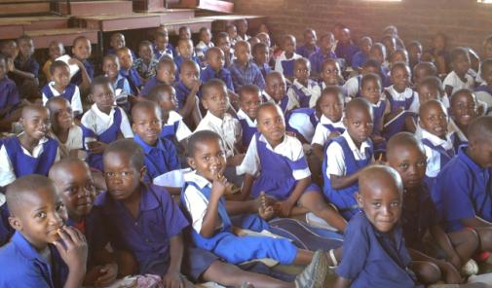

Chimweta Model Primary School was established in the year 2000 as a model school around the Salima District.
As a model school, Chimweta has been having very good results over the years such that learners surrounding the school and nearby places have been coming to attend school. This resulted in having large numbers in school.

The school has 1782 learners. Among these learners, 918 are girls and 864 boys.
Chimweta’s age range is 6-14 years.

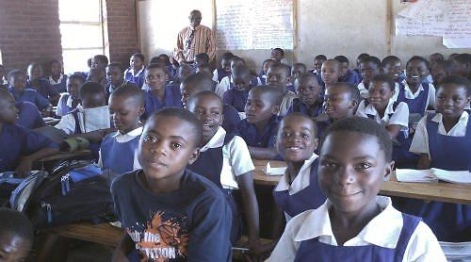
Mr Bakali and standard seven class.

Learners walk to school while others do cycle when coming to school. Very few of them come by vehicles owned by their parents.

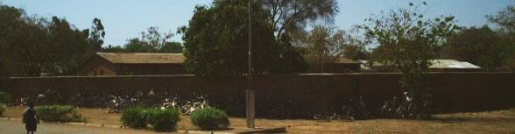

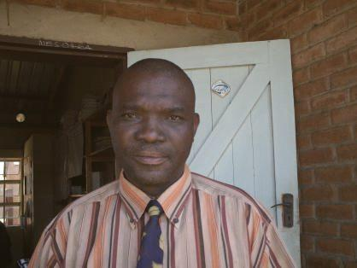

The school’s head teacher is Mr Fred Bakali.

He was transferred to this school following underperformance of the model school in the previous two years. Mr Bakali’s new role in school is to make sure that the school produces results that are convincing as a model school. He came from a school that was performing badly. When Starfish started to build classrooms, teachers’ houses and introducing a feeding programme, the school’s performance improved greatly. A few years later Mr Bakali was appointed head of the head teachers in the zone.
Among other duties, he supervises the teachers as assessing the performance of the learners. He further teaches some of the subjects as Maths and Primary Science

Chimweta school has 24 qualified teachers of which 8 are male teachers one of the teachers is Mrs Mahwayo who is teaching standard 2.

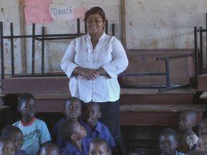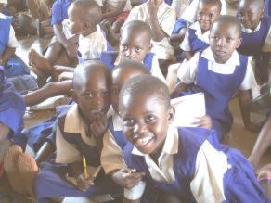

Mrs Mahwayo and her standard 2 Class, This class has an age range of 5-6 years.

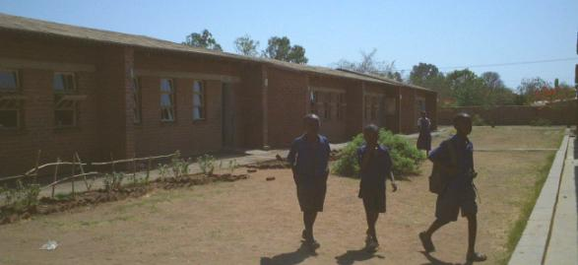

Subjects taught in school are English, Maths, Bible Knowledge, Religious Education, Social Studies, Primary science, Agriculture, Expressive Arts among others.

Among others the school will be engaging in harvesting rain water which will be used to watering the school garden as an eco-project as well as teaching learners where food comes from especially children who are coming from families that do not have fields.
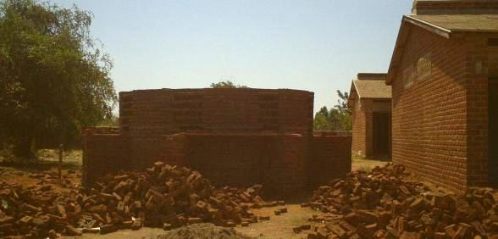Rain bank at Chimweta in progress

Furthermore the school has an orchard that they would like to introduce composting in their lessons of Agriculture.
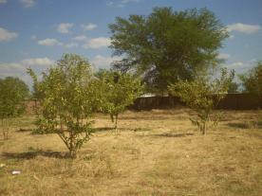

Schools Orchard

The school hope to learn from the UK school on similar projects and share the curriculum.

