MTIYA PRIMARY SCHOOL

END OF ACADEMIC YEAR NEWS

Dear friends at Horsted,

It has been a very good year at Mtiya. We ended our school year very well with large numbers of learners passing their examinations.

We opened the school term o 21st April 2014. Learners came in large numbers over the just ended term.

We introduced reading camps in communities where we had identified that there were learners who were unable to read and write. These camps were within the communities around our school. This activity was supported by EGRA (Early Grade Reading Activities). We targeted standards one to three.
In communities volunteers were taught how to deal with such cases in their communities such that books were provided for learners to use in their reading camps.

On top of the reading camps, we had an open day of education that took place at Chipoka I. Our learners participated and displayed activities like dances, skills as well as competing in reading. Four of our learners were given a gift of ten thousand Kwacha by a parliamentary member of our area who was a guest of honour.

ECO PROJECTS

We had an ECO training whereby teachers and four learners attended the training. Among other things, we learnt about the environment and how can care of our environment that keeps on degrading every year. There is a great need for our school to engage the community as they play a vital role in upbringing of children in their homes. If parents are informed of activities that Mtiya school is doing, we will stand very good chances of working with communities around us.
We chose an ECO committee for our school and below are the names of the committee members. In our next newsletter, you will be informed of the roles of the new committee.
Chairperson: Shadreck Bester
Vice: Melia Kamunde
Secretary: Memory Jawadu
Vice: Falidu Rabson
Treasurer: Lunifa Kachingwe
Over the term, we begun some papier marché where we made teaching and learning materials with the litter we had from school.
It was an interesting activity that the participants enjoyed. They made some alphabetical letters and various things:

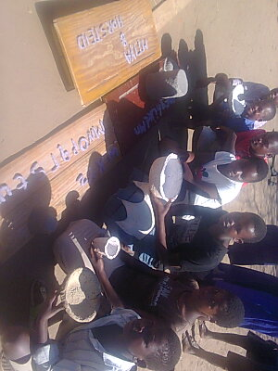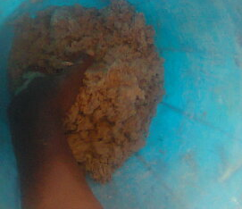
Pupils displaying what they made Left: Paper Marché being mixed
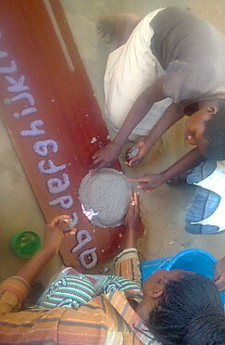

A teacher instructing learners how to make things with paper marché
We successfully had a cassava garden that was well fenced from goats and cattle roaming around the school. We chose the crop as it is drought resistant. Soon we will be selling the product to raise funds for general school needs.
We have prepared a new garden to grow vegetables when we open schools in September.
We had difficulties with our tree seedlings that were eaten by termites making our efforts to have more trees on campus a difficult venture. We will now be looking at growing trees that are not easily attacked by termites.

Sports:
We had games against Chipoka II that is linked to Brunswick house on 14 June and we had the following results:
Football Mtiya 2 Chipoka II 2
Netball Mtiya 19 Chipoka II 19

21 June Mtiya vs Chipoka I
Football 3 2
Netball 8 7

5 July Mtiya against Kambiri
Football 2 2
Netball 9 7

We wish you the very best as you start your new academic year!!!!!!

