

A partner of


PROFILE FOR CHIPOKA 2 JUNIOR PRIMARY SCHOOL

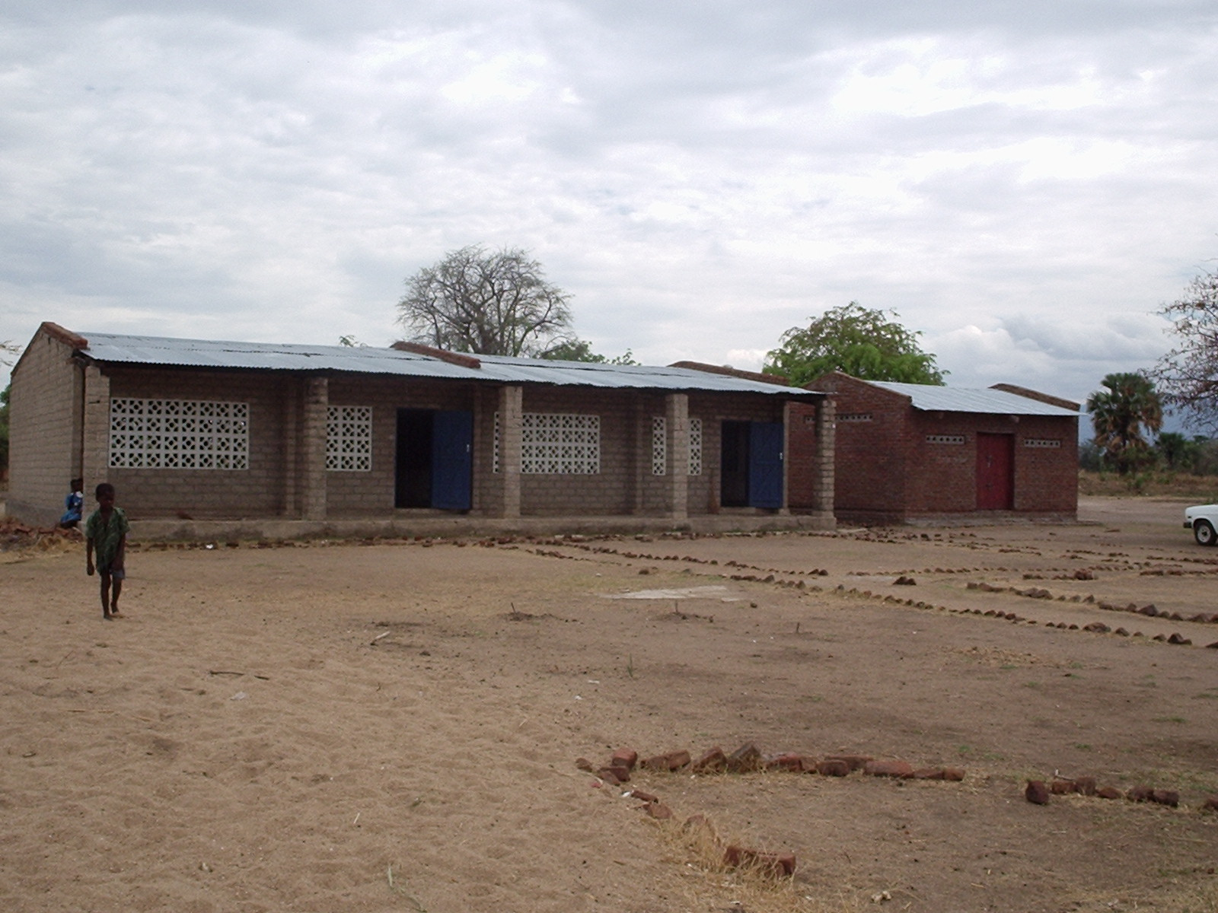

Chipoka 2 Local Education Authority (LEA) Primary School, Box 10, Chipoka, Salima, Malawi. +2659211111
Email: starfish@africa-online.net

Chipoka 2 L.E.A. Primary School is 32 km away from Salima District Township and 500 yards away from Lake Malawi.

The school was established in 2000 under Roman Catholic. Children used to walk long distances to find a school in the area before this was established.
The school management consists of the School Committee, PTA (Parents Teachers Association) then to the District Education Manager. The school however is now run by the governmental despite being established by the Roman Catholic Church.
Chipoka 2 School has 729 pupils in total who are in classes 1-6 only.
Classes have pupils as follows: Class 1 138 boys: 176 girls
Class 2 054 boys: 045 girls
Class 3 045 boys: 052 girls
Class 4 039 boys: 050 girls
Class 5 030 boys: 030 girls
Class 6 035 boys: 035 girls

The age range of the school is 6-17 because some children start going to school late or are repeat classes if they fail the end of year tests. Primary education in Malawi is free but not compulsory; the school drop out rate of the school is also high as you can see from the data form, enrolment declines sharply as we go into the senior classes especially for girls. There are several reasons that contribute to this like long distances children have to walk to school, overcrowding in classes and high pupil teacher ratio among others.

Chipoka 2 School serves a distance of about 2 km in radius.

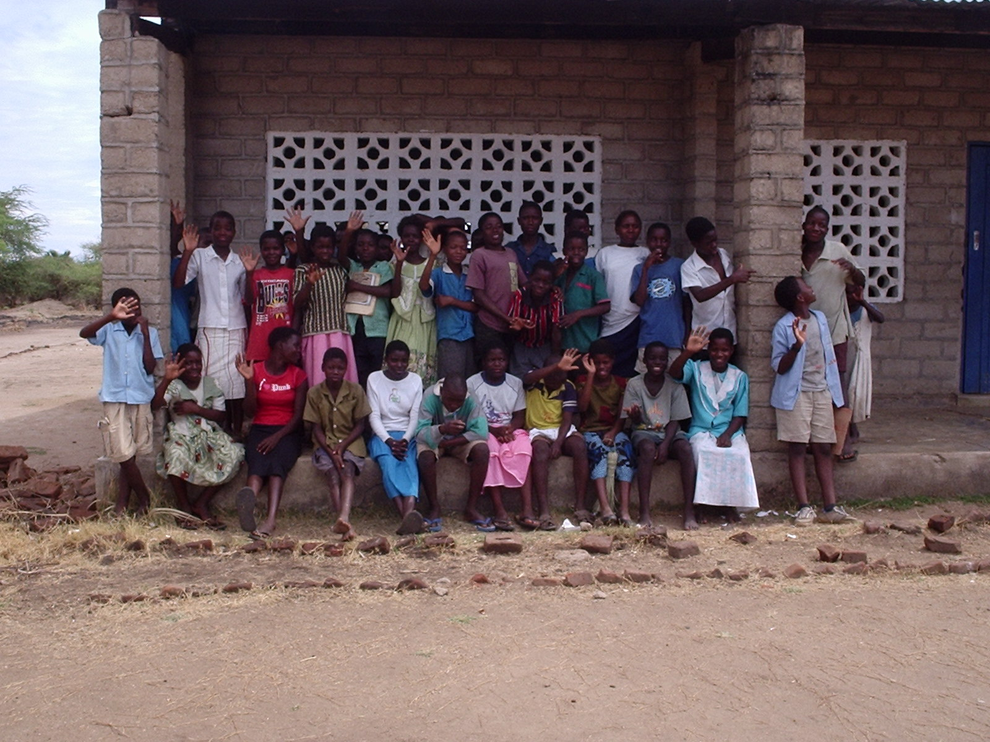
Children at break

Like any other school in Malawi, Chipoka 2 School teaches subjects like, English, Maths, Religious Education, and General Studies. In classes 4 and above pupils begin to learn life skills this mostly concerns HIV/ AIDS, Agriculture, Science, Home Economics, Creative arts. Most teaching is in Chichewa since children can not understand English well in standard 1-4. However, children may be capable to speak English as one reaches 5-8 i.e. in their senior primary classes.

Chipoka LEA School has a dream to have adequate classes and a library as well in order to offer quality education to the pupils.
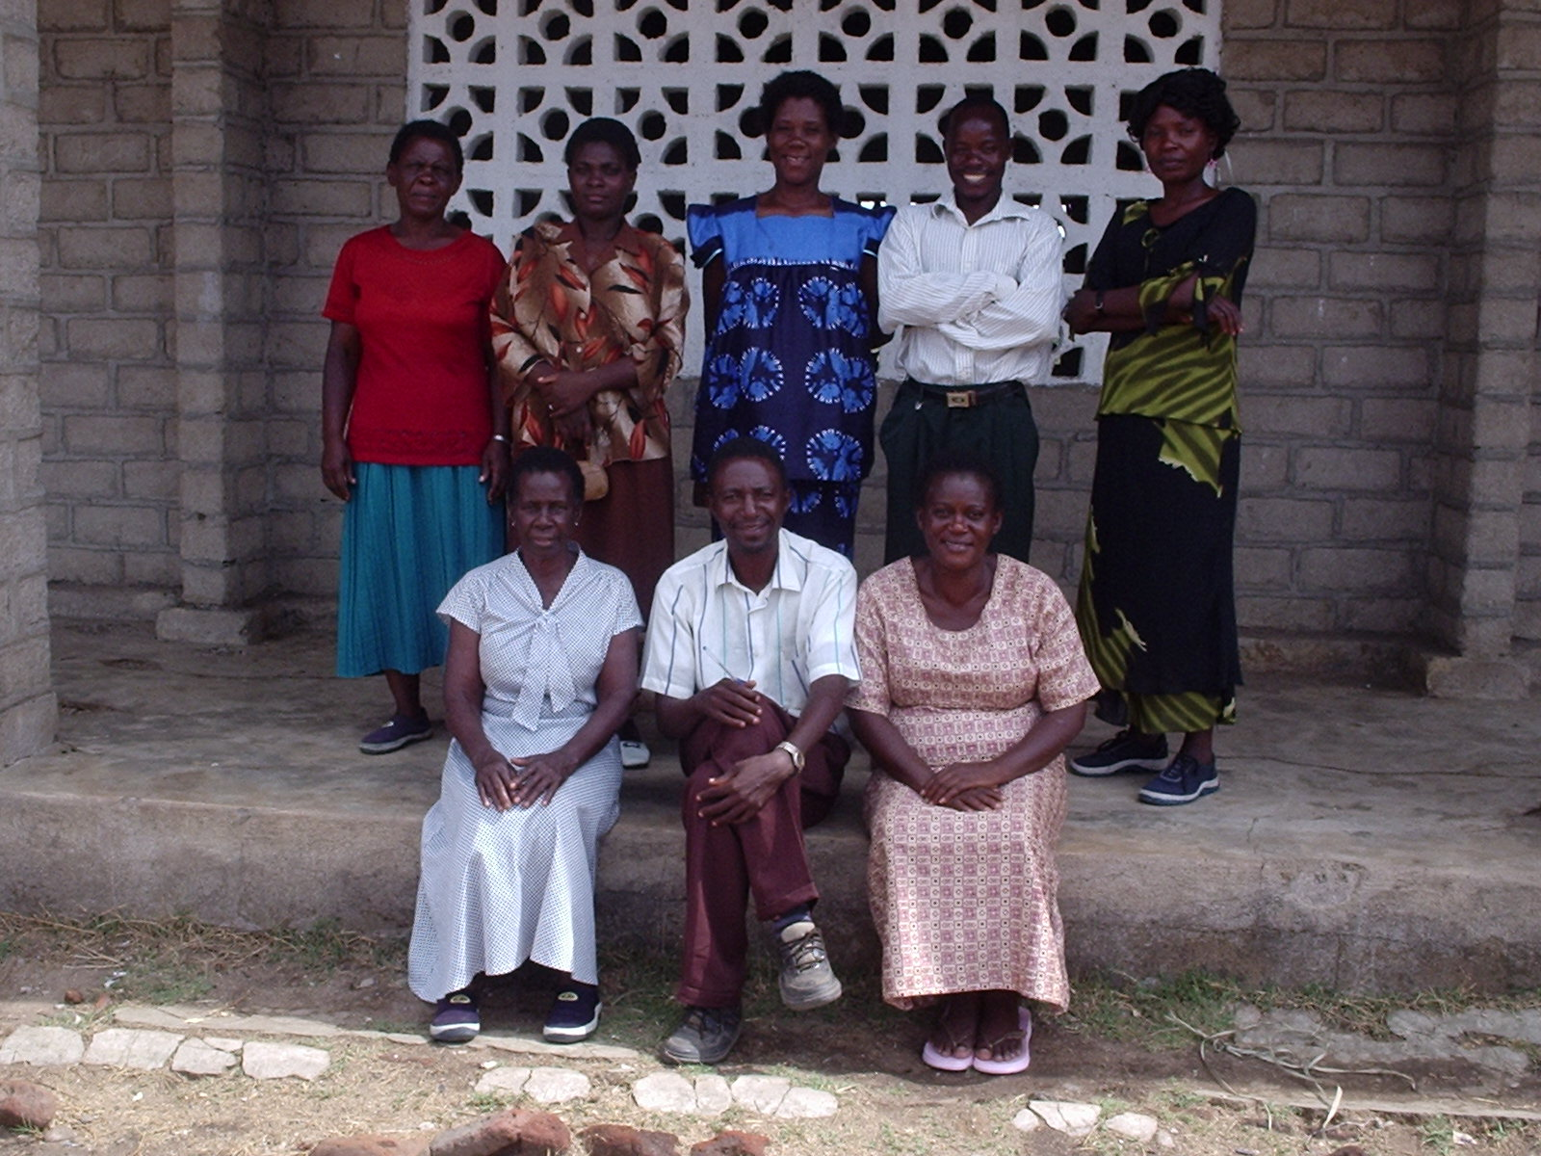

Chipoka2 school staff:
Sitting left to right: Mrs Catherine L Chapema, Lorent K.N. Mthobwa (Head teacher), Rose Chiwaula
Back row left-right: Lucy Mwase, Omega Nkhandwe, Martha Lunga (Deputy head teacher, Ronnex N.J. Yobu, Mary Gama

The school has 7teachers, 5 female teachers and 2 male teachers.

As a school, we want to be involved in the link so that we can learn from our friends in the UK especially in the developed countries. The link will greatly assist children to work hard so that they can be as their colleagues in the UK. Teachers will also be able to enhance their professional skills through dialogue and interaction with fellow teachers in the UK.

