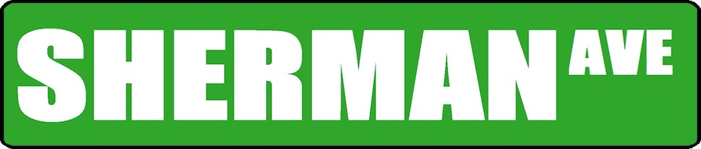

Earl Grey/Boris Yeltsin

May Heinous

Champions

F. Nightingale/

Pope John Paul II

C. Darwin/Khomeini

K. Chopin/Idi-Amin

General Patton/Al Gore

J. Austen/A. Hitler

G. McClellan/M. Sanger

Sacagawea/Hannibal

A. Warhol/J. Kerouac

Napoleon/Columbus

M. Luther/Tubman

Bismarck/De Gaulle

N. Mandela/G. Wallace

Shakespeare/Sarte

Aristotle/Emperor Nero

Tsar Catherine/H. Cortes

F. Franco/S. Milosevic

J. Polk/P. Picasso

I. Newton/Leopold II

T. Marshall/J. McCain

Churchill/F. Kahlo

E. Hemingway/T. Roosevelt

L. Trotsky/Sally Hemmings

Gandhi/Sitting Bull

Da Vinci/Peter the Great

F. Nietzsche/G. Khan

Custer/N. Chamberlain

J. Edgar Hoover/Cleopatra

**Pabst Blue Ribbon Division**

**Miller Genuine Draft Division**

**Keystone Light Division**

**Busch Light Division**

Malcolm X/Mao Tse Tung

WH Harrison/Queen Victoria

Helen Keller/Sun-Tzu

Hammurabi/Audobon