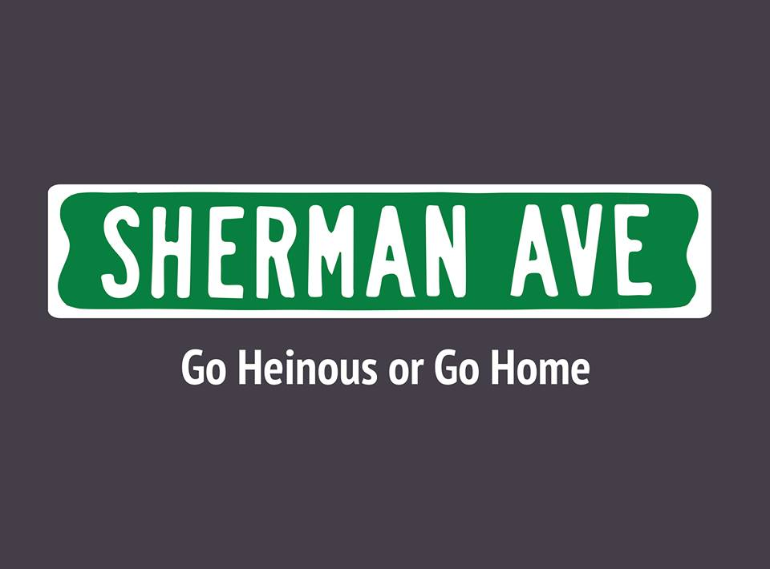
Application due by
5:00 PM on
Saturday, October 10th
Please export all written application, short answer, and prompt responses onto one PDF or Microsoft Word document file to attach in an email with the subject “[Name]’s Sherman Ave Application”
Submit your finished application and any questions/concerns to shermanave1@gmail.com

Name:
Year:
School*:
Major(s)/Minor(s):
Hometown:
Phone Number:
Special Talents:
*You do NOT have to attend Northwestern University to write for Sherman Ave.

1) In 180 characters or fewer, tell your dog you have six months to live. You have six months to live, not the dog.

2) Which state would you remove from the union? Explain.

3) “How odd I can have all this inside me and to you it’s just words.”
-David Foster Wallace
What is inside you?

4) Pitch us a reality TV show.

5) Fire Donald Trump.

6) In two to six sentences, explain why you want to be a part of Sherman Ave.

7) Write three headlines for Sherman Ave.

DO BOTH OF THESE

Prompt 1: Write an article about anything you want. (It can be one of those headlines you just wrote.) (Max 500 words)

Prompt 2: Write an article about a current event. Here are some examples of relevant topics, but feel free to think of your own.
- Classes Starting
- Halloween
- Homecoming
- Pope’s visit to the U.S.
- Presidential Race (No Trump. Please.)
- Northwestern Football
- MLB Playoffs
- McDonalds All Day Breakfast
- Nickelodeon Bringing Back 90s Programming
- Any other current event

