L


isa Mozzini-McDill

Fine Art klazs@aol.com

Artist Statement:
Creating artwork that is realistic but loose, expressive as well as meaningful is an ongoing endeavor. What I think about when painting is emphasizing an exciting play of light and shadow, an interesting composition, and enhancing a scene that evokes a deeper meaning or emotion in me. It is my intent that this depth and emotion I feel will also be communicated and resonates with the viewer.

Education:
Lisa Mozzini-McDill graduated from San Diego State University with Honors, Distinction in Art and a BA in Graphic Communications. She worked as a graphic artist, illustrator, and portrait artist for over 10 years in San Diego. Today she works primarily in oil on plein air landscapes, larger studio work and commissioned portraits. In addition to teaching in her studio and en plein air she demonstrates for various art groups. Lisa has continued her education with workshops by Elizabeth Tolley, John Budicin, Ken Auster, Michael Obermeyer and Joseph Todorovitch. She has been published in Orange County's Best magazine and was featured in the artist's spotlight of The Press-Enterprise, July 14, 2008.

Awards:
2013 Gallery Award, Less Is More, LPAPA
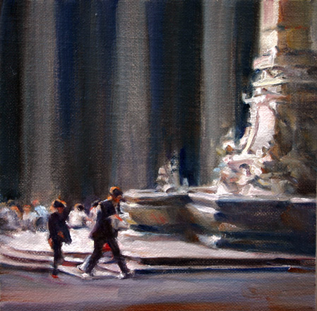
2013 OPA Salon Show of Traditional Oils
2012 Art Renewal Center International Salon Finalist
2012 Hon. Ment., Paint the Lake, Mountain Arts Network
2012 Hon. Ment., SoCalPAPA Paints Back Bay
2011 First Place Winner of Golden Frame Contest
2011 Chapter Winner, San Clemente City Art & Logo Contest
2011 Hon. Ment., California Impressionists, SoCalPAPA
2010 Third Place, Aquatics Show, SoCalPAPA
2010 Award of Merit, Small Works, Brandon Gallery
2010 Hon. Ment., Paint San Clemente
2010 Top Dog, The Riverside Art Museum
2010 Second Place, Pomona Valley Art Association
2010 First Place/Plein Air, FAA Open Juried Show
2010 Product Prize, RAA Multi Media Mini Show
2009 Juror’s Choice, Eternal Light, California Art Club
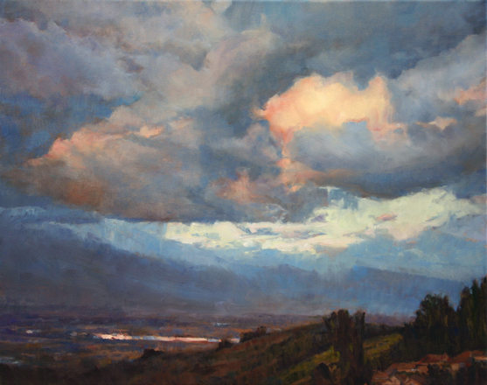
2009 Hon. Ment., Professnl. Category, SoCalArtists
2009 Hon. Ment., Dominick Frascella Show
2009 Hon. Ment., FAA Open Juried Show
2008 Top Dog, The Riverside Art Museum
2008 Third Place, The San Diego Fair
2008 Dean Myers Plein Air Award, FAA
2008 Hon. Ment., Maloof Foundation
2008 Hon. Ment., National Orange Show
2008 Hon. Ment., FAA Open Juried Show
2007 Best of Show, Temecula Valley Art League
2007 Third Place, Le Petit Icon, Escondido
2006 Dorothy Stillens Plein Air Award, FAA
2006 2nd place, Fallbrook’s Joyful Traditions
1981 B of A Achievement Award in Fine Art

Representation:
The Lake House, 909-337-7676 / Artisan Gallery, Mission Viejo Country Club, 949-582-1550

www.lisamozzini-mcdill.com / Portraits / Landscapes / Instruction

