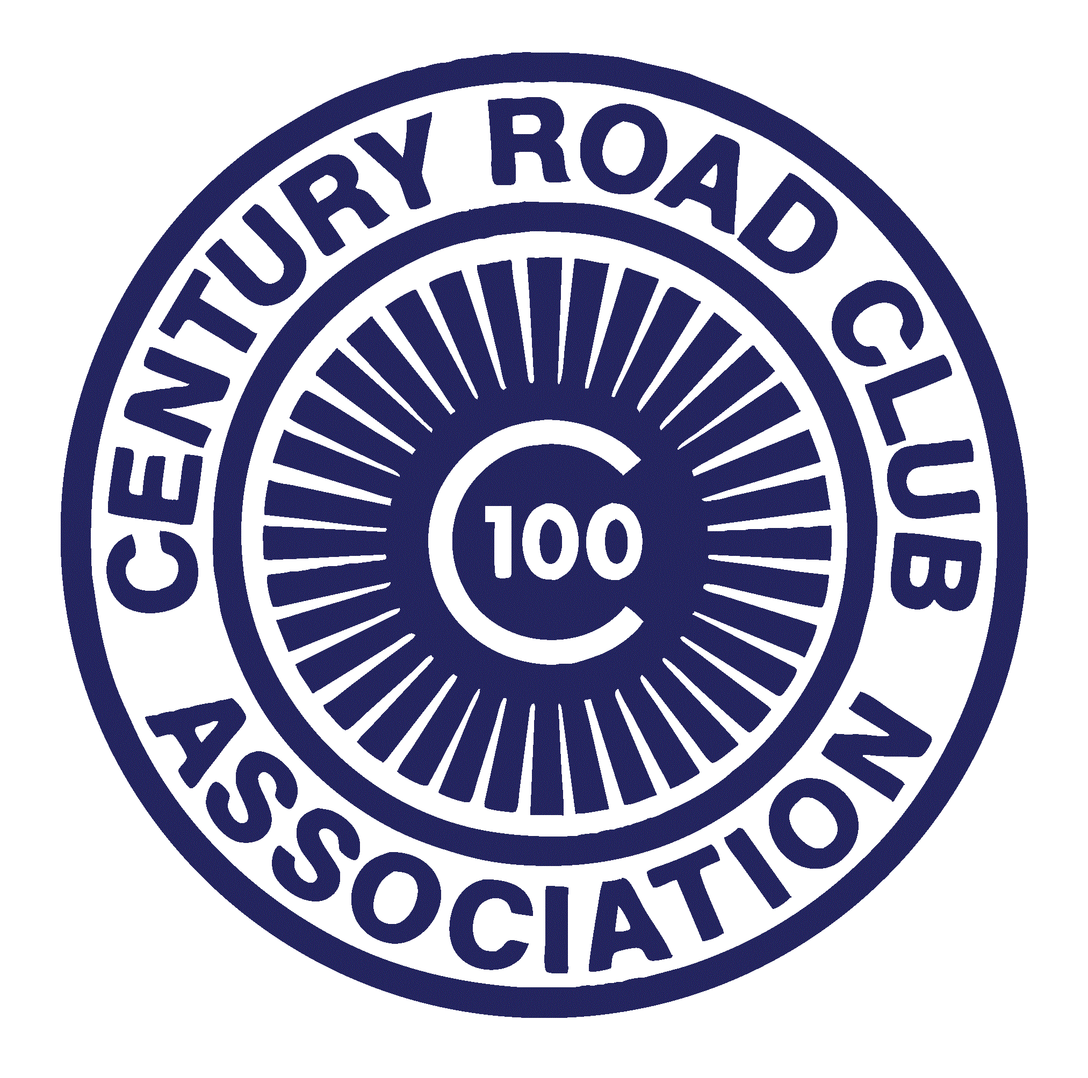
Century Road Club Association

2012 Survey Results

Members,

Thank you to those who took the time to share their feedback with us as we plan for the 2013 season. We received 230 responses up from 187 last year and over 25% of our membership. The responses were received from across the membership base. We have compiled a summary of the key responses, including comparison to the 2011 survey where relevant, and provided a brief comment on the implications to our planning for the future.

We received many additional comments through the survey. It is not practicable to respond to all comments but we have provided in an Appendix, including responses to common feedback.

Our membership is comprised of a broad range of individuals and, as expected, feedback is not always consistent. So while your individual view may not be aligned with the direction taken by the Board on a particular matter, we hope that this process and transparency helps you appreciate our approach and considerations.

Question | 2012  Response | 2011  Response | Implication
How do you rate the value of your CRCA membership | 47.5% Great  33.9% Good  14.5% Acceptable  4.1% poor | 56.4% Great  35.9 Good  5.5% Acceptable  2.2% poor | The increase in fees in 2012 has an expected decline in the measure of ‘value for money’, but the overwhelming majority still believes we offer at least good value. We will not be increasing membership fees in 2013.
Ranking of importance of factors to participate in Club races | Location (4.2)  Experience (4.1)  Community (3.9)  Cost (3.3)  Learning (3.1)  Team Comp (2.3) | Location (4.5)  Experience (4.3)  Cost (3.9)  Community (3.8)  Learning (3.7)  Team Comp (3.3) | The convenience of racing in Central Park with a quality race experience at a reasonable cost continue to be the key factors for members in evaluating Club race. We will continue to focus on improving the quality of our events in 2013 including on-time starts and variability in race finishes.
How effective are motos? | 3.8 of 5 | 4.0 of 5 | We are holding a moto officiating clinic in January as part of our effort to increase the number USAC officiated motos we provide at our races.
Preparedness of marshals | 3.8 of 5 | 3.9 of 5 | Marshals provide a critical role. We remind all members that when they are marshaling, they need to provide 100% attention. We will continue to look into ways to improve the pre-race marshal briefing to improve performance of marshals.
How safe do you feel with CRCA marshals | 3.7 of 5 | 3.8 of 5 | See above.
Effectiveness of rec lane enforcements | 3.1 of 5 | 3.2 of 5 | Club members should firstly realize that recreational lane violations are a safety issue. Infringements, regardless of the reason for their occurrence and whether an advantage was obtained or not, could negatively impact our ability to hold races in Central Park. We will continue to enforce rec lane infringements as vigorously as possible. Credible information provided to the Chief Referee will be evaluated by him or her. For infringements by Club members, the Board will continue to determine the extent of suspension or other penalties through a fair and impartial process.
Should the Club offer pre-reg for Club races? | Yes 46%  No 43%  Unsure 12% |  | There is not clear support for this option (even for those most impacted – A field) and considering the logistical issues pre-reg may create, the Board has decided not to move ahead at this stage.
Of the 15 Central Races, how many should ‘Open’ races | 1 (5%)  2 (13%)  3 (34%)  4 (14%)  5 (24%)  6+ (11%) |  | In 2012 we held 3 open races plus the Masters event where CRCA members received members pricing. The majority of members support this level of open racing. The Board plans on maintaining this level in 2013.
What should CRCA Coaching sessions focus on | Skills (4.6)  First race prep (4.4)  Race clinics (4.3)  Guidance (3.4)  Power (2.9)  Bike fit (2.8) | Skills (4.6)  Race clinics (4.4)  First race prep (4.3)  Guidance (3.7)  Power (3.4)  Bike fit (2.8) | In 2012 the Coaching sessions featured more skills sessions and racing clinics. We will continue to focus on skills work and race clinics, particularly early in the season.
Do you believe CRCA should continue to offer coaching | Yes (75%)  No/Unsure (25%) | Yes (82%)  No/Unsure (18%) | We will continue to offer coaching sessions to members free of charge.
How well does the Club communicate with you? | Very well (63%)  OK (32%)  Poor (5%) | Very well (53%)  OK (44%)  Poor (3%) | The Board has worked to improve communications with members by updating the website more frequently, increasing the number and variety of posts on crca.net and through the use of social media. The Board will seek continue to maintain a high level of communication using existing methods/channels.
Should CRCA continue to contribute to the Harlem Skyscraper? | Yes (61%)  No (20%)  Unsure (19%) | Yes (72%)  No (12%)  Unsure (16%) | The majority of members are in favor of financially supporting this race. Subject to ensuring that Club members receive value for their sponsorships, the Board has budgeted for continued financial support.
How much per member should CRCA contribute to a State-wide drug testing program? | $0 (16%)  $1 (11%)  $3 (12%)  $5 (33%)  Other (3%)  Unsure (25%) |  | Although a significant number of respondents were unsure, there appears to be strong support from members for contribution to the program at the $3 to $5 level. The Board expects to approve a budget which will allocate a $3 per member contribution to the NYSBRA fund.
How do you rate the Club as a whole | 4.2 of 5 | 4.2 of 5
How do you rate the current CRCA Board | 4.2 of 5 | 4.0 of 5
How to you rate the Club’s planning & organization at races | 4.0 of 5 | 3.9 of 5
How do you rate registration at CRCA races | 3.9 of 5 | 4.1 of 5 | In 2012 we started using a computer to assist with race registration and thought we reduced check in times and efficiency. The lower ranking may be a result of full fields during the year and our experiment with pre-registration. We think an efficient registration process is important to the overall race experience and will continue to look for ways to improve this.
How do you rate the performance of marshals | 3.7 of 5 | 3.9 of 5
How do you rate race officials | 3.9 of 5 | 4.1 of 5

Some additional observations:
- Analysis of the responses by field (A/B/C/W) identified no significant differences in the responses we received.
- The scratch format for races was the most popular and all of the race finish locations were viewed favorably.

The full survey responses can be viewed in full here.

The Board is continuing to plan for the 2013 season and we thank those members who took the time to respond. We always appreciate feedback and ideas. Board member contacts are included in the website at www.crca.net. The following appendix provides more detailed responses to specific suggestions and issues raised by the survey and throughout the year.

We hope everyone has a successful 2013 season.

~2013 CRCA Board

Appendix
The following is a summary of some of the repeated survey comments we received from members along with responses from the Board.

Comment | Response
Run more races in Central Park | The Club’s permit with Central Park allows us to hold only 15 races each year. As we are one of many organizations seeking to hold events in Central Park, maintaining our 15 available dates given such high demand is our main concern. Each year we go through a process of selecting from race dates that do not conflict with other Central Park events. In obtaining those dates, we must consider other area bicycle races so that we reduce conflicts.
Host more open races | See above for the limit on races we can hold in Central Park. The Survey results show that the Club is currently holding an optimal mix of Open and Club-only races. Although we are still finalizing our full race schedule for 2013, we expect to offer a similar number of Open races outside Central Park as in 2012. This year we are also assisting with the promotion and organization of the Grant’s Tomb Criterium. Finding additional locations for races in New York City is difficult. Putting on any race requires a substantial amount of time and effort and the current race schedule already involves a significant time commitment by the Board Members.
More Cat 5, More women’s, more masters, more cat 3, fields | Everyone wants more races in his/her category. Unfortunately, we are limited to a certain number of Central Park races by our contract with the Parks Department. We have historically run 4 fields at each race. Additional fields increase the likelihood that a faster field will catch and pass a slower field. This causes the slower field to be neutralized, which negatively impacts that race. The more this happens, the more interruption to racing for that field. Given that restriction, adding a Master’s field means taking away another field. The A/B/C/W structure ensures that every member has an opportunity to race in at least one field. That said, we are planning on experimenting with a 5th field at some races this year to see how well that works and what impact it has on all fields.
Dinosaurs should be guaranteed entry to Club races | In 2012 we had approximately 200 dinosaur members. On average, dinosaur members made up only 44% of our fields each week. Automatically pre-registering all dinosaur members would result in full fields, even though (on average) only 78 dinosaur members show up to race. Dinosaur members receive a discounted price per race, which is the advantage for pre-paying their race fees. Pre-registration, which we trialed on a limited basis in 2012, requires additional administration and additional costs to racers. The Survey results suggest there is not significant support for pre-reg at this time.
Make Club races count for upgrade points | The rules for upgrading are contained in the USAC rules. Our Club member only races (i.e., not Central Park Classic, Maltese, Mengoni etc.) are permitted with USAC as Club Races, which restricts entry to Club members only. Results from such races are not eligible for upgrade points to Category 3 and up. Permitting these races as ‘open’ races allows non-CRCA members to compete in our races, without any marshaling or team duty obligations, which are a necessary component for the Club to run its races. Central Park requires that we have approximately 50 marshals for each race to ensure that races are conducted safely. The Survey shows that Members believe we have about the right mix of Club and open races in our schedule.
Develop more juniors/Improve Junior racing | Junior racing is now funded by the CRC Development Foundation, a separate non-profit organization. CRCA provides all junior members with free membership and free races. We are seeking to enhance our ties with juniors to provide the opportunity for junior participants to transition to road racing at an appropriate time.
Club should focus (or continue to) on women’s racing | In 2012 we introduced the Women’s 3/4 series and the Women’s 4 series. The aim was to provide opportunities for newer women in the sport to compete against women at a similar ability level as we believe this will improve the experience for entry level women. As hoped, other promoters in the area are recognizing the importance of offering women’s fields and 2013 will see a women’s field and series offered in Prospect Park. We also introduced women’s only coaching sessions and women’s only skills clinics, recognizing that this may create a better learning environment for new women in the sport. We received positive feedback about these sessions. We will continue to offer Women’s 3/4 and 4 fields and women’s only coaching sessions and clinics in 2013. We will continue to look for new ways to encourage women in the sport, while balancing the needs of all Club members.
Reduce the traffic in the Park | Our permit to hold races in Central Park does not include closing roads to traffic. A permit that includes closing any part of the park to other users carries a significant fee, and it is unlikely that we would be granted such a permit in any case. It is the job of our marshals to alert other park users (including vehicles) of the existence of our races and where necessary, ask vehicles to wait for a field to pass before entering the roadway. We are also unable to prevent traffic from entering the park. When other events are being set up in the Park, we are notified by the Parks Department and we ensure our marshal captain is aware so that our most experienced marshals are placed in critical places. When you are marshaling please do your part by paying close attention at all times. Best practices include noting lap times so you know when to expect the next field and then taking preventative action where necessary.
Ensure marshals pay attention | Marshals are provided by members of the Club. Our best marshals are those with race experience. We allow members to substitute someone to fulfill their role as a marshal, but that member remains responsible for the marshal’s performance and attention. The performance of marshals is reviewed throughout the race. Members may be subject to suspension for failure to adequately perform their marshaling duty.
Reduce marshaling or reduce the costs paid to substitute marshals | The marshaling requirements are dictated by the Park requirements for our races and the number of members we have. In 2011 we reduced the number of marshaling days required for new members from three to two. We continue to monitor the number of members and marshal dates required but do not anticipate this will be reduced in 2013.
Start races on time | In 2012 two races started late. This was an improvement from 2011. In both cases this was due to the late arrival of those responsible for course setup. In 2011, late starts were caused by this and the lateness or no-show of the ambulance. We improved our pre-race procedures in 2012 to ensure the ambulance arrived on time, which eliminated that as an issue. Both situations in 2012 occurred early in the year and we subsequently revised our procedures to require all key members of the race staff to arrive sufficiently early to ensure an on-time start for our races. All races have started on time since then. In addition, “on time” means at the posted time. We know that if you are getting up for a 6am race, you want it to start on time. Please continue to show up early for registration to help ensure we can be ready to start on time.
More laps/Less laps/start races later | Our permit with the Parks Department requires that our races be complete by 8am (8:30 am in early March). As well as being a contractual matter, safety is improved by completing our races early. In setting our race schedule, we first obtain the available dates from the Parks Department and base our start times on the sunrise time – aiming mostly to start shortly after sunrise to maximize the length of our races. In 2012 we had races start as early as 5:30. Our planned races for 2013 include fewer races starting at 5:30, even when the run rises at that time or earlier. This reduces the race distance for all fields by approximately one lap versus starting at 5:30.
Reduce sub-teams/de-emphasize the team competition | In 2012, the Board agreed that effective for the 2013 season, there would be a reduction in the maximum numbers of riders a team can field in the A and B races and introduced a team limit for women for the first time. The 2013 field limits are as follows: A up to 8, B up to 10, and W up to 10. The Board will reduce each of these limits by an additional rider for 2014. The Board believes this will help prevent large teams from dominating the fields. However we would also encourage all teams to identify and recruit new Club riders to their team as road cycling is a team sport and we believe that the team competition in Club races helps riders and teams prepare for other races where teamwork can help deliver success. The survey results indicated that while many members did not necessarily place a high value on the team and individual competitions, most members also did not feel that it distracted from the racing. That said, in 2013 the Board will aim to increase its coverage of members’ results in non-Club events. However, please be mindful that it is not possible to highlight all individual results as not all race promoters publish results in a timely fashion.
Limit riders on sub-teams | For 2013, the Board approved a reduction in sub-team members that can race in each field and introduced a limit for the W field. The 2013 field limits are as follows: A up to 8, B up to 10, and W up to 10. A further reduction by one for each field is planned to go into effect in 2014.
Eliminate sub-teams in the C field | The issue of sub-teams, particularly in the C field has been discussed by the Board numerous times in 2012 and there are differing views. The main active sub-team in the C field is the Siggis/NYVelocity team. This team provides a structured, coached environment that is attractive to some new riders. The team has been successful in attracting and retaining new talent for the Club. However, because they are more or less the only team in that field, this can create a racing environment less pleasing to other participants. The majority of the Board would like to see more teams active in the C field and we encourage teams to reach out to new members and new members to make contact with teams (particularly those active in the B field) to find a team that might work for them. More experienced members providing guidance and support to new riders (in addition to Club provided coaching and skills sessions) will result in an overall positive experience for our new members.
Promoting & supporting racers who are able to compete at the National/Elite level | In 2012 we introduced a rider stipend program designed specifically to financially support riders looking to race at the National/Elite level. We will offer this support again in 2013.
More social activities & group rides | In 2012 we increased social activities by introducing a Club race number pick event and two Club rides. The two Club rides were not that well attended. A number of members have suggested we run such events and we will continue to look for ways to make it possible for members to interact outside of races. If any member wishes to volunteer to lead a Club ride, please contact us and we will be happy to facilitate.
Get involved with advocacy particularly in Central Park | Volunteer members of the Board also participate in the Central Park safety committee and attend various meetings from time to time with the Central Park Conservancy and Central Park Precinct of the New York Police Department. Our main and most direct focus in terms of advocacy is within Central Park. For various projects that come up from time to time, the Club also backs initiatives to improve cycling safety throughout New York. As a volunteer organization, our resources are limited and we stand behind organizations such as Transportation Alternatives (“TA”) that is extremely active in this broader sense. We encourage members to support TA or other similar organizations where possible.
Ensure bathrooms are open | The Central Park Conservancy/Parks Department staff is responsible for opening facilities and they are aware of our race dates and have staff assigned to be on duty. We raised this issue with them following an incident early in the season and are not aware of any repeat situations. In our early 2013 meeting we will raise this with them again.
Leash dogs in the park | The rules for pets in Central Park are available at http://www.centralpark.com/guide/activities/pets.html  Dogs are allowed off-leash before 9am in most areas of the Park. During our races, the park is open to all users of the Park and we do not have exclusive use of the roadways. As a result, riders and marshals should be aware at all times of the possibility that dogs will be present in the Park and may enter the road during races.
Send more emails – rely less on crca.net and Facebook. Send a newsletter. | We respect our members’ time and email inbox. We know that many of you deal with volumes of email every day. Therefore, we prefer to communicate primarily through crca.net for items such as race schedules and providing more detailed articles/communications. We use Facebook more liberally – to bring attention to crca.net articles/communications and interact more frequently with our members. We save email communication for the most critical matters such as announcing that membership renewal is available, announcing voting for Board members, etc. The Club no longer prepares and mails a newsletter and members should consider crca.net to be our newsletter.
Information on the website can be hard to locate | The website is an effective and efficient communication method. Since it was first created, it has not had a significant re-fresh – or at least not for some time. We will take a critical look at the layout and location of critical information to see how we can make the website more user-friendly.
Create the ability on the website for members to interact with each other (organize rides, transportation to races etc.) | As part of our review of the website and its functionality and design, we will consider adding this functionality. We do not anticipate providing forums for use by anonymous posters.
Provide equal treatment for different teams/favoritism towards certain teams | The comments received seemed to indicate that the manner in which the Board issued punishments appeared to favor certain teams associated with Board members. It should first be noted that rule infringements are identified by the chief referee and USA Cycling rules outline punishments that apply. Infractions involving Club members may also give rise to additional punishment if the incident breaches any of the Club rules. Matters dealt with in 2011 and 2012 that involved a team member of a Board member, were done so after the relevant Board members had recused themselves from the proceedings. The Board does not publish its full deliberations, nor do we believe that is necessary. The Board is satisfied that the process is fair and impartial and intends to continue with the current process, which aims for fair and equitable treatment of all members.
Increase CRCA presence at out of town races | The Board believes that as one of the largest Clubs in the country, we should do what we reasonably can to support bicycle racing in the region. Some Club members only want to race in New York City and we support that also. For those who choose to race at some of the large regional races, we would like them to feel supported by CRCA and having our Club tent and other Club members at those races can help achieve that. In 2013 the Board will continue to look for ways to show support at out of town races. We welcome member input on this topic.
Open up the sub-team culture/improve the sense of community within the Club | Each sub-team operates as a separate organization outside of the Club. The Club allows the team to operate as a sub-team of CRCA, subject to agreeing annually to the Club and sub-team rules. The Club does not impose rules on the teams as far as number of members, which fields must be represented on the sub-team, etc. There are differing views on the impact of sub-teams in racing. Some argue they should be eliminated and all members should race as “CRCA”, while others argue that sub-teams enhance the member experience by allowing groups of individual members to form stronger bonds and create team tactics within our races, and that the presence of sub-team dynamics is simply a part of the sport. Sub-teams are now part of CRCA and we do not anticipate this to change in the short term. We encourage all teams to look to bring in new members, to expand their presence across varying fields, and we encourage new members to interact with experienced members to find a sub-team that will suit them if that is what they want.  We encourage all members to keep racing in perspective, and to look to make connections throughout the Club and beyond. The friendships formed are more valuable than your placing in any race.

