Hello, and welcome to the July edition of Quiet Space
Last week I took a risk - a leap of faith - and signed up for an on-line course in tapestry weaving – a craft/art form I’ve become particularly interested recently.

The risk was two-fold! First of all, despite all the detailed information I’d read about the course, was I going to be able to cope with it? I’ve been on quite a few workshops over the past few months, so I knew the basics, but this course was run by a tapestry artist in the USA and she has a very different style of weaving to the tutor I’m used to.

My second dilemma was paying for the course. I’d never purchased anything on-line using currency other than pounds sterling. The cost for this course was in US dollars. I’d found out the approximate amount of the course in our currency, but I didn’t know exactly how to make the transaction.

These two factors made me hesitate for quite some time. Eventually, I took a leap of faith and hit the ‘register now’ button!

Of course, the payment worked out ok...I’ve yet to find out how I cope with the actual weaving, but I’m glad I took that leap of faith!

Sometimes we have to take a leap of faith and we have to take risks in order to do something we need, or want, to do. Really when you think about it, life is full of risks...and it’s full of tiny, often insignificant, leaps of faith too.

Liz Shields
Chaplain to Clayton Square Shopping Centre

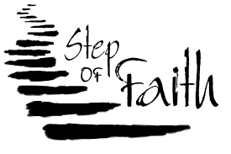

Faith is taking the first step
even when you don't see the whole staircase.
~ Martin Luther King, Jr.

“A ship in harbor is safe, but that is not what ships are built for.”
~ John A Shedd

“None of us knows what might happen even the next minute, yet still we go forward. Because we trust. Because we have Faith.”
~ Paulo Coelho

Words for reflection
“Never be afraid to trust an unknown future to a known God.”
Corrie ten Boom

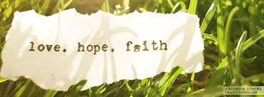

Faith
by Kate McIlhagga

Faithful God, by faith
may we conquer
our deepest fears.
By faithful action
may the chains of poverty be broken.
By faithful struggle
may the web of oppression be overcome.
By faithful commitment
may the walls that divide fall.

God of power and might,
as we go round in circles,
reluctant to make choices,
hesitant to act,
as we offer what is most precious,
give to you what matters most,
open to us the sea of your mercy
and carry us home.

from ‘The Green Heart of the Snowdrop’ (Wild Goose Publications)

