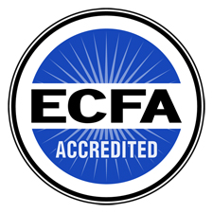

August 2016

Dear Friends,
Double your gift and make a difference in South Sudan!
I am writing to you to share an update on how things are going in South Sudan. First, let me apologize that you’ve not received updates more frequently. Our volunteer staff in the U.S. has been very busy - there has been so much to do and pray about.
You may have seen the news from the last month that South Sudan is once again in conflict. The fact is that the past conflict never did completely resolve and the renewal of fighting in Juba has brought great suffering to the country—including the village of Werkok and Memorial Christian Hospital. Inflation is out of control, supply lines are insecure, transportation is expensive and very difficult, and there is an extreme shortage of medical personnel.
These are just some of the difficulties we are currently dealing with at MCH in South Sudan. We recently received a heartbreaking report from the hospital that they are seeing an increase in malaria patients due to the rainy season and they have no medicine to treat them.
MCH report – End of July, 2016
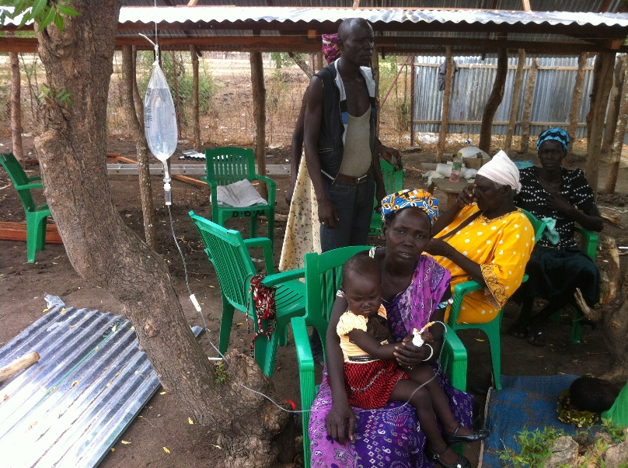 | There is serious malaria outbreak in Bor area since last month. Abraham Maduk said he lost two patients (under 5 years) at Bor Clinic. Abraham Bol said he lost one patient (a child under 8 years) at Malek Clinic. Abraham Pandak said he has been struggling treating malaria cases at MCH.
Abraham Maduk said that he is seeing about 70 - 80 patients at Bor Clinic without medicines. He diagnosed them and sends them to Bor market to find that the local pharmacies had no supplies since the conflict broke out in July. Most of the medicines are brought from Uganda and Kenya. The government hospital has no medicines either.
It is hard to hear this news while we are so far away—but we are not without resources to help. The medicine needed for malaria is not very expensive; in fact we have medicine already purchased and waiting in Nairobi. However, transportation is very difficult and costly. The only option for getting supplies to the hospital is through a chartered flight. This costs $4,700 and that is just one of our immediate needs. Our staff also face hardship as the patients who come for treatment have little or no money to pay and we are waiving the cost sharing fees for more and more patients. These small fees that patients normally pay cover others.
While the difficulties continue, PCC is not without hope. In fact with your help, we can accomplish the following:
- $20 will cover the cost and transportation of 20 malaria kits

- $56 will cover the cost of one malaria treatment for 33 patients

- $150 will cover the cost of x-ray services for 15 patients

- $500 will allow our nurse Abaham Maduck to see, in a month, between 1750-2000 patients in Bor. WOW!
In addition, if you join us by committing to support PCC monthly or quarterly by SEPTEMBER 15 your money will be matched by an anonymous donor up to $6,000. We can and are making a difference to the people of South Sudan. We have included a return envelope for your help or go to pccsudan.org to make your donation online. Please prayerfully consider how you can impact the lives of the Sudanese people by supporting PCC.
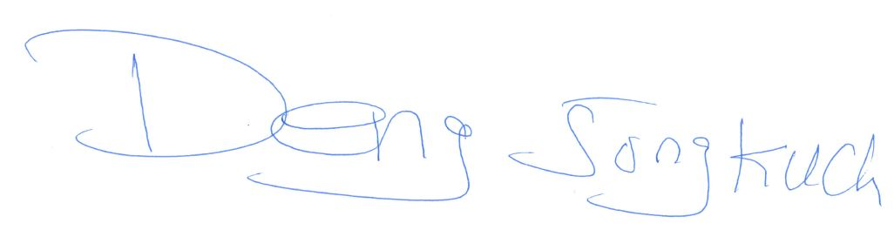As always, we appreciate your support and prayers.

Deng Jongkuch
Executive Director PCC
www.pccsudan.org
Phone: 616.356.2464
Email: info@pccsudan.org
Partners in Compassionate Care (PCC)
1000 Front Ave NW
Grand Rapids, MI 49504

