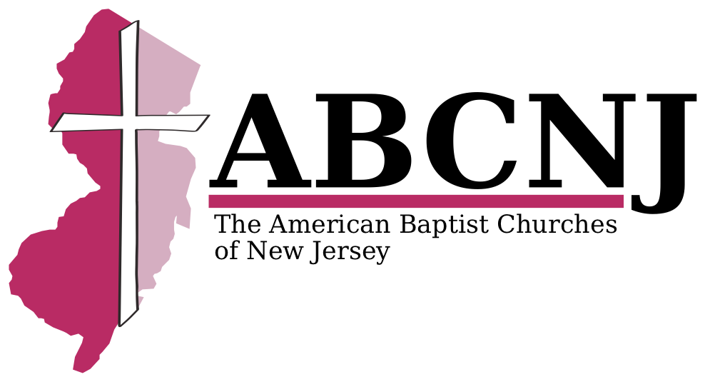
Hurricane Sandy
One Great Hour
of Sharing
Aid Request

CHURCH NAME/CITY: ______________________________________________________________________________________
PASTOR/LAY LEADER: ______________________________________________________________________________________
CONTACT INFO (EMAIL/PHONE): _________________________________________________________________
ABCNJ will consider reimbursements or cash advances for the following situations – briefly share specific needs:
1. Emergency repair costs for church facilities, including parsonages and pastor’s homes.

2. Costs for replacing damaged or lost items that the church owned.

3. Expenses churches incurred in ministering to your people (food, blankets, clothing, etc.).

4. Relocation expenses incurred due to homes without power or that were lost/damaged.

TOTAL OGHS AID REQUEST: $ _____________________
Please bring proof of purchase documentation (bills, invoices, etc.). The region expects that churches will be working with their property insurance company as well. We are prepared to reimburse you for expenses not covered by your policy (such as your deductible).
++++++++++++++++++++++++++++++++++++++++++++++++++++++++++++++++++++++++
AMT Granted: $ ______________ Check#: __________ APPROVAL: ____________________ DATE: ____________

