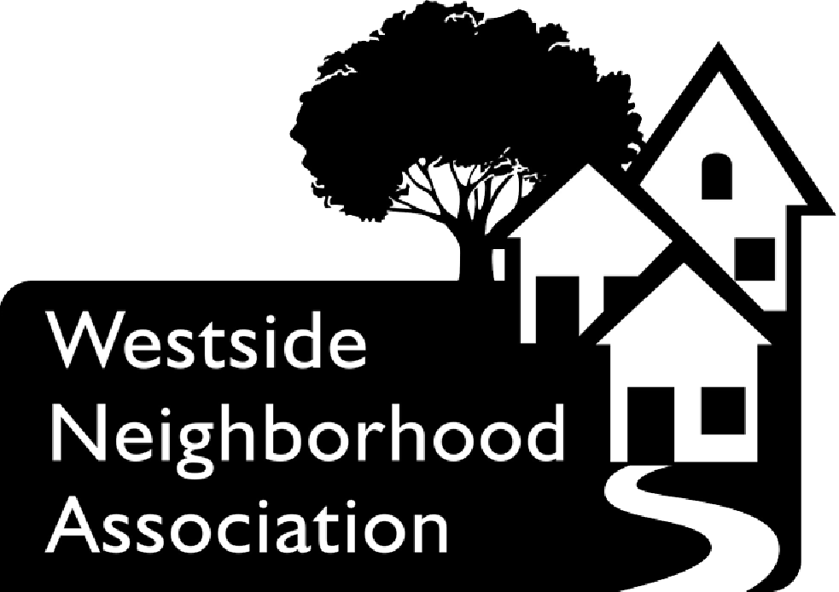

Westside Neighborhood Association
March 21st , 2013 Board Meeting Agenda

Time | Topic | Lead
600 pm | Call to Order | Schury
6:01 pm | Approval of Agenda | Schury
6:03 pm | Approval of 2.21.13 Minutes | Stratton
6:18pm | Guest Presentation- Ingham County Land Bank | Melissa Lott
6:22 pm | Old Business | Schury
6:22 pm | New Business  Westside Spring Cleaning | Cunningham
6:35 pm | President’s report | Schury
6:40 pm | Treasure’s Report | Boehme
6:45 pm | Fiesta | Casavant
6:55 pm | Yard Sale | Kris
6:55 pm | Grants | Nelson
7:00 pm | Riddle School Liaison | Long
7:10 pm | Sexton School Liaison | McCormick
7:10 pm | Community Center Liaison
7:10 pm | Communications | Kris
7:10 pm | Newsletter | Boutel
7:10 pm | Voter Education/Civic Engagement | Cunningham
7:20 pm | Westside History | Gerich
7:30 pm | Summer Quarterly Event | McCormick
7:40 pm | Community Engagement | Fitz
7:50 pm | Crime & Safety | Payne
7:50 pm | MLK Garden | Nelson
7:50 pm | GM Liaison | Pratt
7:50 pm | Scholarships | Pratt
7:50 pm | Business promotions
7:50 pm | Places of worship | Long
8:00 pm | Fun | Casavant
8:05 pm | Good & Welfare | Schury
8:10 pm | Adjournment | Schury

Guest- Melissa Lott- Ingham County Land Bank
Excused-Julie Durham

Guest Presentations-
- Melissa Lott to talk to us about a pilot program the land bank would like to set up in our neighborhood.
Old Business

New Business-
- Westside Spring Cleaning
- The goal: Recruit neighbors to help clean up the neighborhood on April 13 as part of the Spartans Global Day of Service. Volunteers can choose which street(s) they want to work on, or be assigned streets if they have no preference. Each group will have a “street captain” who will pick up supplies at Letts Community Center at 9:30 a.m. The groups will gather at their designated meeting spots at 10 a.m. and start cleaning up trash from the streets, boulevards and yards. When each group is finished with their territory, the volunteers can join other groups or head home.

- Board member are asked to help recruit volunteers.

- A Facebook event has been created. Unfortunately, it’s only open to WNA FB group members. Does anyone know how to change that setting or get around it? The event also is registered with the MSU Day of Service website.

- The library at Letts is on hold for WNA for the morning of the event. We can distribute supplies from there to the volunteers.

- Final trash disposal is still up in the air. The city can’t pick it up (I already asked). We may be able to use the dumpster at Letts. We may have to ask volunteers to dispose of trash in their own weekly trash bins. I’ll work on ironing out the details as soon as I can.

- I have a request in to Home Depot to see if they will donate materials (i.e., trash bags, yard bags).

- Should we do a thank-you event for the volunteers afterward at Letts? Mike has offered to buy pizza.

- Will likely need a budget to pay for supplies.

  - NOTE: This could be a good opportunity to sell tickets to the Fiesta at the pick-up site or during the pizza party (if we have one).
President’s Report:
- Susan Cancro and advent house - would like to explore partnering again on garden and home tour with additional help by board in exchange for equitable division of profit. Has most but not all home tour booklets. I have received 2005-2012. Will get a copyright clearance request to advent house to start digitizing.
- Wca - explored a mega discount card with wca businesses and Ana businesses. Price would be about $700 for 5000 cards. Still in exploratory phase but wca seeks assistance in exploring from wna. Seems to fit well with the wna business directory.
Treasurer’s Report
- See attached treasure’s report
Fiesta
- 10 minutes.

Yard Sale

Grants
- we received a $650 Mayor's Grant for improvements to the Riddle playground, $100 for a summer social event, and $100 for the neighborhood watch/crime and safety committee to put toward a summer event/meeting.
Riddle Liaison

Sexton Liaison
- Sexton prom committee can drive March 23rd, 10-1. If you received the flyer with the ribbon you can place your cans on your front porch or somewhere that is visible from the road in a bag with the ribbon attached.

Community Center Liaison
- Last week I spoke with the community center director to verify our meeting space for the various WNA meetings we would like to hold there. I was told they were on the calendar and I would be mailed a confirmation of each of the dates. I haven't heard anything at this point from Milt. Please let me know if everything was set and available for your meeting this week.
Communications

Newsletter

Voter Education/Civic Engagement
- Candidates Night
  - The target date for the WNA Candidates Night will be early June. AV ballots must be made available by June 22 for the August Primary, and the event should take place before that date.

  - Fourth Ward candidates will be invited to participate. The at-large candidates may also be invited, depending on the total number of candidates on the ballot after the May 14 filing deadline.

  - Event will need a small budget for refreshments.

  - Volunteers to help plan and execute the event are welcome.
Westside History
- Will have an ad in the newsletter and hopefully some stories will follow. I am hoping to speak with Mr Miller about his progress and thoughts for the project before the month is over
Summer Quarterly Event
- No planning yet, but I think it'd be fun to do a picking in the park picnic, and invite neighbors to bring their stringed, and other types of instruments.this would of course depend on where we do the picnic and if our hosts would allow. Cassandra secured $100 grant for event again this year.
Community Engagement
- Exploring a number of community engagement activities that we could do, and one of them is has to do with parent engagement in schools and healthcare. Using a technique created by the Right Question Institute at Harvard, the process involves teaching parents and other adults to be advocates for themselves and their children. The process helps low income families navigate school, health and social services by empowering them to be smarter "customers." This could be a good activity to run at the community center when parents are picking schools for their kids this spring.
Crime & Safety
MLK Garden
- Nothing to report

GM Liaison

Scholarship

Business Promotions
Places of Worship
Fun
- request for 5 minutes
- Lugnuts game and other ideas our group might want to pursue.
Neighborhood Improvement

Good and Welfare

