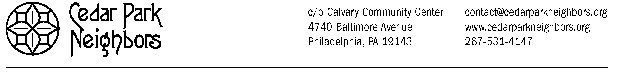
RE-APPLICANTS
CEDAR PARK NEIGHBORS SCHOLARSHIP APPLICATION 2016-2017
DEADLINE TO APPLY: June 15, 2016, 5 p.m.

IMPORTANT NOTE: You must live within the boundaries of Cedar Park in order to apply! Cedar Park is bounded by 46th Street, Kingsessing Avenue, the R-3 tracks, 52nd Street, and Larchwood Avenue. Please contact the committee at scholarships@cedarparkneighbors.org if you have any questions about your eligibility.

LAST NAME: FIRST NAME: M.I.

STREET ADDRESS:

CITY/STATE/ZIP:

MUST BE: Philadelphia, PA 19143

PHONE: CELL PHONE (IF APPLICABLE):

EMAIL ADDRESS:

NAME OF YOUR PARENT(S)/GUARDIAN(S):

POST-SECONDARY SCHOOL YOU WILL ATTEND (2016-2017):

COLLEGE MAJOR: | EXPECTED COLLEGE GRADUATION DATE:

Cedar Park Neighbors Scholarship Support Statement

I, ______________________________, agree to support efforts to generate funds for the Cedar Park Neighbors Scholarship program through the following efforts:

- Permitting the use of my name, photo, image or likeness to be used in advertising and marketing efforts to promote the fund. I realize that neither I nor relatives or others connected to me will benefit financially or otherwise from these promotional efforts.

- Providing updates on my academic progress when requested, during the period that I am accepting funds from the Cedar Park Neighbors Scholarship Fund.

- Participating in fundraising efforts for the scholarship fund as a student and as a college graduate through writing articles, making appearances, and participation in other activities the Cedar Park Neighbors would deem appropriate to the extent possible.

_____________________________ _____________________________ ______________
(Student’s Signature) (Student’s Name-Printed) (Date)
--------------------------------------------------------------------------------------------------------------------------------------
PLEASE CHECK THAT YOU HAVE ATTACHED TO THIS APPLICATION THE FOLLOWING ITEMS:
- Application Narrative:
- Type a 500-word article for the CPN newsletter and/or thank-you letter to the CPN community that talks about your college experience so far, your accomplishments, and how the CPN Scholarship has helped you.
- Discus the 2 CPN-related activities in which you participated this scholarship year. Activities can include:
- Attending the Awards Ceremony during the summer
- Attending the Winter Reception during winter break
- Attending the fundraiser at Dock Street (or contributing to the planning in some way)
- Participating in the holiday food basket drive
- Delivering CPN newsletter to residents (if local)
- Participating in a Cedar Park clean-up day
- A copy of your most recent college transcript (may be unofficial).
- A copy of a course roster for the Fall 2016 semester at a regionally accredited post-secondary school.
- A copy of your FAFSA Student Aid Report (NOTE: This item will be shredded after scholarships are offered to students.)
- An updated resume which includes your school activities, school and community volunteer experiences, work experiences, career goals, references, internships, etc. The resume must be typed.
- A signed copy of the Cedar Park Neighbors Scholarship Support Statement (above).
- Please feel free to submit anything else in writing that tells us what sets you apart and what a CPN Scholarship would mean to you!
-------------------------------------------------------------------------------------------------------------------------------
DEADLINE TO APPLY: Postmarked by June 15, 2016, 5 p.m.
Applications received after this date will be automatically denied.

EMAIL YOUR COMPLETED APPLICATION TO:
scholarships@cedarparkneighbors.org

QUESTIONS? Contact the Scholarship Committee at scholarships@cedarparkneighbors.org

