Gratitude Garden

Print out verse one of Hymn # 3, a “Grateful Heart a Garden is” and read it to the children. Sing it over and over, if you can.
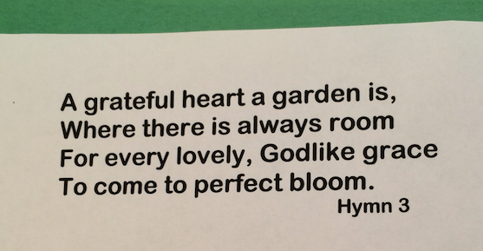

Before your session with them, cut out flowers in different shapes and sizes. Use a green sheet of construction paper to build the garden for each child. Let them glue with a glue stick the flowers on the green paper.

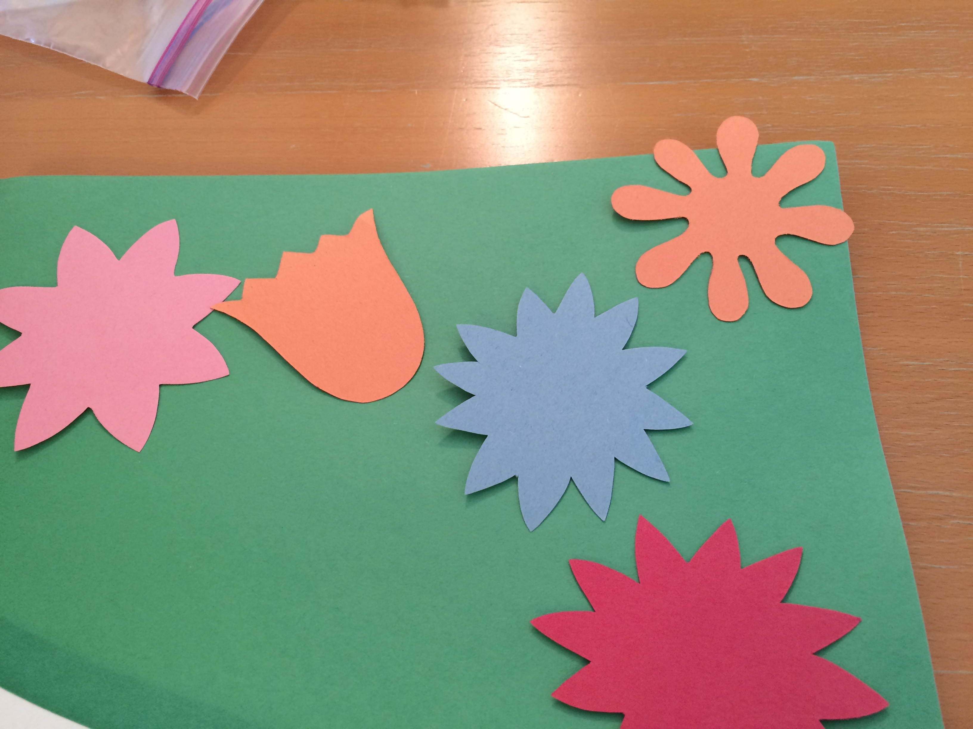

The teacher or parent then writes the things they are grateful for on each flower.

Hang it in a prominent place in the home to refer to all week.

