Jesus walks on the water: Read the story from a Children’s Bible or book

Take one sheet of blue construction paper for the base.
Cut two strips of waves the horizontal length of the paper. Do not glue them on, but glue them only on the right and left sides, so the middle is loose.

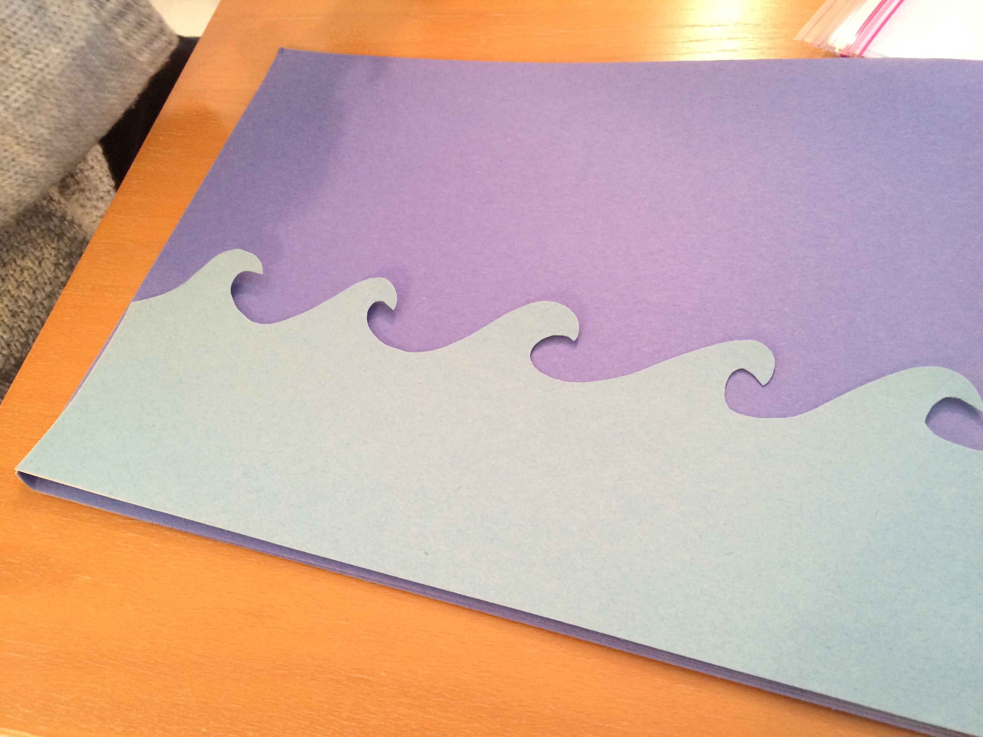

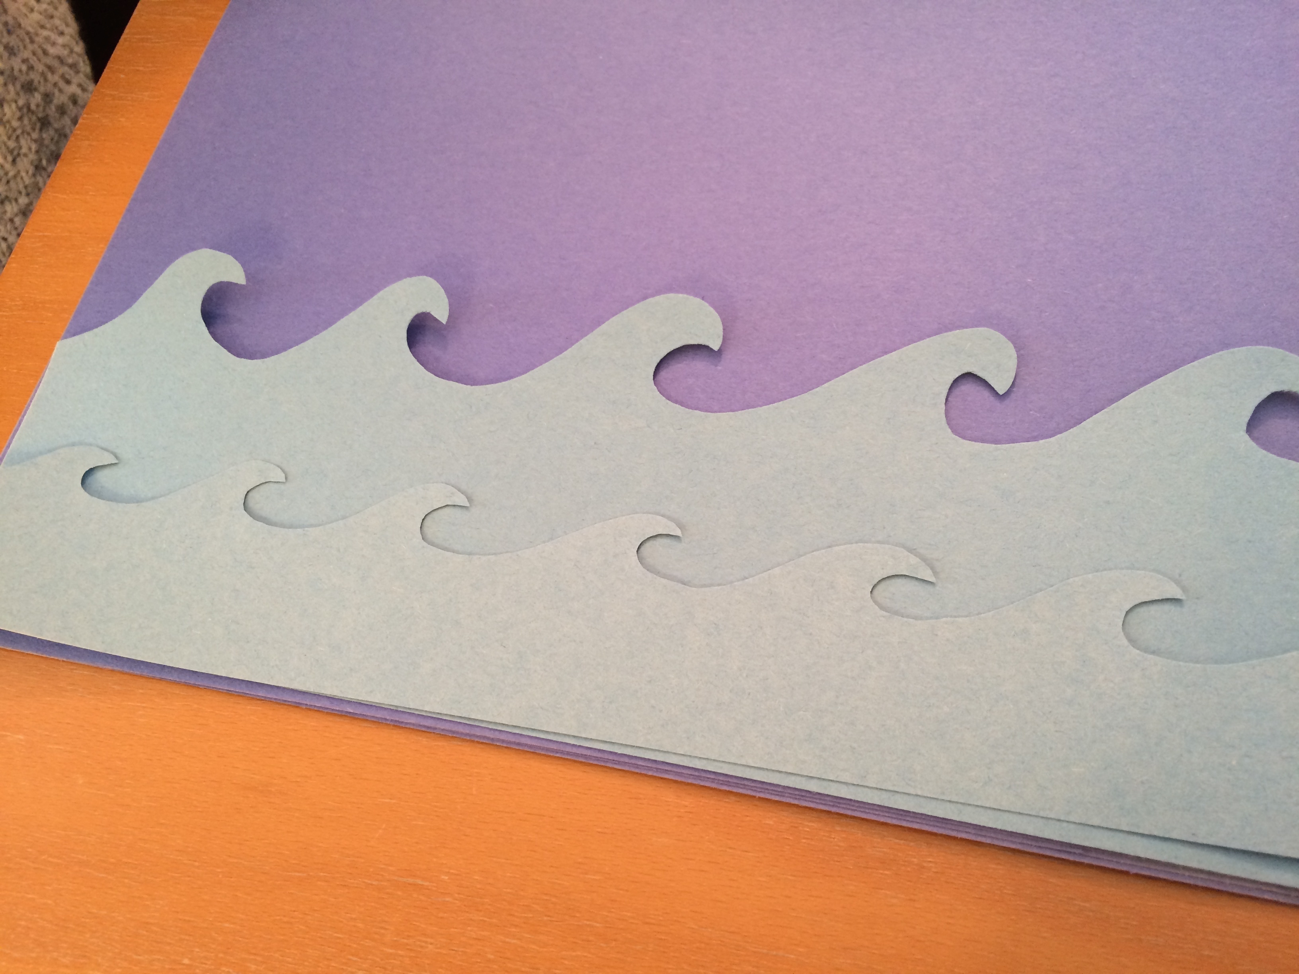

Have the pieces to make the boat already cut out for the child(ren). 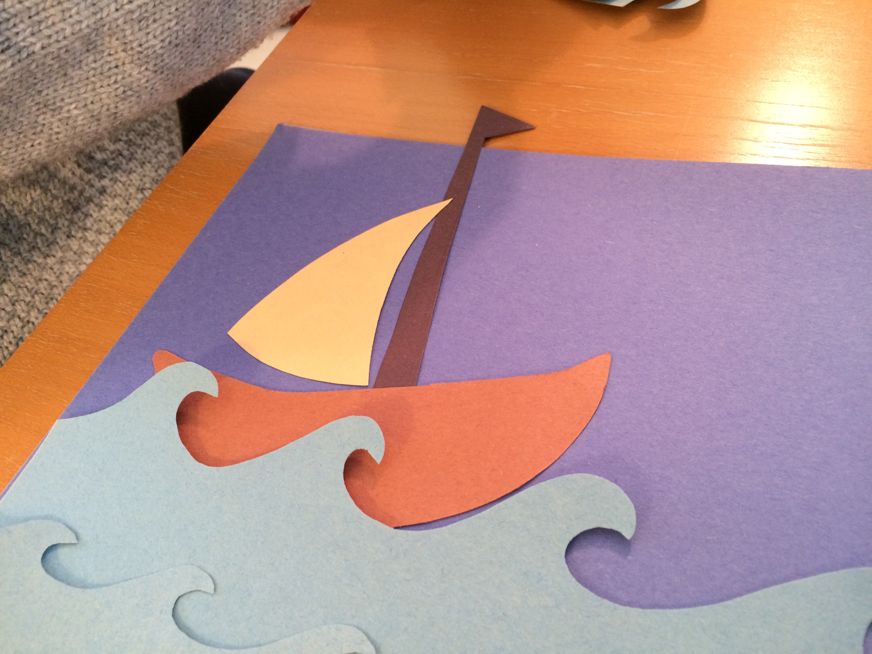

Make a template for a man who wears a robe, to be Jesus. Cut it out for the child and let him color it. Have the child glue a straw on the back of the Jesus figure.

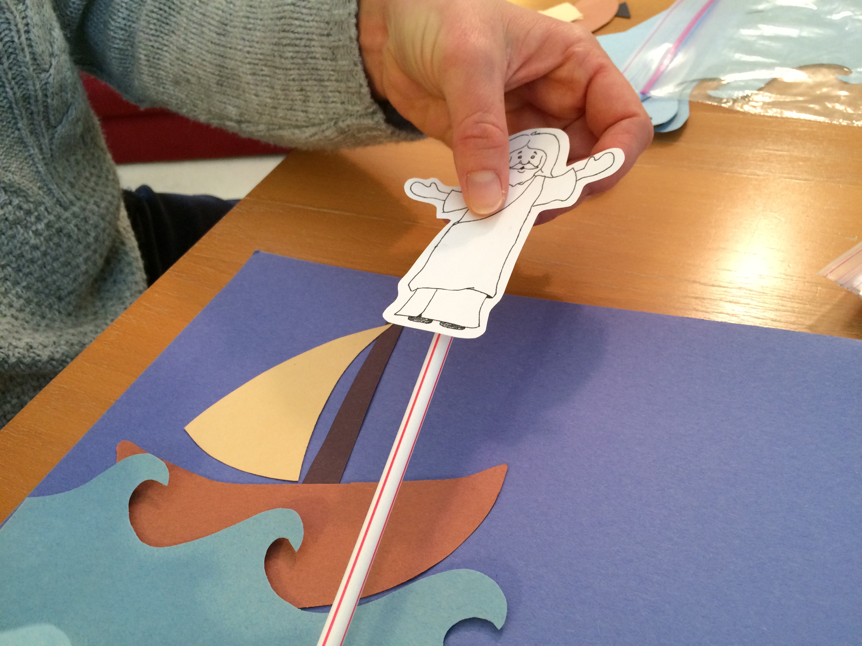

Put the straw figure between the waves and let him walk on the water until he gets to the boat.

