Seven Synonym Bead Necklace:

Take strips of construction paper about 1 ½ inches wide and roll up tightly leaving a hole in the middle. Scotch tape around each colored bead.

Find some white mailing labels and print out the seven synonyms on the sticky label.

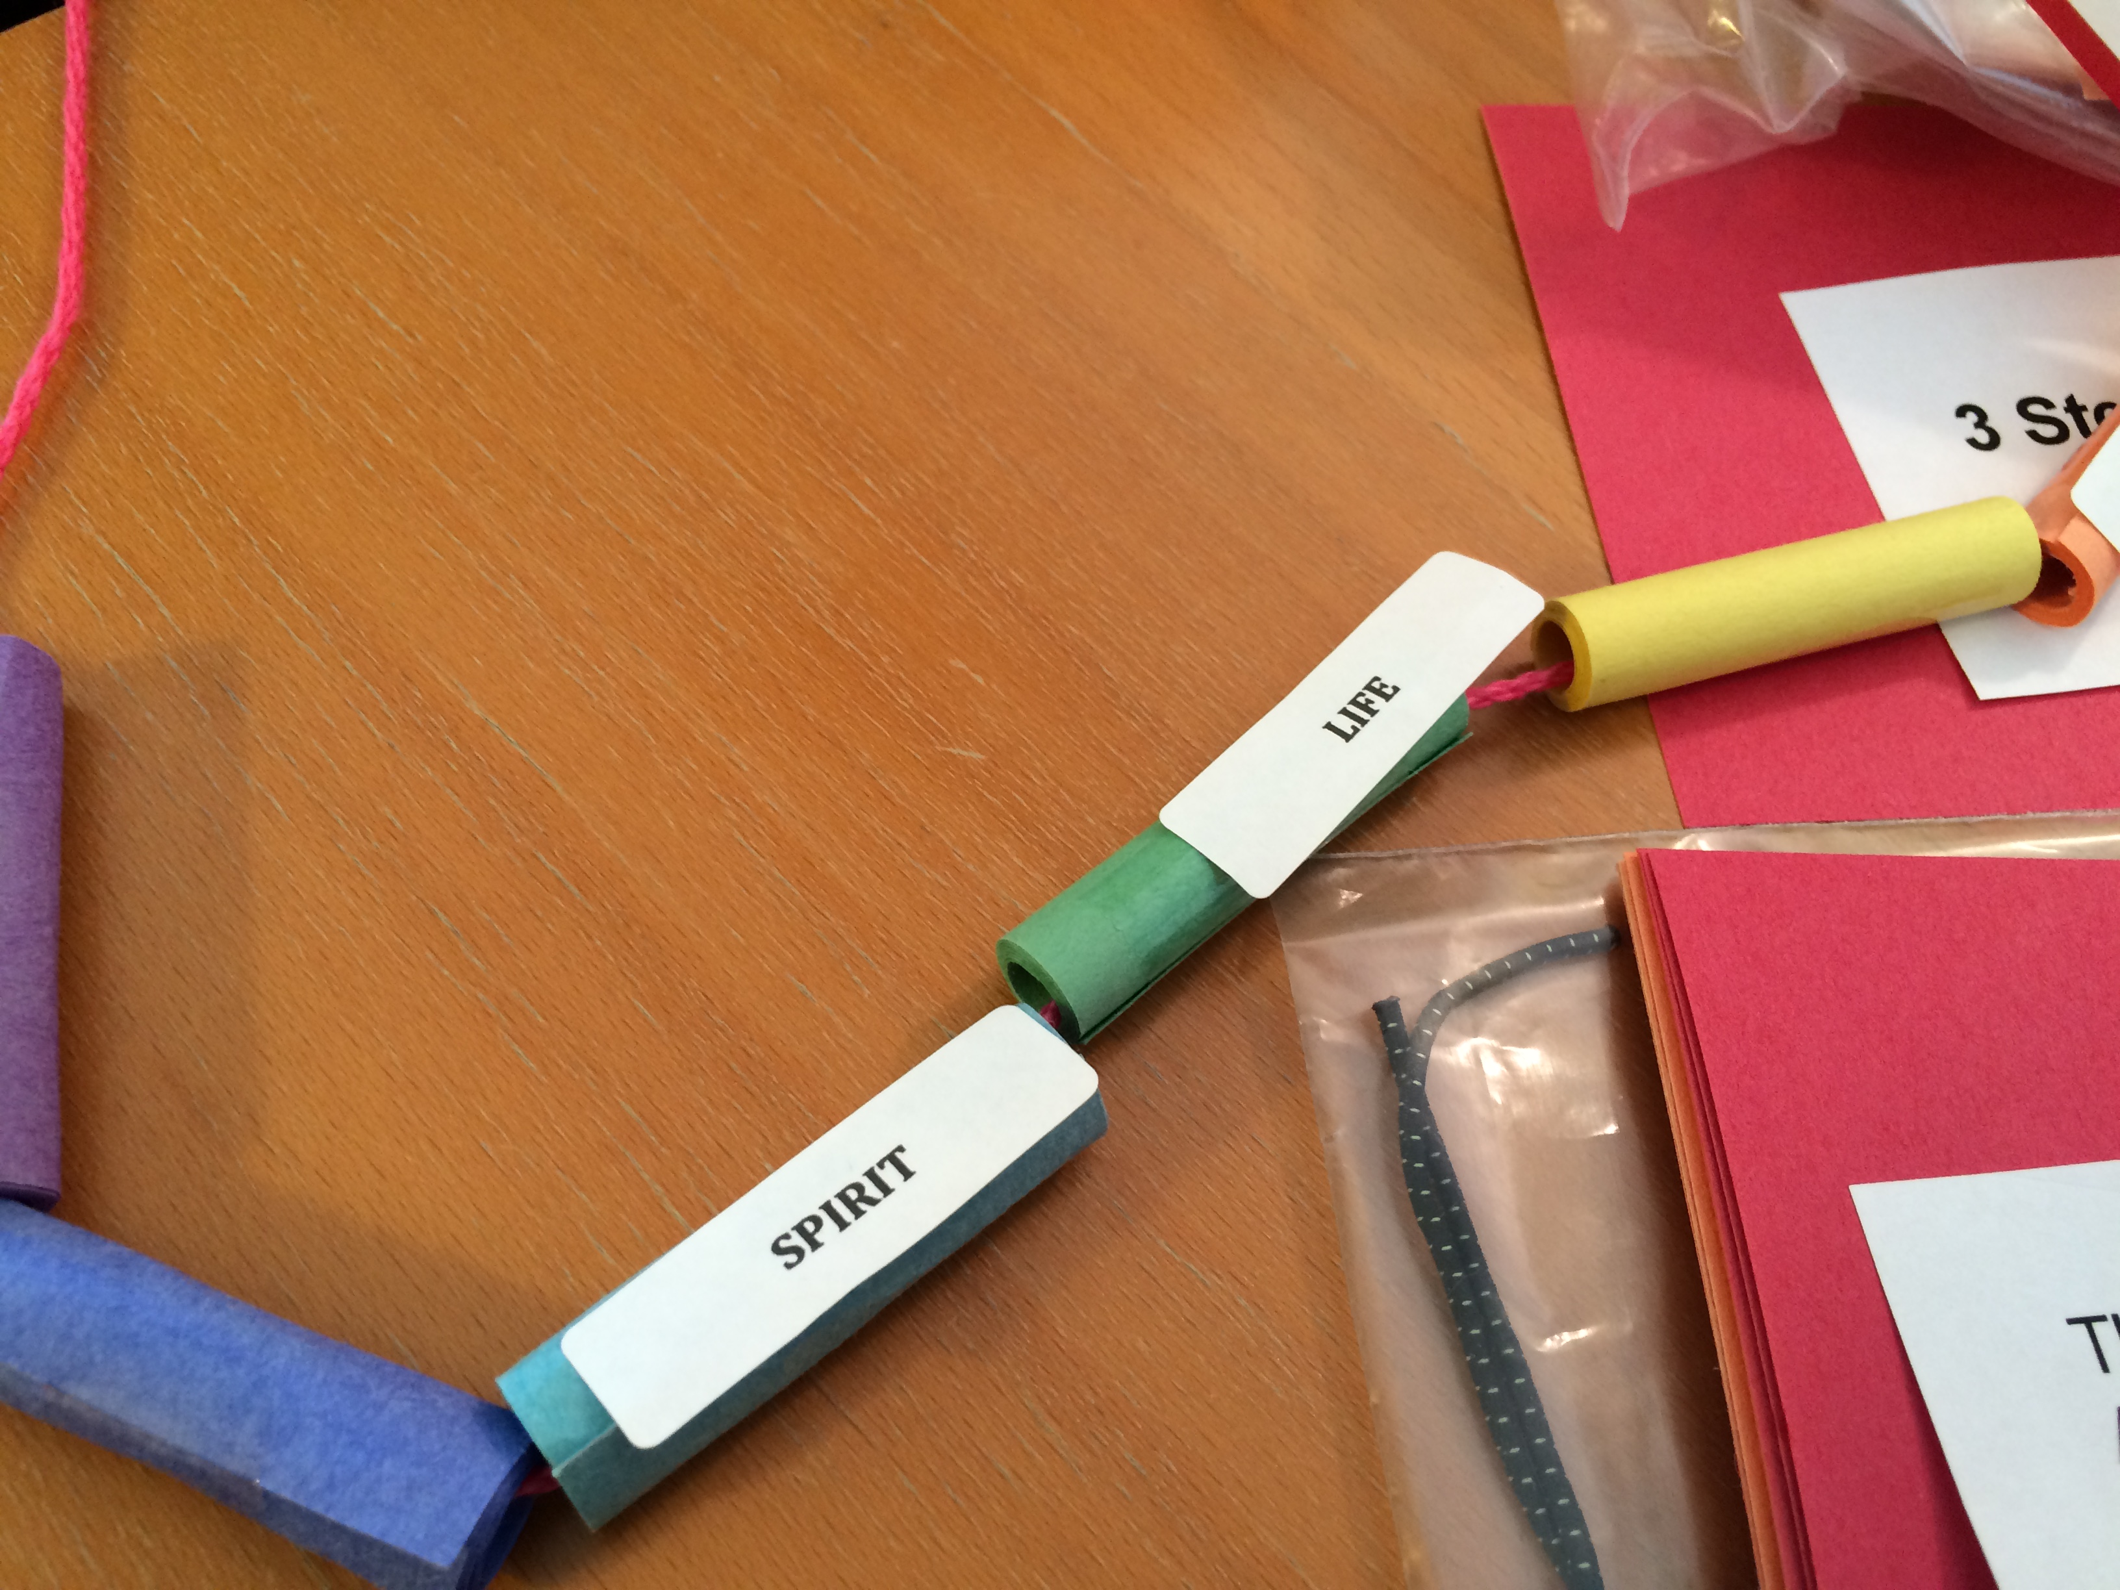

Cut yarn the correct length for a necklace to go over the head of the child and put scotch tape on one end of it, so it makes a needle-like end. Pull the yarn through the seven beads, and tie off on the end.

