Synonyms:
(From the Reading Room there is a wonderful book on the Synonyms. At first work with the bottom half of the book, then add the top half with the definition of God.)

On the wall: use large pictures of a train, or balloons, or flowers (whatever interests your students) and put the name of a synonym on each shape.
- make seven flashcards with the names of the synonyms on each.
- Students can put the card into the pouch on the balloon or train car, etc.
- For older students: have cards with qualities for each of the synonyms. Students can match the quality to each synonym (e.g. Love: patience, kindness, loving)

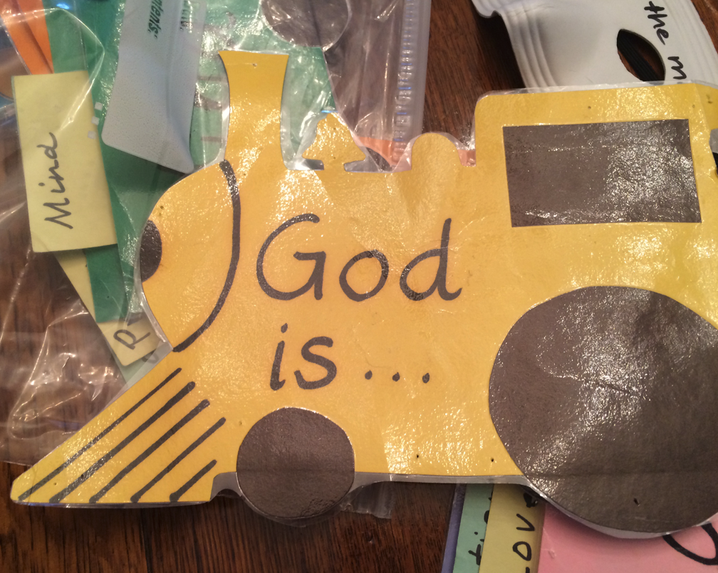
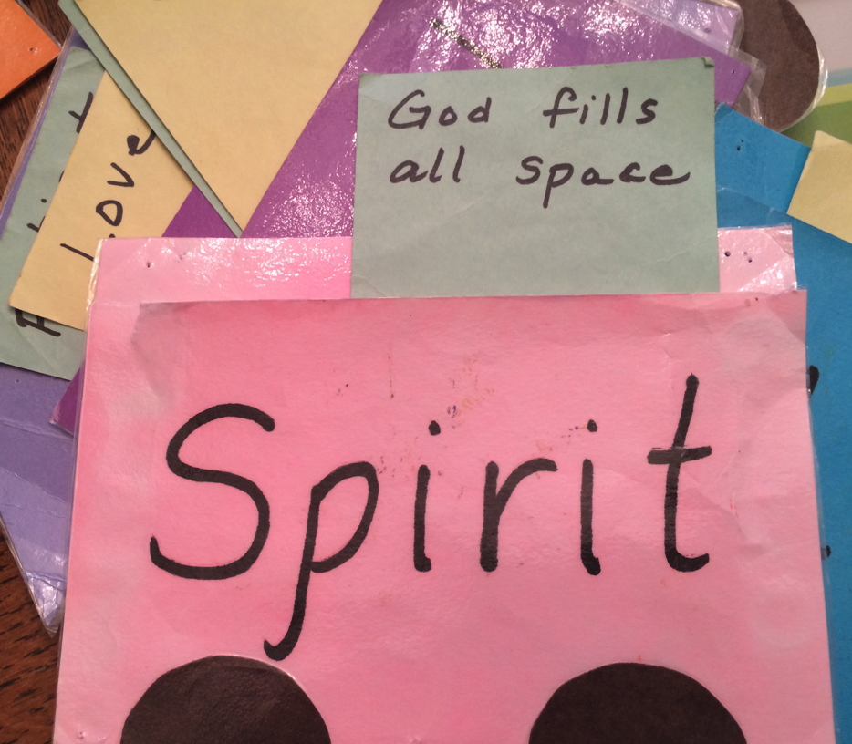

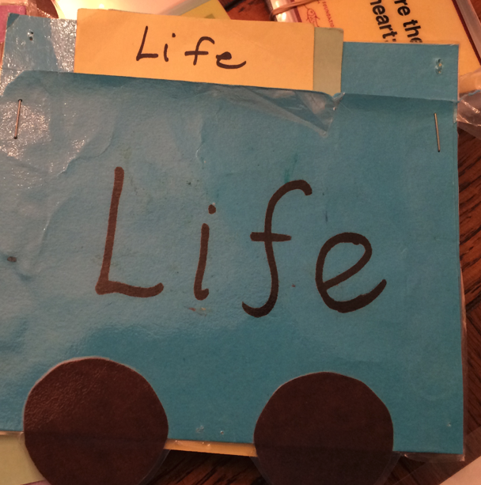

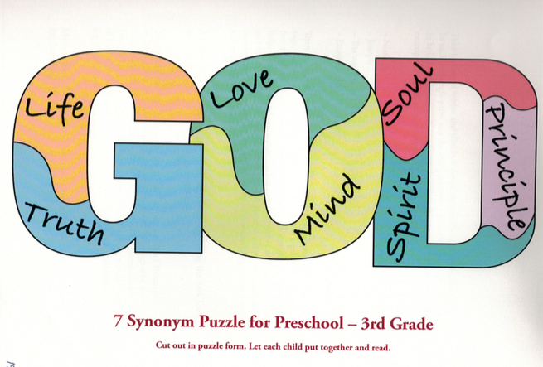

The above puzzle can be made on paper or cardboard or even cut out in wood for an actual puzzle.

After working with the synonyms for a while, maybe several weeks, make a booklet for each child to take home and read to a parent. Each page has a name of a synonym on it. (this shows the cover page)

God is

