Jesus and the loaves and the fishes:

“Divine Love always has met and always will meet every human need.”
Mary Baker Eddy

Start by making some kind of basket for your loaves and fishes:
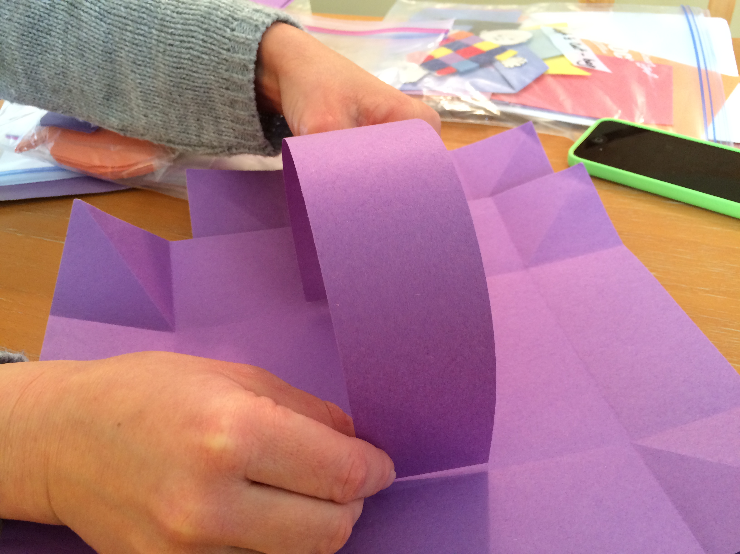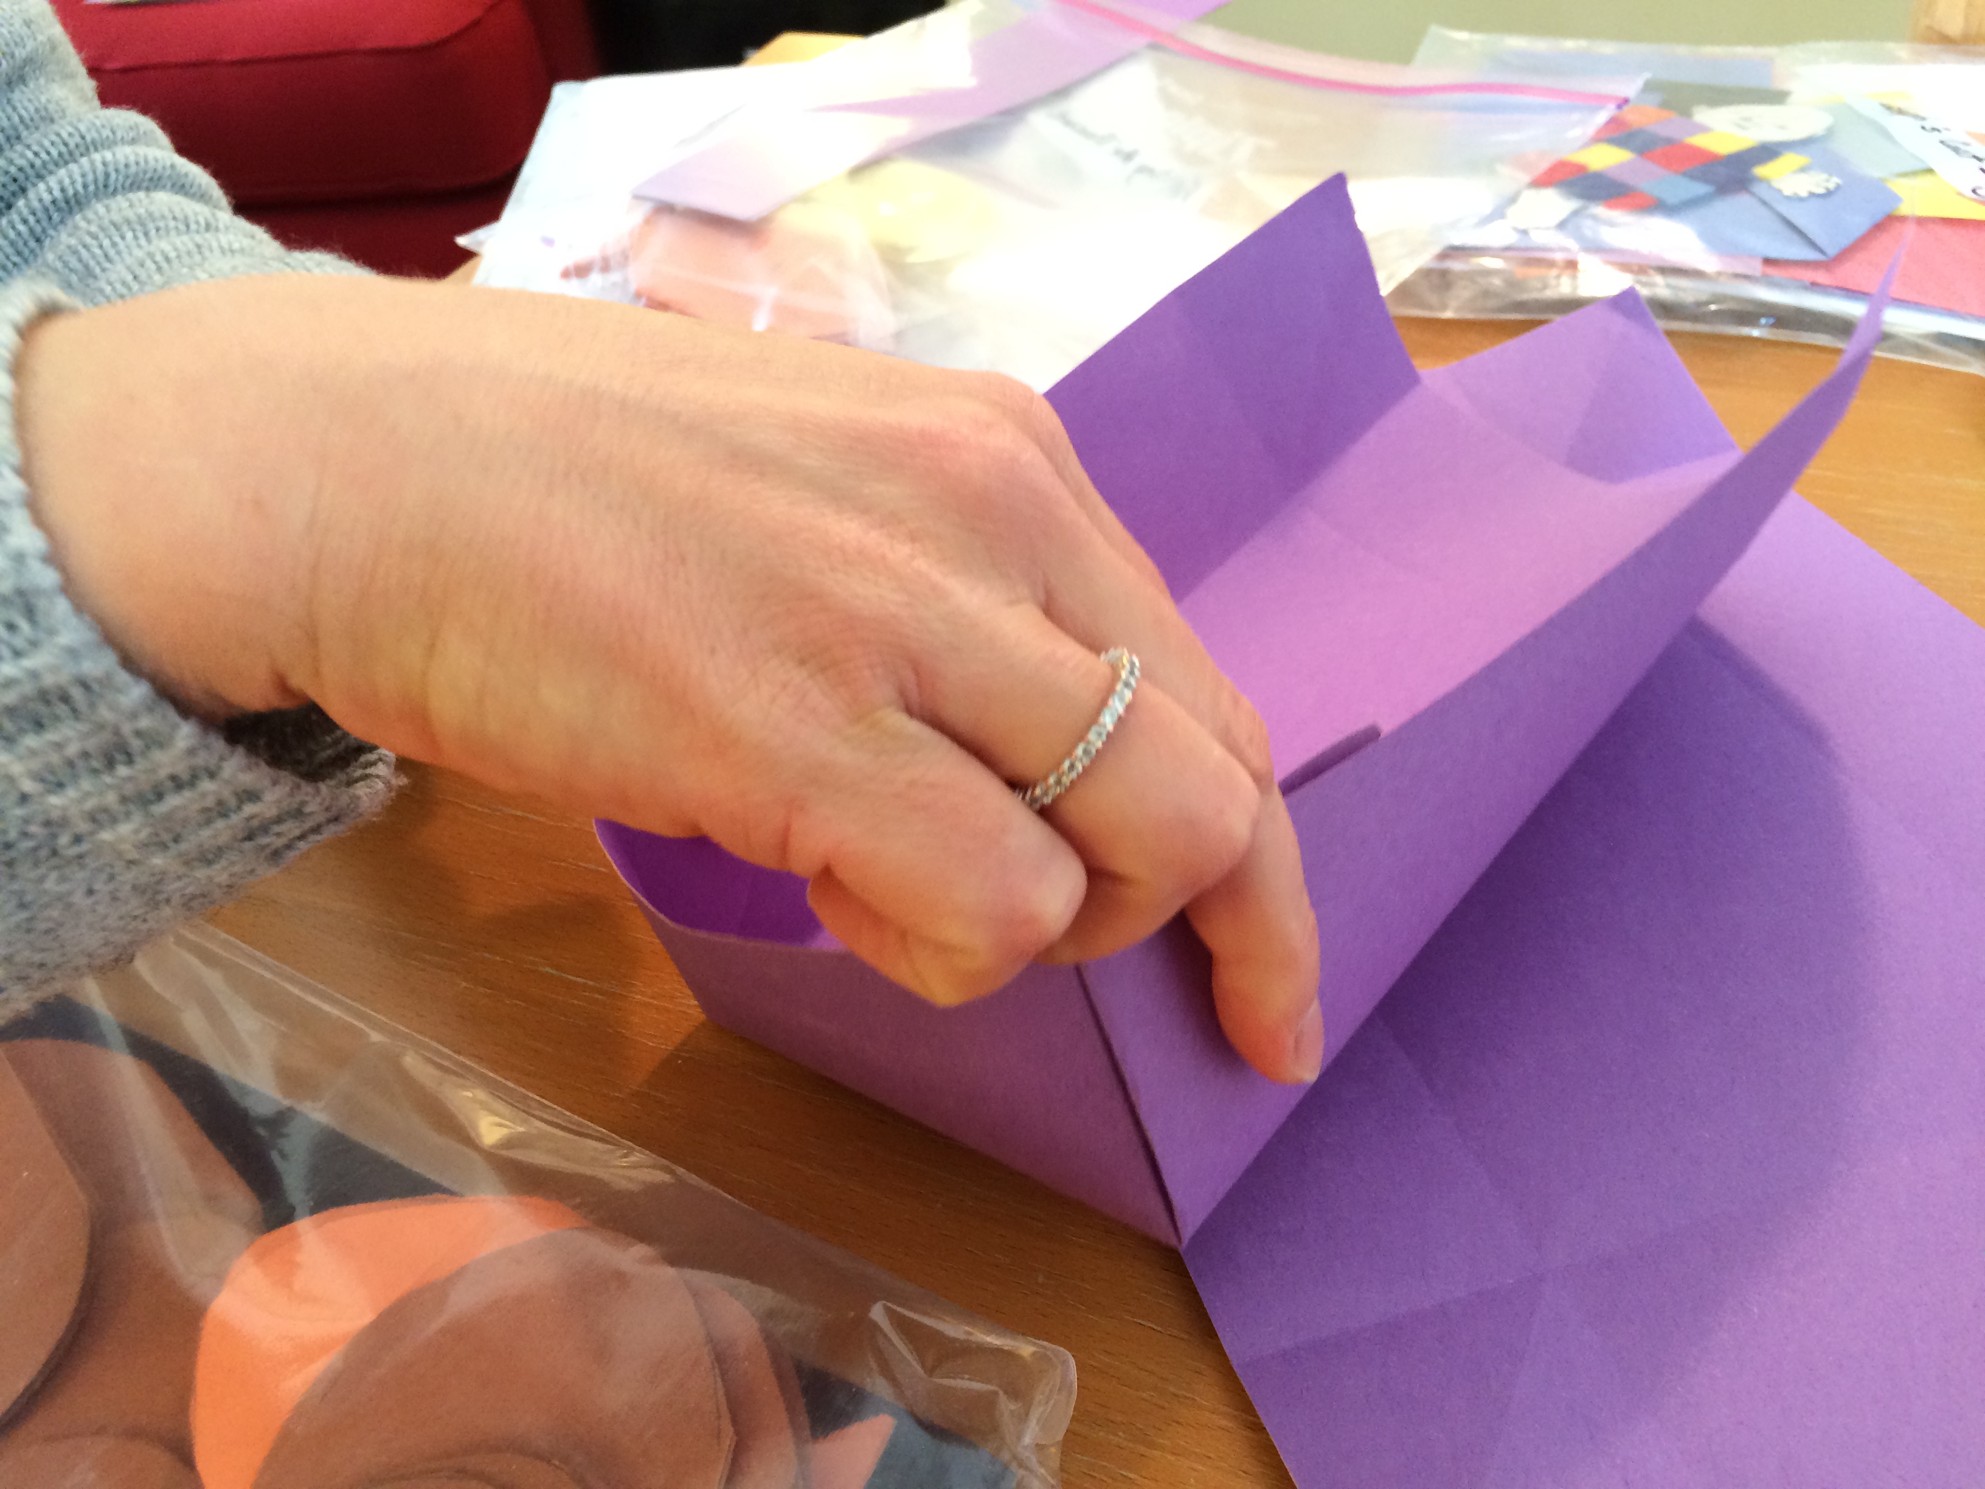

Cut out multiple loaves of bread or single ones:

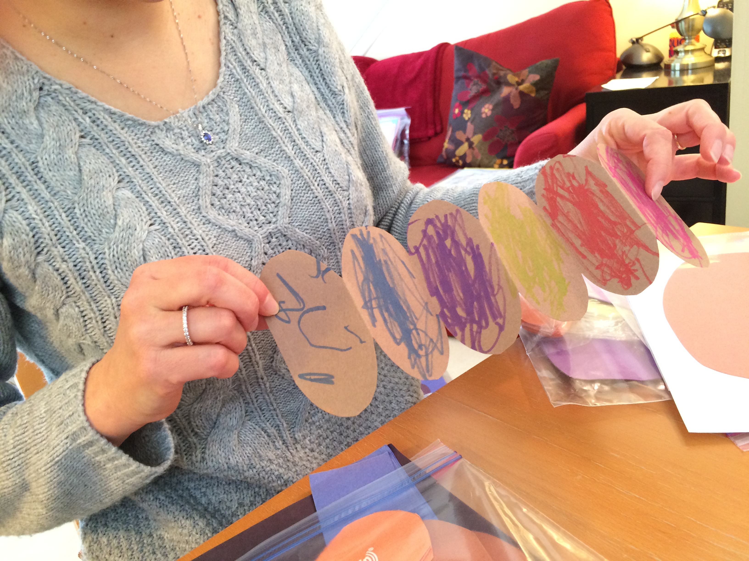

Here is another way to make a basket. Be sure and slit the top so the bread will fit into it:

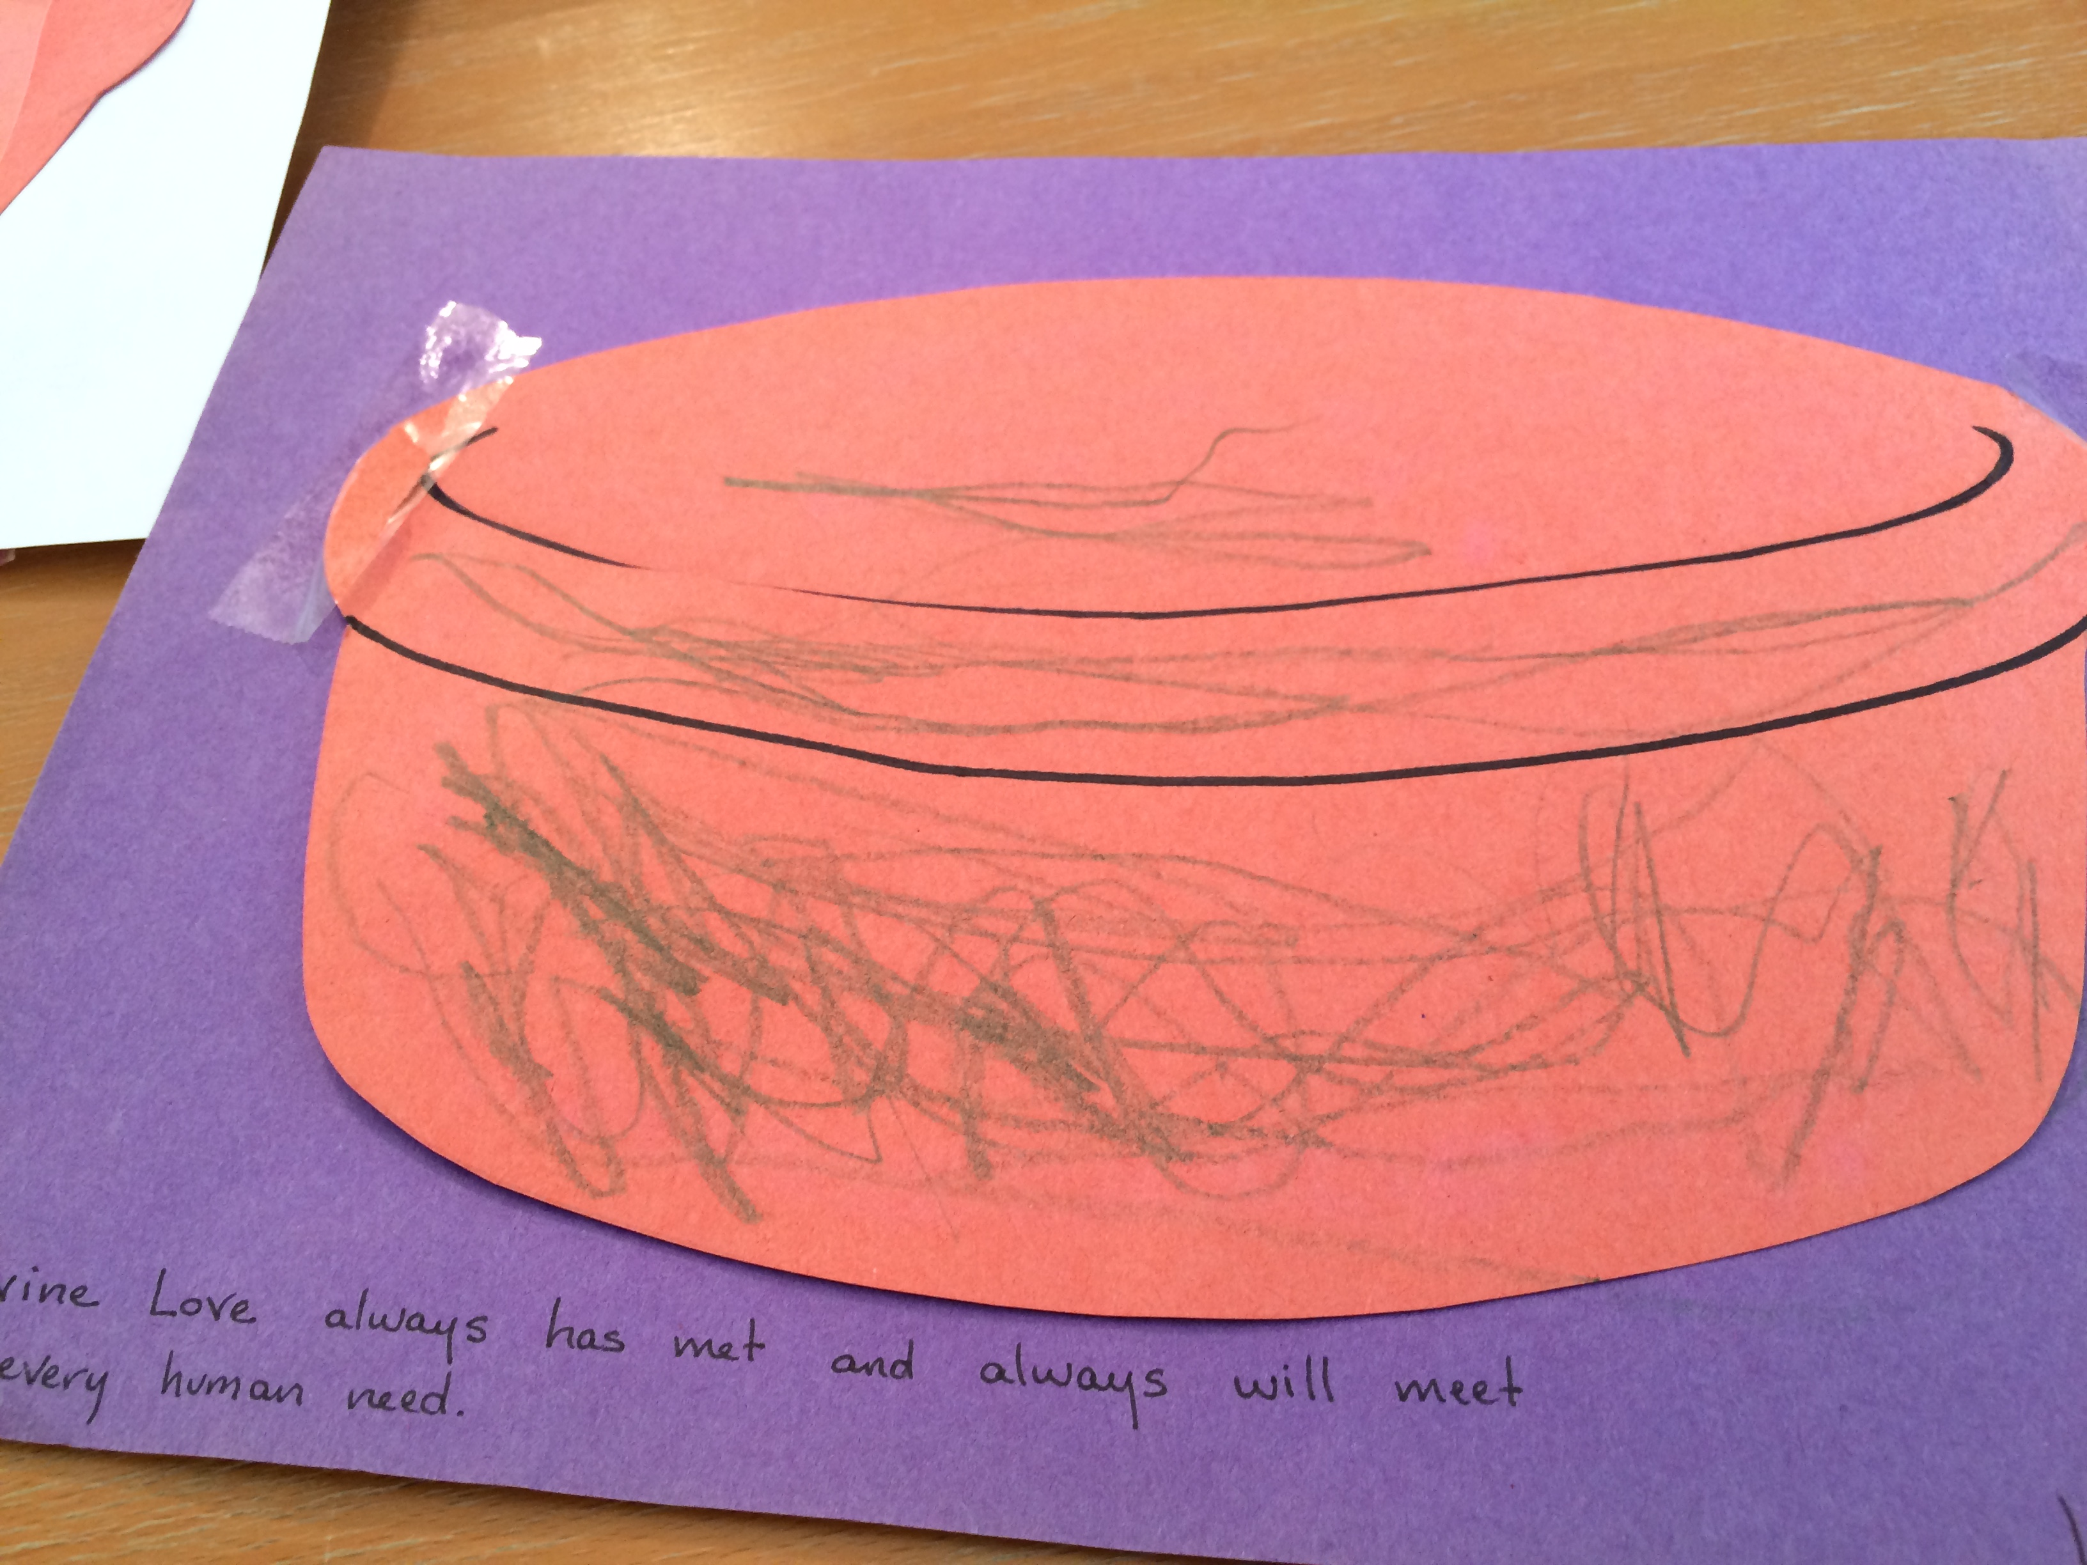

Put the bread in your basket along with the fish:

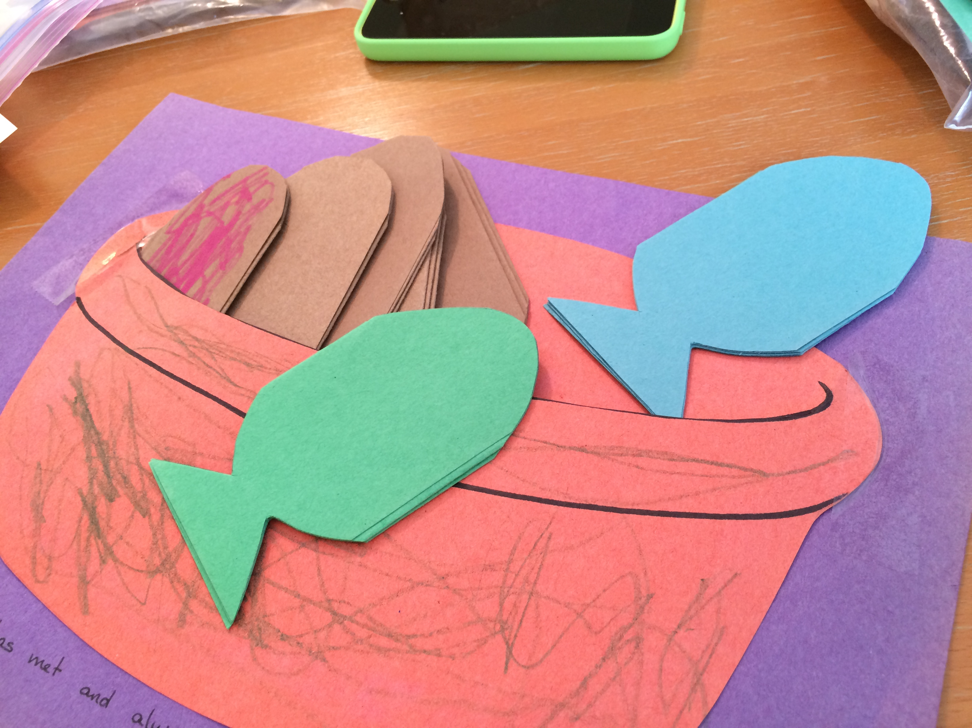

One teacher brought in 5,000 M&M’s so the children could understand how many people that might have been.

