BIBLE BOOKS FOR PRESCHOOL PARENTS: Parents of preschool children can begin a wonderful Bible study time by reading the Bible stories out of some marvelous beginning Bibles. A parent can start with Bibles that have cartoon pictures, and simple words, and graduate up to more realistic illustrations. A parent can even just ‘tell’ the story to their child, showing the pictures, with the King James Version open in their lap.

When students begin to read, one can read the story out of the King James Bible along with the beginning versions of the Bible and share the stories that way. Before bed, is a good time to read a few of these familiar narratives, and talk about the values and principles in them with your child, perhaps right before he/she falls asleep.

There are hundreds of Bibles to choose from, and you can look at Amazon.com or go to a bookstore to find them, but here are some I’ve found:

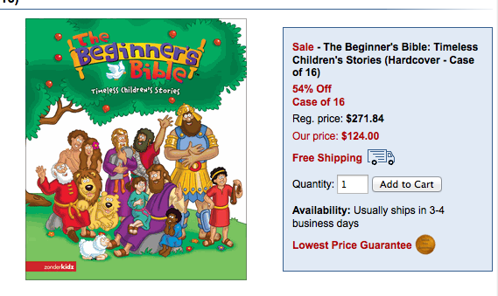

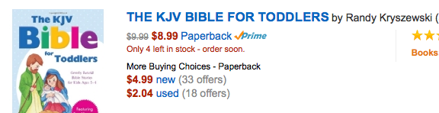
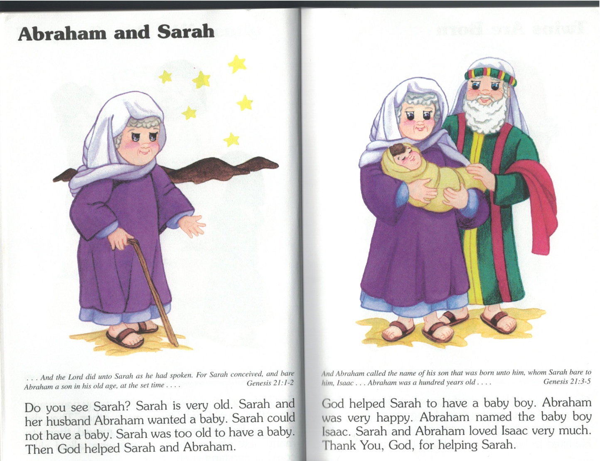

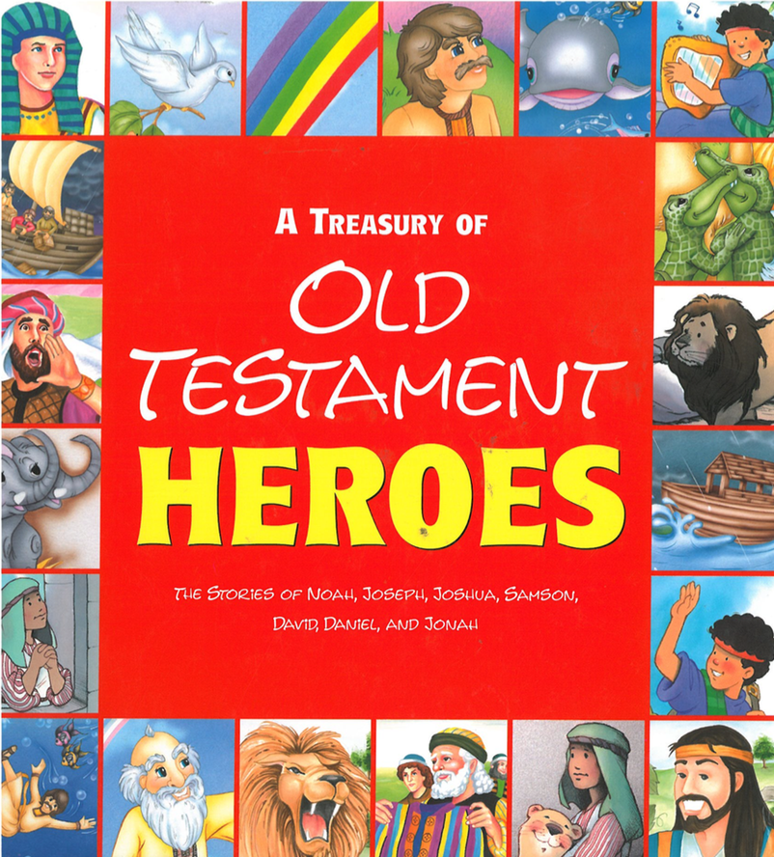

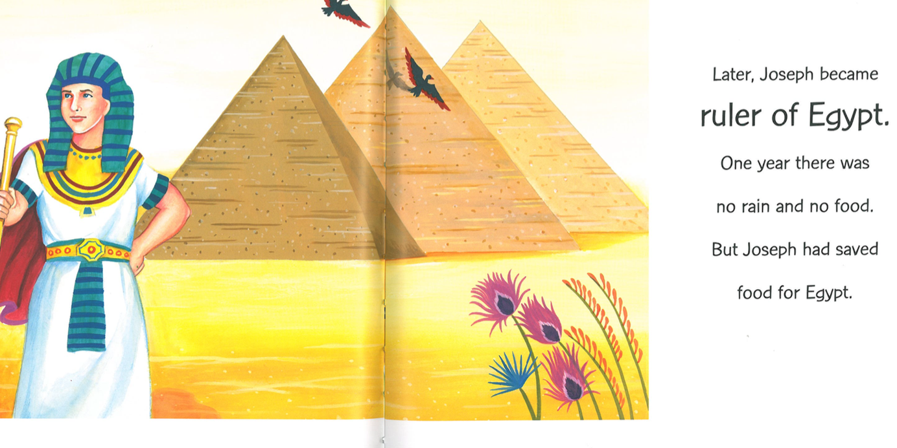

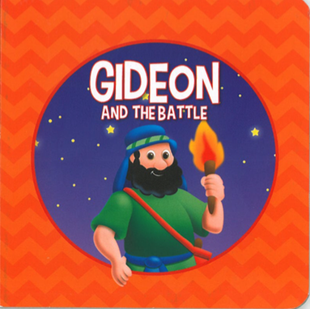

(From the “Dollar Store” for $0.50; there were numerous titles)

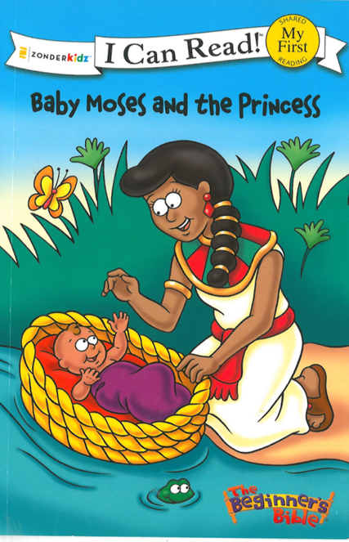(These “I Can Read” books have many, many bible stories.)
