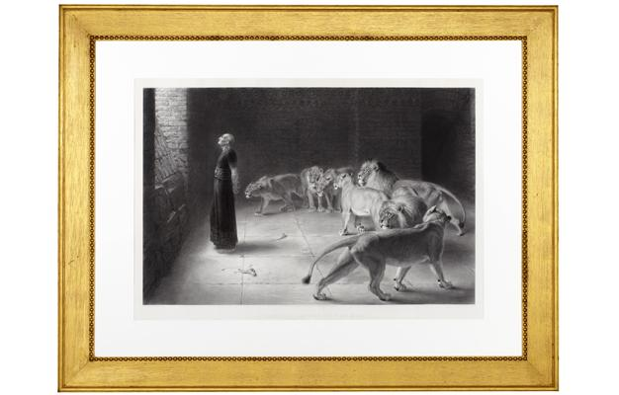
Daniel’s Answer to the King (engraving by Joseph Bishop Pratt)

“I thank you, a million times I thank you for that wonderful picture,” Mrs. Eddy wrote to Julia Field-King (F00110), who gave her this engraving. The story of Daniel in the lion’s den had been a favorite of Mrs. Eddy’s since childhood, and she drew strength from it throughout her life.

Emma Easton Newman wrote in her reminiscence, “It was just at this time that she had received the picture of ‘Daniel’s answer to the King’ and she invited us into the library and asked us to sit down while she ‘talked it to us.’ She pointed out that Daniel had turned his back to the lions and was giving his answer to the king. She said, ‘He has turned his back to the lower or bestial elements of mortal mind and is giving his answer to the king, to the highest, and that is what I have always done.’”

In 1902, Mrs. Eddy showed the painting to a group of visitors at her home, explaining that “when error seemed to press her exceptionally hard, she would leave her work for a few minutes and come and stand before this picture, and study anew the calm and loving manner in which Daniel looked steadfastly to God and God only. He paid no heed to the lions or seeming danger, letting his dear heavenly Father care for the ferocious beasts and keep them at a safe distance. With new and fresh courage, she said, she would return to her work, with a heart full of joy and gratitude for His protecting care.” (From the Methodist Pulpit into Christian Science, p. 157)

She also used the painting to offer encouragement to another student: “Do not be disheartened or in the least down cast. God, the God of Daniel, is able to deliver thee. Come into my library and look at that picture if at any time you feel like it. I often stand before it praying to the same God for grace to help me and all the sufferers and sinners of Adam’s race.” (L10569).

