Lion ^{*Cupcakes}  Ingredients  - Cupcakes (see below for a recipe if wishing to start from scratch!)  - Plain Icing  - Tube of decorating gel/icing or decorative items such as chocolate chips  - Caramel Popcorn | 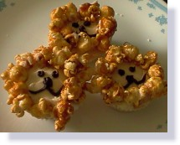
Method
- Spread icing on top of cake.
- Create eyes and mouth using decorating icing or chocolate chips.
- Place caramel popcorn around face for a mane.
Story
- Daniel in the Lion's Den

