Jesus Walks on the Water

Take one full sheet of construction paper for a background. (purple in the picture)
Cut out two sets of waves and glue one down at the bottom of the background.

Glue the other only on the far right side and the left side (so that there is a big open space between the sides for the figure to walk through.

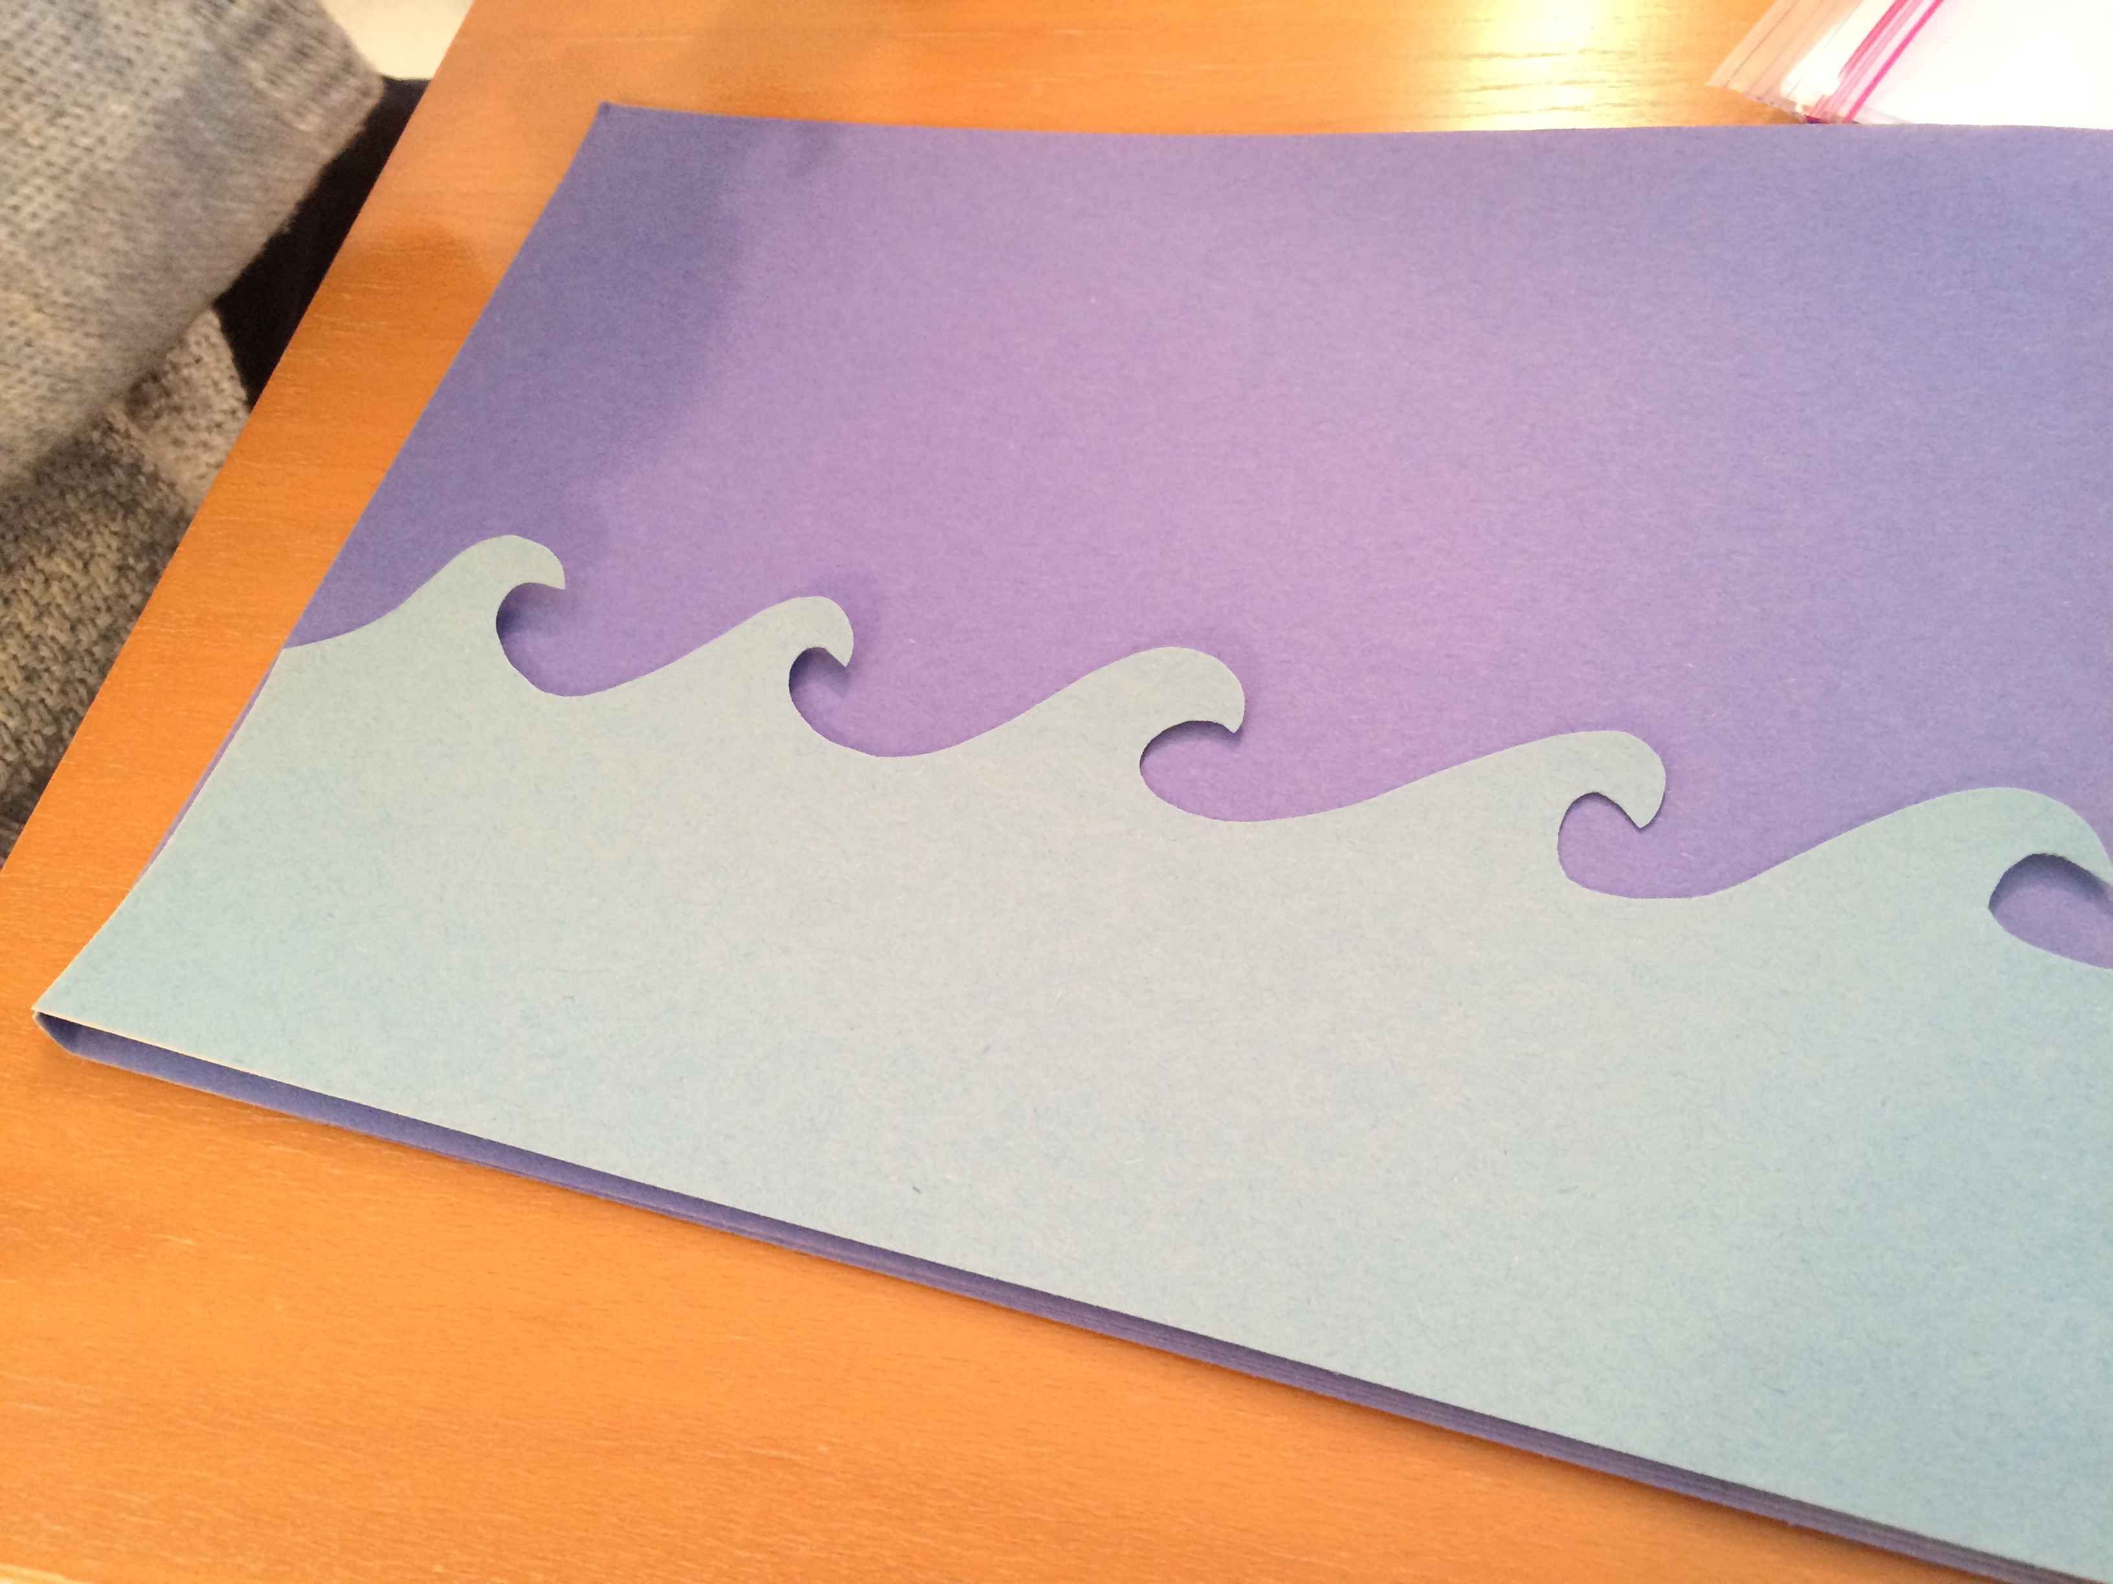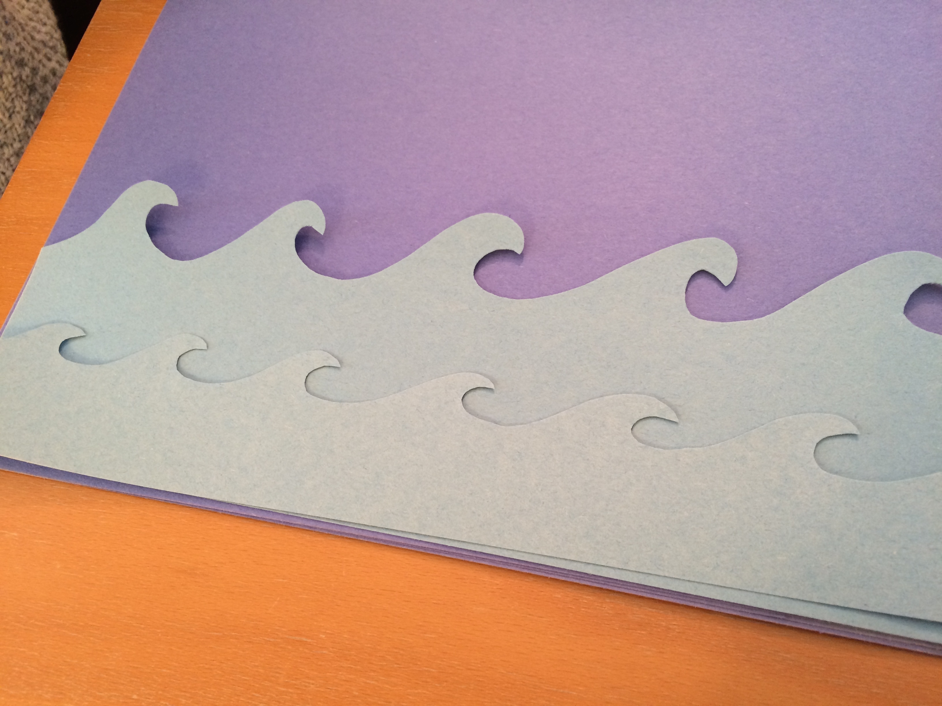

Make a boat out of construction paper. Let the child glue the pieces of the boat together.

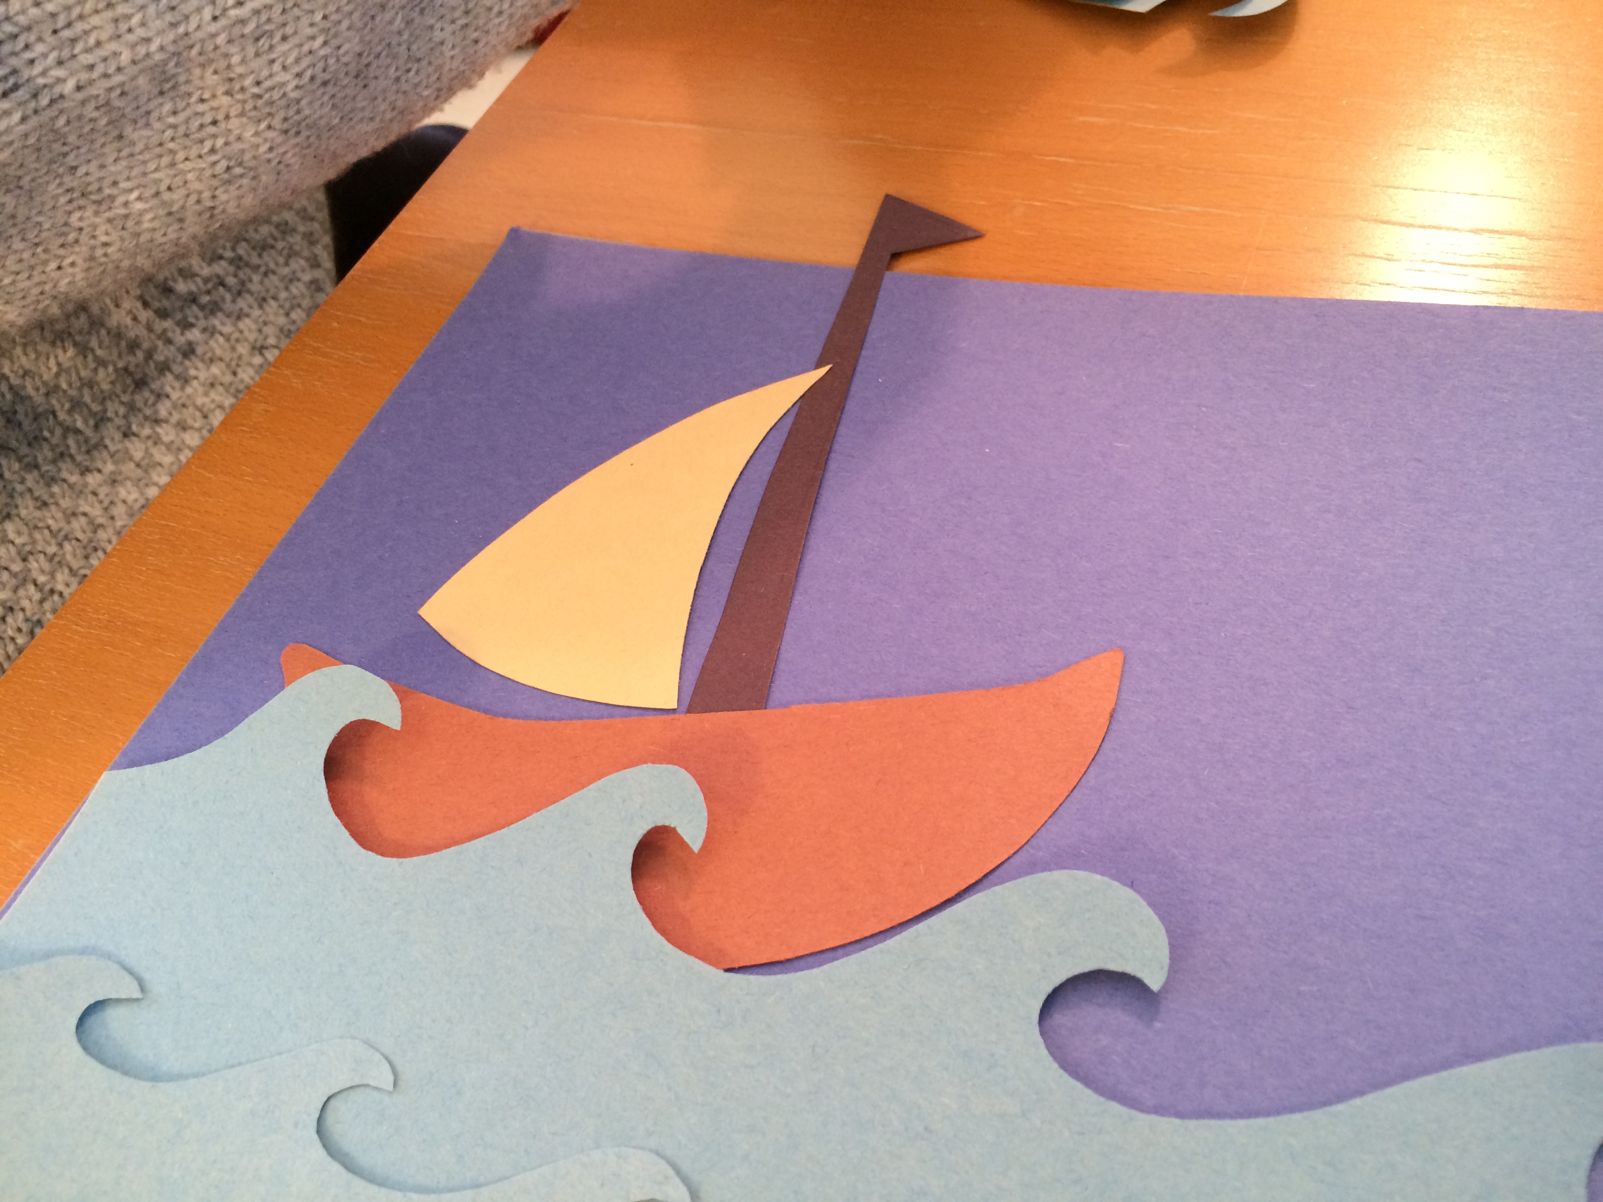

Make a stick puppet of Jesus and tape him to a straw. Slide him between the waves and let him walk on and over the waves while you retell the story.

