Moses and the Ten Commandments: (idea from Sara Borja)

Sara always tries to find some kind of book that contains the story she wants to teach. She has a library of about fifty Children’s Books of Bible stories, some with the whole Bible, and some that have just the one story. She looks for these all the time.

After reading the story of the Ten Commandments and talking about the event, she also talks about the rules that we follow. She uses something like street signs. She even brings little cars, with a road drawn out on paper, to show what would happen if the cars didn’t follow the rules.

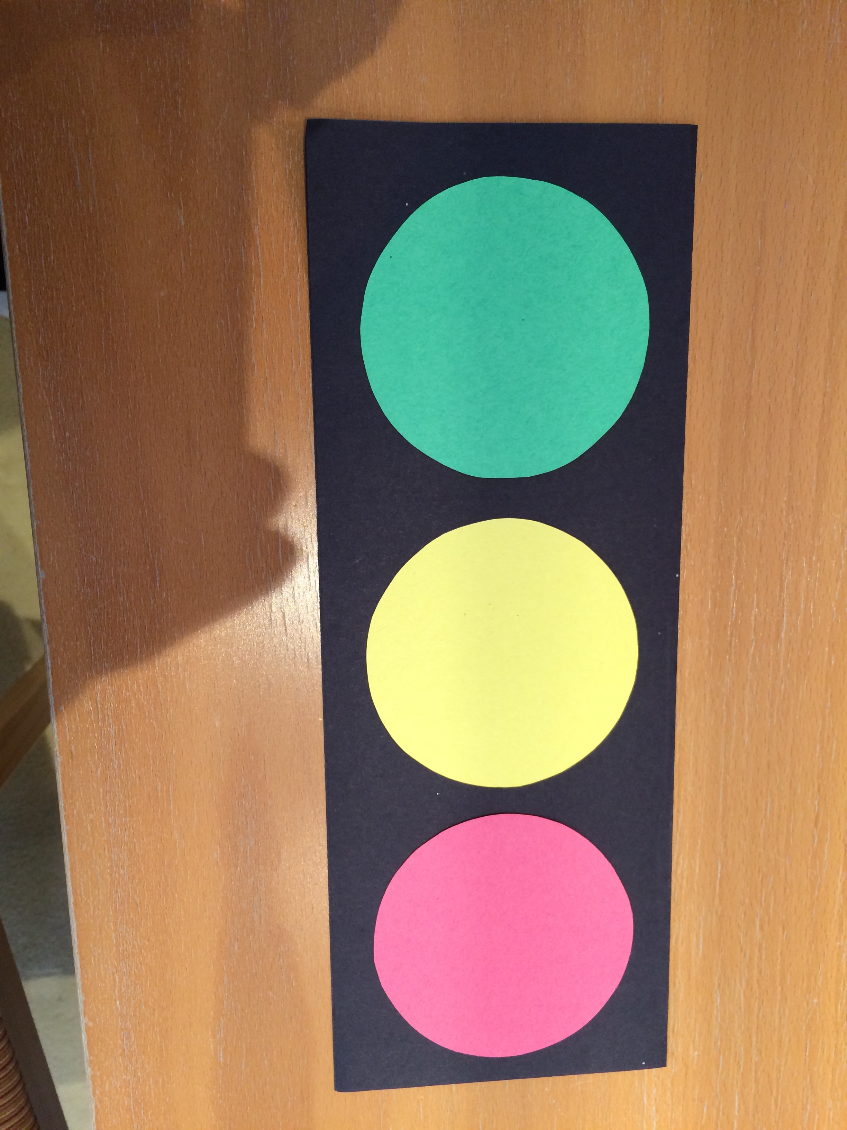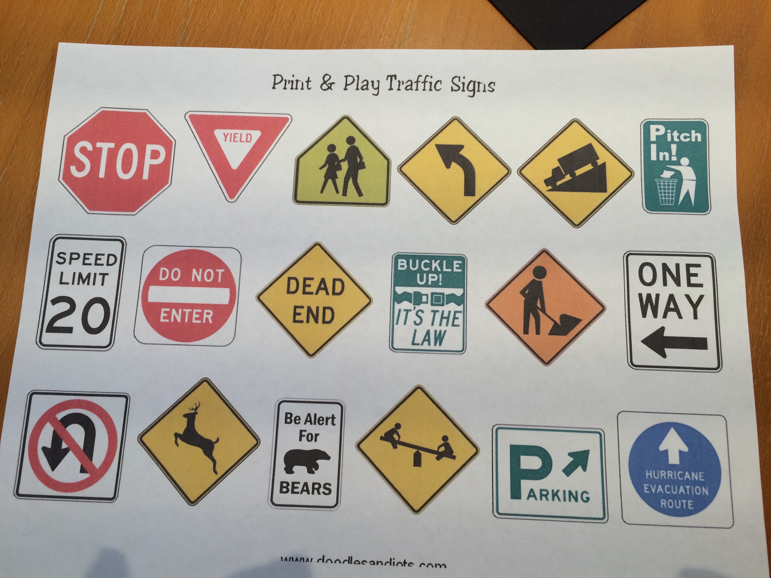

Next she takes a piece of construction paper, and with a precut section of a hillside and Moses, she has the students color his coat and with a glue stick, glue on the pieces.

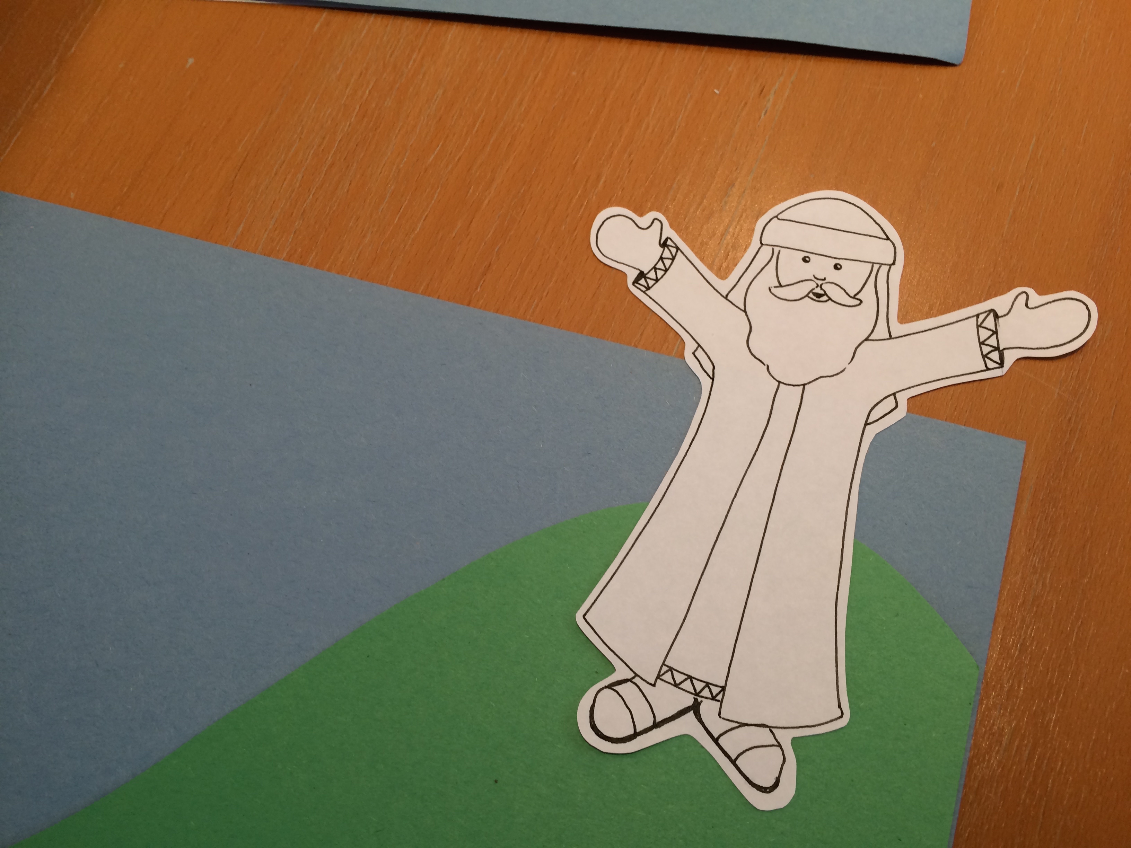

She has made the stones of the Ten Commandments out of tan paper and writes numbers 1-5 on one tablet and 6-10 on the other tablet.

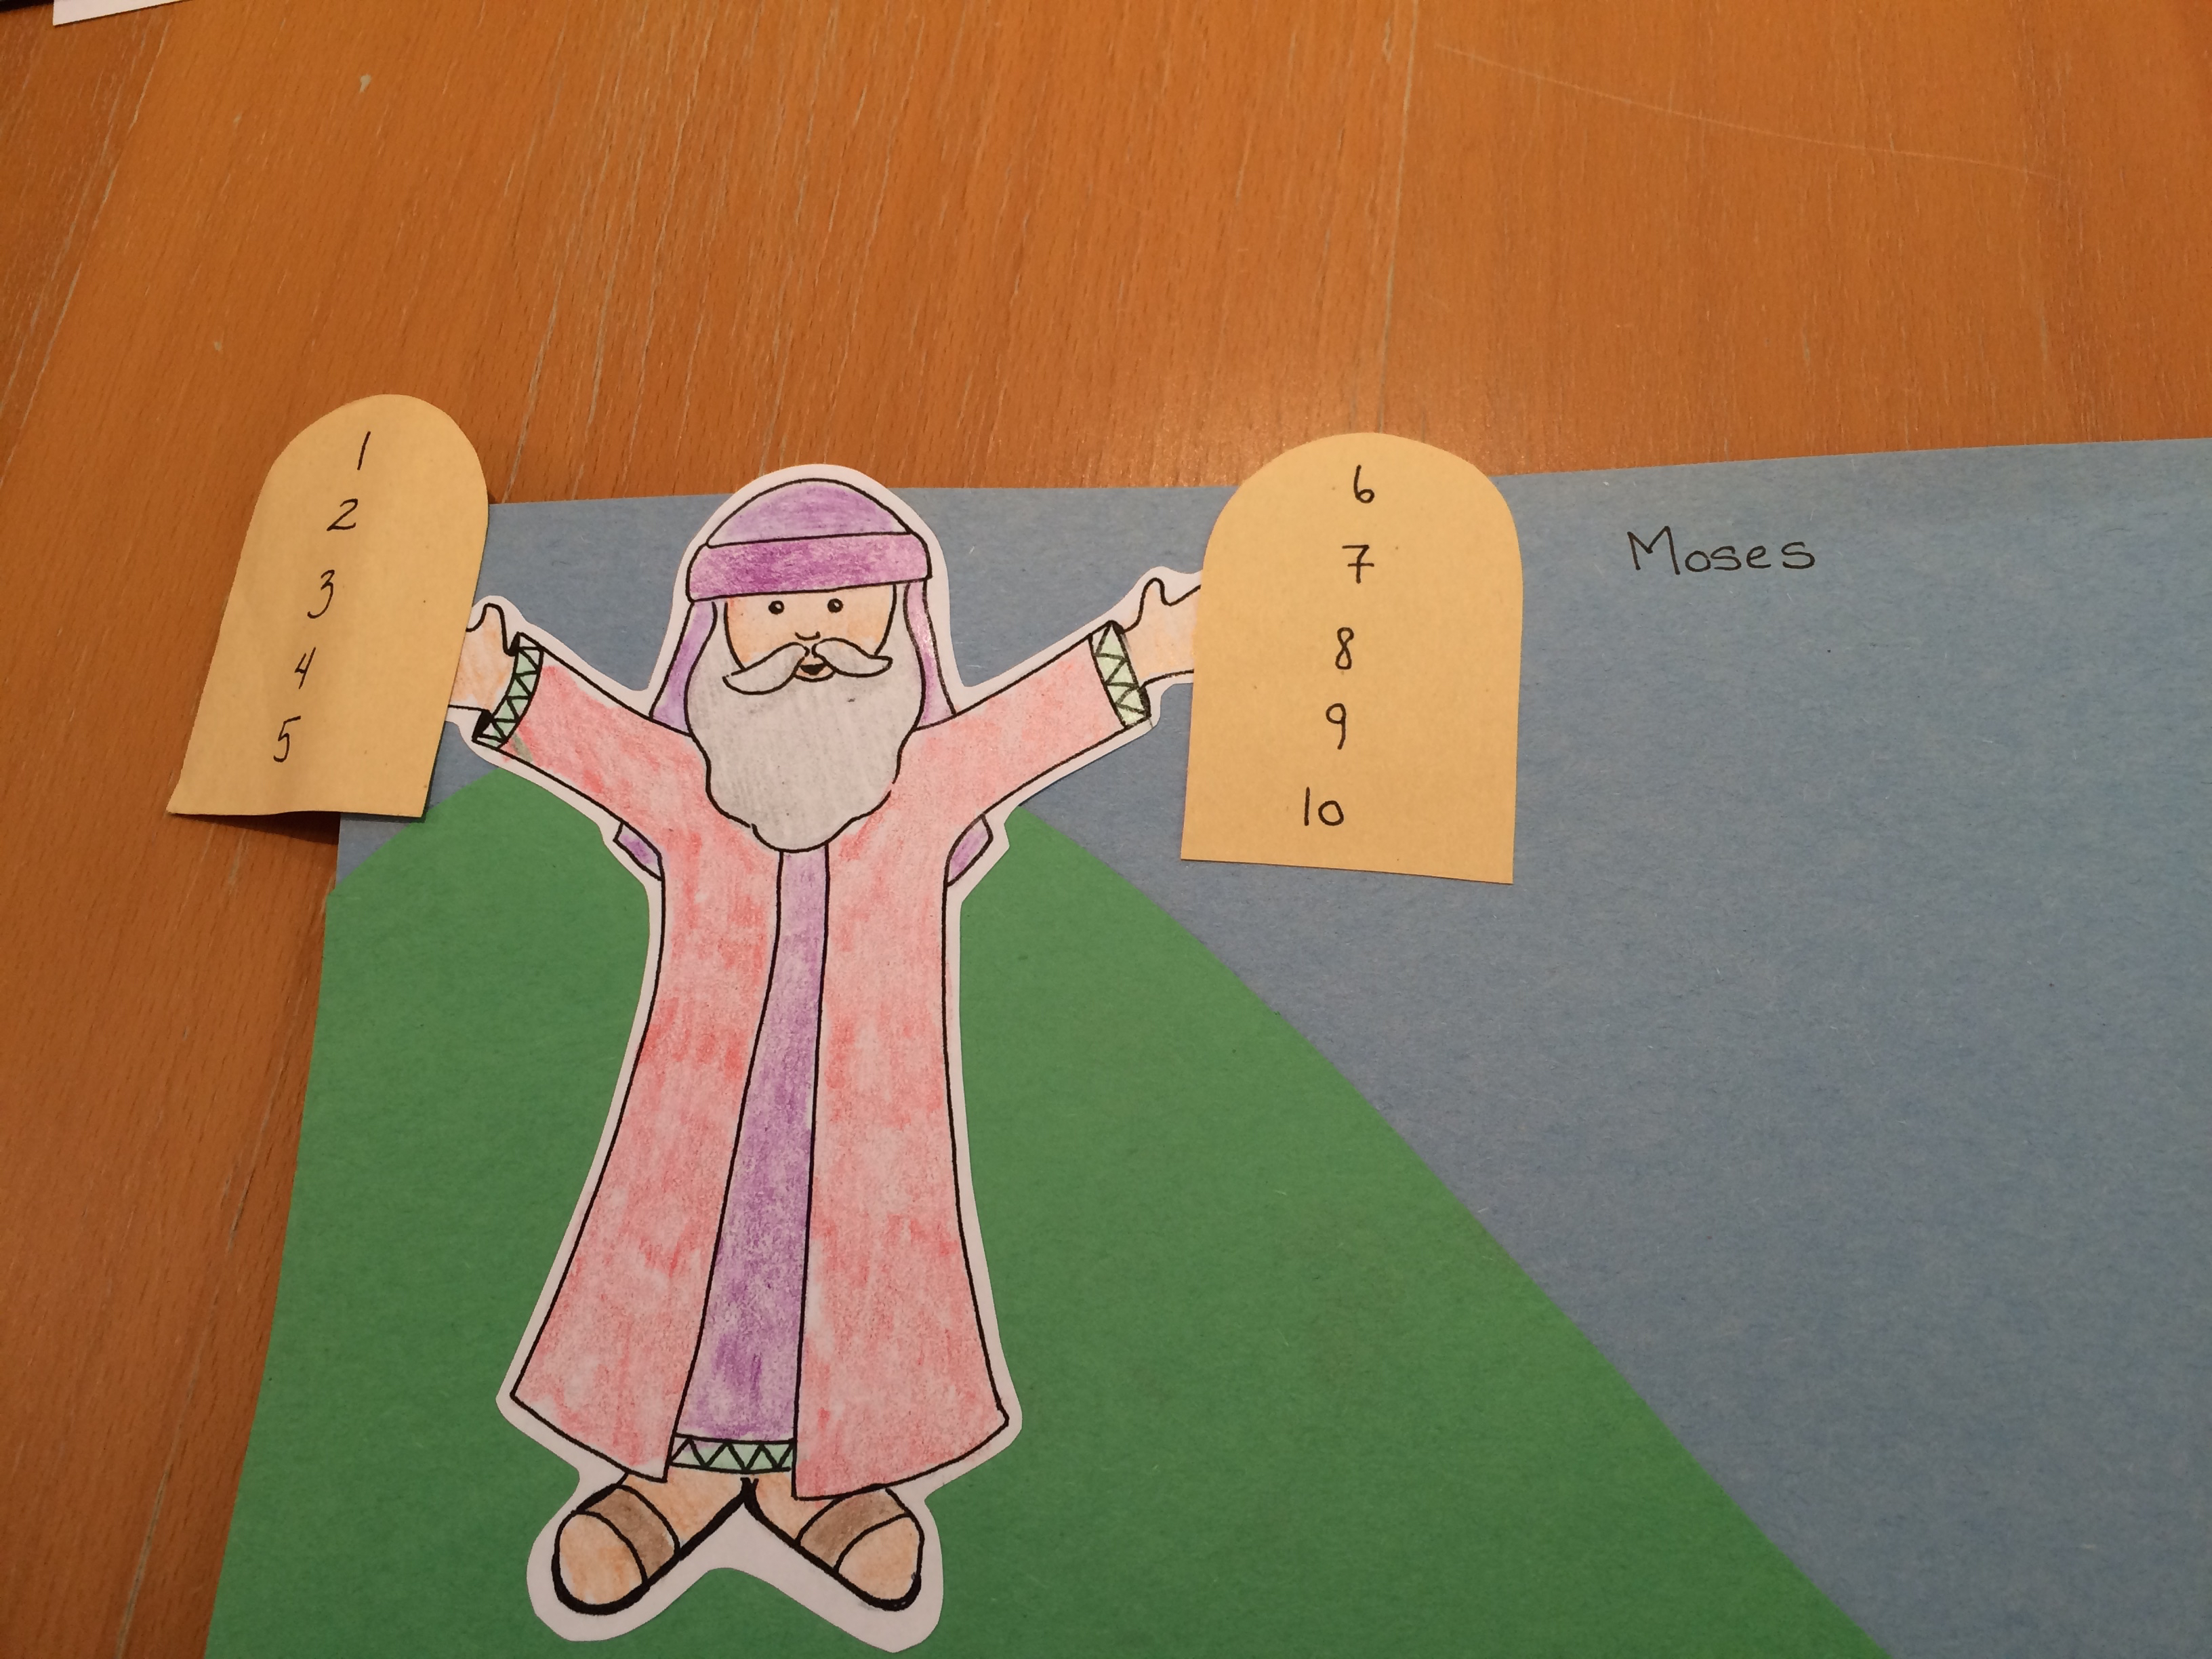

Sara created a little song to go with the project. Children walk their fingers up the green mountain for the verse and down the mountain for the second verse.

Moses and the Ten Commandments Song
(Sung to the tune of “Mary had a Little Lamb”)
Up the mountain Moses went,
Moses went,
Moses went,
Up the mountain Moses went, to listen to God.

Down the mountain Moses went,
Moses went,
Moses went,
Down the mountain Moses went, with the Ten Commandments.

Another addition would be to make a very large set of the stones, with the commandments written out on them, even though they can’t read. Be sure and have the numbers next to the commandments, so they can be referred to.

