Research on: Gethsemane

Matt 26:18, 36, 39-41, 45

18 The Master saith, My time is at hand; I will keep the passover at thy house with my disciples.

“Jesus’ words “My appointed time is near” were probably purposely ambiguous. To the disciples and the owner of the house, they might have implied Jesus’ timing for the Passover meal and prior arrangements for it. In the light of Easter, the words must refer to the now impending Crucifixion, the fulfillment of Jesus mission. . . Jesus is directing his disciples to prepare the way for the Last Supper and his death and demonstrates that he is quietly and consciously taking the steps to complete his mission of tragedy and glory” (EBC.8.533).

36 Then cometh Jesus with them unto a place called Gethsemane, and saith unto the disciples, Sit ye here, while I go and pray yonder.

“Gethsemane = “oil press”, it is the name of the place at the foot of the Mount of Olives, beyond the Kidron Valley” (www.blueletterbible.org).

“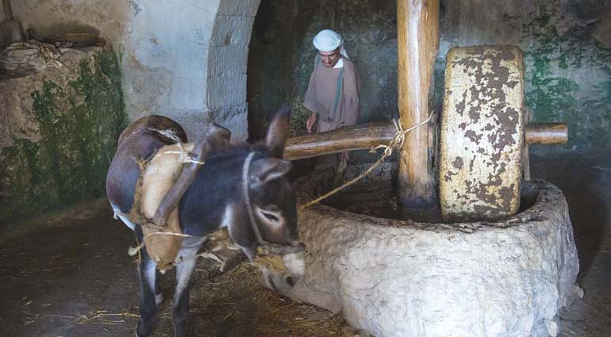

“Jesus and his disciples often frequented this spot on the western slopes of Mount Olivet, separated from Jerusalem by the Kidron Valley. Eight disciples remain at some distance, perhaps outside the enclosure, and the inner three join him. Jesus with stern self-control has so far masked his anguish; now he begins ‘to be sorrowful’ which connotes deep grief and ‘troubled’ which connotes deep distress ((EBC.8.533).

39 And he went a little farther, and fell on his face, and prayed, saying, O my Father, if it be possible, let this cup pass from me: nevertheless not as I will, but as thou wilt.

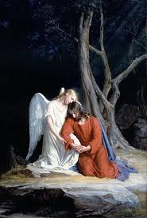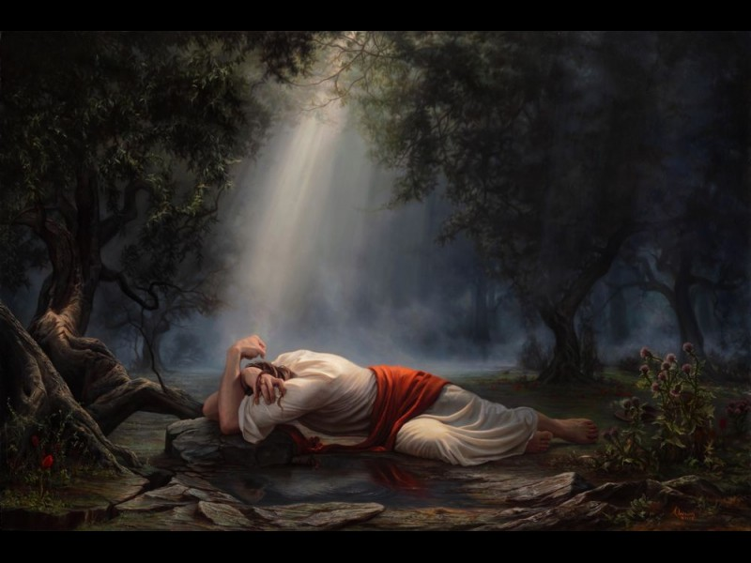

“He went a little farther.—St. Luke adds (Luke 22:41) “about a stone’s cast.” The eight were left, we may believe, near the entrance of the garden; the three, “apart by themselves,” further on; the Master, still further, by Himself. The three heard the words that came from His lips as with a half-consciousness which revived afterwards in memory, but they were then numbed and stupefied with weariness and sorrow. It was now near the dawning of the day, and their eyes had not closed in sleep for four-and-twenty hours” (Ellicot’s Commentary, www.biblehub.com).

“He first kneeled, and then, in the fervency of his prayer and the depth of his sorrow, he fell with his face on the ground, denoting the deepest anguish and the most earnest entreaty. This was the usual posture of prayer in times of great earnestness.

“Let this cup: These bitter sufferings. These approaching trials. The word cup is often used in this sense, denoting sufferings.” (Barnes’ Notes, www.biblehub.com).

“The ‘cup’ refers not only to suffering and death but, as often in the OT – our lot” (EBC.8.544).

“We read in Scripture of sitting, standing, kneeling, and prostration used in prayer; the first and last rarely; standing and kneeling were the most ordinary postures David prayed sitting in his house, 2 Sam. 7:18, Abraham fell on his face, Gen. 17:17, so did Moses and Aaron, Numbers 16:22. Prostration was ordinarily used in great passions” (Matthew Poole’s Commentary, www.biblehub.com).

“Cup is poterion in Greek which means a drinking-vessel; metaphorically, one’s lot or experience, divine appointments, whether favorable or unfavorable, are likened to a cup which God presents one to drink” (blueletterbible.org).

40 And he cometh unto the disciples, and findeth them asleep, and saith unto Peter, What, could ye not watch with me one hour?

“And he cometh unto the disciples — Unto the three from whom he had withdrawn himself a little way; and findeth them asleep — Notwithstanding the distress they saw him in, and the strict command that he had given them to watch. It seems a supernatural heaviness had fallen upon them. And saith unto Peter, What, could ye not watch with me one hour? — According to Mark, (who must be considered as peculiarly accurate in what relates to Peter, his gospel having been revised by that apostle,) Christ addressed himself especially to Peter, saying,Simon, sleepest thou? couldst not thou watch one hour? — “ (Benson Commentary, www.biblehub.com).

“Watch in Greek is gregoreo which means to watch; metaph. Give strict attention to, be cautious, active, take heed lest through remission and indolence some calamity suddenly overtake one; be vigilant, be awake; watchful” (www.blueletterbible.org).

41 Watch and pray, that ye enter not into temptation: the spirit indeed is willing, but the flesh is weak.

“It is doubtful that ‘so that you will not fall into temptation’ means only ‘so that you will stay awake and not fall into the temptation to sleep.’ Indeed, if Jesus’ prediction of their spiritual defection that ‘very night’ should have served as an urgent call to prayer. So now he tells them that only urgent prayer will save them from falling into the coming ‘temptation’. Even in his own extremity, when he needs and seeks his Father’s face, Jesus thinks of the impending but much lesser trial his followers will face. He speaks compassionately: ‘The spirit is willing, but the body (sarx in Greek = flesh) is weak.’ This is not a reference to the Holy Spirit but makes a ‘distinction between man’s physical weakness and the noble desires of his will. But though compassionate, these words, which doubtless hark back to v. 35, are not an excuse but a warning and incentive. Spiritual eagerness is often accompanied by carnal weakness – a danger amply experienced by successive generations of Christians” (EBC.8.533).

45 Then cometh he to his disciples, and saith unto them, Sleep on now, and take your rest: behold, the hour is at hand, and the Son of man is betrayed into the hands of sinners.

“Sleep on now, and take your rest. The hour of the Passion is near: it is too late to pray and gain strength for the temptations ahead. His disciples may as well sleep. The Son of Man is betrayed into the hands of sinners: he who is the resplendent, messianic King takes the path of suffering. Doubtless Jesus could see and hear the party approaching as it crossed the Kidron Valley with torches and climbed up the path to Gethsemane. The sleepers for whom he would die have lost their opportunity to gain strength through prayer. By contrast Jesus has prayed in agony but now rises with poise and advances to meet his betrayer” (EBC.8.533).

