The Christmas Story

Book to purchase with pictures using the King James Version:

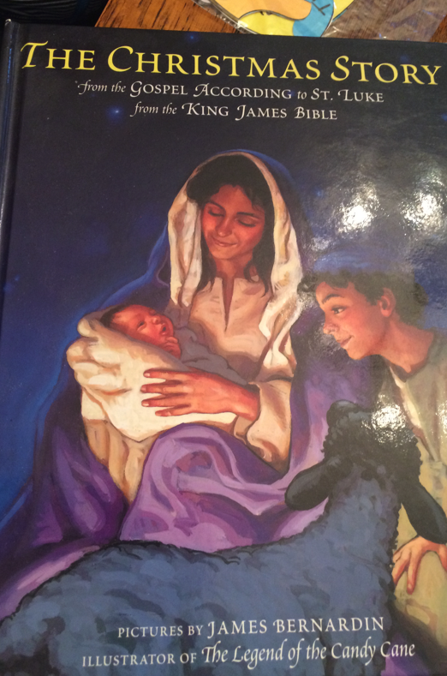

Take a brown folder and make a stable out of it for each child.
Find Christmas Story stickers for each child.
Have them place the stickers on the stable as the story is told.

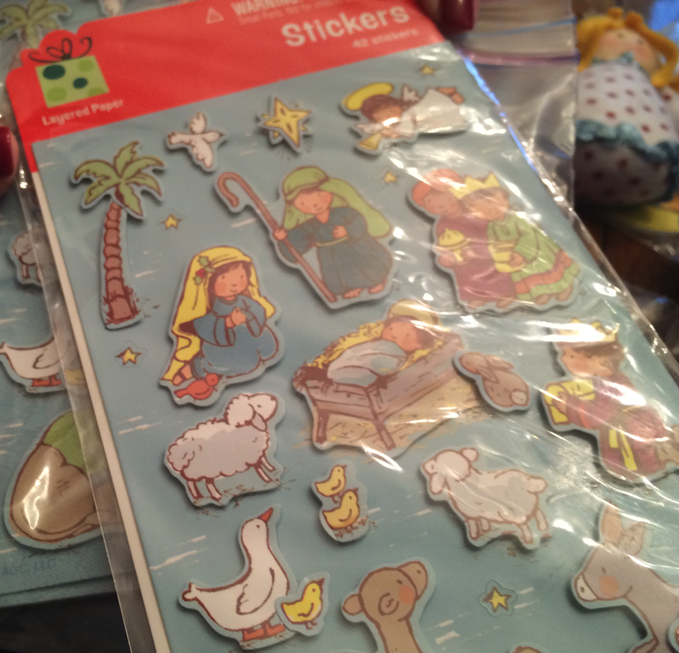

Purchase a Nativity set appropriate for preschool. Here is an example:

