Research on: Annunciation of Mary (angel Gabriel)
The Annunciation has been a key topic in Christian art in general, particularly during the Middle Ages and Renaissance.
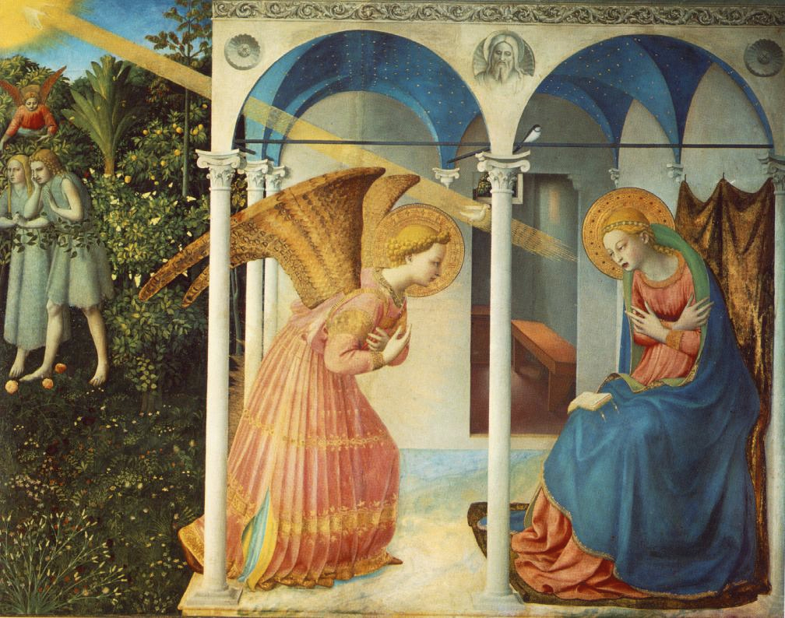
Painting by Fra Angelico) Painting by Henry Ossawa Tanner

Luke 1:26-28, 30-32, 34, 35, 38
26 And in the sixth month the angel Gabriel was sent from God unto a city of Galilee, named Nazareth,
In the sixth month refers to Elisabeth’s pregnancy. She had hid herself for the first half of the pregnancy.
Angel in Greek is angelos which can be translated “messenger” (Strong 32). Gabriel also appears in Daniel 9:22.
27 To a virgin espoused to a man whose name was Joseph, of the house of David; and the virgin’s name was Mary.
Luke tells us specifically that Mary is a virgin. The word in Greek is parthenos (Strong 3933). It is a word much more defined in Greek than its Hebrew counterpart, alma, which can mean simply “a young girl.”
See also Mrs. Eddy’s references regarding the Virgin Mother:
S&H 332:23
S&H 29:14
Ret.70:8
Un. 29:28
My. 261:27
Espoused in Greek means “engaged.” This is a legal contract period prior to marriage. If the contract were to be broken, severe penalties could be carried out.
The name Mary is from the Hebrew Miryam. Though scholars have differing views on the meaning of the Hebrew name, we do know that yam means “sea” in Hebrew. Some believe the name Miryam may have its origin in Egypt – Merari – which means “beloved.” Others think the name derives from the Hebrew verb mara meaning “to be rebellious” (Strong 4813). Another possibility is that Miryam derives from meri (bitterness, rebellion – Strong 4805).
28 And the angel came in unto her, and said, Hail, thou that art highly favoured, the Lord is with thee: blessed art thou among women.

“Hail - This word of salutation is equivalent to "Peace be with thee," or "Joy be with thee;" a form of speech implying that she was signally favored, and expressing joy at meeting her.
“Highly favoured - By being the mother of the long-expected Messiah - the mother of the Redeemer of mankind. Long had he been predicted; long had the eyes of the nation been turned to him, and long had his coming been an object of intense desire” (Barnes’ Notes, www.biblehub.com).

29 And when she saw him, she was troubled at his saying, and cast in her mind what manner of salutation this should be.

“Troubled at his saying - Disturbed or perplexed at what he said. It was so unexpected, so sudden, so extraordinary, and was so high an honor, that she was filled with anxious thoughts, and did not know what to make of it” (Barnes’ Notes, www.biblehub.com).

30 And the angel said unto her, Fear not, Mary: for thou hast found favour with God.
The angel Gabriel calms Mary by saying “Fear not.” She is immediately reassured by the promise that she has found favour or “grace” with God.
31 And, behold, thou shalt conceive in thy womb, and bring forth a son, and shalt call his name JESUS.
Mary is to name the child, not Joseph (as in Matthew’s account). The name Jesus is a transliteration of the Hebrew Joshua. The Hebrew name Joshua means “Jehovah is salvation” – hence the meaning of Jesus as Savior.
32 He shall be great, and shall be called the Son of the Highest: and the Lord God shall give unto him the throne of his father David:
He shall be “great in power, in wisdom, in dominion, on earth and in heaven” (Barnes 184).
Son of the Highest – that is, to say “Son of God.”
34 Then said Mary unto the angel, How shall this be, seeing I know not a man?
To know is a Semitism for sexual relations. Mary asks how is this to be since she has had neither a husband nor relations with a man.
35 And the angel answered and said unto her, The Holy Ghost shall come upon thee, and the power of the Highest shall overshadow thee: therefore also that holy thing which shall be born of thee shall be called the Son of God.
Luke answers Mary’s “how” question. Gabriel says that the Holy Ghost or Holy Spirit will come upon her, and power from the most High will overshadow her. The child to be born is to be called “holy” – the Son of God. Spirit is the creative power.
Jesus’ humanhood is pure, free from corruption (Barnes 184).
Mrs. Eddy writes, “The more I understand true humanhood, the more I see it to be sinless . . . ” (Un. 49:8).
This is not fulfillment of a request by a woman who wants a child; this is God taking the initiative. The child is the holy Son of God.
38 And Mary said, Behold the handmaid of the Lord; be it unto me according to thy word. And the angel departed from her.
Mary states her willingness to be obedient to God’s word. She is resigned to doing only God’s will. “The conclusion to this scene wraps the mantle of Hannah around Mary as she echoes the words of her OT predecessor: ‘Let thine handmaid find grace in thy sight’ (I Sam. 1:18)” (NIB 9.52).
Sources:

The Anchor Yale Bible: The Gospel According to Luke (i-ix). Introduction, translation and notes by Joseph A. Fitzmyer. New York: Doubleday 1970.

Barnes, Albert. Barnes’ Notes on the New Testament. Grand Rapids: Kregel, 1962.
Barnes, Albert. Barnes’ Notes on the Bible. 1875. Cited by biblehub.com. Accessed on 8-8-14.

Brown, Raymond E. The Birth of the Messiah. New York: Doubleday, 1993.
Eddy, Mary Baker. Miscellaneous Writings, 1883-1896. Boston: The First Church of Christ, Scientist, 1896. Via Concord Online www.concordworks.com

__________. The First Church of Christ, Scientist and Miscellany. Boston: The First Church of Christ, Scientist, 1913. Via Concord Online www.concordworks.com

__________. Retrospection and Introspection. Boston: The First Church of Christ, Scientist, 1891. Via Concord Online www.concordworks.com.

__________. Science and Health with Key to the Scriptures. 1875. Boston: The First Church of Christ, Scientist, 1911. Via Concord Online www.concordworks.com.

__________. Unity of Good. Boston: The First Church of Christ, Scientist, 1888. Via Concord Online www.concordworks.com

The Expositor’s Bible Commentary: Matthew, Mark, Luke. Ed. Frank E. Gaebelein et al. Vol. 8. Grand Rapids: Zondervan, 1984.

Gill, John. Exposition of the Entire Bible. 1746-63. Cited by biblehub.com. Accessed on 8-8-14.

The Interpreter’s Bible. Ed. George Arthur Buttrick et al. 12 vols. New York: Abingdon, 1953
The Interpreter’s Dictionary of the Bible. Ed. George Arthur Buttrick et al. Nashville: Abingdon, 1989.

Jamieson, Robert, A. R. Fausett, and David Brown. A Commentary on the Old and New Testament. Cited by biblehub.com. Accessed on 8-8-14.

The New Interpreter’s Bible: Luke and John. Nashville: Abingdon Press, 1995.
Strong, James. Strong’s Exhaustive Concordance. Grand Rapids: Baker, 1987.

Abbreviation key:

AYB = The Anchor Yale Bible
EBC = The Expositor’s Bible Commentary
IB = The Interpreter’s Bible
IDB = The Interpreter’s Dictionary of the Bible
NIB = New Interpreter’s Bible
Mis. = Miscellaneous Writings
My. = The First Church of Christ, Scientist, and Miscellany
Ret. = Retrospection and Introspection
S&H = Science and Health with Key to the Scriptures
Un. = Unity of Good

