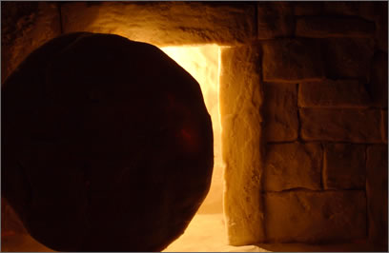

Resurrection View coming up out of the tomb!