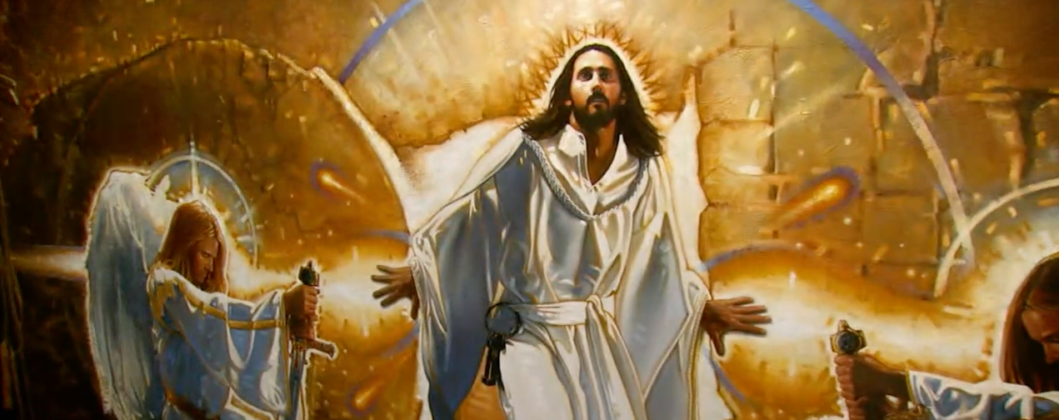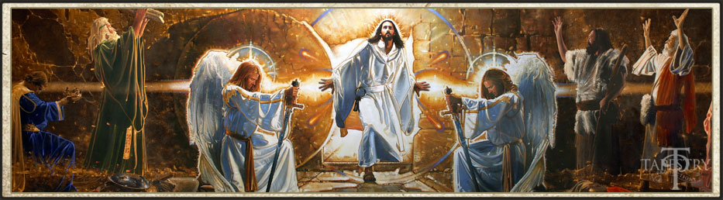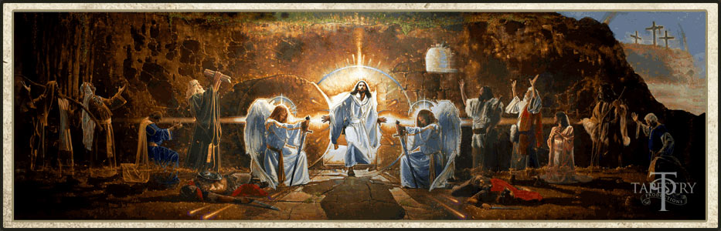

**Ron DiCianni’s mural of the Resurrection**