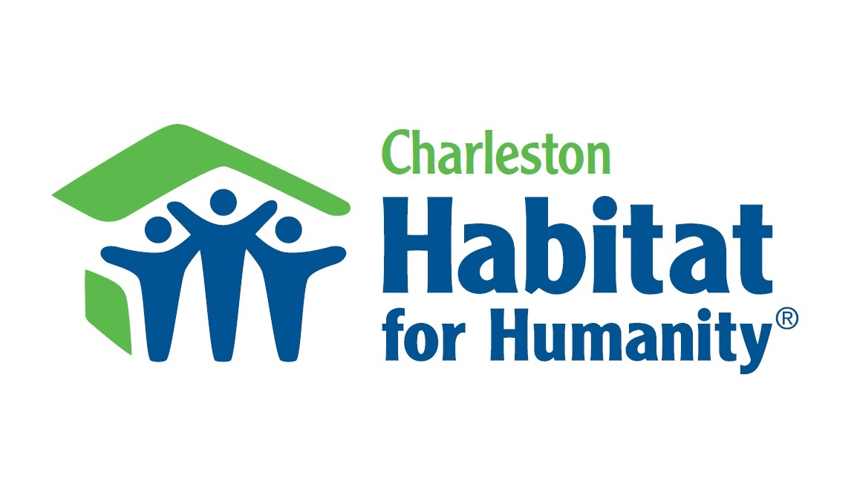

O.A.R. and Phillip Phillips to partner with Charleston Habitat for Humanity during upcoming concert in Charleston, SC

NORTH CHARLESTON, JULY 25, 2014 – Rock band O.A.R. and singer Phillip Phillips will partner with the Charleston Habitat for Humanity during their 2014 joint summer tour to raise funds to help low-income families in need of affordable housing.

The tour will host an online auction for a VIP concert experience to the Charleston concert, which takes place on July 25 at Family Circle Magazine Stadium on Daniel Island, with proceeds from the auction going to Charleston Habitat for Humanity. The VIP experience includes two premium tickets to the concert and an opportunity to meet with the artists.

“Home means everything to us. It’s our DNA. It’s who we are,” said Marc Roberge of O.A.R. “We had the chance to meet amazing people building Habitat for Humanity homes in LA, pouring love and sweat into the foundation, taking pride in the work they were doing, alongside the Habitat partner family, and it was an honor to be a part of that. Words can’t properly describe the positive swell that brought to our hearts. We hope the donation from our tour will help families, like the ones we met, achieve their dreams of homeownership.”

The tour will also donate 10 concert tickets to Charleston Habitat for Humanity for use by local Habitat volunteers, staff and partner families, who will also have the opportunity to meet the artists.

Charleston Habitat for Humanity will be on site during the concert to raise awareness about the affordable housing programs available within the community, as well as opportunities to volunteer or support their local work.

“My team has personally seen the incredible impact Habitat for Humanity can have on lives. We have worked on builds from the Musician's Village rebuild in New Orleans following Hurricane Katrina to local neighborhoods in my community,” said Phillip Phillips. “Habitat's roots stem from my home state of Georgia but their reach is now worldwide I am honored to partner with Habitat for Humanity in carrying out their mission - to build homes, communities, and hope."

In addition, O.A.R., in partnership with Charleston radio station 105.5 The Bridge hosted a day of volunteering on-site with winners of a week-long radio contest. Winners were treated to lunch catered by Black Bean Co. and an acoustic performance set after their volunteer shifts ended.

About Charleston Habitat for Humanity
Charleston Habitat for Humanity is a locally run affiliate of Habitat for Humanity International, a nonprofit, ecumenical Christian housing organization. Charleston Habitat for Humanity provides affordable homeownership opportunities for working families of moderate income in the cities of Charleston and North Charleston. Families can qualify for either new homes or home repair programs. Financial and in-kind support comes from homeowner principal mortgage payments; contributions from individuals, businesses, grants and foundations; sales from the Charleston Habitat for Humanity ReStore; and volunteer labor on our construction site.

About Habitat for Humanity International
Habitat for Humanity International’s vision is a world where everyone has a decent place to live. Anchored by the conviction that housing provides a critical foundation for breaking the cycle of poverty, Habitat has helped more than 4 million people construct, rehabilitate or preserve homes since 1976. Habitat also advocates to improve access to decent and affordable shelter and supports a variety of funding models that enable families with limited resources to make needed improvements on their homes as their time and resources allow. As a nonprofit Christian housing organization, Habitat works in more than 70 countries and welcomes people of all races, religions and nationalities to partner in its mission. To learn more, donate or volunteer visit habitat.org.

About O.A.R.
O.A.R. first began to develop their unique sound while in high school in Rockville, Maryland. With three albums under their belt before they finished college, the band began pursuing their musical dreams full time in the summer of 2001. By the end of 2008, the band had released six studio albums and three live double disc CDs. To date O.A.R. has sold close to 2 million albums and over 2 million concert tickets, including two sold-out shows at New York City's Madison Square Garden. In 2011 the band released their most recent studio album, King, which debuted at #12 on the Billboard 200 chart, #3 on the Billboard Digital Album Chart, and was #3 at iTunes on the day of the release. King was the follow-up to the band’s 2008 release, All Sides, which contains the Platinum hit radio single “Shattered.” The band will be releasing their next studio album, “ The Rockville LP”, June 10, featuring the hit single, “Peace”, as well as touring the United States with Phillip Phillips. www.ofarevolution.com

About Phillip Phillips
One of the biggest singles of 2012, the quadruple-platinum “Home” announced Phillip Phillips as a singer/guitarist of both rare authenticity and massive pop appeal. Centering on the American Idol season 11 winner’s rich, raspy vocals and masterful guitar skills, “Home” served as the lead single from The World from the Side of the Moon - a platinum plus-selling album that debuted #4 on the Billboard Top 200 Album chart and #1 on the Billboard Rock Album chart upon its November 2012 release. Phillips’s widely acclaimed debut also features the platinum single “Gone, Gone, Gone” and the Phillips’ penned “Where We Came From,” as well as a host of numbers that flaunt the 23-year-old Georgia native’s songwriting chops. Phillips released his sophomore album Behind The Light last month as new single “Raging Fire” continues to climb the charts. www.phillipphillips.com

###

Media Contacts:

Charleston Habitat for Humanity
Katie Norris
Director of Development
katie@charlestonhabitat.org
(843) 568-3160

O.A.R.
Lucy Sabini
lsabini@vanguardrecords.com
(310) 829-9355 ext. 137

Phillip Phillips
Meghan Prophet
meghan.prophet@pmkbnc.com
(310) 854-4800

